Dimitris Milakis
Transport Engineer, Ph.D.
Department of Geography and Regional Planning,
School of Surveying Engineering,
National Technical University of Athens (NTUA),
9 Iroon Polytechneiou street, 157 80 Zografos Campus, GREECE
Tel. +30 210 77 17 354
Fax. +30 210 77 22 752
Email: milakis@mail.ntua.gr

Thanos Vlastos
Associate Prof. NTUA
Department of Geography and Regional Planning,
School of Surveying Engineering,
National Technical University of Athens (NTUA),
9 Iroon Polytechneiou street, 157 80 Zografos Campus, GREECE
Tel. +30 210 77 22 630
Fax. +30 210 77 22 752
Email: vlastos@survey.ntua.gr

Urban characteristics and travel behaviour on the macro- and micro- scale. An integrated approach for the case of Athens.

Dimitris Milakis^{a,}*, Thanos Vlastosª

ªDepartment of Geography and Regional Planning, School of Surveying Engineering, National Technical University of Athens (NTUA), 9 Iroon Polytechneiou street, 157 80 Zografos Campus, Greece
*Corresponding author. Tel.: +30 210 77 17 354; Fax: +30 210 77 22 752; Email address: milakis@mail.ntua.gr

Abstract

The aim of this paper is the comprehensive investigation of the effects of the physical characteristics of urban form on travel behaviour. To this end, the most crucial spatial parameters of both macro- and micro- scale are firstly identified. Secondly the relative significance/importance of these two planning scales is examined, under the scope for promoting sustainable travel choices. The results show that several parameters of both spatial scales could be used in order to affect travel behaviour (f.e. urban density and pavement width). However, the interventions would be more effective only if the two planning levels were activated simultaneously and regarded as equivalent dimensions of the sustainable mobility strategy.

1. Introduction

Urban transport planning was characterised by a turnover on the strategic goals during the 90s. The “new realism” (Banister, 1999) disconnects the implementation of transport projects from demand, which keeps increasing. The theory of past decades that the expansion of road network will meet the needs for unrestricted demand is now rejected. The interest is focused on the demand restraint and management, and the promotion of public transport and alternative means (walking, cycling).

In the long-term the interest focuses also on the possibility to change travel behaviour through changes on the physical characteristics of urban form. The discussion has already opened on a political level concerning the implications of compact city form on travel choices.

However, research on this scientific field is still open and no final conclusions have been drawn. Many studies either offer contradictory results or are unable to account reliably for the relationship between urban form and travel behaviour. It must also be noted that most research has been carried out in American cities and this is still another reason why their conclusions should be transferred with caution in Europe. European cities have historically followed a much different model of development, and their structure differs significantly from those of American cities, particularly with regard to densities and mixture of land uses.

The aim of this paper is to investigate the effects of the physical characteristics of urban form on travel behaviour. In order to achieve a comprehensive approach a three-stepped methodology was developed. In the first two steps the relation between urban form characteristics and travel choices on two spatial levels, the macro- and micro- level, is investigated. In the third step the relative significance/importance of these two spatial levels is examined, in order for more sustainable travel choices to arise. The case study for this research is Athens, where these relations have not been examined until now.

Past studies have focused only on one spatial level and thus they have underestimate the relations between the macro- and micro- scale. It must also pointed out that the methodologies for each spatial level include an in depth analysis, which aims to contribute to the general debate of the last 25 years in the field of land use transport interaction.

2. Literature review

A fair amount of empirical research has analysed the relations of the land use transport system. Most studies have focused on the urban macro-scale parameters like density, land use mix, distance from city centre, city size etc. Micro-scale issues have drawn less attention, mainly because it is assumed that this planning level cannot play significant role towards sustainable mobility. Finally, no studies have investigated the spectrum of relations existing between the urban macro-scale, the urban micro-scale and the travel choices.

2.1 Studies focusing on urban macro-scale

One of the most important studies was conducted by Newman and Kenworthy (1989, 1999). The work dealt with data from 32 cities in four continents and came to the conclusion that the energy consumption by private vehicles in urban areas is influenced by residential density. They diagnosed a strong negative relationship (R²=0.8594) between residential density and energy consumption. This relationship is exponential for densities beneath 30 persons per hectare and linear for higher levels. Although this work met with severe criticism, both at ideological (Gordon and Richardson 1989, 1997; Breheny, 1997) and methodological level (Gomez-Ibanez, 1991; Wegener, 1998; Mindali et al., 2004), it still remains a landmark study on this field.

Results similar to those of Newman and Kenworthy are yielded by the research conducted by ECOTEC (1993) in Great Britain. The findings indicate that an increase in population density leads to a decrease in the number of kilometers travelled per person by car and correspondingly to an increase in the distance travelled per person by public transport and on foot.

Other studies focus on different urban macro-scale parameters. For example several studies examine the influence of land use mix on travel choices (Cervero, 1988, 1996; Frank and Pivo, 1994a), while others focus on jobs-employment balance (Cervero, 1989; Ewing et al., 2001; Frank and Pivo 1994b). Special attention has been given to the parameter ‘distance from centre’. These studies come mainly from Europe, as it is assumed that the monocentric form of most European cities plays an important role in determining travel length (Mogridge, 1985; Spence and Frost, 1995; Curtis, 1995, Naess and Sandberg, 1996). Finally, several studies examine the role of city size (Breheny, 1995; Williams, 1997).

In all the studies referred above, various urban macro-scale, socio-economic and travel characteristics were employed. If one compares the results of these studies, it becomes evident that there are significant differences (e.g. as regards the threshold of residential density at which a noticeable change in travel behaviour occurs), or even contradictions. According to Van Wee (2002), the main reasons for the variety of the results are:
- the low level of difference among the urban form characteristics in the study areas,
- the various research methodologies,
- the different sizes of the regions studied,
- the different understanding of the same parameters in different countries,
- differences in culture and outlook, particularly in regard to travel behaviour,
- the indirect effects in the form of the relationship between land use and socio-economic characteristics, which also influence travel behaviour.

2.2 Studies focusing on urban micro-scale

Urban micro-scale refers to the neighbourhood level characteristics. Most studies on the urban micro-scale level utilise general (usually qualitative) descriptors of neighbourhood characteristics. Then they examine the influence of these descriptors on travel behaviour, without identifying the separate effects of specific features of the urban environment such as the pavement and road width, the parking availability etc. The most common descriptors are (a) the road network form (Flemming and Pund, 1994, Messenger and Ewing, 1996; Crane and Crepeau, 1998) and (b) the neighborhood type (traditional-, suburban-, auto-, transit- development) (Handy, 1992; Friedman et al., 1994; McNally and Κulkarni, 1997; Cervero and Kockelman, 1997)

3. 1st Step: Investigation of the urban macro-scale effects on travel behaviour

3.1 Conceptual model

In this paragraph the research for the investigation of the urban macro-scale effects on travel behaviour is presented. The conceptual model (fig. 1) and the research questions are initially posed:
- Is there any relation between urban form parametres and travel choices? If yes, which of these parametres are the most significant and reliable?
- The urban or the non-urban form parametres (e.g. socio-economic) affect travel behaviour more? Is there any interaction between them?
- If there is such an interaction, which of the urban form parametres affect travel choices directly?

3.2 Data and methodology

In order to answer the above questions a three-leveled methodology was developed. Each level addresses one question and forms the basis for the examination of the next. Greater Athens was case-studied. The study metropolitan area of Athens consists of 82 municipalities, with a total population of 3 833 400 persons. The spatial unit for the present analysis was the municipality, since it is the smallest area for which data is available. 95% of the population of the study area is concentrated in a basin, of about 1270 km2, and surrounded by sea and mountains. This basin includes 65 municipalities. The average municipality size is 15 km². Data derive from surveys carried out by the Metro Development Study (MDS), in 1996, namely on
- land use and socio-economic characteristics and
- travel characteristics
The land use surveys covered 74 500 hectares (66 600 blocks). Travel characteristics and social-economic characteristics of households derive from a total of 29 358 interviews (general sampling 2% of the population) (AM-DPGS, 1998).

Three categories of parametres were used in the research:

The Urban Form Parametres (UFPs)
- net residential density
- jobs-employment balance
- land use balance
- distance from centre
- road space per person

The non-Urban Form Parametres (non-UFPs)
socio-economic, namely:
- household income
- household size
- car ownership
and
- public transport accessibility

Travel characteristics
- modal split (car, public transport, walking)
- mean journey length by car and
- per capita energy consumption by car

At the first level, the aim was to investigate whether UFPs influence travel behaviour and which of them significantly explain the variability of each of the five travel characteristics chosen for this study. Five multiple regressions were performed, with travel characteristics serving as dependent variables and UFPs as explanatory variables.

In each multiple regression, the final model was approached in successive steps. In each step, the level of significance of each parametre and the total explanatory power of the model were examined. The base model consisted of the five UFPs. If the ‘t-value’ and the corresponding level of significance for a parametre was less than 10%, then the parametre in question was removed from the next regression step. At the same time, the value changes for the corrected co-efficient of determination (adjusted R²) at each step of the regression were examined.

At the second level, the aim was to compare the degree of influence exercised by UFPs and non-UFPs on travel characteristics and to identify and measure any mutual influences. Firstly, the R²-value is determined separately for UFPs and for non-UFPs. Then a third multiple regression is applied, in which all the parametres listed above are included as explanatory variables. This third calculation allows one to find the degree of direct and indirect influence exercised by every group of parametres on travel characteristics. However, it is certainly difficult, if not impossible, to define a causal relation. Furthermore, if one assumes that a particular UFP causes changes in non-UFPs and, ultimately, indirectly influences travel behaviour, this is not a particularly helpful conclusion, when it comes to applying respective policies. The time frame for realising such a chain of changes is excessively long and certainly not politically viable.

At the third level, the aim was to establish which UFPs directly influence travel behaviour. There, each non-UFP is divided into two sets, the one of low and the other of high values. For every non-UFP (control parametre), four multiple regressions are applied to each set. The most significant UFPs, according to the first level of analysis, are used as explanatory variables in each regression. Then UFPs are checked to ascertain whether they retain their significance and form, either positive or negative, of their relation to the dependent variable. Ιf, in both sets of values, an explanatory variable
- retains its significance in terms of the ‘t-value’ criterion, and
- retains the same form of relationship,
its relationship with the specific travel characteristic is considered to be direct. This means that the change in a particular UFP will influence travel behaviour, independently of both the socio-economic parametres and the accessibility of public transport.

3.3 Results

The most crucial characteristics of urban form affecting travel behaviour were identified at the first level of the analysis. These characteristics are presented in table 1.

The second level of the analysis allows one to compare the influence of UFPs and non –UFPS on travel behaviour. The results indicate that UFPs exert more influence than non-UFPs on:
- the use of public transport,
- walking,
- the mean journey length by car, and
- the energy consumption by car.

By contrast, non-UFPs exert more influence than UFPs on
- the use of car.

UFPs, directly or indirectly, explain the variability of ‘mean journey length by car’ (81.0%). Then come ‘energy consumption by car’ (74.6%), ‘public transport use’ (63.9%), ‘car use’ (46.6%) and ‘walking’ (24.8%). Non-UFPs, directly or indirectly, explain the variability of ‘car use’ (75.6%), ‘energy consumption by car’ (57.2%), ‘public transport use’ (37.4%), ‘mean journey length by car’ (19.1%) and ‘walking’ (17.3%).

From the third level of analysis the results regarding UFPs that directly influence travel behaviour are derived. The results indicate that, the UFP or UFPs directly influencing
- public transport use, are ‘net residential density’ and ‘jobs-employment balance’,
- car use, is ‘net residential density’
- walking, is ‘net residential density’
- mean journey length by car, are ‘distance from centre’ and ‘road space per person’, and
- energy consumption by car, is ‘distance from centre’ and ‘road space per person’.

The overall conclusion, arising from all of the results above, is that density is the most important UFP, which influences travel behaviour. This relationship is to a great extent direct, that is, it is independent of socio-economic characteristics and of public transport accessibility. Nevertheless, car use also depends to a great extent upon non-UFPs. Finally, it could be argued that residential density is an efficient tool for increasing the use of public transport at the expense of the car. Such influence can be expected to remain particularly strong up to a threshold of 200 persons per hectare (see fig. 2 and table 2).

Similar conclusions, however, are not to be drawn regarding the influence of residential density on mean journey length and on energy consumption by car. In fact, this parametre did not maintain its significance level in all the sets of the control parametres. By contrast, as regards the above travel characteristics, the parametre ‘distance from centre’ was particularly significant and independent of non-UFPs.

Thus, an increase in residential density and a decrease in distance from the city centre, could constitute two basic tools towards sustainable mobility. These two pillars of such a strategy could then rest upon small scale changes in other physical characteristics of urban form, namely ‘jobs-employment balance’ and ‘road space per person’, which were of lesser importance and influence on travel behaviour. In particular:
- ‘jobs-employment balance’ does indeed influence the number of journeys per person by public transport and car, but not the journeys per person on foot, the mean journey length and the energy consumption by car, and
- ‘road space per person’ does indeed influence the mean journey length and energy consumption by car, but not the number of journeys per person by car, public transport and on foot.

A summary of the results from the three levels of the analysis are presented in table 3.

4. 2nd Step. Investigation of the urban micro-scale effects on travel behaviour

4.1 Conceptual model

In this paragraph the research for the investigation of the urban micro-scale effects on travel behaviour is presented. The conceptual model and the research questions are initially posed:
- Is there any relation between urban micro-scale parametres and travel choices?
- If yes, which of these parametres are the most critical?

4.2 Data and methodology

In order to answer the above questions, four multiple linear regressions were conducted. The municipality of Kallithea was case-studied and data from AUTO (1997) and the Transport Study of Kallithea (1989) were used. The spatial unit was traffic zone (22 in total). Kallithea is placed at a distance of 5.5 km southern from the city center with a total population of 135 000 persons. It has a quite high density (690 person/ha) and is surrounded by some of the most important road arteries of Athens (see fig. 3). Two categories of parametres were included in this part of the research:

Urban micro-scale characteristics
- Height of buildings to road width ratio
- Pavement width
- Percentage of two-way roads
- Distance from the metro station
- Percentage of main arteries in the road network
- Availability of parking spaces

Travel characteristics
- Modal split (car use, public transport use)
- Mean journey length by car
Urban micro-scale characteristics were used as explanatory variables, whereas each travel characteristic was used as dependent variable. In each regression the corrected coefficient of determination and the t-value of each parametre were checked. In this case no threshold for the t-value was determined.

4.3 Results

Public transport use was found to be positively influenced by the following parameters (Table 4):
- Height of buildings to road width ratio, and
- Pavement width
and negatively influenced by the parametres:
- Distance from the metro station
- Percentage of two-way roads
- Percentage of main arteries in the road network
- Availability of parking spaces

In contrast, car use was found to be positively influenced by the parameters (see Table 4):
- Distance from the metro station
- Percentage of two-way roads
- Percentage of main arteries in the road network
- Availability of parking spaces
and negatively influenced by the parametres:
- Height of buildings to road width ratio, and
- Pavement width

However, public transport and car use is highly correlated (r = -0.985). That explains why the parametres of influence are the same in both cases, but they have adverse effects (negative in the first case and positive in the second, and vice versa). It is assumed that some of the parametres primarily influence public transport use and as a result they subsequently affect car use. More specifically, it is estimated that the parametres:
- Pavement width, and
- Distance from the metro station
affect mainly public transport use. The increase of the pavement width facilitates the accessibility of public transport stations. On the other hand, the nearer the origin of a trip to the metro station, the easier it is to walk to the station. The latter is confirmed by a relevant study, which found out that the range of a metro station is gradually decreased especially over 500 m (Dimitriou, 2004: 184-185).

The parametres that primarily affect car use are estimated to be the following:
- Percentage of two-way roads
- Percentage of main arteries in the road network
- Availability of parking spaces
- Height of buildings to road width ratio

The first three parametres are positively correlated with car use. All of them reflect the difficulties that may face if someone use a car. As the number of two-way roads in a network increases, so do the degrees of freedom available for a car to move. This means easier and faster reaching of the destination and of course avoidance of unnecessary kilometres.

In the same way, if a road network comprises many arteries, it will be easier and faster for someone to reach his destination and of course to avoid traffic congestion. Consequently, the easier for someone to get to an artery, the more he will use his car, especially if his trip is quite long (intermunicipal trips).

The next parametre that primarily affects car use is the availability of parking spaces. The fewer the parking spaces, the more difficult for someone to use his car. Consequently, the supply of plenty parking spaces and especially one that is free of charge, is a motive for intense car use.

The last parametre “height of buildings to road width ratio” describes indirectly the degree of congestion. As the number of activities at the side of the road increases the space available for traffic diminishes. More houses at the side of the road, the less road space. The increase of the above ratio could be a product of:
- increasing buildings’ height and maintaining road width
- decreasing road width and maintaining buildings’ height
- increasing buildings’ height and simultaneously decreasing the road width
All these cases are correlated with more congested road network, as (a) more cars will use the constant road space or (b) constant number of cars will use less road space. It is quite reasonable then that an increase in the above parametre will lead, due to the congestion, to less car use. This is a point confirmed by the research results.

Finally, as far as it concerns mean journey length, the results show that this parametre is not affected by urban micro-scale characteristics (see Table 4). This is quite reasonable as journey length depends mainly on the distance between origin and destination of the trip (see the results of the 1st methodological step in paragraph 3.3). This means that if the decision to make a car trip is done, then urban micro-scale characteristics will play no role in determining its length.

5. 3rd Step. Investigation of the relative significance/importance of the urban macro- and micro- scale effects, towards more sustainable travel behaviour

In this methodological step the relative significance/importance of the urban macro- and micro- scale effects towards more sustainable travel behaviour is examined. The fundamental question is whether changes of urban characteristics in only one spatial level would be adequate in order to change travel behaviour. Should we give priority to one spatial level or should the interventions be directed towards both spatial levels simultaneously?

The theoretical basis for the examination of the above questions comprises (a) the action spaces theory (see Hägerstrand, 1970) and (b) the travel cost-time budgets theory (see Zahavi, 1974). ‘Action space’ is the geographical area that someone could reach in a given time-period by using a specific means (f.e. his bicycle). A four-leveled methodology was developed, which follows a bottom-up approach. In the first level, the mean travel time (one-way trip) for the case of Athens was calculated. It was found to be 32 minutes. Based on this time, the action spaces of public transport users and walkers who live in the municipality of Kallithea, were spatially determined (fig. 3, 4).

In the third step, the car share for each traffic zone of the municipality of Kallithea was calculated taking into account only trips destinated outside the action spaces of public transport users and walkers. Finally, in the forth step, the question of, whether the car share variability between the zones could be explained/influenced by the urban micro-scale characteristics or not was examined.

According to the regression results (Table 5), car trips outside the action spaces cannot be influenced by urban micro-scale characteristics. The explanatory power and t-values for all micro-scale parametres were significantly decreased in comparison with the corresponding values for all car trips (see table 4). It should be noted that these trips constitute a quite large proportion (25%) of the total trips made by car and that they are expected to increase even more in the following years, as cities will further sprawl. It is then assumed that the intervention on urban characteristics in order to promote more sustainable travel patterns would be more effective only if an integrated approach is adopted.

6. Conclusions

Land use policies are often regarded as a panacea against excessive car use and its implications. Proposals related with urban form changes (especially the compact city) have been adopted on a political level and included in political documents. However, research on this scientific field is still incomplete and the results it yields cannot be regarded as definitive. Indeed, many studies either offer contradictory results or are unable to reliably account for the relationship between urban form and travel behaviour.

In this paper a comprehensive approach of land use transport system is presented. Urban macro- and micro- scale characteristics were included in our methodology, in order to examine their influence on travel behaviour. It was also examined the relative significance of these two planning scales towards more sustainable travel patterns. The conclusions of this research are separated into three paragraphs, corresponding to the three steps of methodology.

6.1 Urban macro-scale

The results presented in paragraph 3, support the notion that land use policies can constitute an effective tool for changing travel behaviour, although travel behaviour is largely dependent on socio-economic parametres. However, the crucial urban form parametres, and their critical thresholds for travel behaviour, may vary from country to country, especially among cities in Europe and America, which means that no universal standards can be adopted.

In the case of the Athens Metropolitan Area the two most crucial urban form parametres were found to be ‘net residential density’, and ‘distance from centre’. Thus, an increase in residential density and a decrease in distance from the city centre, could constitute two basic tools towards sustainable mobility. The two pillars of such a strategy could then rest upon small scale changes in other physical characteristics of urban form, namely ‘jobs-employment balance’ and ‘road space per person’, which were of lesser importance and influence on travel behaviour.

A threshold of 200 persons per hectare was also found in the case of Athens. Below this threshold, when density increases, car use decreases and public transport use increases significantly. Such a threshold is very high in comparison with others found in studies both in America (Frank and Pivo, 1994a) and Europe (Stead, 2001). Finally, neither urban form parametres, nor socio-economic parametres were found to influence the number of trips on foot significantly.

Generally, it is proposed that, in every case, one should first analyse the existing relationships between land uses and transport, without underestimating the role of non-urban form parametres (e.g. socio-economic). It is also proposed that, in every case, one should identify the urban form parametres that directly influence travel behaviour, to ensure that any policies subsequently applied are effective. Otherwise any land use policies aiming to change travel behaviour run the risk of being ineffective.

6.2 Urban micro-scale

The intervention on the urban micro-scale characteristics could also constitute a tool for changing travel behaviour. This influence regards mainly public transport and car use. On the contrary, mean journey length by car was not found to be influenced by urban micro-scale characteristics.

It is estimated that the increase of pavement width and the orientation of urban development around metro stations will lead to an increase of public transport use. Limited parking availability and traffic restraints are estimated to lead also to a considerable decrease in car use. Journey length by car cannot be controlled through changes in the urban micro-scale characteristics. If, for example, someone decides to make a journey by car, the distance of the destination will mainly influence its length, especially for a commuting journey.

6.3 Relative importance of the two planning scales

In the last part of the research (paragraph 5) the relative significance/importance of the urban macro- and micro- scale effects, towards more sustainable travel behaviour was examined. The fundamental question was whether we should give priority to one spatial level or whether the interventions should be directed at both spatial levels simultaneously, in order for more sustainable travel patterns to arise.

According to the results, the intervention on the urban micro-scale characteristics cannot influence a quite large part of the trips made by car. These, not influenced trips, are about 25% of the total trips made by car, which are destinated outside the action spaces of public transport users and walkers. The action spaces were calculated on the basis of the mean travel time (one-way trip) for the case of Athens, which was found to be about 32 minutes.

The question then, is how we can influence this group of trips? The first and obvious solution is to improve public transport accessibility in order to expand the action space of passengers in a given time period. Indeed, the expansion of the public transport network and the interconnection of all means would influence travel choices for the benefit of public transport use. However, is it possible to expand public transport network in order to cover the entire city space?

All the cities around the world expand towards their periphery. Urban sprawl is a phenomenon that Athens has also experienced throughout the last 20 years. Residential densities in the new suburbs are quite low, as a result of the tendency for more housing space per person and a yard. Detached houses constitute a more desirable residential pattern.

Under these conditions, investment in public transport will not be beneficial in economic terms. In Athens, where public transport network is restricted in central areas with high density, public transport organisations are not profitable. This is the case for nearly all the cities around the world. Therefore, it would be an utopia to expect the public transport network and the corresponding action space of a passenger to cover the whole trip destinations in the future city.
A second solution has been investigated by this study. It regards the intervention in the urban macro-scale characteristics. According to the results, it is possible to have a modal shift towards public transport and to reduce journey length by car, through land use changes on that scale. Two goals can be achieved through these changes (a) to bring the origins and destinations of trips closer and (b) to increase public transport patronage without the need for a financially unprofitable expansion of the network.

The ultimate conclusion is that the intervention on urban characteristics will be effective only if an integrated approach is adopted. This means that the two levels of planning (micro- and macro-) should be activated simultaneously and regarded as equivalent dimensions of the same strategy, the strategy for sustainable mobility and for better quality of the urban environment.

Acknowledgements

This research is co-funded by the European Social Fund (75%) and National Resources (25%) under the programme “HRAKLEITOS”.

7. References

Athens Urban Transport Organization (AUTO), Department of Research and Development (1997) Development of a Transportation Model for the Public Transport Network. Phase A’ - Trip Generation, AUTO-DRD, Athens.
Attiko Metro S.A.., Department of Planning and General Studies (AM-DPGS) (1997) Metro Development Study, Athens.
Banister, D. (1999) ‘Planning more to travel less. Land use and transport’, Town Planning Review, 70 (3), pp. 313-338.
Breheny, M. (1995) ‘The compact city and transport energy consumption’, Transactions of the Institute of British Geographers, 20 (1), pp. 81-101.
Breheny, M. (1997) ‘Urban compaction: feasible and acceptable?’, Cities, 14 (4), pp. 209-217.
Cervero, R. (1988) ‘Land-Use Mixing and Suburban Mobility’, Transportation Quarterly, 42 (3), pp. 429-446.
Cervero, R. (1989) ‘Jobs-Housing Balancing and Regional Mobility’, Journal of the American Planning Association, 55 (2), pp. 136-150.
Cervero, R., Kockelman, K. (1997) ‘Travel Demand and the 3Ds: Density, Diversity, and Design’, Transportation Research Part D, 2 (3), pp. 199-219.
Crane, R., Crepeau, R. (1998) ‘Does neighborhood design influence travel? A behavioral analysis of travel diary and GIS data’, Transportation Research Part D, 3 (4), pp. 225-238.
Curtis, C. (1995) ‘Reducing the need to travel: strategic housing location and travel behaviour’, in: Earp, J.H., Headicar, P., Banister, D., Curtis, C. (eds) Reducing the need to travel: some thoughts on PPG13, Oxford Planning Monographs.
Dimitriou, D. (2004) Analysis of passengers behaviour in Athens metro stations, Master thesis, Hellenic Open University, Patras.
ECOTEC (1993) Reducing transport emissions through land use planning, HMSO, London.
Ewing, R., Dumbaugh, E., Brown, M. (2001) ‘Internalizing Travel by Mixing Land Uses. Study of Master-Planned Communities in South Florida’, Transportation Research Record, 1780, pp. 115-120.
Fleming, R., Pund, G. (1994) ‘The impact of the planning of urban areas on the use and attractiveness of local bus service’, Proceedings of the 17th ARRB (Australian Road Research Board) Conference, part 7.
Frank, L.D., Pivo, G. (1994a) ‘Impacts of Mixed Use and Density on Utilization of Three Modes of Travel: Single-Occupant Vehicle, Transit, and Walking’, Transportation Research Record, 1466, pp. 44-52.
Frank, L.D., Pivo, G. (1994b) ‘Relationships between Land Use and Travel Behavior in the Puget Sound Region’, Prepared for the Washington State DOT by the Washington State Transportation Center, University of Washington, Seattle, WA.
Friedman, B., Gordon, S., Peers, J. (1994) ‘Effect of neotraditional neighborhood design on travel characteristics’, Transportation Research Record, 1466, pp. 63-70.
Gomez-Ibanez, J. (1991) ‘A Global View of Automobile Dependence’, Journal of the American Planning Association, 57 (3), pp. 376-379.
Gordon, P., Richardson, H.W. (1989) ‘Gasoline Consumption and Cities – A Reply’, Journal of the American Planning Association, 55 (3), pp. 342-346.
Gordon, P., Richardson, H.W. (1997) ‘Are Compact Cities a Desirable Planning Goal?’, Journal of the American Planning Association, 63 (1), pp. 95-106.
Hägerstrand, Τ. (1970) ‘What about people in regional science’, Papers of the Regional Science Association, 24, pp. 7-21.
Handy, S. (1992) ‘Regional Versus Local Accessibility. Neo-Traditional Development and its Implications for Non-work travel’, Built Environment, 18 (4), pp. 253-267.
Kolliopoulos, J., Efmolpidis, B. (1989) Kallithea Transport Study, Municipality of Kallithea, Athens
McNally, M.G., Kulkarni, A.. (1997) ‘Assessment of influence of land use-transportation system on travel behavior’, Transportation Research Record, 1607, pp. 105-115.
Messenger, T., Ewing, R. (1996) ‘Transit-Oriented Development in the Sun Belt’ Transportation Research Record, 1552, pp. 145-153.
Mindali, O., Raveh, A., Salomon I. (2004) ‘Urban density and energy consumption: a new look at old statistics’, Transportation Research Part A, 38 (2), pp. 143-162.
Mogridge, M.J.H. (1985) ‘Transport, Land Use and Energy Interaction’, Urban Studies, 22 (6), pp. 481-492.
Naess, P., Sandberg, S.L. (1996) ‘Workplace Location, Modal Split and Energy Use for Commuting Trips’, Urban Studies, 33 (3), pp. 557-580.
Newman P., Kenworthy J. (1989) Cities and Automobile Dependence. An International Sourcebook, Gower, Aldershot.
Newman, P., Kenworthy, J. (1999) Sustainability and Cities. Overcoming Automobile Dependence, Island, Washington DC.
Spence, N., frost, M. (1995) ‘Work travel responses to changing workplaces and changing residences’, in: Brotchie, J., Batty, M., Blakely, E., Hall, P., Newton, P. (eds) Cities in Competition. Productive and Sustainable Cities for the 21st Century, Longman, Melbourne.
Stead, D. (2001) ‘Relationships between land use, socioeconomic factors, and travel patterns in Britain’, Environment and Planning B: Planning and Design, 28 (4), pp. 499-528.
Van Wee, B. (2002) ‘Land-use and transport: Research and policy challenges’, Journal of Transport Geography, 10 (4), pp. 259-271.
Wegener, M. (1998) ‘Sustainable Urban Spatial Structures, Do we Need to Rebuild Our Cities?’ Summary of the research project ‘Sustainable Urban Spatial Structures’ (1993-1998), IRPUD - Institute of Spatial Planning, University of Dortmund.
Williams, J. (1997) ‘A Study of the Relationship between Settlement Size and Travel Patterns in the United Kingdom’ URBASS Working Paper 2, UCL, Barlett School of Planning, London.
Zahavi, Y. (1974) ‘Traveltime Budgets and Mobility in Urban Areas’, Report FHW PL-8183, US Department of Transportation, Washington DC.
Parametres entered in the base model | Final models
Parametres entered in the base model | Public transport | Car | Foot | Mean journey length by car | Energy consumption by car
 | Constant: 0.125  (2.011 / 0.048)^{α} | Constant: 1.828  (14.579/ 0.000) | Constant: -0.050  (-1.300 / 0.197) | Constant: 6 282.539  (4.449 / 0.000) | Constant: 41.843  (4.388 / 0.000)
Net residential density | 0.050  (5.456 / 0.000) | -0.190  (-8.127 / 0.000) | 0.025  (3.138 / 0.002) | -428.736  (-1.929 / 0.058) | -5.305  (-3.535 / 0.001)
Jobs-employment balance | 0.018  (2.953 / 0.004) | -0.089  (-3.991 / 0.000) | -- | 184.386  (1.699 / 0.094) | -2.537  (-3.463 / 0.001)
Land use balance | -- | -- | 0.140  (2.397 / 0.019) | -- | --
Distance from centre | -6.0Ε-06  (-3.032 / 0.003) | -- | -- | 0.210  (5.904 / 0.000) | 4.0Ε-04  (1.651 / 0.103)
Road space per person | -- | -- | -- | 4.576  (2.578 / 0.012) | 0.041  (3.393 / 0.001)
Adj. R² | 0.625 | 0.451 | 0.230 | 0.799 | 0.731
F-value | 45.979* | 34.204* | 13.129* | 71.470* | 49.247*
^{α} (t-value / significance)
* statistical significance of 1%
Table 1. The final models of the 1st level of the analysis on the urban macro-scale.

 | Residential density increase from 10 to 30 persons/hectare | Residential density increase from 210 to 230 persons/hectare
Journeys/person by car | + 18.6% | + 1.6%
Journeys/person by public transport | - 6.9 % | - 0,6%
Journeys/person on foot | + 24.1% | + 1.9%
Mean journey length by car | - 30.7% | - 2.5%
Energy consumption by car | - 37.2% | - 3.1%
Table 2. The effects on travel characteristics from the density increases.

Crucial UFPs
 | Public transport | Car | Foot | Mean journey length by car | Energy consumption by car
Net residential density | √ (+)  → | √ (-)  → | √ (+)  → | √ (-) | √ (-)
Jobs-employment balance | √ (+)  → | √ (-)  →
Land use balance |  |  | √ (+) | √ (-) | √ (-)
Distance from centre | √ (-) |  |  | √ (+)  → | √ (+)  →
Road space per person |  |  |  | √ (+)  → | √ (+)  →
Range of influence
UFPs | 29.0% – 63.9% | 0.6% – 46.4% | 12.9% – 24.9% | 63.6% – 81.0% | 29.2% – 74.6%
non-UFPs | 2.5% – 37.4% | 29.8% – 75.6% | 5.3% – 17.3% | 1.7% – 19.1% | 11.8% – 57.2%
√ : Crucial UFPs
(+): Positive influence
(-): Negative influence
Table 3. Summary of results from the three levels of the analysis for the examination of the urban macro-scale effects on travel behaviour.

Parametres | Final models
Parametres | Public transport | Car | Mean journey length by car
Height of buildings to road width ratio | 0.114  (2.361 / 0.032)^{α} | -0.353  (-2.654 / 0.018) | 6693  (1.929 / 0.073)
Pavement width | 0.036  (2.894 (0.011) | -0.323  (-2.366 / 0.032) | 1121  (1.399 / 0.182)
Percentage of two-way roads | -0.032  (-1.208 / 0.246) | 0.279  (1.838 / 0.086) | 1136  (0.687 / 0.503)
Distance from the metro station | -2.06Ε-05  (-2.411 / 0.029) | 0.251  (1.956 / 0.069) | -0.330  (-0.736 / 0.473)
Percentage of main arteries in the road network | -0.075  (-1.575 / 0.136) | 0.071  (0.696 / 0.497) | -2377  (-0.750 / 0.465)
Availability of parking spaces | -0.018  (-2.894 / 0.011) | 0.380  (2.658 / 0.018) | 406  (0.980 / 0.343)
Adj. R² | 0.851 | 0.852 | 0.042
F-value | 20.989* | 21.059* | 0.860
^{α} (t-value / significance)
* statistical significance of 1%
Table 4. The final models of the analysis on the urban micro-scale.

 | Coefficient | (t-value / significance)
Height of buildings to road width ratio | -1.103 | (-1.499 / 0.155)
Pavement width | 0.082 | (0.484 / 0.635)
Percentage of two-way roads | -0.590 | (-1.681 / 0.113)
Distance from the metro station | 7.24Ε-05 | (0.761 / 0.458)
Percentage of main arteries in the road network | -0.517 | (-0.769 / 0.454)
Availability of parking spaces | -0.095 | (1.085 / 0.295)
Adj.R² | 0.216
(F-value / significance) | (1.963 / 0.136)
Table 5. The regression results of the 3rd methodological step. Car trips, which are destinated outside the action spaces of walkers and public transport users, serve as dependent variable.

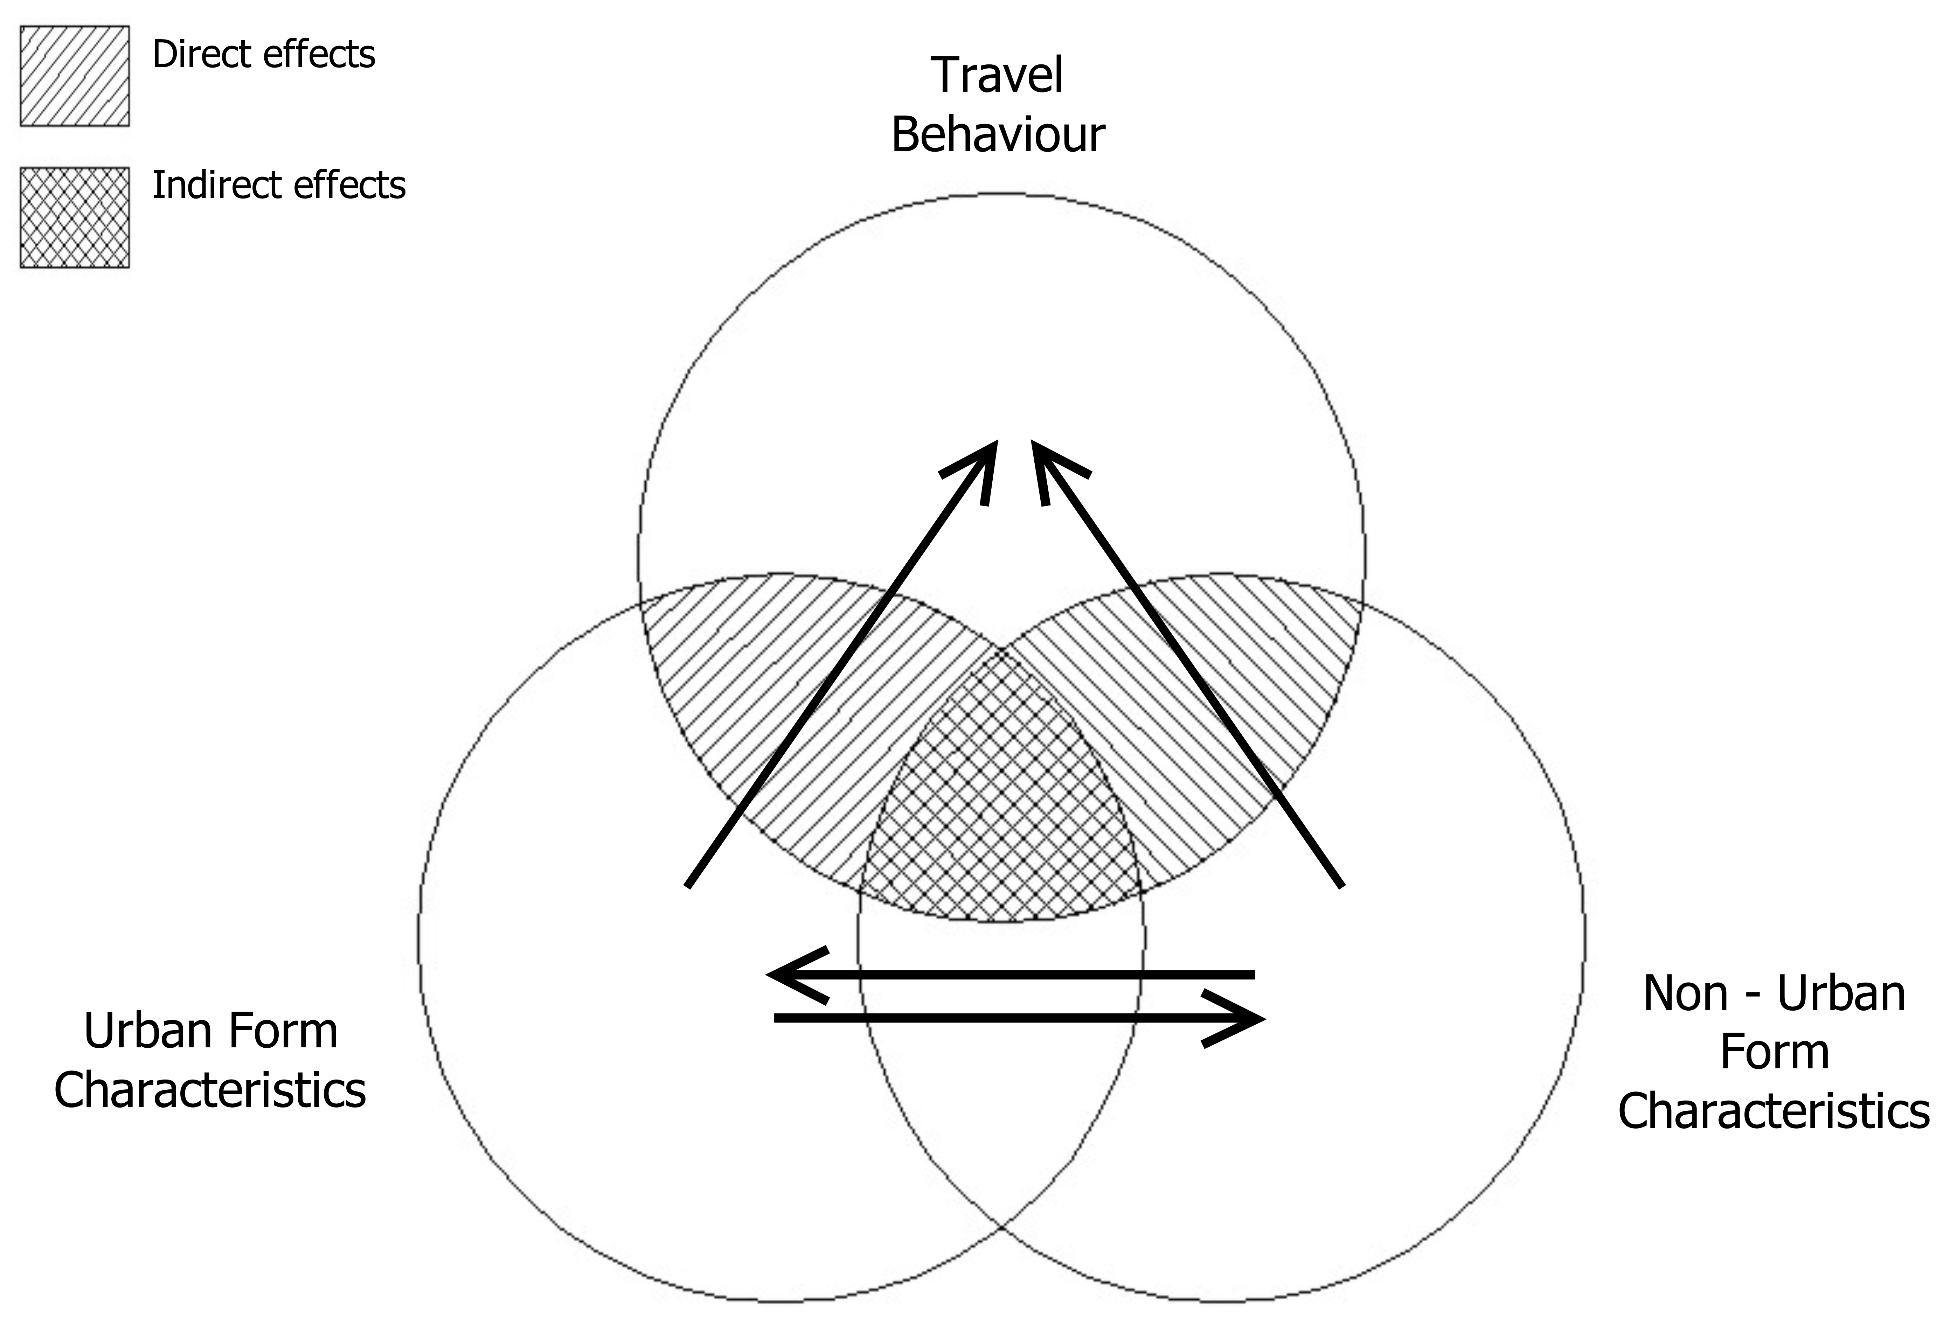

Fig. 1. The conceptual model of the research for the examination of the urban macro-scale effects on travel behaviour.

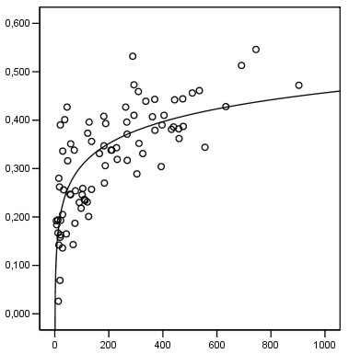
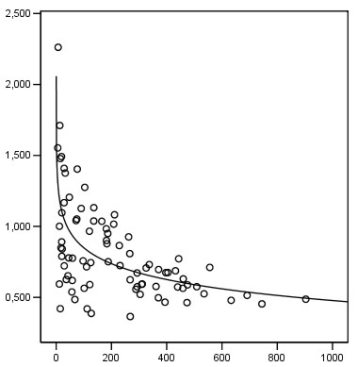
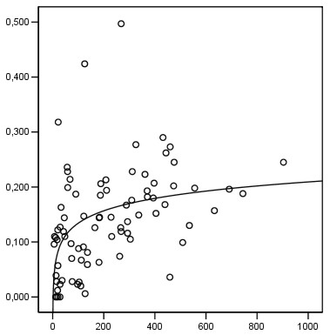
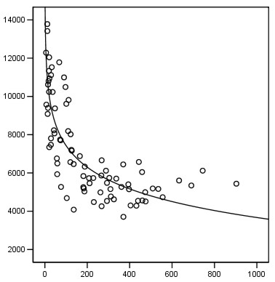
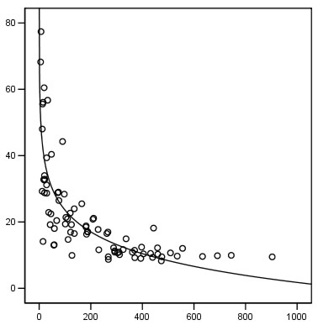
Journeys/person by Public Transport
Net residential density
Journeys/person by car
Net residential density
Journeys/person on foot
Net residential density
Net residential density
Mean journey length by car
Net residential density
Energy consumption by car

Fig. 2. Graphical representation of the relationships between density and travel characteristics.

Kallithea
Study area
2.7 Km
Action space of walkers
originated in Kallithea
Center of Athens

Fig. 3. The action space of walkers, who start their trip from the municipality of Kallithea (study area).

Kallithea
Study area
Action space of public transport users originated in Kallithea
Center of Athens
Fig. 4. The action space of public transport users, who start their trip from the municipality of Kallithea (study area).

