The Introduction of Dynamic Features in a Random-Utility-Based Multiregional Input-Output Model of Trade, Production, and Location Choice

Tian Huang
Graduate Student Researcher
The University of Texas at Austin
6.512. Cockrell Jr. Hall, Austin, TX 78712-1076
huangtian@mail.utexas.edu
and
Kara M. Kockelman
(Corresponding author)
Associate Professor and William J. Murray Jr. Fellow
Department of Civil, Architectural and Environmental Engineering
The University of Texas at Austin
6.9 E. Cockrell Jr. Hall, Austin, TX 78712-1076
kkockelm@mail.utexas.edu Phone: 512-471-0210

ABSTRACT
This study introduces dynamic features into the random-utility-based multiregional input-output (RUBMRIO) model. The RUBMRIO model predicts interzonal trade and travel patterns, as well as business and household location choices, using consumption and production process data. It equilibrates production and trade, labor markets and transportation networks simultaneously. Multinomial logit models predict the origins of productive inputs, including commute behaviors (for the input of labor).
With household locations and expenditures/incomes relatively well known for the very near future, one can predict current trade patterns by making household consumption, as well as (foreign and domestic) export demands, exogenous to the model, resulting in short-term predictions. The long-run equilibrium, wherein household locations and consumption patterns are endogenous, will differ from this short-term image.

Key Words: Dynamic Integrated Transportation-Land Use Models, Trade Flow Patterns, State Economy

Accepted for presentation at the World Conference on Transportation Research,
June 24-28, 2007, Berkeley, California

1. INTRODUCTION
Integrated transportation-land use models are valuable tools for planning and policy making. Many efforts have been devoted to developing these, primarily for purposes of prediction. At the disaggregate level, Von Thünen’s (1966) isolated state model was extended by Wingo (1961) and Alonso (1964), who both incorporated budget constraints. De la Barra (1995) incorporated elastic demand and land use intensities. In all these models, an equilibrium pattern is generated from the utility maximizing behavior of individuals.
Taking an aggregate perspective, Wilson’s (1970) entropy-maximizing methods have been used to model spatial interaction. Putman’s (1983 and 1991) Disaggregate Residential Allocation Model (DRAM) and Employment Allocation Model (EMPAL) are the well-known successors to Lowry’s (1964) model. These are the most widely used spatial allocation models in the U.S. today.
Input-output (IO) theory also is widely used, for describing inter-industry productive relationships. When coupled with random utility theory for the distribution of productive input, a spatial IO model emerges. MEPLAN (Echenique, 1985; Hunt and Echenique, 1993; Hunt and Simmonds, 1993; Abraham and Hunt, 1999), TRANUS (de la Barra 1995), PECAS (Hunt and Abraham, 2002) and RUBMRIO (Kockelman et al. 2005; and Ruiz-Juri and Kockelman, 2004 and 2006) are based on this theory. MEPLAN, TRANUS and PECAS represent dynamics by allowing the travel costs associated with freight and person flows to affect land use decisions in the next iteration of the model, along with network system changes (e.g., roadway expansions) and exogenous economic shocks (e.g., increases in export demands).
Other spatial IO applications also exist. Kim et al. (2002) developed such a model for estimating interregional commodity flows and transportation network flows to evaluate the indirect impacts of an unexpected event (an earthquake) on nine midwest states. Canning and Wang (2005) tested an IO program for interregional, inter-industry transactions across four regions and ten sectors using a global database documented in McDougall et al. (1998). Rey and Dev (1997) introduced a series of specifications for extra-regional linking econometric and IO methods, and thus extending multiregional IO models (which, traditionally, have fixed inter-zonal flow shares). Ham et al. (2005) estimated interregional, multimodal commodity shipments via an equivalent optimization adding interregional and modal dispersion functions to their system’s objective function.
Also promising are computable general equilibrium (CGE) models (e.g. Buckley, 1992; Bröcker, 1998; Logfren and Robinson, 1999; and Kim et al. 2002 and 2003). CGE models address three major limitations of IO models: they free up the fixed coefficients for productive relationships, they recognize price-expenditure interdependencies, and they allow for supply-side effects (rather than being solely demand driven). However, their intense data demands, including relative price information, are onerous if not impossible to adequately address, and system equilibration (for solution of factor and commodity markets) is complex and not necessarily convergent. Furthermore, most CGE models consider only a single region’s trade and production decisions. Multiregional CGE models do exist; for example, Kim and Hewings (2003) developed a CGE model for four sectors and five metropolitan areas in Korea, and Logfren and Robinson (1999) simulated a four-region economy with five commodity-producing activities. Li and He (2005) extended a two-region CGE model into a three-region model for China to simulate interregional trade patterns and environmental impacts. However, major multi-regional examples remain rare.
This study builds on the work of Ruiz-Juri and Kockelman (2004), which developed a Random-Utility-Based Multiregional Input-Output (RUBMRIO) model of Texas trade. Their RUBMRIO model describes the production and trade patterns across Texas’ 254 counties. Production is driven by Texas’ 18 foreign exports and 50 other U.S. states, and trade flows are converted to vehicle trips, in order to capture the impact of network congestion on trade and production decisions.
In this paper, the RUBMRIO model is extended to characterize near-term production and trade patterns based on current settlement and earnings patterns, and to introduce dynamic features which forecast the evolution of a region’s trade patterns – from a state of short-term disequilibrium to longer-run scenarios.

2. THE ORIGINAL RUBMRIO MODEL
The RUBMRIO model was developed to predict trade patterns, as well as business and household locations, using production and consumption data. It derives from IO-type productive dependencies across economic and social sectors, using nested logit models for inputs and transportation mode choice. Driven by final export demands, the model relies on a production process characterized by fixed technical coefficients derived from IMPLAN data. The choice of input origins is determined using random utility theory, by estimating the utility of purchasing commodity m from every possible provider zone j via the set of available transportation modes t.
Recognizing that air and water modes carry only 3.3% and 2.5% of Texas’ $589 billion of traded commodities (according to the 2002 Commodity Flow Survey [BTS 2005]) and that these two modes generally require some surface transport (to and from their appropriate ports), the version of the RUBMRIO model used here does not predict such mode use. Moreover, since 10% of Texas’ commodity trade (and 23% of its shipped tons) is carried via pipeline (in the form of mined gas and gasoline) [BTS 2005], RUBMRIO assigns only 55% of mining sector flows to the modeled road and railway networks.
Currently, RUBMRIO utility functions are a function of transport distance, and linear functions of logsum (expected minimum cost) terms emerging from upstream production decisions. These purchase-weighted logsums of upstream inputs serve as input sales prices, in utility-consistent units. Kockelman et al. (2005) calibrated the origin choice models using CFS 1997 data (BTS 2001), which do not offer travel cost information. Zhao and Kockelman (2004) applied fixed-point theory to examine existence and uniqueness conditions for RUBMRIO’s model solutions. Under weak assumptions on output sales prices and spatial purchase probabilities, the solution prices and commodity flows were shown to be unique. Ruiz-Juri and Kockelman (2004) extended the base application by incorporating domestic demands from all other U.S. states (including the District of Columbia), wage relationships, and land use constraints. The model converts monetary trade flows into vehicle trips, thus allowing for congestion feedbacks.
As is shown in Figure 1, the model’s long-run application is driven by export demands, both foreign and domestic, by commodity type. Transport costs or distances, and network capacity and performance assumptions are also key inputs. By simply assuming initial commodity sales prices, the model runs iteratively to equilibrate trade and network traffic flows. In this way, exogenous final demands seek expected-cost-minimizing distributions of suppliers (across production zones). Intermediate production then is generated to meet these final demands, and distributed according to trade utilities. Average input prices (in units of utility) are purchase-weighted logsums, which generate (output) sales prices, via recognition of technical coefficients (the production process). The newly computed output prices feed back, into origin-choice utility functions, thus launching a new trade iteration.
Given information on labor demand per capita of production, the equilibrated production levels for each sector imply levels of demanded labor. These labor linkages result in work trips via Ruiz-Juri and Kockelman’s (2006) multinomial logit model of origin choice. By converting monetary trade flows into vehicle flows, and applying deterministic user equilibrium to assign traffic flows to highway networks, the model recognizes congestion feedbacks via a distance updating factor. This factor is the ratio of congested (shortest–path) travel time to free-flow (shortest–path) travel time. This allows for a second, outer feedback loop, for a new iteration of trade and traffic, using the updated distance values, which serve as a proxy for travel times and cost.
The existing RUBMRIO model takes a long-term, equilibrium view of inter-regional interactions, and the household sector (see Table 1 for sector descriptions) is endogenous to the model. In Ruiz-Juri and Kockelman’s (2004) implementation, state-level population was given and distributed based on wages that equilibrate labor supply and demand at the county level. In the short term, however, household locations and expenditures/incomes are relatively well known, and one may better predict trade patterns by making household consumption, as well as (foreign and domestic) export demands, exogenous to the model. By dynamic adjustment of household consumption (as a function of county-level supply-demand imbalances), the model provides a prediction of each region’s evolutionary path. This is the approach taken here.

3. SPECIFICATION OF THE DYNAMIC RUBMRIO MODEL
This section specifies a short-term RUBMRIO model for prediction of current trade patterns, as well as a transition mechanism from the short-term to the long-term model.

Short-Term vs. Long-Term Model Structures
The long-term model used here is the equilibrium state for inter-county and inter-sectoral interactions – including an endogenous household/labor sector. In reality, household locations and household expenditures are relatively fixed in the near term, which leads to what we refer to as the “short-term” model structure. Essentially, households in every zone (i.e., every Texas county, for the application in question) can be regarded as residing in a port with an export demand for commodities. Any disequilibria of the supply and demand for labor in the zones motivate households to move, resulting in a corresponding change of household expenditures, thus moving the short-term prediction to a longer-term perspective. The basic structure of the model is unchanged, but short-term and long-term labor supply solutions are clearly distinguished, and form the basis for the transition mechanism. Figure 2 illustrates the connected procedures, and perspectives.
Thus, in this short-term model, household demands are exogenous to the model, and essentially added to the final demand which drives Texas’s economy. Correspondingly, the household sector is removed from the IO table of productive sectors. As with any transaction in this spatial IO model, a zone’s households’ purchases may come from any of the other zones. Purchases are assigned using the random utility principles defined in Eqs. 1 and 2, using parameters estimated by Ruiz-Juri and Kockelman (2004). Eq. 3 illustrates the new, short-term production function that incorporates a fourth term ($H_{\text{ij}}^{m}$), in order to account for household demands.
${\text{Uh}}_{\text{ij}}^{m}=δ^{m}⋅d_{\text{ij},\text{highway}}$ [1]
$H_{\text{ij}}^{m}=H_{j}^{m}\frac{\text{exp}({\text{Uh}}_{\text{ij}}^{m})}{\sum_{i}{\text{exp}({\text{Uh}}_{\text{ij}}^{m})}}$ [2]
$x_{i}^{m}=\sum_{j}{X_{\text{ij}}^{m}}+\sum_{k}{Y_{\text{ik}}^{m}}+\sum_{s}{Z_{\text{is}}^{m}}+\sum_{j}{H_{\text{ij}}^{m}}$ [3]
In Eq. 1, ${\text{Uh}}_{\text{ij}}^{m}$ is the (systematic) utility of zone j’s households when purchasing goods from sector m in zone i, the$δ^{m}$’s are logit model parameters calibrated using Austin Travel Survey (ATS) data for home-based non-work trips (Ruiz-Juri and Kockelman, 2004), and $d_{\text{ij},\text{highway}}$ is the road-network distance between zones i and j. In Eq. 2, $H_{j}^{m}$ is zone j’s (total) household demand for commodity m, and $H_{\text{ij}}^{m}$ is zone-j household purchases of commodity m from zone i. In Eq. 3, $x_{i}^{m}$ is the production of commodity m in zone i, $Y_{\text{ik}}^{m}$ are flows of commodity m from producing zone i to foreign export zone k, and $Z_{\text{is}}^{m}$ are domestic export flows from zones i to states s.
The 2002 IMPLAN data (MIG, 2002) provide information on household expenditures by sector at the county level. Table 1 bridges the CFS commodity codes, NAICS and IMPLAN codes adopted here. Table 2 summarizes household expenditures profile. The $418 billion annual expenditures by Texas households represent nearly 63 percent of the total final demand that drives the state economy in the short-term model application. Household demands need to be met, and these clearly should be a major factor in near-term trade predictions.

Transitioning from Short- to Long-Term: Model Dynamics
By assumption, the main distinction between the short- and long-term models is treatment of the household sector. Household migration in response to trade pressures and demand/supply imbalances thus provides the mechanism for transitioning from short- to long-term. Many factors determine a county’s attractiveness, for population migrations, including environment and topography, wages and educational opportunities, risk of natural hazards and access to artistic and cultural institutions. While, no model can control for all such factors explicitly, this work currently allows households to move in proportion to the long-run/equilibrium and short-run labor supply-demand imbalances.
As is shown in Figure 2, the labor force (and associated household members) moves toward zones of excess demand, increasing production and easing the local labor market imbalance (at least temporarily). Eq. 4 describes the change in labor supply, and Eq. 5 illustrates the proportionality assumed between labor and households.
[4]
$H_{j}^{t}=H_{j}^{t−1}⋅\frac{{\text{LabSupply}}_{j}^{t}}{{\text{LabSupply}}_{j}^{t−1}}$ [5]

Here, and represent the number of workers supplied in zone j at time points t-1 and t, respectively; is the long-run equilibrium number of workers demanded by industries in zone j at time t-1; and represents change in labor as a fraction of the current excess supply (or excess demand). Thus, K reflects the speed of evolution in worker and household locations toward the long-term equilibrium state. Based on intuition regarding flexibility in population movements, $K$ was set equal to 0.05 per one-year interval in these applications of the dynamic RUBMRIO model. If imbalances are significant, predicted growth rates can be dramatic (e.g., over +100%, as well as approaching -100%). Nevertheless, it is useful to note that during the 1990-2000 period only four of Texas’ 254 counties experienced an annualized population increase over 5%. A K factor of 0.05 is an important assumption, and future model extensions will focus on calibrating this parameter more rigorously.
In Eq. 5 $H_{j}^{t−1}$ and $H_{j}^{t}$ are total household demands across all sectors in zone i at time point t-1 and t, as in Eq. 2. These are assumed to be proportional to worker numbers (i.e., labor supply).

A Comparison of Model Dynamics
As spatial input-outut models, MEPLAN and TRANUS model economic interactions and trade flows in a manner very similar to RUBMRIO. Their dynamics are rather different, however. Three key things affect TRANUS and MEPLAN dynamics: changes to the transportation network (e.g., added capacity and pricing), changes in the location and levels of (exogenous) basic production, and land constraints (reflected through pricing signals).In MEPLAN, the "exogenous" production of basic goods is located via a separate model, based on Cobb-Douglas-like cost calculations and tempered by inertial terms (so that new levels are proportional to prior levels). The land use model keeps track of floorspace availability and developable land constraints (Abraham and Hunt, 1999). TRANUS is very similar in the sense that interactions rise to meet demand, while congesting the network and affecting contemporaneous accessibility measures. Transport system improvements may then be undertaken that affect accessibility measures in the following time steps (Donnelly et al., 1999).
By introducing household movements as the dynamic feature of RUBMRIO and making household demands exogenous to the short-term model, RUBMRIO tempers unrealistic equilibrium-based predictions, producing predictions that should prove closer to reality. Since the long-term equilibrium will never be reached (thanks to system shocks, in terms of export demand levels, for example), the dynamic model offers an evolutionary path which is valuable for near-term planning and policy making.
Other techniques may also be useful for achieving robust dynamics. For example, a combination of average wage and land rent information could produce measures of zonal attractiveness for new entrants.

Incorporation of Domestic Import Traffic Flows
According to CFS 2002 data, Texas attracted $215.8 billion commodities annually. Those import purchases are considered in the production process via a “leakage” technical coefficient table. However, their impacts on transportation network need to be addressed explicitly. The commodity price in one state to all the purchasing counties is assumed to be the same, which lead to the assumption that the import amount solely depends on the transportation cost between the origin and destination. Therefore, the import purchases are based on the utility defined in Eq.6, and the generated trips are obtained by using Eq.7 and Eq.8 sequentially.
${\text{Ui}}_{\text{sj}}^{m}=λ^{m}\text{log}[\text{exp}(β_{0,\text{highway}}^{m}+β_{\text{highway}}^{m}⋅d_{\text{sj},\text{highway}})+\text{exp}(β_{\text{railway}}^{m}⋅d_{\text{sj},\text{railway}})]$ [6]
$I_{\text{sj}}^{m}=I_{s}^{m}\frac{\text{exp}({\text{Ui}}_{\text{sj}}^{m})}{\sum_{j}{\text{exp}({\text{Ui}}_{\text{sj}}^{m})}}$ [7]
${\text{ITrips}}_{\text{sj}}=\sum_{m}{{\text{prop}}_{\text{sj},\text{highway}}^{m}⋅I_{\text{sj}}^{m}⋅{\text{TCF}}^{m}⋅\text{PCE}}$ [8]
In Eq.6, ${\text{Ui}}_{\text{sj}}^{m}$ is the (systematic) utility of acquiring commodity m in U.S. state s and transporting it to producing zone j’s, the $β$’s and $λ$’s are logit model parameters calibrated using CFS 1997 (Kockelman et al., 2005), and $d_{\text{ij},\text{highway}}$ is the road-network distance between state s and zone j. In Eq. 7, $I_{s}^{m}$ is state s’s (total) export to Texas for commodity m, and $I_{\text{sj}}^{m}$ is zone-j’s purchase of commodity m from state s. In Eq. 8, ${\text{ITrips}}_{\text{sj}}$ is the total vehicle trips generated from transporting commodities from state s to zone j, ${\text{prop}}_{\text{sj},\text{highway}}^{m}$ is the proportion of import flows of commodity m transported by highway from state s to producing zone j, ${\text{TCF}}^{m}$ is the Truck Conversion Factor for commodity m (Ruiz-Juri and Kockelman, 2004), and PCE is the truck-to-car equivalent factor, which is assumed to be 2 vehicles per truck unit.

Data Sources
Distances between Texas’ 254 county zones and all U.S. states, over both highway and railway networks were estimated using TransCAD’s shortest-path routine. The two networks are based on Caliper’s (2002) national railway network and the FHWA’s (2005) National Highway Planning Network. Foreign exports were derived from Texas Business and Industry Data Center (2004), and domestic demands were taken from the CFS 2002 data (BTS, 2005). IMPLAN’s (MIG 2002) household and population values for Texas counties were used for the short-term population profile, and TWDB (2006) state level population projections for 2010 and 2020 were applied for calibrating the new county population for short-term model application in 2010 and 2020. The State’s population additions in 2010 and 2020 are allocated according to the long-term, equilibrium labor demand shares across counties. Due to the small number of data periods available and the limited accuracy for long-range projection, Texas’ future foreign export demands are estimated based on trends derived from the 1997 and 2002 annual export data. Similarly, Texas’ future domestic demands are estimated based on trends derived from the 1997 and 2002 CFS data by applying exponential five-year growth rate to move the data forward from 2002 to 2010 and then 2020. Of course, the 1997-2000 period was a booming period, which capitalized on the North American Free Trade Agreement; actual rates of growth in export demand through 2020 may be quite a bit lower. Texas’ future import data (not including foreign imports) are estimated in a similar way, based on the trends derived from CFS 1993, 1997 and 2002 data.

4. MODEL APPLICATION

Description of Scenarios
This study applies a dynamic version of the RUBMRIO model to anticipate changes in Texas trade patterns over the next 20 years. The base year for the application is 2002, based on TBIDC and IMPLAN demand data (for foreign and domestic exports, as well as county population and household expenditures). The equilibrium version of the RUBMRIO model was used to simulate the long-term optimal state of trade patterns and population distribution. When compared to current population numbers, these equilibrium estimates indicate locations of worker imbalance, thus providing the levels of dynamic adjustment (in workers and households, by county) for the subsequent time point. The model runs in 1-year time steps for 18 years, until 2020.

Application Results

This section describes and compares the model outcomes of the three time points, in terms of production and population levels, and their associated trade flows.
In the 2002 scenario, Texas’s economy is driven by $121 billion in foreign exports, $124 billion in domestic demands and $418 billion in household expenditures. The short-term model generates $1,238 billion of total trade flows (of which over 33% are value added), while the long-term model generates $1,366 billion total trade flows. The positive $127 billion difference in the total trade flows is expected, considering that the long-term equilibrium tracks toward a more uniform distribution of household and firm location and production choices, spatially – thanks to use of logit model average probabilities. In reality, of course, locations (and trade) may remain reasonably concentrated, since development decisions are reasonably discrete, even at the county level. Table 3 shows RUBMRIO predictions of vehicle trip percentages. The short-term model’s predictions are much closer to reality, as determined using Texas 2002 Vehicle Inventory and Use data sets.
Texas’ 254 counties can be grouped into five super-regions (Figure 3): north, west, northwest, east, and south. Figure 4 illustrates the trade patterns among these regions. The short-term model predicts that nearly 70% of total trades are intra-super-regional trades (Figure 4A), with trade flows declining with trading distance (as expected).
Figure 4’s comparison of equilibrium and dynamic disequilibrium predictions is quite dramatic. The long-term equilibrium approach predicts a relatively even distribution of trade (Figure 4B), with total intra-super-regional trades accounting for less than 22% of total trade flow values, and each region actively trading with all others. Essentially, the decision to model household demand endogenously or exogenously plays a major role in prediction. Households constitute a major consumption force in any economy, and their current, clustered locations strongly shape the future.
As time marches forward, current population and trade patterns are predicted to shift, in response to market forces. During the 2002-2020 periods, Texas’ northwestern region is predicted to experience rapid (near-term) growth, at an annual rate of 2.37%. The northern and eastern regions are predicted to continue their moderate growth, at annual rates of 0.2% and 0.14%, respectively (Figure 5A). The corresponding population change in these five regions is shown in Figure 5B. From 2002 to 2020, the northwest region is predicted to gain 2.8 million in population; the rapid population increase in the northwest region plays a major role in its trade growth. Since the long-term model does not take into account the concentration effects and the northwest region is in a better location to trade with domestic markets, the northwest region’s economy grows fast, which in turn attracts more population and results in the increase of household demand. The trade and population interaction causes the striking performance of the northwest region. The south region maintains the same population level and thus the same trade level. It is reasonable that if the exogenous final demand does not change, then the activeness of trade depends on the population. Population shifts (Figure 6) toward a long-term equilibrium in the 18-year time horizon modeled here tend to mirror the shifts in trading.
Since trade utilities are a function of transport distances and input prices, with commodity prices generated endogenously by the model, transport distance or cost is the fundamental factor affecting trade patterns in these models. Of course, productive technologies (in the form of somewhat distinction IO tables for the five regions) and export demands are also key. And, in the near term, as discussed above, meeting household demand is paramount, as this dominates final demand. In the longer term, the rates of growth in export demand ultimately tip the balance toward domestic trade (50% of the total demand expected in 2020), and labor and households are expected to shift, to locations with greater latent demand for labor. In terms of producing exports, the northwestern and northern regions dominate trade with other U.S. states, and 16 of Texas’ 31 major ports. The western and southern regions enjoy greater market shares in supplying foreign exports.

5. CONCLUSIONS
This paper introduces and applies a dynamic RUBMRIO model for Texas’ 254 counties, with production, population and trade patterns driven by foreign, domestic and household demand. By removing the household sector from the spatial IO tables, and assuming stickiness in migration, the model recognizes the strong evolutionary impacts that existing populations have on the State’s future.
In addition, Texas’ domestic imports are now recognized, via inbound goods movements, making predicted traffic patterns more realistic. All traffic assignment for congestion feedback is now accomplished using C++ codes, bypassing external assignment routines, speeding the overall model run times.
The dynamic RUBMRIO model described here can be further enhanced, by introducing a size term for input origin, thus reinforcing the attractiveness of such centers (and their associated agglomeration economies) to recognize the supply power of existing centers of population and production. By recognizing the power of path dependence and historic advantage, such a specification would slow the system’s evolution to any long-run “equilibrium” trade pattern, but may be far more realistic for prediction. A more formal calibration of population migration, in the presence of supply-demand imbalances and regional attraction factors, including market wages, also would be valuable. Finally, translation of trade distances to generalized cost values will permit roadway-pricing applications of the model. It is a pity that the CFS data do not offer information on such key variables. However, data from other sources (e.g., Reebie’s TRANSEARCH estimates of trade) may fill this void, allowing reasonable parametric modifications to the current model coefficients.
In summary, the dynamic features of this model of spatial interaction and location choice offer valuable predictions of future trade patterns and assessment of regional transportation conditions. Such specifications should prove a powerful tool for policy makers, transportation planners and developers, particularly for network level policies, including the coming Trans Texas Corridors (e.g., TTC69 and TTC35), as well as tolling and trade policies. It is clear that long-run equilibrium solutions can differ dramatically from their short-term, current-population constrained versions. It is critical that we get the dynamics of spatial and trade evolution right.

ACKNOWLEDGEMENTS
This material is based upon work supported by the National Science Foundation under Grant No. 9984541. We wish to thank the National Science Foundation CAREER Award program, as well as those who provided software, data, and information. These include Howard Slavin (Caliper Corporation), Michael Oden and Ming Zhang (both from the University of Texas’ Department of Community and Regional Planning), Natalia Ruiz-Juri (from the University of Texas’ Department of Civil, Architecture and Environmental Engineering), Takuya Maruyama (visiting scholar under Japan’s Society for the Promotion of Science) and Annette Perrone (for her editing assistance).

REFERENCES
Alonso, W. (1964). Location and Land Use. Cambridge, MA: Harvard University Press.

Abraham,J.E. and Hunt, J.D. (1999). Firm location in the MEPLAN model of Sacramento.
Transportation Research Record No. 1685, 187-198.

Bröcker, J. (1998). Operational spatial computable general equilibrium modeling. The Annuals of Regional Science (32) 367–387.

Buckley, P. (1992). A transportation-oriented interregional Computable General Equilibrium model of the United States. The Annuals of Regional Science 26(4) 331–348.

Bureau of Transportation Statistics (BTS) (2005). 2002 Commodity Flow Survey Data CD-ROM, Washington, D.C.

Caliper Corporation (2002). TransCAD Software 2002, Newton, Massachusetts.

Canning, P. and Wang, Z. (2005). A Flexible Mathematical Programming Model to Estimate Interregional Input-Output Accounts. Journal of Regional Science, 45(3), 539-563.

De la Barra, T. (1995). Integrated Land Use and Transport Modeling: Decision Chains and Hierarchies. Cambridge University Press, New York.
Donnelly, R., Costinett, P., Upton, W. J. (1999). The Oregon statewide and substate travel forecasting models. Transportation Research Circular No. E-C011.
Echenique, M. H. (1985). The Use of Integrated Land Use Transportation Planning Models: The Cases of Sao Paolo, Brazil and Bilbao, Spain, in The Practice of Transportation Planning, M. Florian (ed.), The Hague: Elsevier.

Federal Highway Administration (FHWA) (2005). National Highway Planning Network version 2005.08. http://www.fhwa.dot.gov/planning/nhpn/ (Accessed May 2006).

Fischer, M.M. (2000). Novel modes of spatial interaction modeling: from conventional to neural network based styles of modeling. Paper prepared for the 12th International Symposium of the PRSCO Secretariat, Tokyo, Japan, 2000.

Ham, H. J., Kim, T. J. and Boyce, D. E. (2005). Implementation and Estimation of a Combined Model of Interregional, Multimodal Commodity Shipments and Transportation Network Flows. Transportation Research Part B 39, 65–79.

Hunt, J. D. and Echenique, M. H. (1993). Experiences in the Application of the MEPLAN Framework for Land Use and Transportation Interaction Modeling. Proc. 4th National Conference on the Application of Transportation Planning Methods, Daytona Beach, FL, pp. 723-754.

Hunt, J. D. and Simmonds, D.C. (1993). Theory and Application of an Integrated Land-Use and Transport Modeling Framework, Environment and Planning 20B, 221-244.

Hunt, J.D., Abraham,J.E. (2002). Design and Application of the PECAS Land Use Modeling System. Presented at the 8th Computers in Urban Planning and Urban Management Conference, Sendai, Japan, 2003. Available at http://www.ucalgary.ca/~jabraham/Papers/pecas/8094.pdf (Accessed June 2006).

Kim, T.J., Ham, H. and Boyce, D.E. (2002). Economic impacts of transportation network changes: implementation of a combined transportation network and input-output model. Papers in Regional Science, 81, 223-246.

Kim E., Hewings J.G.D, and Hong C. 2002. An Application of Integrated Transport Network-Multiregional CGE Model I:A Framework for Economic Analysis of Highway Project. The 49th annual North American Meetings of the Regional Science Association International, San Juan, Puerto Rico, 2002.

Kim, E., Hewings G. (2003). An Application of Integrated Transport Network- Multirregional CGE Model II: Calibration of Network Effects. Regional Economics Applications Laboratory (REAL) Discussion Paper 03-T-24.

Kockelman, K.M., Jin, L., Zhao, Y., and Ruiz-Juri, N. (2005). Tracking Land Use, Transport, and Industrial Production using Random-Utility Based Multiregional Input-Output Models: Applications for Texas Trade. Journal of Transport Geography, 13 (3), 275-286.

Li, S. and He, J. (2005). A Three-regional Computable General Equilibrium (CGE) model for China. Paper prepared for the 15th International Conference on Input-Output Techniques, Beijing, China, 2005. Available at http://www.sanken.keio.ac.jp/papaios/iioa/conf/2005/paper/shantong_jianwu.pdf (Accessed June 2006).

Lowry, I. S. (1964.) A Model of Metropolis, RM-4125-RC. Santa Monica, CA: Rand Corporation.

McDougall, R.A., Elbehri, A. and Truong, T.P. (1998). Global Trade Assistance and Protection: The GTAP 4 Database. Center for Global Trade Analysis, Purdue University. https://www.gtap.agecon.purdue.edu/databases/archives/default.asp (Accessed July 2006).

Minnesota IMPLAN Group (2002). IMPLAN Professional: Social Accounting & Impact Analysis Software. Minnesota IMPLAN Group, Inc. Stillwater, Minnesota.

Rey, S.J. and Dev, B. (1997). Integrating Econometric and Input-Output Models in a Multiregional Context. Growth and Change, 28, 222-243.
Ruiz-Juri, N. and Kockelman, K.M. (2006). Evaluation of the Trans-Texas Corridor Proposal: Application and Enhancements of the Random-Utility-Based Multiregional Input–Output Model. Journal of Transportation Engineering, 132 (7), 531-539.
Ruiz-Juri, N. and Kockelman, K.M. (2004). Extending the Random-Utility-Based Multiregional Input-Output Model: Incorporating Land-Use Constraints, Domestic Demand and Network Congestion in a Model of Texas. Proceedings of the 83rd Annual Meeting of Transportation Research Board, Washington, D.C.

Texas Business and Industry Data Center (TBIDC) (2004). Texas Export Database.
http://www.bidc.state.tx.us/exportdb2/default.cfm (Accessed July 2004).

Texas Water Development Board (2006) Population Projection Data. http://www.twdb.state.tx.us/data/popwaterdemand/2003Projections/PopulationProjections.asp (Accessed May 2006).

Texas State Data Center and Office of the State Demographer (2006). Population in 1990 and 2000.
http://txsdc.utsa.edu/data/census/2000/redistrict/pl94-171/desctab/tot_tab20.txt.
(Accessed October 2006).

Texas Vehicle Inventory and Use Survey 2002. http://www.census.gov/prod/ec02/ec02tv-tx.pdf (Accessed May 2006).

Von Thünen, J. H. (1966). Von Thünen’s Isolated State, P. Hall (ed.). London: Pergamon Press.

Wilson, A. G. (1970). Entropy in Urban and Regional Modeling. London: Pion.

Wingo, L. (1961). Transportation and Urban Land. Baltimore: Johns Hopkins Press.

Zhao, Y. and Kockelman, K.M. (2004). The Random-Utility-Based Multiregional Input-Output Model: Solution Existence and Uniqueness. Transportation Research-B, 38 (9), 789-807.

LISTS OF TABLES AND FIGURES

TABLE 1. Description of economic sectors in RUBMRIO model
TABLE 2. Foreign, domestic and household demands (in billions of 2002$)
TABLE 3. Truck trip generation (2002)

FIGURE 1. Original RUBMRIO model structure
FIGURE 2. Dynamic RUBMRIO model structure
FIGURE 3. Texas’ five county groups
FIGURE 4. Short-term and long-term (equilibrium) RUBMRIO model predictions
FIGURE 5. Model predictions of trade and population change for 2002-2020
FIGURE 6. Model predictions of population distribution for 2010 and 2020

TABLE 1. Description of economic sectors in RUBMRIO model

 | Description | IMPLAN | NAICS | SCTG
1 | Agriculture, Forestry, Fishing and Hunting | 1~18 | 11 | 1,3,4,25
2 | Mining | 19~29 | 21 | 10~18
3 | Construction | 33~45 | 23 | --
4 | Food Manufacturing | 46~84 | 311 | 2, 5~9
5 | Chemicals Manufacturing | 147~171 | 325 | 19~24
6 | Primary Metals Manufacturing | 203~223 | 331 | 32
7 | Fabricated Metals Manufacturing | 224~256 | 332 | 33
8 | Machinery Manufacturing | 257~301 | 333 | 34
9 | Electronic and Electric Equipment | 302~343 | 334,335 | 35,38
10 | Transportation Equipment | 344~361 | 336 | 36, 37
11 | Other Durable & Non-Durable Manufacturing | 85~111, 112~146, 362~373, 374~389 | 312~316, 339, 321~324, 337 | 26~31,  39~43
12 | Transportation, Communications & Utilities | 391~397, 398~400, 413~424, 30~32 | 48, 49, 51, 22 | --
13 | Wholesale trade | 390 | 42 | --
14 | Retail trade | 401~408, 409~412 | 44, 45 | --
15 | FIRE (Finance, Insurance & Real Estate) | 425~436 | 52, 53 | --
16 | Services | 437~509 | 54~56, 61~62, 71~72, 81, 92 | --
17 | Households
18 | Government

TABLE 2. Foreign, domestic and household demands (in billions of 2002$)

Sector Name | Foreign Exports | Domestic Demand | Household Demand
Agriculture, Forestry, Fishing and Hunting | 3.010 | 0.931 | 0.299
Mining | 7.182 | 1.034 | 1.719
Construction | 0 | 0 | 0
Food Manufacturing | 3.781 | 8.758 | 8.807
Chemicals Manufacturing | 18.39 | 30.45 | 1.586
Primary Metals Manufacturing | 0 | 5.026 | negligible
Fabricated Metals Manufacturing | 6.055 | 7.986 | negligible
Machinery Manufacturing | 37.95 | 27.90 | 0.502
Electronic and Electric Equipment | 11.84 | 6.685 | 0.292
Transportation Equipment | 12.00 | 1.421 | 0.074
Other Durable & Non-Durable Manufacturing | 21.10 | 34.27 | 6.451
Transportation , Communications & Utilities | 0 | 0 | 32.23
Wholesale trade | 0 | 0 | 34.49
Retail trade | 0 | 0 | 116.0
FIRE (Finance, Insurance & Real Estate) | 0 | 0 | 91.68
Services | 0 | 0 | 117.0
Households | 0 | 0 | 0
Government | 0 | 0 | 7.016
Total | 121.3 | 124.5 | 418.1
Note: Foreign export is estimated from the trend line of the data of 1993, 1997 and 2001; domestic demand is calculated from CFS 2002; household demand is from IMPLAN data of Texas (2002).

TABLE 3. Truck trip generation (2002)

Sector Name | VIUS | Short-Term RUBMRIO | Long-Term RUBMRIO
Agriculture, Forestry, Fishing and Hunting | 11.17% | 6.36% | 6.88%
Mining | 34.36% | 37.13% | 34.63%
Food Manufacturing | 7.44% | 7.37% | 7.83%
Chemicals Manufacturing | 15.27% | 16.04% | 18.46%
Primary Metals Manufacturing | 0.87% | 2.91% | 3.86%
Fabricated Metals Manufacturing | 0.49% | 2.64% | 2.81%
Machinery Manufacturing | 1.61% | 1.60% | 1.49%
Electronic and Electric Equipment | 1.20% | 0.45% | 0.98%
Transportation Equipment | 0.19% | 0.36% | 0.48%
Other Durable & Non-Durable Manufacturing | 27.39% | 25.15% | 22.59%
Note: VIUS data are quoted from Ruiz-Juri and Kockelman (2006), and were computed using the 2002 Texas Vehicle Inventory and Use Survey.

FIGURE 1. Original RUBMRIO model structure

Note: i and j are indices for zones/counties; k indexes export zones, and m and n stand for economic sectors. $λ^{m},β_{0}^{m},β_{\text{highway}}^{m},β_{\text{railway}}^{m}$ are the logit model parameters, $A_{j}^{\text{mn}}$ and $A_{0j}^{\text{mn}}$are the technical coefficients with and without import considerations (see Kockelman et al., 2005). $d_{\text{ij},\text{railway}},d_{\text{ij},\text{highway}}$ are railway and highway distances between counties. Initial values of and are typically set to zero.
FIGURE 2. Dynamic RUBMRIO model structure

FIGURE 3. Texas’ five county groups

FIGURE 4. Short-term and Long-term (equilibrium) RUBMRIO model predictions of trade patterns (2002)

A. Short-term prediction

B. Long-term (equilibrium) prediction

FIGURE 5. Model predictions of trade patterns for 2002-2020

A. Trade Production

B. Population Change

FIGURE 6. Model predictions of population distribution for 2010 and 2020

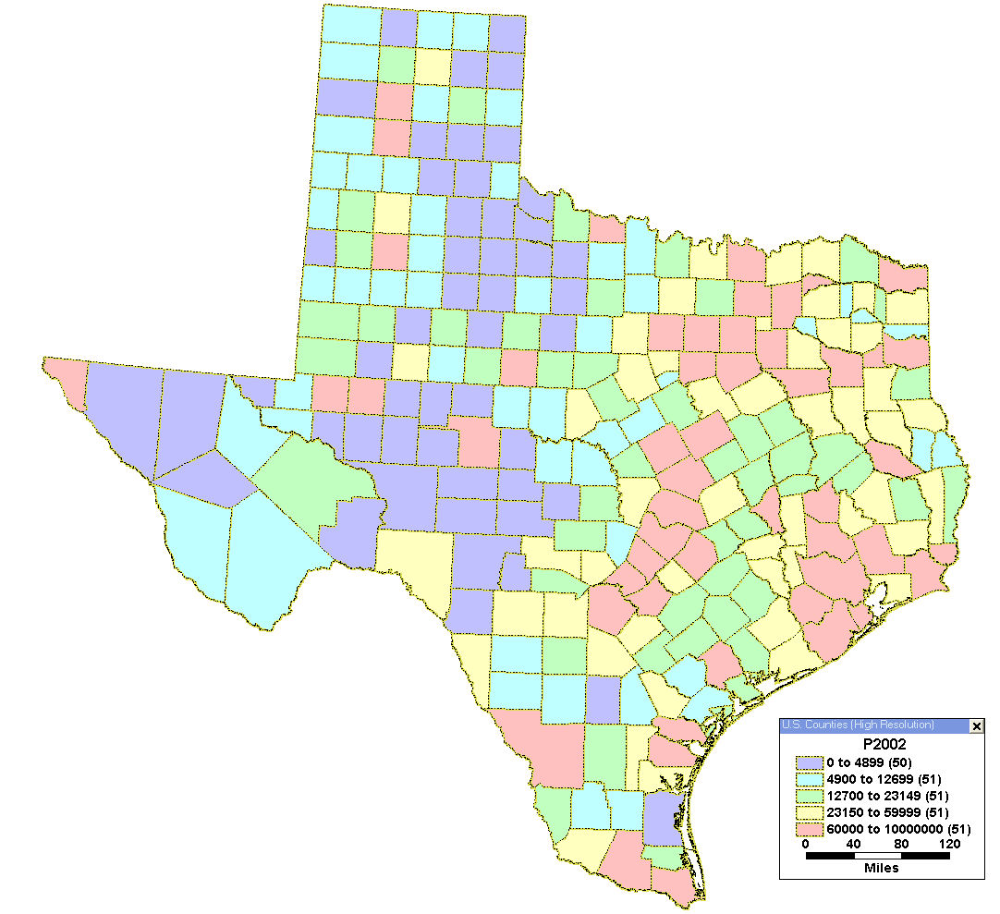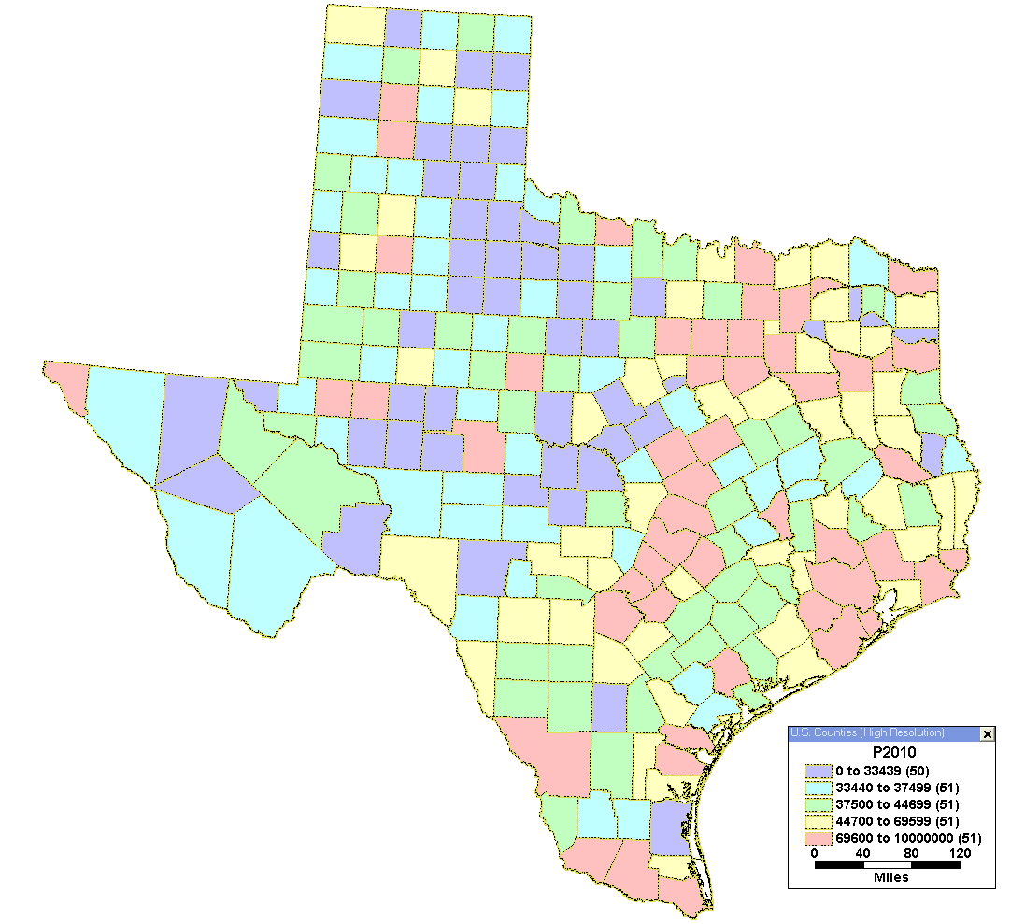

A. 2002 Texas County Populations B. 2010 Population Predictions

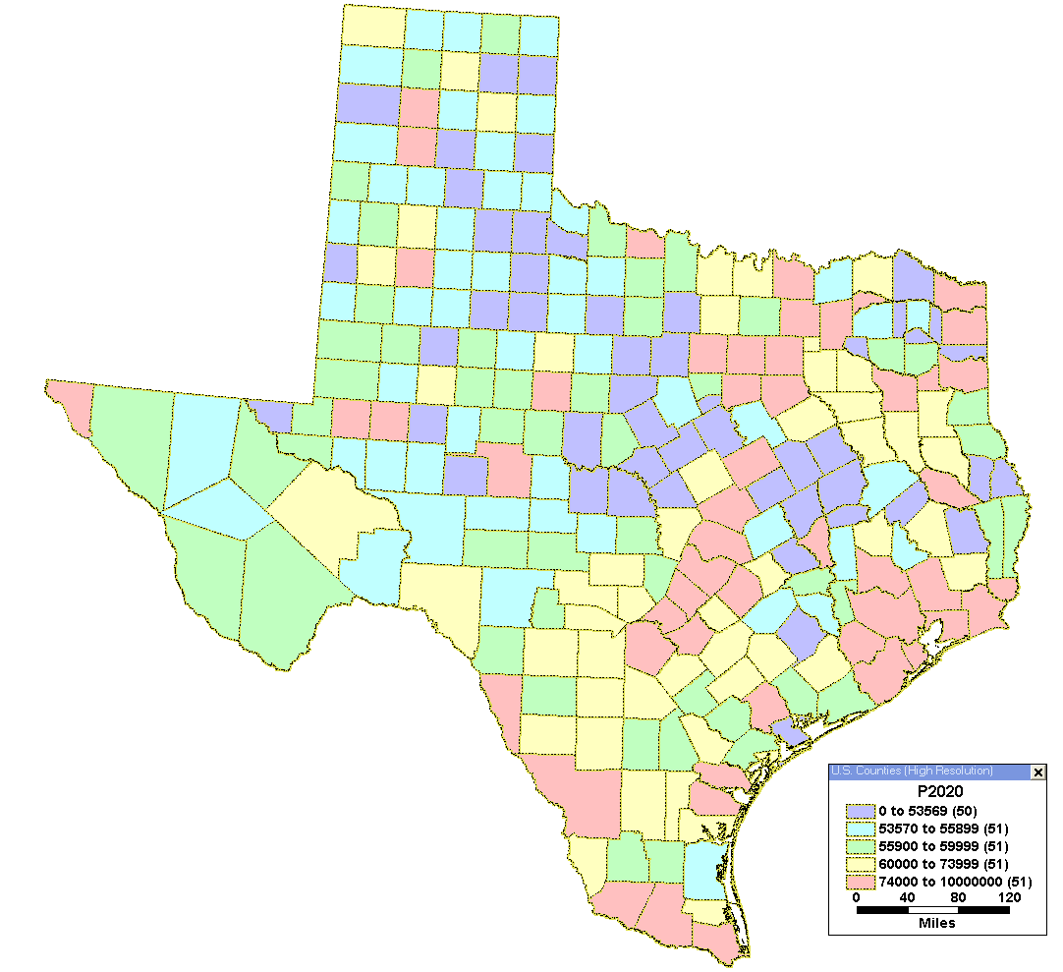
C. 2020 Population Predictions

