SIMAURIF: AN INTEGRATED LAND-USE TRANSPORTATION MODEL IN PARIS REGION

André DE PALMA(*), Kiarash MOTAMEDI (*),
Dany NGUYEN-LUONG (**), Hakim OUARAS (*), Nathalie PICARD (*)

(*) University of Cergy-Pontoise - THEMA
95011 Cergy-Pontoise Cedex, FRANCE.

(**) Institut d’Aménagement et d’Urbanisme de la Région d’Ile-de-France (IAURIF)
15 rue Falguière, 75740 Paris Cedex 15, France.

Abstract: This paper describes the first part of an integrated and dynamic land-use transportation model on Paris Region. It uses three existing models: UrbanSim (a land use model), Davisum-METROPOLIS (a dynamic traffic model) and a travel demand model. The project uses the micro-simulation technique, the discrete choice theory and a grid of 50 000 square cells. The period of calibration runs from 1990 to 1999, the period of simulation from 1999 to 2026. SIMAURIF will be used to forecast the 2026 land use of Paris Region as well as the distribution of households and jobs among cells.

Keywords: transportation systems, land use modelling, integrated land use transportation model, simulation, calibration

1. INTRODUCTION

The Institute for Urban Planning of Paris Region (IAURIF), in collaboration with the University of Cergy-Pontoise, has been elaborating since September 2003 a research project on interaction between transportation and land use. This project, called SIMAURIF, is granted by PREDIT (Inter-ministerial land transport research and innovation program), DREIF (Governmental department of transportation) and RFF (National Rail Network).

It aims to develop an integrated and dynamic land-use transportation model for Paris Region. We use three existing models: UrbanSim which is a path dependent land use model, Davisum-METROPOLIS which is a dynamic traffic model, and the travel demand model developed by IAURIF. The project is complex and ambitious because it puts together three concepts. At first, it’s based on a large grid which partitions Paris Region into 50 000 square cells by 500 meters. This grid allows taking into account the notion of proximity and the spatial dynamics at the local level (a cell interacts with its eight neighbours). Then, the project uses the micro-simulation technique for land use modelling. We use disaggregate data where households and jobs are represented individually. At last, the dynamic simulation uses a step of one year for UrbanSim and of three years for the traffic model. An interface (managing module) has been developed which allows exchanging input and output data between models. The period of calibration runs from 1990 to 1999, the period of simulation from 1999 to 2026. This project required a huge amount of data for input as well as for calibration. The data processing was feasible thanks to the power of a geographical information system.

The project is led with a double approach, both global and local. Global, because it takes into account the environmental and political constraints and regional accessibility. Local, because it takes into account urban features, transport coverage and real estate prices for each cell and its neighbourhood. The cellular location choices of households and jobs are modelled by discrete choice models (logit), as well as the probability of transition between the vacant to developed types, whereas the real estate price model is a hedonic regression model. SIMAURIF will be used to forecast the 2026 land use of Paris Region as well as the distribution of households and jobs among cells. The project should be completed in the end of 2007.
The interest of this concept is in the use of micro data and in the models that are estimated. Microsimulation allows capturing the heterogenetity of economic agents. Estimated models provide a flexible framework that is more adaptable to each case and to be the best representation of the phenomena. To the best of our knowledge, it is the first time that dynamic travel data are used in such a model.
In this paper, we shortly present the three models and the common architecture. Then we describe the fastidious but crucial step of collecting input and calibration data. Most interactions between the land use dynamics and the transportation dynamics are taken into account in the short, middle and long term. Finally, we present the partial results of the calibration. This constitutes a pioneering and innovative work in the topics of modeling land-use transportation interaction (De la Barra,1990).

The Ile-de-France

The Paris Region is called Ile-de-France Region. It embraces Paris and its suburbs, and is one of the most important metropolises in the world. The city of Paris has about 2 millions inhabitants, on a regional total of 11 millions. The total number of jobs is 5.1 million. The region’s surface is 4,610 sq. miles (12,000 sq. km). With 2% of the surface of France, it represents 19% of the population, 22% of the jobs of the country. There are 3 levels of administrative territorial divisions in Ile-de-France: 1 “région”, 8 “départements” (counties) and 1300 “communes” (municipalities). In addition, we consider the 3 counties around Paris as close suburb or “small ring” and the 4 counties far away from Paris as far suburb or “large ring”.

2. THE THREE MODELS AND THE COMMON ARCHITECTURE

2.1. UrbanSim

UrbanSim is a land use model developed at the University of Washington (USA). It is based mainly on microsimulation principle and four models : three Discrete Choice Models (Multinomial Logit) (households and jobs localization choices and development type choice models) and a hedonic regression model (land price model). All entities are presented in a disaggregated way. The current version of UrbanSim (version 4.0) is integrated into the OPUS framework (Open Platform for Urban Simulation) which provide a wide variety of tools to assemble and create flexible and adaptable urban models communicating with other models (Waddell et al., 2005).

The data structure of UrbanSim is essentially based on a large grid. This high level of spatial resolution is original in France. Considering the availability of data on administrative units, the data preparation requires a huge amount of data and spatial analysis that we have performed thanks to the Geographical Information System (GIS) tool.

2.2. The trips demand model

A data preparation module is needed to build the origin-destination matrix that represents the trips generated by population and activities and their distribution on origins and destinations. This module uses a mathematical model calculating an origin-destination matrix for three purposes (home-work, home-shopping and others), based on three classical steps: trips emissions and attractions, trips distribution, mode choice (private cars/public transport).
We use the demand model elaborated for the Paris Region by IAURIF and which was calibrated with the last Global Travel Survey of 2001 (DREIF,2005). The zoning contains 606 TAZ (Traffic Analysis Zones).

  - Davisum-METROPOLIS

METROPOLIS is a full dynamic transportation model for planning applications. It is developed at the University of Cergy-Pontoise (see de Palma, et al., 2002). It is now integrated into Davisum commercialized by PTV in Germany. It provides, among others, the user surplus as a measure of accessibility for travelers. This measure takes into account the time-dependent congestion situation of the transportation system. Currently, we have completed a calibration of METROPOLIS, the road traffic assignment model.

2.4. The common architecture

An architecture (Fig. 1) has been designed to integrate these three models within a coherent framework. A prototype of interface has been developed which allows an exchange of the input and output data and a process control.

This interface was developed in such a way that the user can introduce the general parameters’ values and visualize some major results. The key information transferred between the traffic and the land use model is the travellers’ surplus matrix. To make a complete loop, we should feed a revised Origin – Destination (O-D) matrix to the traffic model that is based on the new geographical distribution of population and jobs. This cycle is reproduced by time step that can correspond to one or more years according to the evolution of transportation system conditions and projects (currently, a step of three years is chosen).

Both the land use and traffic models use MySQL DBMS for data storage. These data are structured in multiple tables. These tables can be viewed and edited by using “MySQL Control Center”. Davisum-METROPOLIS has its own graphical interface to manage simulation parameters, supply data and demand data.

Demographic Model
E_{s}(t) Number of jobs in sector s
E_{sl}(t)
UrbanSim

Macro-economics Model
M_{i}(t) Number of households type i
M_{il}(t)

t -> t+3

Toolbox
Davisum-METROPOLIS
O-D
Matrix
tt_{OD,}
Accessibility (O, D)

Fig. 1. Architecture of SIMAURIF

3. INPUT DATABASE

We use different sources to build the input database: general census, numerical land use database, global travel survey, the notary database of real-estate transactions, local land use plans, commercial and offices surfaces data, income tax files etc. Since the data are presented in different geographical units that do not match perfectly with grid cell, we had to develop some methods to perform data fusion and transformation. For example, we’ve managed to localize the 11 000 households of the travel survey in the grid. Finally, five main tables are built: grid cells, households, jobs, travel times and logsum tables. There are also 32 other secondary tables (IAURIF-THEMA, 2004).We've used the IAURIF numerical land use cover coming from aerial pictures (400 000 parcels classified into 83 different types).

To build the database, we’ve largely used the GIS tool. The grid layer was intersected with about twenty other layers to produce information at the cell level.

As far as concerned the transportation database, the roads network of Paris Region contains more than 16000 links, the transit network contains about 4000 links.

4. CALIBRATION DATABASE

  - UrbanSim

For each of the four UrbanSim models, we have constructed a significant sample of individual observations from five sources: the general census, the global travel survey, the land use evolution database (Fig. 2), the notary database of real-estate transactions and the regional employment survey.

Finally, each of calibration databases was used as an input to the econometric software SAS in order to perform estimation of a discrete choice model or a linear regression model.
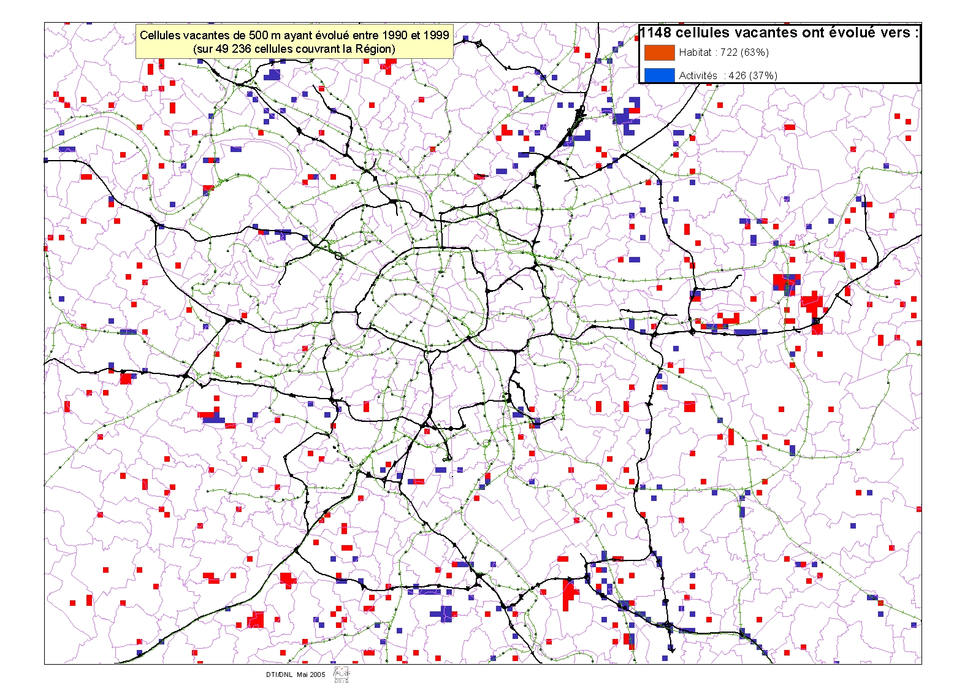
Fig. 2. Evolution of vacant cells to housing and activities between 1990 and 1999

  - The trips demand model

The calibration databases (one for each step) were built using the global travel survey of 2001 (IAURIF-THEMA, 2005).

  - Davisum-METROPOLIS

At first, the road and transit networks were updated. For the METROPOLIS part (the dynamic assignment of the O-D matrix on the roads network), the calibration was done in two steps. The first step was a semi disaggregate calibration using the indicators based on the Global Travel Survey of 2001 and an aggregation of detailed traffic counts. The disaggregate calibration of the second step was based on the counts given by stations localized on coded network (THEMA, 1998).

The aggregated indicators are based on the following data:
-The number of trips during the rush hour (estimated)
-The number of trips between 7:30 and 9:30 (survey results)
-The distribution of travel time in 15 minutes classes (survey)
-The average travel time over all the trips (survey)

Two parameters have been modified to minimize the distance between measured and simulated values: a global factor multiplied by capacities and a factor multiplied by the rush hour demand to obtain the overall morning demand.

The congestion function gives the links travel time in function of traffic density. It was estimated using the traffic counts.

Model | Formulation
Bottleneck
Model of local flow stability
Greenberg’s model
Greenshields’ model
Drew’s model

The traffic count stations use magnetic loops and provide the number of passed vehicles, their average speed and length and finally the occupation rate of the detector. We obtained these data by the intervals of 6 minutes. We compute the average traffic density over pieces of road. We estimate 5 types of functions for each station and choose the most relevant one.

5. RESULTS OF THE CALIBRATION PROCESS

  - UrbanSim

Two logit location models and one regression model of UrbanSim are now calibrated.

Household Location choice Model
As many of the data are represented at a commune level, we find it necessary to study the problem in two levels: commune and grid cell. Table 2 compares the two estimation results for household location choice model. The overall explanatory power is slightly greater at the grid cell level than at the commune level (McFadden's LRI=0.2414 and 0.2272, respectively). Concerning the variables, commune level variables are often less significant than grid cell level variables.

The most significant variable is the dummy variable indicating that the cell or commune is located in the same district as the one in which the household lived before it moved. This indicates that households have strong preferences for relocating not too far from their previous residence (We note that 53% of household heads work and live in the same district). The negative coefficient for Paris dummy reflects the fact that, ceteris paribus, individuals prefer the suburbs to Paris. However, this negative coefficient may be seen with effect of other variables, which are particularly high in Paris (e.g. number of subway stations).

We found that price effects significantly varied as a function of household head age, and household income and size. A reference household with a single member aged 40 with a yearly income equal to exp(9.97)=21,400 € is not sensitive to the prices of flats. According to commune level estimates, older and larger families are slightly more sensitive to the prices of flats. Interestingly, larger or older families are more sensitive to houses prices than to flats prices, which is consistent with the fact that, when they become older and/or have children, families have a stronger tendency to live in a house rather than in a flat.

Households prefer living in communes with many metro or tramway stations, but dislike the close proximity of such stations. Note that a station located in the commune is clearly beneficial since it improves accessibility. On the opposite, a very close station may be detrimental because of the noise, so the sign of the overall effect is not clear a priori. The positive signs for subway stations around and railway stations in the commune suggest that individuals easily walk or drive (or take the bus) long distances (more than 500 meters, to go to adjacent cells, or to other cells located in the same commune) in order to reach a station (We note that the communes in Paris, where there are metro stations, are smaller than other communes). The negative sign for the number of metro stations around might be explained by the fact that most of the metro stations are located in places which also benefit from a good bus and trains service. Therefore, the benefit of metro stations is less than the benefit of train stations, whereas their negative effects are of the same order of magnitude. The negative sign of rail stations at commune level is harder to explain, but not significant at the 5% level.

Table 2: Separate estimations results at commune and grid cell level
Variable | Estim. at commune level |  | Estim. at cell level
Variable | Coefficient | t-statistic | Coefficient | t-statistic
Same district as before move | 2.53879 | 275.91 | 2.53494 | 272.47
Paris | -0.25412 | -10.10 | -0.16871 | -10.29
Log(Price of Flat) | 0.00644 | 0.20 | 0.02178 | 0.94
Log(Price of Flat)* (Age-40)/10 | -0.02976 | -1.74
Log(Price of Flat)* (Log(Income)- ) | 0.40919 | 8.20 | 0.24849 | 5.84
Log(Price of Flat)* (Number of hh members – 1) | -0.04236 | -2.40
Log(Price of House) | 0.08735 | 3.70 | 0.13934 | 7.41
Log(Price of House)* (Age-40)/10 | -0.10359 | -8.78 | -0.11371 | -20.90
Log(Price of House)* (Log(Income)- ) | 0.18693 | 5.78 | 0.14874 | 5.17
Log(Price of House)* (Number of hh members – 1) | -0.10932 | -8.38 | -0.13038 | -20.43
Number Subway stations around |  |  | -0.00412 | -2.37
Number Subway stations in the commune / cell | 0.00518 | 4.59 | 0.00146 | 0.21
Number Railway stations around |  |  | 0.01326 | 3.85
Number Railway stations in the commune / cell | -0.00940 | -4.86 | 0.00616 | 0.60
Average travel time from j, commuting (TC) [hr] | 0.02483 | 0.80 | 0.04007 | 1.45
TC*(Dummy female) [hr] | -0.37377 | -8.28 | -0.29400 | -6.56
Distance to highway [km] | -0.00594 | -3.10 | -0.00146 | -0.74
Distance to arterial [km] | -0.00798 | -2.98 | -0.01500 | -5.87
Distance to Chatelet (Paris centre) [km] | 0.00167 | 2.94 | -0.00054 | -1.06
% households with 1 member * 1 member in h | 1.87670 | 20.62 | 2.27023 | 30.73
% households with 2 members* 2 members in h | 1.33649 | 4.20 | 1.77322 | 10.03
% households with 3+ members* 3+ member in h | 2.22967 | 22.16 | 2.07516 | 27.98
% hh with no working member * no working member in h | 7.79690 | 33.91 | 5.38190 | 33.49
% hh with 1 working member * 1 working member in h | -0.93134 | -5.84 | 0.50248 | 4.58
% hh with 2+ working member * 2+ working member in h | 1.66425 | 14.83 | 0.40430 | 5.01
% hh with a young head | 0.45006 | 3.01 | 1.02140 | 10.86
% hh with a young head * young head in h | 4.77740 | 28.34 | 3.24295 | 29.59
% hh with a middle age head * middle aged head in h | -0.69337 | -4.16 | -0.16208 | -1.51
% Rich hh * Rich h | 3.28038 | 28.36 | 2.87636 | 36.58
% Medium Income hh * medium income h | 1.62120 | 10.11 | 1.92296 | 17.00
% Poor hh * poor h | 0.45889 | 3.53 | 1.06997 | 12.11
% households with a foreign head * foreign head in h | 5.04570 | 26.74 | 4.57810 | 37.26
% households with a foreign head * French head in h | -1.99493 | -17.44 | -1.30553 | -16.71
% of surface in Significant Urban Zones * Rich h | 0.67811 | 4.97 | -0.22815 | -4.28
% of surface in Significant Urban Zones * Med. Inc. h | -0.08340 | -0.78 | -0.19330 | -5.16
% of surface in Significant Urban Zones * Poor h | 0.43164 | 4.45 | 0.16457 | 4.99
Log of the number of residential units | 0.06682 | 9.26 | 0.02295 | 3.27
% of Flats in total dwellings * Foreign head in h | 1.36775 | 15.42 | 0.67595 | 11.37
% of Flats in total dwellings * French head in h | 0.48469 | 7.28 | 0.16077 | 3.76
% of Flats in total dwellings * (N. of members - 1) | -0.08459 | -4.29 | -0.05561 | -4.29
% of Flats in total dwellings * young head in h | -0.13120 | -2.43 | -0.03680 | -1.01
% of Flats in total dwellings * old head in h | -0.76601 | -8.40 | -0.18806 | -2.82
% of surface in Noisy Zone | -0.08929 | -1.56 | -0.07667 | -1.52
% of surface covered by Forest | -0.11708 | -3.09 | -0.29739 | -5.05
% of surf. covered by Forest * N. of Children | 0.42292 | 6.87 | 0.46115 | 4.99
% of surface covered by Waterplain | 0.20360 | 1.62 | 0.33284 | 4.24
% of surface covered by Parks and Gardens | -0.42727 | -4.22 | -0.15159 | -2.93
% of surf. covered by Parks * N. of children | -0.12942 | -0.71 | 0.61447 | 6.67
% of surface covered by Sport spaces | 0.44171 | 2.50 | -0.37138 | -4.06
% of surf. covered by Sport spaces * N of children | 0.26755 | 0.83 | 0.78619 | 4.93
Notes: “%” sign represents the proportion. “N. of children” counts family members aged 11 or less.

All the distance variables have a negative sign, indicated that, ceteris paribus, households prefer to locate close to arterials or highways, or close to Paris center (Chatelet).

We tested (results not reported here) a non monotonous specification for the distance to arterial or to highway. The idea was that the close proximity to a highway is a nuisance because of pollution and noise, whereas individuals also dislike a too large distance to highway, for accessibility considerations. However, we failed to estimate the intuitive inverse U-shaped effect for those distance variables, with a large number of specifications for the covariates. This suggests that accessibility and travel time considerations dominate pollution and noise nuisance considerations with respect to location choice.

We failed to estimate significant effects for average travel time using Private car or accessibility variables, probably because of the large correlation between the variables measuring distances, average travel times and accessibility.

The demographical and social structure of population is important in the households’ location choice. Households globally tend to prefer locating close to households with a rather young head. As far as age, household size or income is concerned, households tend to locate close to similar houses. Foreign households tend to locate in grid cells and, to a lesser extent, communes with more foreign households, whereas French households prefer to locate in places with less foreign households.

According to grid cell estimates, rich or medium income households tend to locate far away from ‘Significant Urban Zones” (areas with high concentrations of social and economic difficulties targeted for government assistance), whereas poor people have a stronger tendency to locate there. Intuitively enough, households dislike noise. An official report, Boiteux, Bumstark et al (2001), considers that a noise level higher than 55db causes from 4 to 1.1% decrease of housing prices. It gives about 40% lower prices for this level of noise.

The positive coefficient for the logarithm of the number of households in the cell reflects the fact that new households tend to locate in the already more populated areas. The coefficients of the fraction of collective dwellings (crossed with nationality, household size and age) suggests that French people, larger and older families prefer locations with less collective dwellings.
Table (3): Housing Price Estimation Results

Variable | Average Dwelling |  | Flats |  | Houses
Variable | Coeff | t-Stat | Coeff | t-Stat | Coeff | t-Stat
Intercept | 12.8461 | 65.36 | 12.4362 | 76.70 | 13.0972 | 72.88
Paris | 0.1483 | 1.63 | -0.0472 | -0.63 | 0.2747 | 3.30
Average travel time private car | -0.0008 | -1.54 | -0.0018 | -3.94 | -0.0015 | -3.08
Number of employments (/1000) | -0.0010 | -0.99 | 0.0024 | 2.89 | 0.0029 | 3.11
Log of number of employments | 0.0204 | 3.71 | 0.0089 | 1.97 | 0.0295 | 5.88
% households with a medium income | -2.1624 | -16.48 | -1.8436 | -17.03 | -2.2916 | -19.10
% households with a low income | -2.9731 | -16.05 | -3.2086 | -20.99 | -3.6871 | -21.76
% households without active member | 0.9149 | 2.64 | 1.3059 | 4.57 | 1.3615 | 4.30
% households with one active member | 0.4902 | 2.35 | 0.8818 | 5.11 | 0.8070 | 4.22
% households with a single member | -0.0875 | -0.42 | 0.7494 | 4.32 | 1.1503 | 5.98
% households with a middle aged head | -0.2071 | -1.05 | -0.4376 | -2.68 | -0.6086 | -3.37
% households with an old head | -0.0614 | -0.23 | -0.7490 | -3.40 | -0.6340 | -2.60
% households with a foreign head | 1.1972 | 4.78 | 1.3319 | 6.44 | 1.6740 | 7.30
% schools with special cares | -0.0846 | -1.97 | -0.0991 | -2.80 | -0.0872 | -2.22
% of commune in free zone | -1.1984 | -4.21 | -0.8850 | -3.77 | -0.1765 | -0.68

Housing Price

The estimated coefficients for housing price model are presented in Table 3. The R² for the model is 0.53 for average overall price but 0.62 for flats and 0.70 for houses. This justifies the distinction of these two dwelling types.

The housing price depends on the average travel time to destinations, number of employments in the commune and on the socio-economic structure of population. A decrease in the average travel time significantly increases the price: 10 minutes less imply a 1.5 - 1.8% increase in price of houses and flats. The price is very sensitive to socio-economic structure of the commune: a 10% increase in the proportion of low income households causes a 30% decrease of the price. Such a decrease for the proportion of medium income households results in a 21% decrease of the price. The fraction of households with no or only one working member has a positive effect on the price.

Employment Location choice Model
In table 4, we report the results of estimated employment location choice model. We have considered the establishments that have moved or have been created. The estimation is performed separately for each sector of activity (16 according to the French activity classification). The presented model concerns the middle sized establishments (between 10 and 1000 employees). Large and small establishments move with different frequencies and behave differently in their location choice. For the sectors of Automobile industries and agriculture, we had not enough observations to obtain satisfying results.

The quality of estimation given the low number of observations is good enough (McFadden’s pseudo R2 between 23.1% and 84.1%). For alternative sampling the units should be weighted by their capacity to receive the employments. To remove the sampling bias caused by a uniform sampling over cells, we have added the number of employments in each cell as an explanatory variable. This variable is almost the most significant variable. The vocation of cell for tertiary sector is one of the most significant variables for many cases, especially commerce and services.

Personal services and consumers’ good manufacturing activities show an interest for Paris but other sectors are going out of Paris city. Commerce, service and finance are the sectors that present an interest for inner ring of suburbs and Real estate activities show a greater interest for outer ring.

All the activities dislike greater public transit travel times. This effect is more significant for professional services and has a greater weight for real estate and financial activities. The train stations are appreciated but the coefficient for number of subway stations is negative except for consumers’ good manufacturing. This can be seen on the negative coefficient for Paris and the fact that the activities are migrating out of Paris city.

  - The trips demand model
The three steps were calibrated. The formulas of generation, distribution and mode choice are now updated (IAURIF-THEMA, 2005).

  - Davisum-METROPOLIS

For METROPOLIS, the final results have shown that the bottleneck function provides a good fit for all the points and noting its rapidity and efficacy we have chosen to use it for all the links. In the estimation procedure we have taken into account and corrected the heteroskedasticity of speed measures. It means that we observed a more important dispersion in speeds observed for the small densities. It is because of the higher freedom of drivers to choose their speed where there are not many vehicles on road. The quality of fit for the functions (with average data) is good. We have obtained an r-square more than 0.95 in 98% of the stations. At last, we have extended the estimated parameters to other links according to their type and number of lanes.

Accessibility measures
We consider a first set of accessibility variables, computed using the method proposed by Jean Poulit in 1974, based on the logarithm of product supply at each destination. The variable Q_{j} represents the opportunity at destination j (number of employments or shops) and log(Q_{j}) is considered as the benefit of travelling to destination j. The utility S_{ij} of travelling from origin i to destination j, subtracting travel cost (C_{ij}), is:

$S_{\text{ij}}=λ\text{log}\left(Q_{j}\right)−C_{\text{ij}}$, (2)

where λ is a weighting factor which is computed as λ=α/a, where α is the value of time (VOT), and a is an empirical coefficient used in the gravity trip distribution model. In the gravity model, the volume of travel between origin i and destination j, denoted by (V_{ij}) is given by V_{ij}=E_{i}*A_{j}*f(C_{ij}), where

E_{i} is the production of trips from i and A_{j} is the attraction of trips to j. These parameters have been estimated using travel survey data (see IAURIF/THEMA, 2005). In those estimates, the travel cost parameter, C_{ij} depends only on travel time tt_{ij} linearly:

Table (4): Employment location choice Estimation Results
Sector | Agricultural and food industries (2) |  | Conusmmers' good Manufacturing (3) |  | Equipements manufacturing (5) |  | Intermdiary goods manufacturing (6) |  | Energy (7) |  | Construction (8) |  | Commerce (9)
Pseudo R2 | Number of observations | 48.8% | 167 | 52.9% | 878 | 53.4% | 463 | 37.2% | 512 | 84.1% | 260 | 23.1% | 1329 | 33.1% | 4030
 | Coeff. | T-st. | Coeff. | T-st. | Coeff. | T-st. | Coeff. | T-st. | Coeff. | T-st. | Coeff. | T-st. | Coeff. | T-st.
Paris | 0.2900 | 0.32 | 1.1297 | 3.58 | -0.6454 | -1.21 |  |  | -1.8115 | -1.90 |  |  | -0.2725 | -1.85
Suburbs of Inner Ring |  |  | 0.6267 | 3.57 | -0.4807 | -2.50 | -0.5237 | -1.97 |  |  | -0.0912 | -0.96 | 0.1766 | 2.67
Avg travel time from j, commuting (TC) [min] | -0.0293 | -3.50 | -0.0116 | -1.68 | -0.0052 | -0.77 |  |  | -0.0216 | -1.38 | -0.0245 | -6.41 | -0.0125 | -5.11
Avg travel time from j, Private Car [min] |  |  | 0.0121 | 1.25 |  |  | -0.0719 | -1.75 |  |  | 0.0064 | 1.38
Accessiblity by Private Car |  |  |  |  |  |  | -0.0540 | -2.06 | -0.0033 | -0.26 |  |  | -0.0024 | -1.11
Number Subway stations around | -0.2454 | -2.57 | 0.0629 | 2.25 |  |  | -0.1667 | -3.19 | -0.3604 | -2.90 | -0.0851 | -3.46 | -0.0428 | -3.19
Number Railway stations around | 0.1225 | 1.26 |  |  |  |  | 0.0736 | 1.16 | 0.0818 | 0.54 |  |  | 0.0007 | 0.03
Distance to Chatelet (Paris centre) [km] |  |  | -0.0192 | -2.00 |  |  | 0.0019 | 0.23 |  |  | -0.0283 | -5.58 | -0.0140 | -4.55
Distance to highway [km] |  |  | -0.0537 | -1.44 | -0.0954 | -2.48 | -0.0468 | -1.64 |  |  | -0.0106 | -0.60 | -0.0984 | -7.02
Log(Price of Dwelling) | -0.3858 | -0.99 | -0.3027 | -1.98 |  |  |  |  | 0.0414 | 0.08 | -0.3736 | -3.30
Number of residential units around | -0.1263 | -4.48 | -0.0074 | -0.99 | -0.0485 | -3.36 | -0.0658 | -4.81 | 0.1224 | 5.00 | -0.0328 | -5.04 | 0.0132 | 3.97
Surface of commercial spaces | 0.0940 | 2.04 | 0.0153 | 1.39 | 0.0248 | 0.88 |  |  |  |  | 0.0119 | 1.39 | 0.0458 | 9.05
Surface of commercial spaces around | -0.0048 | -0.52 | -0.0084 | -2.61 |  |  | -0.0056 | -1.04 | 0.0305 | 3.05 |  |  | -0.0073 | -4.96
Total surface of offices (/1000) | 0.0065 | 1.80 | 0.0018 | 2.02 |  |  | 0.0060 | 3.79 |  |  |  |  | 0.0027 | 5.98
Total surface of offices around (/1000) | 0.0009 | 1.17 |  |  |  |  |  |  | 0.0005 | 0.79 | 0.0002 | 1.11
Has the cell vocation for tertiary sector | 0.5147 | 1.90 | 0.5314 | 5.01 | 0.4812 | 3.15 | 0.2817 | 2.17 |  |  | 0.3611 | 5.08 | 0.7401 | 17.20
Number of employments in sector 1 | -0.2455 | -1.24
Number of employments in sector 2 | 0.2944 | 2.60
Number of employments in sector 3 |  |  | 0.1915 | 3.08 |  |  | 0.0974 | 1.48
Number of employments in sector 5 |  |  |  |  | 0.2213 | 3.20 | 0.0803 | 1.40
Number of employments in sector 6 |  |  | 0.1215 | 2.32
Number of employments in sector 7 |  |  |  |  |  |  |  |  | -0.1589 | -0.69
Number of employments in sector 8 |  |  |  |  |  |  |  |  |  |  | 0.1869 | 4.01
Number of employments in sector 9 |  |  |  |  |  |  |  |  |  |  |  |  | 0.4099 | 12.10
Number of employments in sector 10 |  |  |  |  |  |  |  |  |  |  |  |  | 0.0778 | 4.77
Number of employments in sector 11 |  |  |  |  |  |  |  |  |  |  | -0.1602 | -4.31 | -0.0655 | -3.09
Number of employments in sector 12 |  |  |  |  |  |  |  |  |  |  |  |  | -0.1079 | -4.94
Number of employments in sector 13 |  |  | 0.2837 | 4.15 | 0.1577 | 1.99 | 0.1678 | 2.04 |  |  | 0.3414 | 7.27 | 0.1280 | 4.36
Number of employments in sector 14 |  |  |  |  |  |  | 0.1448 | 1.54
Number of employments in sector 15 |  |  |  |  |  |  |  |  |  |  |  |  | -0.1251 | -5.61
Number of employments in sector 16 |  |  |  |  |  |  |  |  |  |  | -0.0985 | -3.46
N. of geolocalized establishments in same sector | 1.1621 | 9.67 | 0.0212 | 3.8332 | 1.1813 | 18.3403 | 0.5790 | 17.3146 | 4.7168 | 12.6427 | 0.0873 | 13.5737 | 0.0122 | 14.98
No geolocalized establishment in same sector in cell | -0.6586 | -1.61 | -0.9756 | -2.8331 | -1.1132 | -3.9247 | -0.8585 | -3.1636 | 0.4831 | 1.2237 |  |  | -1.4455 | -2.81

Table (4) continued: Employment location choice Estimation Results
Sector | Transportation (10) |  | Finance (11) |  | Real Estate (12) |  | Professional Services (13) |  | Personal Services (14) |  | Education, Health, social actions (15) |  | Administration (16)
Pseudo R2 | Number of observations | 44.3% | 1035 | 64.7% | 1015 | 53.4% | 426 | 48.2% | 5938 | 49.2% | 2162 | 31.3% | 1294 | 45.3% | 674
 | Coeff. | T-st. | Coeff. | T-st. | Coeff. | T-st. | Coeff. | T-st. | Coeff. | T-st. | Coeff. | T-st. | Coeff. | T-st.
Paris |  |  | -0.3444 | -1.12 | -0.6473 | -1.36 | -0.4547 | -3.58 | 0.1111 | 0.62
Suburbs of Inner Ring |  |  | 0.4252 | 2.39 | -0.2072 | -0.76 | 0.1624 | 2.19 | 0.3287 | 2.97 | -0.1318 | -1.44
Avg travel time from j, commuting (TC) [min] | -0.0139 | -2.96 | -0.0348 | -4.86 | -0.0330 | -3.66 | -0.0255 | -10.00 | -0.0184 | -4.59 | -0.0200 | -5.06 | -0.0214 | -3.54
Avg travel time from j, Private Car [min] |  |  | 0.0134 | 1.46 |  |  |  |  |  |  |  |  | 0.0091 | 1.11
Accessiblity by Private Car | -0.0043 | -1.05 |  |  | -0.0139 | -1.87
Number Subway stations around | -0.0404 | -1.73 |  |  | -0.0698 | -1.80 | -0.0418 | -3.60 |  |  | -0.0914 | -4.46
Number Railway stations around | 0.0275 | 0.61 | 0.2868 | 6.48 | 0.2965 | 4.54 | 0.0597 | 3.48 | 0.0742 | 2.58 | 0.1728 | 5.30 | 0.0099 | 0.21
Distance to Chatelet (Paris centre) [km] | -0.0182 | -3.46 |  |  | -0.0312 | -2.65 | -0.0147 | -4.82 | -0.0171 | -3.27 | -0.0148 | -3.58 | -0.0090 | -1.28
Distance to highway [km] | -0.1630 | -5.14 | -0.0727 | -2.14 |  |  | -0.0991 | -7.01 | -0.1512 | -5.97 |  |  | -0.0431 | -1.53
Log(Price of Dwelling) | -0.5962 | -4.07 | 0.3193 | 1.91 |  |  | 0.0818 | 1.27 | 0.5419 | 5.57 | -0.0950 | -0.83 | -0.6031 | -3.45
Number of residential units around | -0.0385 | -5.63 | 0.0426 | 6.08 | 0.0303 | 2.83 | 0.0333 | 11.33 | 0.0145 | 3.29 | 0.0192 | 3.77 | 0.0337 | 5.89
Surface of commercial spaces | 0.0225 | 2.71 | 0.0233 | 2.09 |  |  | 0.0071 | 2.35 | 0.0623 | 7.75
Surface of commercial spaces around |  |  | -0.0072 | -2.72 |  |  | -0.0047 | -3.68 | -0.0084 | -4.12 | 0.0023 | 0.88
Total surface of offices (/1000) |  |  |  |  | 0.0049 | 3.48 | 0.0030 | 7.02 | 0.0022 | 3.27 |  |  | 0.0066 | 4.57
Total surface of offices around (/1000) |  |  | 0.0008 | 3.46 |  |  | 0.0002 | 1.95 | 0.0004 | 2.70 | -0.0001 | -0.78 | -0.0014 | -4.72
Has the cell vocation for tertiary sector | 0.3392 | 3.63 | 0.3373 | 2.84 | 0.3831 | 2.47 | 0.4930 | 12.09 | 0.5109 | 7.39 | 0.2598 | 3.32 | 0.3811 | 3.33
Number of employments in sector 1 | -0.1483 | -1.60
Number of employments in sector 2
Number of employments in sector 3
Number of employments in sector 4 |  |  |  |  |  |  | -0.0492 | -1.79
Number of employments in sector 5 |  |  |  |  |  |  | 0.0408 | 2.19
Number of employments in sector 6 |  |  |  |  |  |  |  |  | -0.0937 | -3.07
Number of employments in sector 7 |  |  |  |  |  |  | -0.1291 | -5.78
Number of employments in sector 8 |  |  |  |  |  |  | -0.1467 | -5.46
Number of employments in sector 9 | 0.0663 | 0.98 |  |  | -0.2027 | -1.64 | 0.0533 | 1.53 | 0.1354 | 2.47
Number of employments in sector 10 | 0.2342 | 6.96 |  |  |  |  | 0.0589 | 3.74
Number of employments in sector 11 | -0.1546 | -3.38 |  |  |  |  | -0.0982 | -4.84
Number of employments in sector 12 |  |  | 0.1846 | 3.08
Number of employments in sector 13 | 0.1827 | 2.86 |  |  | 0.2511 | 2.37 | 0.3152 | 11.20
Number of employments in sector 14 |  |  |  |  | 0.2807 | 2.10 | 0.2373 | 6.22 | 0.2939 | 5.60 |  |  | 0.2685 | 3.57
Number of employments in sector 15 |  |  |  |  |  |  | -0.1376 | -5.92 |  |  | 0.2327 | 5.67 | 0.1945 | 3.02
Number of employments in sector 16 | -0.1255 | -3.25 | 0.2495 | 4.81 |  |  |  |  |  |  | 0.0552 | 1.72
N. of geolocalized establishments in same sector | 0.2638 | 18.2378 | 0.0347 | 6.5466 | 0.0669 | 5.18 | 0.0082 | 13.9623 | 0.0122 | 7.7423
No geolocalized establishment in same sector in cell | -1.0814 | -3.1389 | -2.1313 | -2.9045 | 0.0356 | 0.09 | -1.2390 | -2.3804 | -0.2630 | -0.5544

Accessibility from origin i is the log-sum of the accessibilities over all the destinations:

. (3)

The variability of Poulit accessibility (to employment or to shops) at the grid cell level is very limited, especially by private car. The between-districts differences represent more than 1/3 of the variance and mainly reflect differences between the city of Paris, inner ring and outer ring. Note that the coefficient of variation of the accessibility variable is very low, so one point difference represents a large fraction of the variance. Indeed, Lorenz curves (see Fig. 3) show that the four Poulit accessibility measures are very equally distributed among the population. Therefore, it seems that the Poulit accessibility measures severely underestimate inequalities, and have to be taken cautiously. (For more information about Lorenz curves see Lorenz, 1905)

We therefore also consider another accessibility measure that is unfortunately restricted to access to employment using private car. The “accessibility to employment (M)” variable corresponds to the average travellers’ surplus for home to work travels computed by METROPOLIS. See de Palma et al. (2002) for more details. In addition to the travel time, this measure takes into account schedule delay cost (omitted in Poulit accessibility measures), but not the opportunities offered by the destination. This measure is more unequally distributed than Poulit accessibility measures but much less than travel times (see Fig. 4 for Lorenz curve).

The average travel time by Private Car is slightly more unequally distributed than the average travel time by Public Transit (see Fig. 4). Note that the average travel time by Private Car roughly increases when the distance to Paris Center increases, whereas the average travel time by Public Transit is also low in some regions of the outer ring. This is probably because the above averages are computed using OD matrix and people living in the outer ring tend to travel by car for longer trips and by Public Transit for shorter trips. The accessibility to employment by Private Car is regularly increasing with the distance to Paris Centre, whereas the accessibility to employment by Public Transit varies less regularly with the distance to Paris Centre, depending on the geographical distribution of train stations.

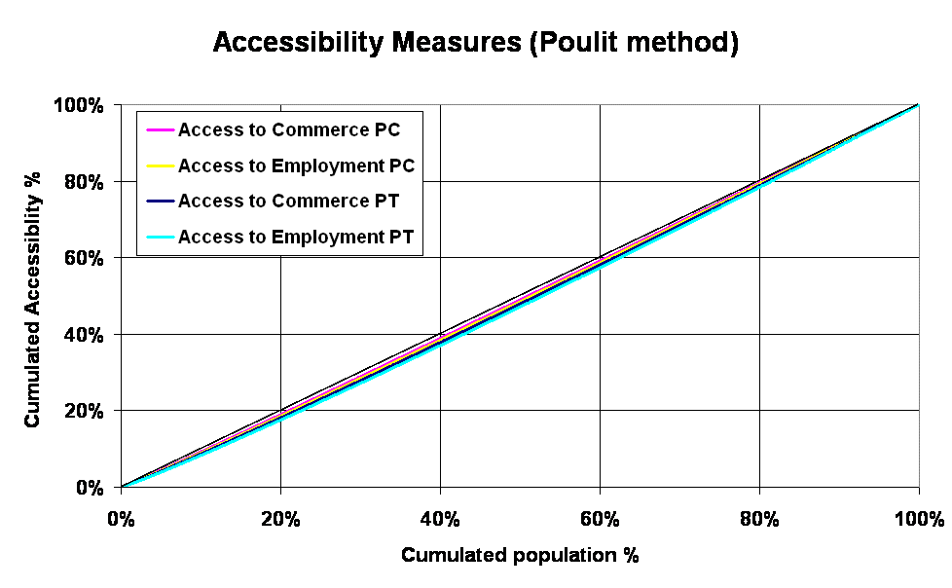
Fig. 3. Lorenz curve for Poulit accessibility measures

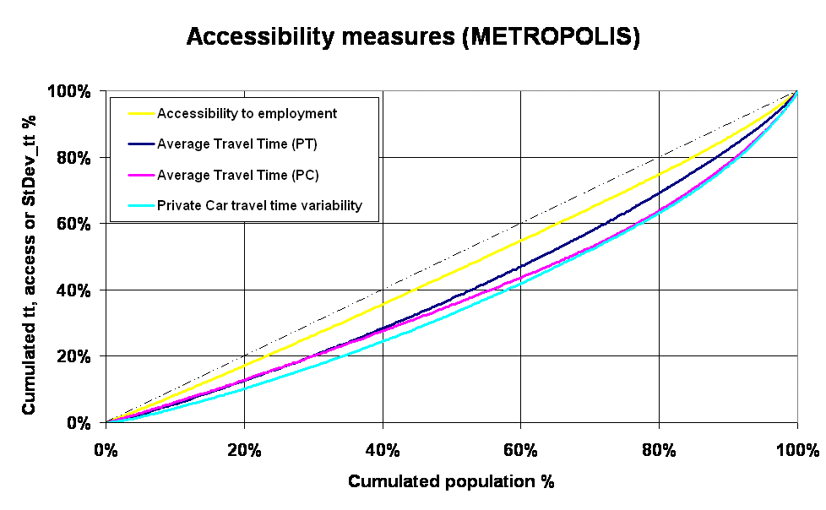
Fig. 4. Lorenz curve for METROPOLIS accessibility measures

6. VALIDATION

  - UrbanSim

We run the two logit models on our own calibration databases and computed the percent of corrected predictions at an aggregated level (8 “departments”). For the household location choice model, the prediction rate is good for Paris (94%) and the near suburb (65%) but disappointing (28%) for the far suburb. Actually, if we look deeply, we find that 72% of the households in the far suburb are localized by the model indeed in the far suburb but not in the right zone, so the equilibrium within the far suburb is respected (IAURIF-THEMA, 2005).

  - The travel demand model

To validate the three models of the trips chain, we compared the aggregated matrices (the same 8 zones) coming from the model and the aggregated matrices coming from the global travel survey. Secondly, we compared the number of intra-zonal trips for each purpose with those given by the same survey. The comparison shows globally a good adequation (IAURIF-THEMA, 2005).

  - Davisum-METROPOLIS

Figure 5 presents the distribution of average travel time for trips originated by any cities in the region.
Fig. 5. Results of the transportation model. Average travel time departing from any city (at left there are the districts of Paris and at right the far suburb)

6. Conclusion
This paper has presented the three building blocks of an integrated transportation and land use system and the first results of calibration and validation. We have designed the architecture of the integrated system that to the best of our knowledge would be the first dynamic integrated transportation – land use model in France.

At this stage, we have designed the architecture of the integrated system and calibrated three modules of UrbanSim. We’ve also updated the traffic model (demand and supply). The necessary software elements of the interface have been developed. The input database of UrbanSim is achieved and the calibration tasks for the different modules arefinalized. We are in the process of running the whole system.

REFERENCES

De la Barra, T. (1990) Integrated Land Use and Transportation Modelling: Decision Chains and Hierarchies, Cambridge Urban and Architectural Studies, No. 12, Cambridge, UK.
de Palma, A. and Marchal, F. (2002), Real cases applications of the fully Dynamic METROPOLIS Tool-box: an Advocacy for Global Large-scale Mesoscopic Transportation Systems, Networks and Spatial Economics, Vol. 2 No. 4, Kluwer Academic Publishers, pages 347-369.
de Palma, A., Picard, N. and Waddell, P. (2007) “Discrete choice models with capacity constraints: an empirical analysis of the housing market of the greater Paris region”. Journal of Urban Economics, forthcoming.
DREIF (2005) Enquête Globale de Transport 2001, Paris, France.
IAURIF-THEMA/T&R (2004), SIMAURIF – Report n°1. DRAST/PREDIT, N°03MT11
IAURIF-THEMA/T&R, SIMAURIF Intermediary report (2005). DRAST/PREDIT, N°05MT6008
Lorenz, M. O. (1905). Methods of measuring the con-centration of wealth Publications of the American Statistical Association. 9: 209-219.
THEMA/T&R (1998-2002), QUATUOR: Outils dynamiques de simulation pour la gestion des déplacements en Ile-de-France. DRAST/ PREDIT, N°98MT30 and N°99MT35, N°00MT66, University of Cergy-Pontoise, THEMA.
Waddell P., Borning A., Noth M., Freier N. Becke M and Ulfarson G. (2003) Microsimulation of Urban Development and Location Choices: Design and Implementation of UrbanSim. Networks and Spatial Economics, Vol. 3 No. 1, pages 43-67.
Waddell, P., Sevcikova H., Socha D., Miller E. and Nagel K. (2005) “Opus: An Open Platform for Urban Simulation”, The Computers in Urban Planning and Urban Management Conference, London, U.K.

Acknowledgements

This study has been financed by the French Ministry of transportation (PREDIT) and the Transportation department of Ile-de-France region (DREIF). An earlier version of this paper benefited from the comments of participants in The 53rd Annual North American Meetings of the Regional Science Association International in Toronto. We thank Hana Sevcikova and anonymous referee for their fruitful comments.

