Vehicle-Type Choice and Neighbourhood Characteristics:
The Case of Hamilton, Canada

Dimitris Potoglou, Ph.D.
Researcher
OTB Research Institute for Urban, Housing and Mobility Studies
Department of Transport and Infrastructure
Delft University of Technology
P.O. Box 5030 2600 GA Delft
Delft, the Netherlands
Tel. +31-015-2785833
Fax. +31-015-84422
E-mail. d.potoglou@tudelft.nl

May 2006

Prepared for the 11th World Conference on Transport Research
University of California, Berkeley, US
June 24 - 28, 2007
Abstract
This paper examines the relationship between vehicle-type choice and neighbourhood characteristics in the metropolitan area of Hamilton, Canada. Neighbourhood characteristics are introduced by several proximity and urban form measures derived through high-resolution spatial data and the use of GIS. Estimates of a multinomial logit model suggest that the choice of less fuel-efficient vehicles is marginally affected by the diversity of land-uses at the household's place of residence after controlling for household socio-demographics and individuals' characteristics and travel attitudes to work.

Keywords: vehicle type choice, light-duty vehicles, automobile demand, urban form, neighbourhood characteristics, accessibility

1. Introduction
Light duty vehicles (LDVs) such as Sport Utility Vehicles (SUVs), minivans and pickup trucks are the fastest growing types of vehicles in North America. Between 1981 and 1998, Canadian sales of SUVs grew from 13,000 to 126,000 units making up 10% of the market, whereas during the same period, sales of mini- and full-sized vans grew from 2% to 19% (Schingh et al., 2000). Despite record high prices of crude oil, in the period of January to September 2004, manufacturers in Canada produced 350,000 SUVs surpassing the total of 331,634 SUVs that they produced in the entire year of 2003 (Magnusson, 2005).

It is apparent that these trends set a considerable barrier towards sustainable urban transport because LDVs are less fuel-efficient and emit considerably higher levels of carbon dioxide and other pollutants than passenger cars. Hence, even if the distance travelled by private modes remained unchanged the increased market-penetration of less fuel-efficient vehicles would result into higher levels of emissions and gasoline consumption. Moreover, LDVs put pressure not only on the demand for fossil fuels, but also on the road infrastructure and parking spaces, which must comply with the size of such vehicles.

Factors such as the diffusion of urban development, namely urban sprawl, have resulted into high demand for consumer durables (e.g. automobiles), longer work and non-trips, and consequently high gasoline consumption. Furthermore, researchers argue that suburban households are also more likely to own LDVs than households living in more compact parts of urban areas (Niemeier et al., 1999). The latter raises an important question: Are only household socio-demographics and vehicle attributes that affect a household's decision to adopt an LDV or is this decision also affected by characteristics of the built environment? In other words, to what extend can urban form affect the vehicle-type choice behaviour of a household? While this is an important question, there has been limited research towards this direction.

The objectives of this paper are threefold. First, this paper aims at contributing towards a better understanding of vehicle-type choice behaviour by taking into account urban form characteristics. Second, it offers experience from the Canadian metropolitan context, where research on car ownership and vehicle-type choice has been sparse with no account for characteristics of the built environment (for example, Mohammadian and Miller, 2003). And third, it is demonstrated how fined-grained spatial data can be used in deriving high-resolution urban form measures with the help of GIS. In pursuit of these objectives, the focus is on the latest vehicle-type choices made by a sample of households in the Census Metropolitan Area (CMA) of Hamilton, Canada. The analysis is based on exploratory analysis and discrete choice modelling frameworks. The developed multinomial logit (MNL) model allows for exploration of potential variations of vehicle-type choice based not only on socio-demographic characteristics, but also on urban form characteristics such as land-use diversity.

2. Case Study: The Census Metropolitan Area of Hamilton

2.1 Study Area
Hamilton is located on the west shore of Lake Ontario, approximately 70 km southwest from the City of Toronto. The CMA is comprised of three administrative units, namely the City of Hamilton, the City of Burlington and the town of Grimsby (Fig. 1). With a population of approximately 600,000 in 2001, the Hamilton CMA is the fourth largest urban centre in Ontario - after Toronto, Ottawa and Mississauga - and the ninth largest in Canada. Hamilton is an important functional component of the Greater Toronto Area (GTA) and an area with automobile ownership rates above Canada's average. In particular, Hamilton's auto ownership rate of light-duty vehicles per capita (i.e., 0.62) is above the national average (0.54) and generally higher than most cities of its size including Kitchener-Waterloo (0.61), London (0.59), Toronto (0.5) and Ottawa (0.48) (IBI Group, 2005).

The majority of the population in the metropolitan area of Hamilton is mainly concentrated in the City of Hamilton, which enumerates approximately 500,000 residents. The former municipalities of Flamborough, Glanbrook, and Ancaster are much less urbanized and consist of smaller rural communities. These less urbanized parts of the CMA exhibit uniform land use patterns and are poorly served by transit resulting into higher automobile dependency (IBI Group, 2005). With regard to demographics, the GTA and Hamilton in particular are among the fastest-growing population centres in the country. Projections estimate that in the next 30 years the population of Ontario will grow by approximately 4 million and much of this growth is expected to be absorbed by cities in the GTA.

In parallel, current demographic trends drawn from the 2001 Canadian Census indicate increasing rates of population growth in the suburban parts of the CMA. Characteristic examples of such growth are the areas of Ancaster and Waterdown (southeast of Flamborough), where the population has increased by 30 and 20 percent, respectively (Canadian Census Analyzer, 2001). As a result of this substantial population growth within car-dependent communities, automobile demand and use is expected to increase. These patterns in conjunction with households' tendency towards light-duty vehicles are expected to worsen current environmental quality, increase the demand for gasoline and put an extra barrier on the City's plans for sustainable development and mobility.

[Figure 1, about here]

2.2 Sources of Data
The data set used in this study was obtained through an Internet survey conducted by the Centre for Spatial Analysis at McMaster University in April 2005 (see, Potoglou and Kanaroglou, 2007a). The objective of the survey was to conduct analysis of household car ownership (Potoglou and Kanaroglou, 2007d), vehicle-type choice and the potential demand for alternative fuelled vehicles through a stated choices experiment (Potoglou and Kanaroglou, 2007c) in the CMA of Hamilton. Respondents were recruited through e-mail address-lists provided by major employers in the CMA and a snowballing method asking participants to recommend the survey to other residents in the area.

While the use of the Internet as a data collection method presents a number of challenges and potential of biases over conventional methods, well-planned design and administration procedures would allow for a considerably reliable sample within short time-frame and low financial costs (Dillman, 2000). The criticism of the Internet focuses on response biases, lack of control over questioning and the possible confusion of the respondents because of the wording of the questions (Cobanoglu et al., 2001). To prevent such issues in the present study, two pilot surveys and one pre-test survey were conducted prior to the official release of the questionnaire. Respondents in the pre-tests and the pilot surveys reported problems and suggested changes that improved the overall wording and presentation of the questionnaire. Moreover, the computerized format of the questionnaire allowed for the development of uncomplicated directions through automatic routing to questions, thus preventing response errors and the need for training the respondents. Another issue with Internet surveys is the potentially weak representativeness of the obtained sample, mainly because of limited access to the Internet. While limited access may be a rather serious concern in developing countries, the CMA of Hamilton, where Internet access is approximately 58% percent, is among the top 15th urban centres in Canada (Kellerman, 2004). Finally, it is worth mentioning that since the analysis focuses on a subgroup of the population, as is the case with vehicle buyers, concerns regarding weak representativeness of the total population could be rather insignificant, since potential over-sampling of that segment of the population is rather desirable (Ben-Akiva and Lerman, 1985).

The survey data collected were comprised of 902 households and included information on household characteristics, number and type of vehicles, the location of the dwelling - geocoded using reported six-digit postal code and the number of years living in their current residence. Also, the data set included information on previously owned vehicles by make, model and year. Since the analysis in this paper concerned vehicle-type choices of the latest vehicle, this study made use of a subset of the sample comprised of 642 households that owned at least one vehicle after excluding those observations with missing information on variables of interest.

As Figure 1 suggests, households residing in the city of Burlington were significantly underrepresented in the sample compared to the 2001 Canadian Census. Furthermore, the municipal district of Dundas was over-represented because of its close proximity to McMaster University, which was significant node for disseminating the survey. Table 1 shows a comparison of household characteristics in the sample with the 2001 Canadian Census and the 2001 Transportation Tomorrow Survey (TTS, 2001). First, it is shown that medium- and high-income households are overepresented in the sample, which is quite typical for a self-administered questionnaire. Secondly, the sample under-represents single-person households, while it is representative of two-member households and over-represents households with more than three members. Finally, the sample over-represents households with two or more cars because of the selection rule applied in order to include households possessing at least one vehicle. In the present case, over-representation is probably desirable based on the a priori expectation that the variability in vehicle-type choices increases with household income, household size and car ownership. In addition, Ben-Akiva and Lerman (1985, Chapter 8) argued over-representation in the sample improves the efficiency of the relevant estimated parameters. Analysis of the sample data confirms that medium and high-income households are indeed associated with higher variability in vehicle-type choices. It should be also noted that underrepresented groups have sufficiently large number of observations, as inferred from the analysis in the following sections of this paper hence, the estimated parameters are expected to be unbiased. Finally, the survey data were complemented with another three sources of data: the 2001 Transportation Tomorrow Survey (TTS, 2001), bus-stop locations of local-transit operators in the cities of Hamilton and Burlington, and GIS layers of traffic analysis zones (TAZs), land-use patterns and enhanced points of interest such as schools, shopping locations and public services.

[Table 1, about here]

3. Selection of Variables
The analysis in this paper concerns choices of the latest vehicle-type acquisition (purchase or lease) in a subgroup of households in the CMA of Hamilton. The dependent variables included four categories of vehicles, namely passenger car, van, sport-utility vehicle (SUV) and pickup truck, which were derived from EPA's Fuel Economy Guide database based on the reported make and model of vehicles (FEG, 1972-2005).

3.1 Socio-demographic Characteristics
With regard to the selection of explanatory variables, this was based on data availability and previous literature-review articles on automobile demand and vehicle-type choice (Bunch, 2000; de Jong et al., 2004; Choo and Mokhtarian, 2004; Potoglou and Kanaroglou, 2007b). Vehicle-type choice has been studied in the past from a number of different technical and empirical perspectives including testing of new modelling approaches (Bhat and Sen, 2005), development of operational models (Mohammadian and Miller, 2003) as well as studying the influence of attitudes, life-style (Choo and Mokhtarian, 2004) and residential/population density (Zhao and Kockelman, 2000; Bhat and Sen, 2005) on households choices to acquire a certain type of vehicle.

Our review of these studies reveals a substantial overlap in the selection of explanatory variables between existing studies and the analysis in this paper. Such variables include household and individuals' sociodemographics. In particular, household size, number of children and number of vehicles already owned have been reported consistently in several empirical studies. Using the 1995 Nationwide Personal Transportation Travel survey (NPTS) data, Zhao and Kockelman (2000) found that households were more likely to chose vans and less likely to own SUVs or pickups when household size increased. Also, Cao et al. (2006) showed that the probability of a household to own a minivan or an SUV increased with the presence of children under the age of 18. These findings were also consistent with the study by Mohammadian and Miller (2003) who conducted an empirical analysis of vehicle-type choice and vintage of vehicles in the Greater Toronto Area. In particular, the authors found that the ratio of the number of children divided by household size had a positive association with the choice of vans. As well, Bhat and Sen (2005), using a sample of the 2000 San Francisco Bay Area Travel Survey (BATS), showed that increased household size and number of employed persons would encourage households to own minivans. In addition, Bhat and Sen (2005) found that presence of children of age less than 15 years increased the probability of households to own SUVs and Minivans, whereas households with children between the age of 16 and 17 were more likely to own minivans.

With regard to the number of vehicles owned variable, Zhao and Kockelman (2000) showed that the number of vehicles owned prior to purchase were positively associated with the choice of pickups and minivans. Also, Mohammadian and Miller (2003) introduced the existing number of vehicles into their model, classified into different types, namely number of subcompact, mid-size, large and special purpose vehicles. Their analysis revealed that availability of a particular vehicle-type in the vehicle fleet had a positive impact on the choice of the corresponding class in the model. For example, households already possessing a number of sub-compact cars were more likely to purchase another sub-compact car. Based on these findings, the authors proposed that people's behaviour may be state dependent and previous choices may affect current behaviour.

The association between household income and choice of a particular type of vehicle, however, has not been consistent across studies. For example, Cao et al. (2006) revealed a positive association between household income and the choice of SUVs, whereas Bhat and Sen (2005) showed that only households with total household income greater than $115,000 were more likely to own a pickup or a van, but not an SUV. Moreover, Zhao and Kockelman's (2000) study found that household income was positively associated with the choice of vans and SUVs, while households with high income were less likely to acquire a pickup truck.

With respect to individual characteristics, previous studies reported that gender, age and education level were statistically significant when modelling vehicle-type choice. McCarthy and Tay (1998) showed that females, minorities (i.e., non-white) and individuals older than 45 years of age were more likely to own fuel efficient vehicles (i.e., passenger cars). Also, Mohhamadian and Miller (2003) and Cao et al. (2006) found that males prefer larger cars and pickup trucks, respectively. Finally, individuals with high-education level have been consistently less likely to own a pickup truck.

It is worth mentioning that the study of Cao et al. (2006) focused on vehicle-type choice (i.e., choice between a passenger car, van, SUV and pickup) taking into account both neighbourhood design (traditional vs. suburban) and individuals' travel attitudes. The latter set of variables was used as proxy in order to account for individuals' self-selection. In the present study, the survey asked respondents how often they chose a certain mode (i.e., car, passenger in car, public transit, walk or bike) when travelling to work during the course of one week. Next, a dummy variable was created to represent workers who were regular users of alternative modes of transportation, namely walk, bike or take transit more than three times per week. In this way, we accounted for self-selection at work, thus allowing for a more comprehensive exploration of the association between urban form and vehicle-type choice.

3.2 Urban Form Measures
While there are similarities in the selection of household and individual explanatory variables between the aforementioned papers and the present study, there is a notable difference with regard to the definition of urban form measures. This difference seems to stem from the geographical focus of different studies or from data availability issues. In particular, previous studies have been focusing either on neighbourhoods from different cities (Cao et al., 2006) or at the national (e.g. Zhao and Kockelman, 2000) and regional (Mohammadian and Miller, 2003) levels, which ultimately have prohibited the use of comprehensive high-resolution spatial data. Thus, vehicle-type choice studies have mainly used aggregate measures of residential and population density (e.g. Zhao and Kockelman, 2000; Bhat and Sen, 2005; McCarthy and Tay, 1998) or perceived (stated) accessibility (Cao et al., 2006), which may also involve the risk of response bias because such measures are individuals' stated perceptions and possibly may not represent the actual case. Findings in the aforementioned studies suggest that high levels of residential/population density at the place of residence are likely to shift choices of households towards more fuel-efficient vehicles. Also, Cao et al. (2006) found that availability of parking (i.e., outdoor spaciousness) may encourage households to acquire pickup trucks, whereas long-distance commuters where more likely to buy SUVs. However, the authors considered these findings spurious, since none of the accessibility measures were significant when controlling for other socio-economic characteristics.

To perform a more comprehensive analysis on the influence of urban form (for a discussion see, Srinivasan, 2002) on vehicle-type choice, we propose the use of fine-grained spatial data for developing urban form measures. Specifically, GIS layers of the 2005 land-use patterns (DMTI Spatial Inc., 2005a) in the Hamilton CMA and households' geocoded locations as reported by respondents helped to derive a high-resolution measure of land-use diversity, namely the entropy index (EI₅₀₀) within walking distance (500m) from a households' dwelling. The EI₅₀₀ was calculated as follows:
${\text{EI}}_{\text{500}}=−\sum_{i=1}^{k}{\frac{p_{i}⋅\text{ln}(p_{i})}{\text{ln}(k)}}$ [1]
where, p_{i} is the proportion of the developed land in the kth land-use type. In this study, five (k=5) types of land use were included: commercial, residential, governmental, parks and industrial. Values of EI₅₀₀ vary between 0 and 1, with one indicating even distribution among all land-use categories (heterogeneity) and zero implying a single type of land-use within the radius of 500 meters (homogeneity). An illustration of the development of the EI₅₀₀ using the ARCGIS 8.3 software is shown in Figure 2a.

Furthermore, we developed a density mix measure, namely the Mixed Density Index (MDI) at the traffic analysis zone (TAZ) level (i.e., a composite index of the mix of households and jobs per zone) (Cervero and Kockelman, 1997; Chu, 2002; Potoglou and Kanaroglou, 2007d) using data from the 2001 Transportation Tomorrow Survey (TTS, 2001). Household densities were derived from the expansion of the TTS sample of households and employment density was computed through the summation of all work-trips (expanded) per TAZ during a day. The MDI was computed as follows:
${\text{MDI}}_{i}=\frac{{\text{ED}}_{i}⋅({\text{RD}}_{i})}{{\text{ED}}_{i}+{\text{RD}}_{i}}$ [1]
where, ED_{i} and RD_{i} are the employment (number of workers per acre) and residential densities (number of households per acre) with a TAZ i. Figure 2b presents the variation of MDI over the study area.

[Figure 2, about here]

Another set of accessibility/proximity measures were derived using the DMTI's Enhanced Points of Interest (EPOI) GIS layers (DMTI Spatial Inc., 2005b). These measures included the average distance to retail and food stores, shopping malls, schools, entertainment facilities (e.g., cinemas, cafes) as well as the number of the aforementioned locations within walking distance from each dwelling in the sample. In the same way, we computed the number of bus stops within walking distance using data provided by the municipalities of Hamilton and Burlington.

4. Results and Discussion

4.1 Exploratory Analysis
Table 2 provides a descriptive analysis of the demographic and economic profiles of households in the sample versus vehicle-types chosen. Compared to aggregate sample shares, high-income households preferred less passenger cars shifting their choices towards more energy-consuming vehicles. Because forty percent (40%) of households in the sample did not report their income, a separate "not-reported" income class was created in order to include these observations in the model and to estimate the average effects of this class in the vehicle-type choice. Also, Table 2 shows that shares of passenger vehicles shift towards vans and SUVs when household size increases. The case of three-member households is characteristic of that trend, in which 14.5% and 9.8% of that group chose SUVs and vans, respectively. The same pattern of choices occurs when the number of children increases. With regard to respondents' characteristics, there are no significant differences in the share of vehicle-types between males and females. However, there is a pattern indicating the individuals with lower education level would prefer more SUVs and pickups. Finally, respondents of 24 years of age or older tend to choose more SUVs, van and pickups than younger drivers.
[Table 2, about here]

The starting point of the analysis was to examine potential spatial trends in the choices of vehicle-types in the sample of households. Specifically, the objective was to explore if purchases of light-duty vehicles exhibit any particular pattern in the suburban parts of the study area. For this purpose, the location of households was plotted into four maps based on their most recent vehicle-type choice, namely passenger cars, SUVs, vans and pickup trucks. Next, Kernel estimation was applied for each vehicle-type map in order to identify potential trends over space. Kernel estimation is a smoothing procedure, which is generally used to identify a generalized pattern of spatial data (Bailey and Gatrell, 1995). The unit of measurement is the number of events per unit area (i.e., intensity), which in this case is the number of passenger cars, SUVs, pickup trucks and vans per square kilometre. Figure 3 shows that the surface of passenger-car buyers exhibits high intensity around the city-centre of Hamilton and generally, appears more compact than the other three types of vehicles. On the other hand, the presence of light-duty vehicles is more intense in suburban/rural areas than passenger cars. In particular, van purchases appear more intense in the areas of Ancaster, the southern parts of the City of Hamilton as well as the town of Grimsby whereas, SUVs and pickup trucks exhibit high intensity in Ancaster and the area of Waterdown (between Dundas and Burlington).

[Figure 3, about here]

Since the dependent variable (i.e., choice of vehicle type) is categorical, it would not be possible to estimate the Pearson's correlation coefficients between the outcome and explanatory variables. To explore potential correlations between vehicle-type choice and urban form/accessibility measures, a series of MNL models were developed specifying only the explanatory variable of interest and alternative specific constants in each run. Therefore, each row in Table 3, presents estimated coefficients of the corresponding variable in a separate model, in which no other factors, except the alternative specific constants, were specified in the model. All else being equal, mixed density at the TAZ level (marginally) and diversity of land-uses (i.e., the Entropy Index) within walking distance had a negative association with households' choices for SUVs. On the other hand, there was no association between the choice of light-duty vehicles and household density. Further, the choice of SUV was marginally associated with the number of retail stores, the number bus stops within 500m of the dwelling, whereas average distance to entertainment facilities was positively associated with households' choices for vans (all else being equal). The last step of this exploration examined if residents of certain municipalities exhibit any pattern in vehicle-type choices. As shown in Table 3, only residents of Hamilton had a negative association with the choice of SUVs, whereas residents of Ancaster and Stoney Creek were more likely to own SUVs. Finally, there was no significant association between vehicle-type choice and residents of Flambrough, Burlington and Dundas. While the aforementioned analysis may indicate a correlation between vehicle-type choice and urban form, a full model that controls for household and individual characteristics would provide a clearer view of this relationship.

[Table 3, about here]

4.2 MNL Vehicle-Type Choice Model
Table 4 reports estimation results of the final MNL model of vehicle-type choices using the econometric software NLOGIT ver. 3.0 (Greene, 2002). Since the estimation of the model involves categorical variables, which might share common unobserved characteristics (i.e., correlated error terms), we tried to estimate a series of nested logit models using all possible tree specifications (Hunt, 2000; Hensher and Greene, 2002). However, inclusive value parameters were not statistically significant than zero or one suggesting that none of the attempted Nested Logit models was a significant improvement over the MNL logit (Ben-Akiva and Lerman, 1985). Overall, the performance of the MNL was moderate as indicated by the goodness-of-fit measure rho-square (ρ² = 0.09). The likelihood ratio test showed that the model was statistically significant and all parameters - other than the alternative specific constants - were not zero. The hypothesis of parameters being zero was rejected because the χ² value equal to 93.1 (d.f. = 7) was higher than the critical value of χ² = 24.322 (d.f. = 7). The main strategy to derive the final model was to include factors from three categories of data: urban form/ neighbourhood proximity measures, household and individual characteristics. Also, the final selection of the model was based on obtaining the highest value of the likelihood ration index, while ensuring that all parameters had the expected sign and were statistically significant.

First, we specified in the model a full set of alternative specific constants, one for each vehicle-type, except the passenger car option, which was considered the base alternative. All constants appeared to be statistically significant implying that all else being equal, respondents were more likely to choose a passenger car followed by an SUV, a van and pickup truck (lowest objective utility). With regard to other explanatory variables, the final model showed that household characteristics significantly affect vehicle-type choices. Specifically, larger households would prefer to purchase a van than any other type of vehicle, which is a consistent finding in the vehicle-type choice literature (McCarthy and Tay, 1998; e.g. Mohammadian and Miller, 2003; Bhat and Sen, 2005). Moreover, homeowners and households owning more than one vehicle were more likely to acquire a pickup truck, suggesting that a pickup truck is often a vehicle-type purchased for special purposes and in order to diversify households' transportation options. These findings were in line with the studies of Cao et al. (2006) and Zhao and Kockelman (2000). Other household-level variables tested included total household income, number of workers as well as number of males, however, none of the above improved significantly the performance of the model.

As expected individual characteristics such as educational level and marital status were statistically significant (the latter at the 5% confidence level). In more specific, singles and individuals holding a bachelor's degree or higher were less likely to acquire a pickup truck. Also, individuals who regularly (i.e., more than three days per week) walk, bike or take public transit to work were less likely to purchase an SUV. While this finding is consistent with a priori expectations, it is not in agreement with Cao et al.'s (2006) findings who argued that pro-bike individuals were more likely to own SUVs because of the carrying capacity of these vehicles. On the other hand, our study possibly reveals that individuals who bike, walk or take public transit are aware of environmental issues and consciously choose more sustainable modes of transportation as well as express preferences for more fuel-efficient vehicles such as passenger cars. Furthermore, contradicting findings may reveal behavioural differences between the Canadian and US populations indicating the need for further research.

After controlling for household and individual characteristics as well as travel attitude to work, the entropy index (EI₅₀₀) was the only statistically significant (at the 5% level) urban form characteristic. This finding agrees with our a priori expectations that households living in areas where there is diversity of land-uses including residential, commercial, governmental and industrial development as well as parks are less likely to purchase an SUV. In contrast, the mix density of households and jobs at the TAZ level, and all the proximity measures discussed in the previous section were not significant. Finally, another hypothesis was that long-distance commuters - specified as a dummy variable for individuals working at distance greater than 10 km from their home, would be less likely to own LDVs, however, this variable did not improve the model significantly. This finding contrasts with the results of Cao et al. (2006), in their case study in California, who found that long-distance commuters were more likely to own an SUV. The latter represents another interesting aspect of the behavioural context between Canadian and American households.

5. Conclusions
The market shares of light-duty vehicles are increasing, thus putting another barrier towards the sustainability of urban transportation systems. The objective of this paper has been to conduct an analysis of vehicle-type choice behaviour in a segment of the population in the metropolitan area of Hamilton. This task involved both an exploratory analysis and discrete choice modelling on households' most recent vehicle purchase. After controlling for household and individual characteristics as well as self-selection at work, urban form measures and proximity characteristics at the place of residence were taken into consideration.

Exploratory analysis showed that there was a pattern between choices of less fuel-efficient vehicles and suburban development. Further, after controlling for socio-demographics as well as travel attitudes to work, analysis showed that vehicle choices were marginally influenced by the diversity of land-uses at the place of residence. The results of these models are in line with current literature and in particular the positive association between household demographics and choice of vans and SUVs. The findings of this paper suggest that there is potential for land-use policies to encourage mixed land-uses in order to shift choices from SUVs, pickups and vans towards smaller and more efficient vehicle options. Overall, this paper provides a topic for further discussion and international comparisons between different urban land-use and behavioural contexts.

Acknowledgements
This research was supported by the City of Hamilton and Canada's Natural Sciences and Engineering Research Council (NSERC). The data collection was conducted as part of the author's doctoral thesis under the supervision of Professor Pavlos S. Kanaroglou at the Centre for Spatial Analysis in the School of Geography and Earth Sciences at McMaster University, Canada. The comments and suggestions of Professor Antonio Paez, three anonymous referees and the organizers of the F2 sessions of WCTR are gratefully acknowledged.

References
Table 1. Sample characteristics vs. the 2001 Census and the 2001 TTS

 |  | Sample (%) | 2001 Census  (%) | 2001 TTS  (%)
Household Size | 1 | 14.6 | 24.5 | 27.0
Household Size | 2 | 32.3 | 31.0 | 33.1
Household Size | 3 | 19.3 | 16.0 | 16.2
Household Size | 4 or more | 33.8 | 26.0 | 25.9
Car Ownership | 0 | - |  | 14.7
Car Ownership | 1 | 38.9 |  | 41.1
Car Ownership | 2 | 40.8 |  | 34.6
Car Ownership | 3 or more | 20.3 |  | 9.3
Household Income (CAN$) | < $29,999 | 2.5 | 17.8
Household Income (CAN$) | $30,000 - 79,999 | 23.1 | 47.6
Household Income (CAN$) | > $80,000 | 34.3 | 34.5
Household Income (CAN$) | Not Reported | 40.2 | -
Home Ownership | Own | 76.0 | 68.3
Note: Empty cells indicate that data are not available from the specific source
Table 2. Sample profile by most recent purchase of vehicle-type
 |  | Vehicle Type
 |  | Car |  | Pickup |  | SUV |  | Van |  | Sample Totals
Household Income  (CAN$) | < $29,999 | 2.3  (93.8) |  | 0.0  (0.0) |  | 0.0  (0.0) |  | 0.2  (6.2) |  | 2.5
Household Income  (CAN$) | $30,000 - 79,999 | 18.8  (81.8) |  | 0.8  (3.4) |  | 1.2  (5.4) |  | 2.2  (9.5) |  | 23.1
Household Income  (CAN$) | > $80,000 | 23.8  (69.5) |  | 1.7  (5.0) |  | 3.3  (9.5) |  | 5.5  (15.9) |  | 34.3
Household Income  (CAN$) | Not Reported | 31.8  (79.1) |  | 1.4  (3.5) |  | 3.1  (7.8) |  | 3.9  (9.7) |  | 40.2
Household  Size | 1 | 13.6  (92.6) |  | 0.3  (2.1) |  | 0.5  (3.2) |  | 0.3  (2.1) |  | 14.6
Household  Size | 2 | 26.5  (82.1) |  | 1.4  (4.3) |  | 2.2  (6.8) |  | 2.2  (6.8) |  | 32.2
Household  Size | 3 | 14.0  (72.6) |  | 0.6  (3.2) |  | 2.6  (13.7) |  | 2.0  (10.5) |  | 19.3
Household  Size | 4 | 15.4  (64.7) |  | 1.2  (5.2) |  | 2.2  (9.2) |  | 5.0  (20.9) |  | 23.8
Household  Size | > 4 | 7.3  (73.4) |  | 0.3  (3.1) |  | 0.2  (1.6) |  | 2.2  (21.9) |  | 10.0
Nr. of Children | 0 |  | 14.4  (85.0) |  | 0.6  (3.7) |  | 1.1  (3.7) |  | 0.8  (6.7) |  | 16.9
Nr. of Children | 1 |  | 2.5  (64.0) |  | 0.2  (4.0) |  | 0.5  (12.0) |  | 0.8  (20.0) |  | 3.9
Nr. of Children | 2 |  | 2.1  (57.6) |  | 0.2  (4.3) |  | 0.3  (7.6) |  | 1.1  (30.4) |  | 3.6
Nr. of Children | 3 |  | 0.3  (50.0) |  | 0.04  (7.1) |  | 0.04  (7.1) |  | 0.2  (35.7) |  | 0.5
Nr. of Children | 4 |  | 0.0  (0.0) |  | 0.0  (0.0) |  | 0.0  (0.0) |  | 0.1  (100.0) |  | 0.1
Respondent's  Age | Age < 25 | 7.5  (88.9) |  | 0.0  (0.0) |  | 0.5  (5.6) |  | 0.5  (5.6) |  | 8.5
Respondent's  Age | 24 < Age < 45 | 41.3  (77.3) |  | 1.7  (3.2) |  | 4.0  (7.6) |  | 6.4  (12.0) |  | 53.4
Respondent's  Age | Age> 46 | 27.9  (73.4) |  | 2.2  (5.7) |  | 3.1  (8.2) |  | 4.8  (12.7) |  | 38.0
Respondent's Gender | Male | 32.2  (76.8) |  | 1.2  (3.0) |  | 2.8  (6.7) |  | 5.6  (13.5) |  | 41.6
Respondent's Gender | Female | 44.9  (77.3) |  | 2.6  (4.5) |  | 6.6  (8.3) |  | 5.3  (10.4) |  | 58.4
Respondent's  Education Level | High School | 11.5  (76.2) |  | 0.9  (6.0) |  | 1.3  (8.6) |  | 1.4  (9.3) |  | 15.1
Respondent's  Education Level | Diploma | 17.5  (69.4) |  | 1.6  (6.3) |  | 2.5  (9.9) |  | 3.8  (15.1) |  | 25.2
Respondent's  Education Level | Bachelor's Degree | 27.4  (79.7) |  | 0.8  (2.3) |  | 2.5  (7.3) |  | 3.8  (11.0) |  | 34.4
Respondent's  Education Level | Graduate School | 19.3  (80.4) |  | 0.6  (2.5) |  | 1.4  (5.8) |  | 2.7  (11.3) |  | 24.0
Respondent's  Education Level | Not Reported | 1.1  (84.6) |  | 0.0  (0.0) |  | 0.2  (15.4) |  | 0.0  (0.0) |  | 1.3
Note: Percentages in parentheses show the marginal distribution within each group of demographic or socio-economic information. | Sample Shares | 76.8 |  | 3.9 |  | 7.9 |  | 11.7 |  | 100.0

Table 3. MNL estimates including only one neighbourhood characteristic and alternative specific constants per estimation

 | Vehicle-Type
Variable | Van | SUV | Pickup  Truck
Entropy Index within walking distance (500m) | -0.848^{x} | -1.724*** | -0.777^{x}
Mixed Density Index (MDI) at the TAZ level | -0.946^{x} | -0.250* | -0.483^{x}
Household Density at the TAZ level | x | x | x
Number of:
Retail stores with 500m | -0.527^{x} | - 0.145* | 0.511^{x}
Bus stops within 500m | -0.138^{x} | -0.287** | -0.162^{x}
Shopping malls within 500m | x | x | x
Food-stores within 500m | x | x | -x
Entertainment facilities within 500m | x | x | x
Average distance to:
Shopping malls | x | x | x
Food stores | x | x | x
Entertainment facilities | 0.573* | 0.432^{x} | 0.441^{x}
Household Dwelling Location
Household lives in:
Hamilton | -0.372^{x} | -0.521* | -0.639^{x}
Ancaster | 0.57^{x} | 1.225* | 0.000^{x}
Burlington | x | x | x
Dundas | x | x | x
Grimsby | x | x | x
Flambrough | x | x | x
Stoney Creek | 0.780* | 0.352^{x} | -0.405^{x}
Glambrook | x | x | x
Note:
*** Significant at the 0.01 level
** Significant at the 0.05 level
* Significant at the 0.10
x Non-significant

Table 4. Estimation results of households' latest vehicle-type choice

Independent Variable | Van | SUV |  | Pickup  Truck
Constant | -2.653*** | -1.643*** |  | -4.591***
Household Characteristics
Number of Children (< 19 years of age) | 0.814***
Number of Vehicles already owned |  |  |  | 0.459**
Home Owner  (Dummy: 1 if household owns the dwelling; 0 otherwise) |  |  |  | 1.789*
Respondent Characteristics/Attitudes
Education Level  (Dummy: 1 if respondent holds a Bachelor's degree or higher; 0 otherwise) |  |  |  | -0.793*
Marital Status: Single (1 if single; 0 otherwise) | -1.069** | -1.069**
Takes Transit/Walks/Bikes to Work  (1 yes; 0 otherwise) |  | -1.106**
Urban Form Measures
Entropy Index within 500m of the dwelling |  |  | -1.338**
Number of Observations | 642
Likelihood ratio index = - 2 (L(C) - L(β), (d.f., p) | 93.1 (7, 0.000)
Log-Likehood at zero, L(0) | -890.0
at constants, L(C) | -498.4
at convergence, L(β) | -451.7
Rho-Square (ρ²= 1- [L(β)/L(C)]) | 0.09
Adjusted Rho-Square  (Adj-ρ² = 1 - [(L(β)-M)/L(C)]) | 0.07

*** Significant at the 0.01 level
** Significant at the 0.05 level
* Significant at the 0.10
Note: The alternative Car is considered as the base alternative

Figure Captions
Fig. 1 Locations of sampled households
Fig. 2 Intensity maps of households' most recent vehicle using Kernel estimation
Fig. 3 (a) Calculation of the Entropy Index, (b) The Mix Density Index per TAZ,
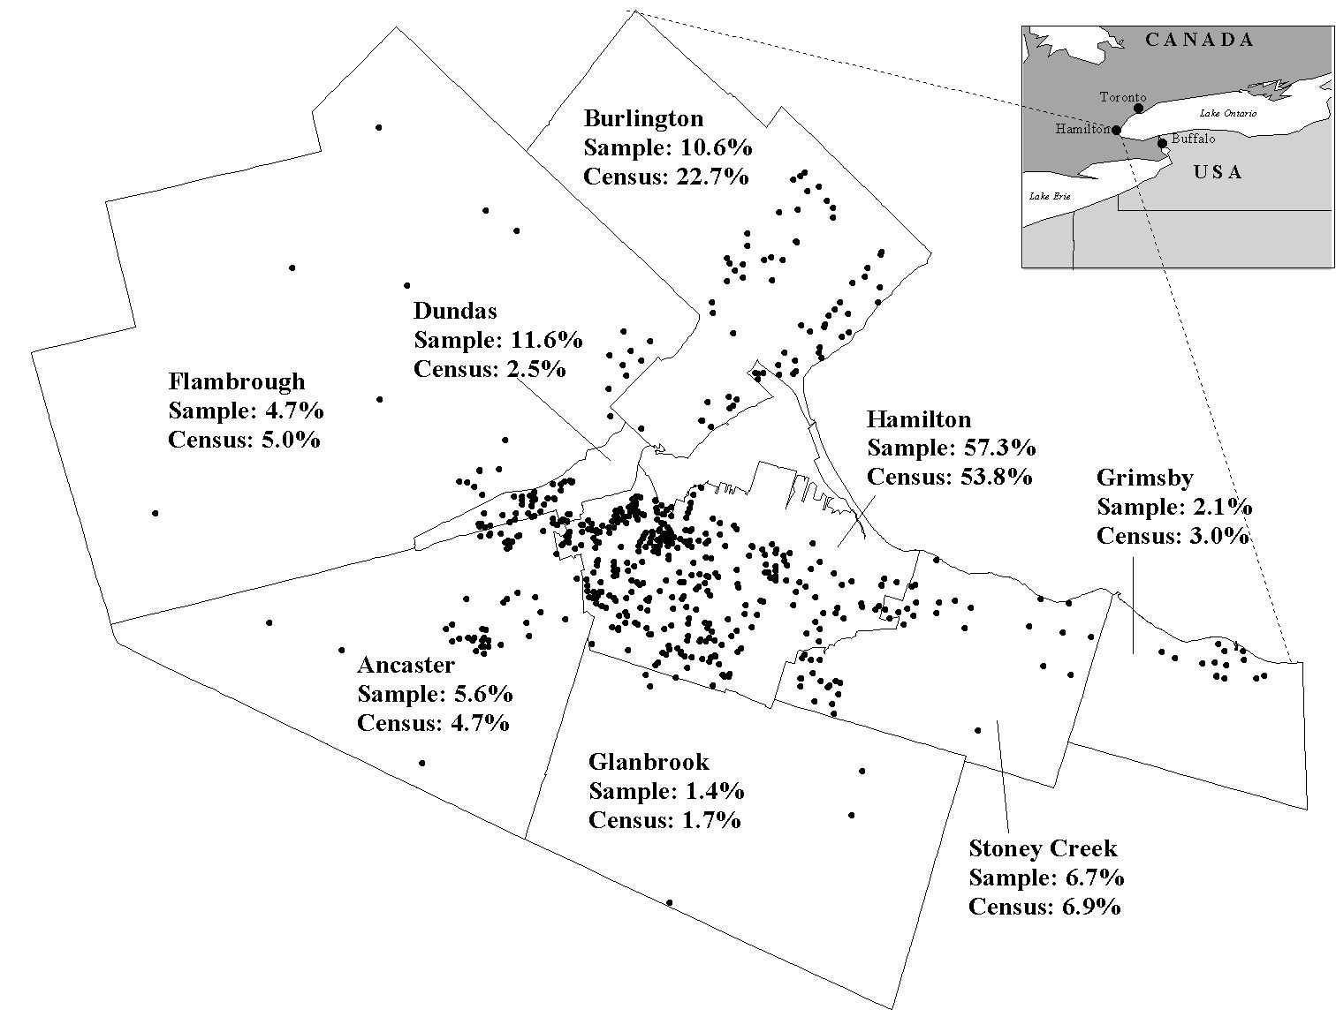

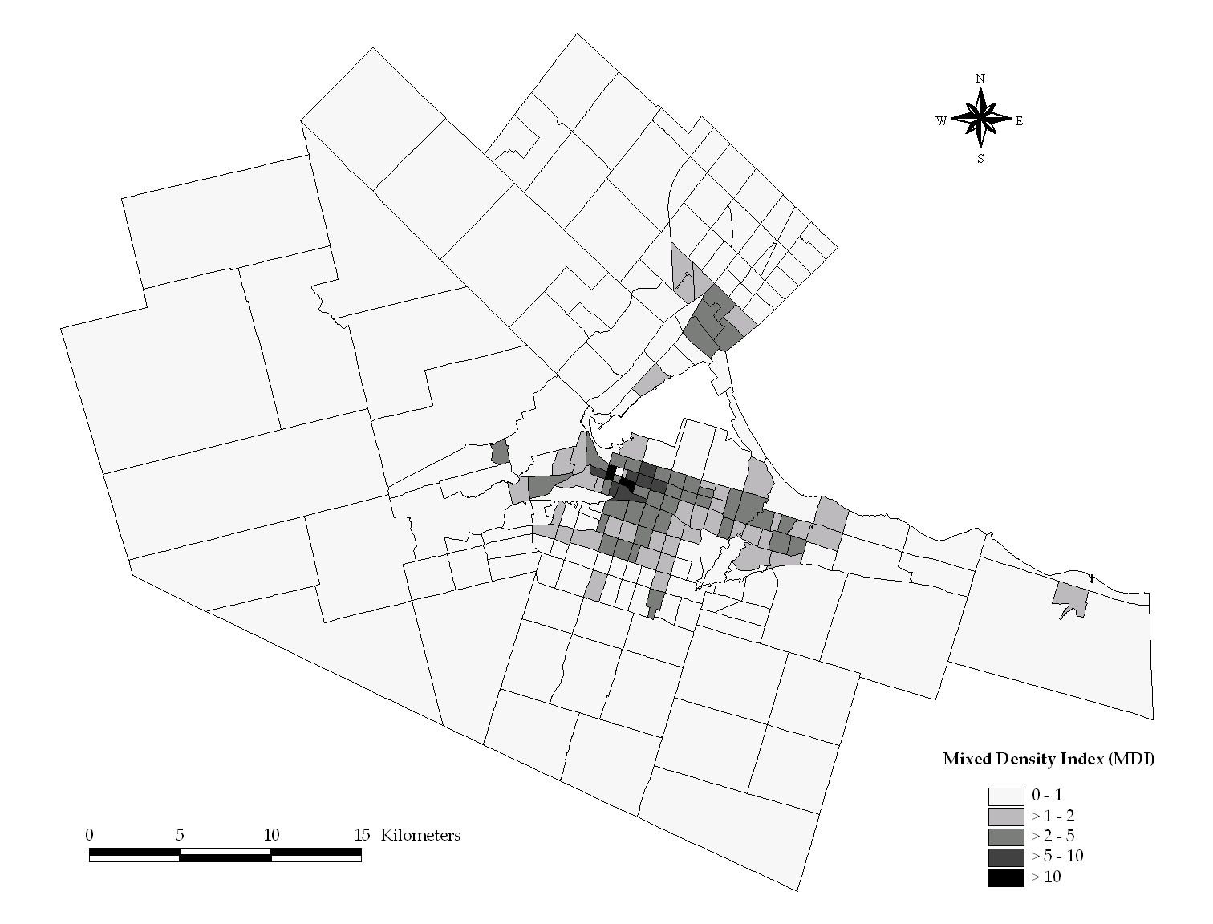
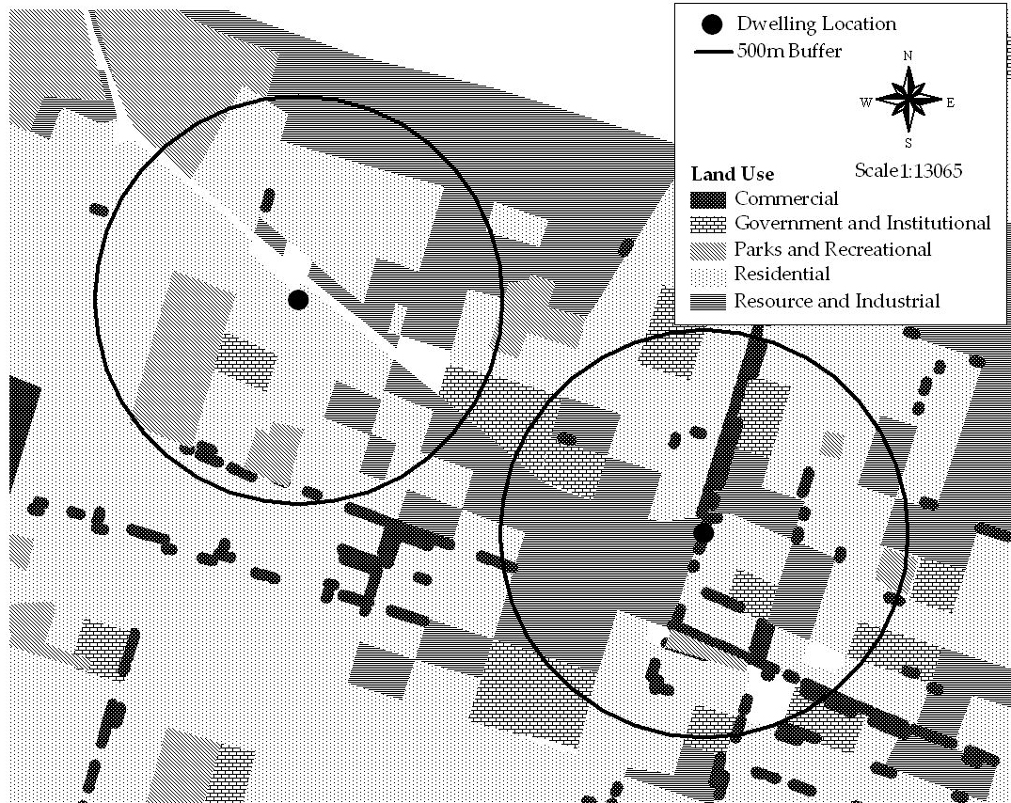
(a)
(b)

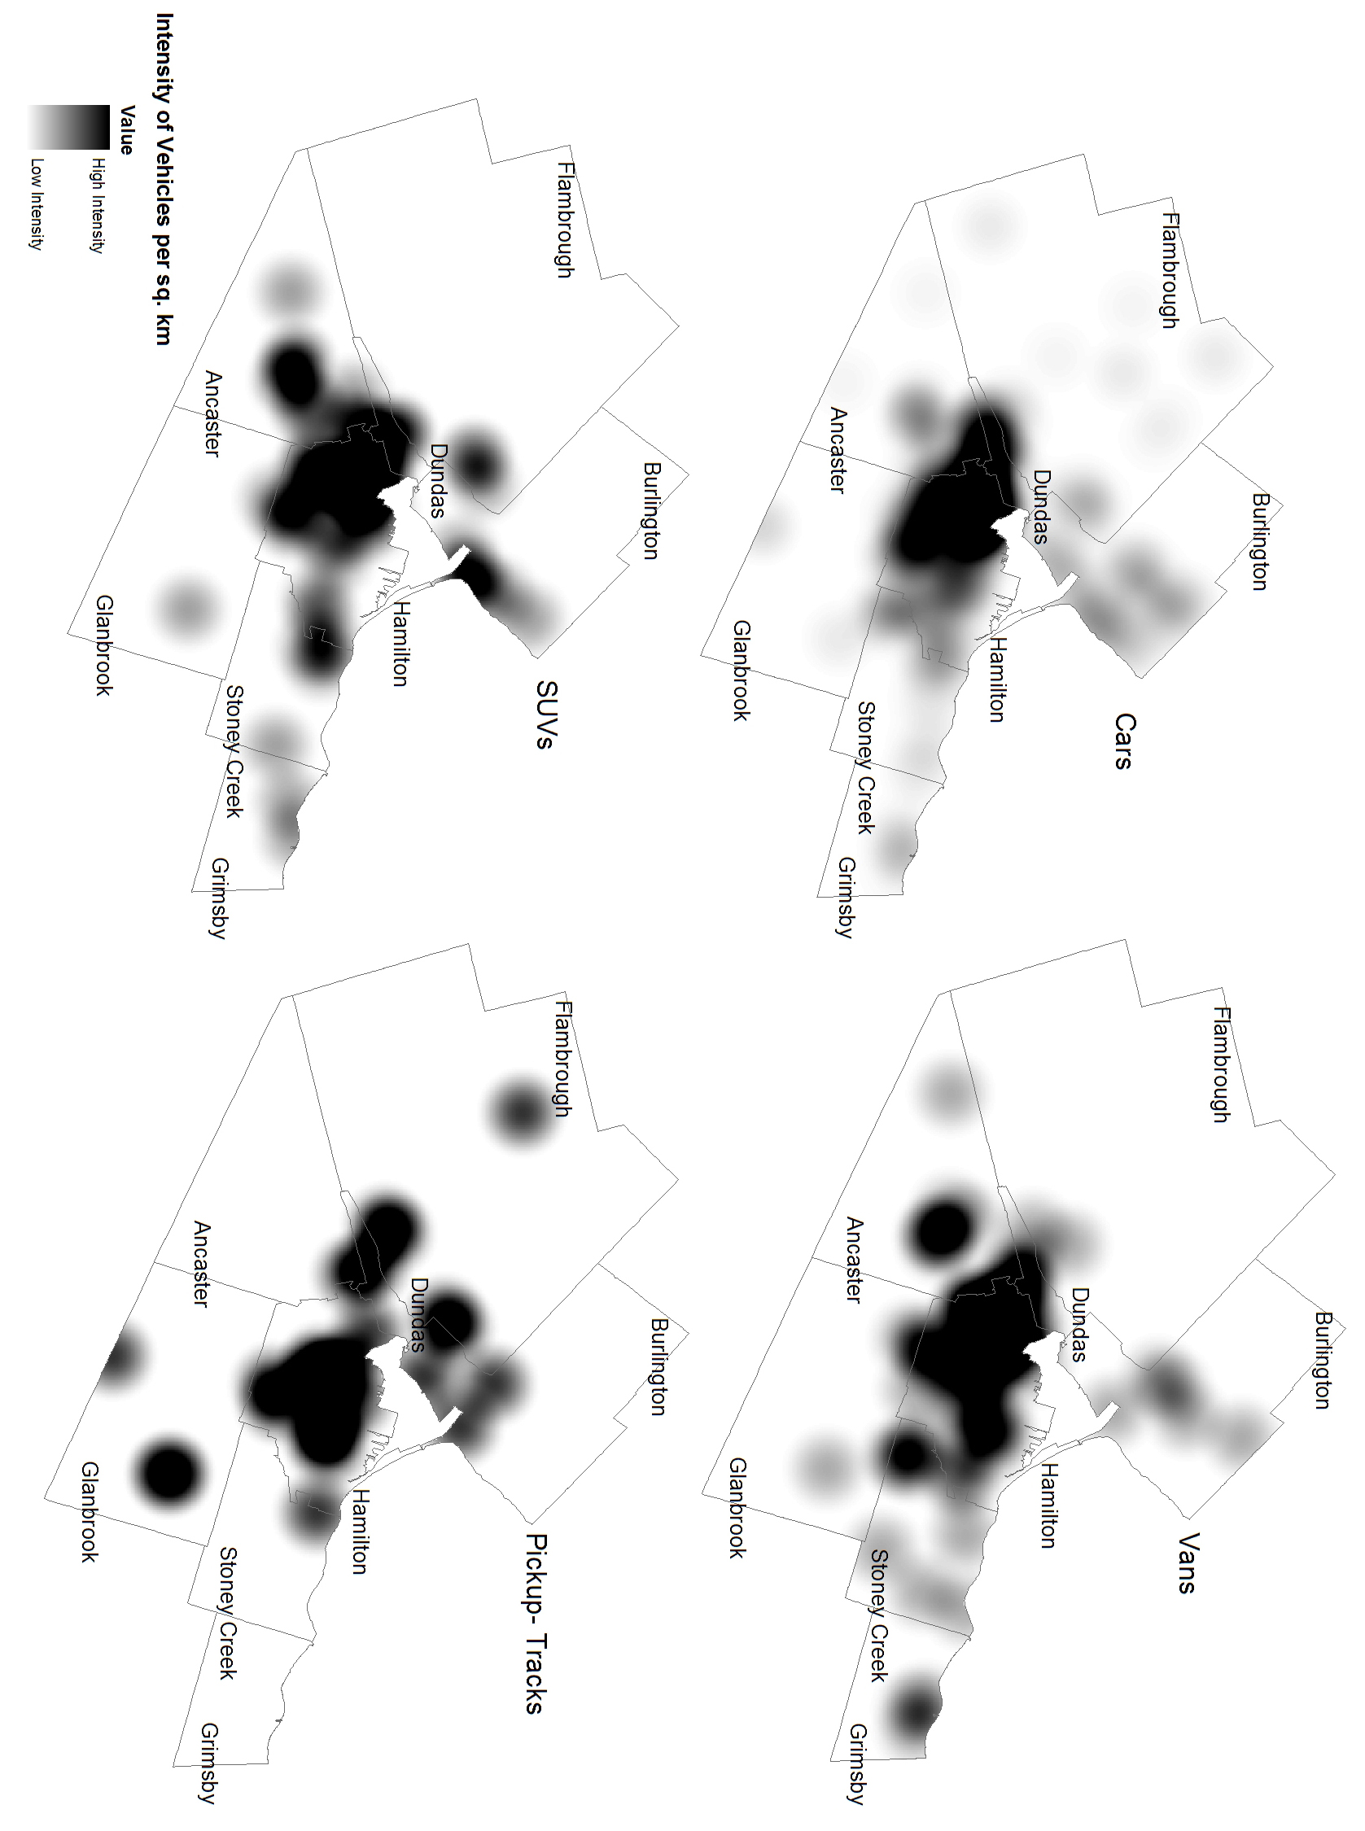

In 2001, the population densities in Ancaster, Flamborough and Glanbrook were 155.6, 77 and 59.6 persons per sq. Km, respectively. In contrast, population densities in the municipal districts of Dundas (1,047 persons per Sq. Km and, Hamilton (2,703 persons per Sq. Km) were the highest in the area (Canadian Census Analyzer, 2001).

