Research on the City Civilization Sustainable Development Supported by Transportation System:
Based on a Pedestrian Area Study of Gulangyu in Xiamen, China

Xin Pei¹
Master Candidate
Institute of Transportation Engineering
Tsinghua University
Beijing, 100084
Tel: 86-10-62772615
Fax: 86-10-62795339
Email: peix@mails.tsinghua.edu.cn

Huapu Lu
Professor
Institute of Transportation Engineering
Tsinghua University
Beijing, 100084
Tel: 86-10-62795339
Fax: 86-10-62795339
Email: luhp@tsinghua.edu.cn

¹ Corresponding author.

Abstract:
Most cities embody some essential blocks with various culture resources which play a significant part in sustainable development of city civilization. In order to develop the function of these culture resources sufficiently, a certain transportation system such as system based on pedestrian system could be effective. This paper firstly studies at a case of Gulangyu, which is a pedestrian island of Xiamen in China, and then compared some pedestrian areas of China and other countries so as to propose the general solution of transportation system planning to the conservation of urban essential blocks finally.
Based on the design of pedestrian system, we can plan the whole transportation system to support the sustainable development of urban essential areas so as to realize the sustainable development of city civilization and bring a lively city to people.
Keywords:
Sustainable Transportation System, Pedestrian Transportation System, Pedestrian Island, Urban Conservation
- Introduction
Every city possesses certain areas with historic heritage, traditional culture or various open spaces for communication and recreation, which embody the civilization of the city. These urban essential blocks are significant for culture inheritance and expansion of the city and also crucial to the joy of the civic lives. Hence the sustainable development of these blocks is a primary task for a city’s cultural development.
In China, the conservation of the cities with long history and profound culture has been started although mostly from urban design. Since transportation system is the backbone of urban areas, we focused on maintaining the civilization and supporting it through a carefully designed transportation system. The current situation in China is that researchers on the urban conservation generally regard the modern traffic as the destroyer to the protection areas while the transportation planners always omit the protection principles of the historic heritage. Therefore, this study intends to research on the civilization sustainable development based on the transportation system in order to support the city conservation and sustainable urban development both in views of urban conservation and transportation planning. Because of the flexibility and comfort of walk with little pollution and harm to the conservation areas, the pedestrian transportation system is considered as a sustainable transportation system in the conservation districts.
Gulangyu is an islet belonged to Xiamen, locating in the southeast of China and well known as a natural and human landscape of China. It is a pedestrian island with certain land-use forms and corresponding transportation system. According to the fieldwork, this study analyses the interaction between land-use and transportation system of Gulangyu and presents the transportation system and traffic management policy based on the pedestrian system.
On the contrast of the case study of Gulangyu, this study further researches on some other pedestrian areas in the cities inside and outside China, such as Pingyao Ancient City in China, York and Liverpool in Britain. These pedestrian areas seem as “pedestrian islands” without motor cars among the sea of cars. Compared with Chinese cases, the pedestrian areas in Liverpool and York are indeed the open space without barriers or walls and don’t seem to separate from the whole city.
Taking into account of the contrast and analysis of the pedestrian islands, this paper intends to find the approach to achieve the sustainable transportation system in the conservation areas so as to support the city conservation and sustainable development. Based on the review of literatures of pedestrian transportation system, the research emerges the framework of the transportation system planning based on the pedestrian system and proposes the methods to planning and design a sustainable transportation system in the urban conservation area.

Sustainable Transportation System in Urban Conservation areas
In a sense, the sustainable urban development should be composed of urban conservation and urban development so that the research on urban conservation in perspective of transportation planning is considered as an important aspect to realize the sustainable urban development especially the civilization sustainability. Since the transportation system is the fundamental infrastructure of the city, the sustainable transportation system is the foundation of the urban sustainability.
  - Definition and Objectives of Sustainable Transportation System (STS)

2.1.1 Existent definition
William R Black (1996) considered the Sustainable Transportation System (STS) as the system “satisfying current transport and mobility needs without compromising the ability of future generations to meet these needs”. World Bank defines STS as three aspects: financial, ecological and social sustainability. World Business Council for Sustainable Development (WBCSD) (World Bank, 2002) defines the STS as: the needs of society to move freely, gain access, communicate, trade and establish relationships might be improved without sacrificing other essential human or ecological requirements now or in the future.

2.1.2 Definition of STS
Sustainable transportation system should include following subsystems at least: (1) social economies; (2) traffic demand and supply; (3) energy; (4) environment. Focusing on the current problems in the urbanization process of Chinese cities, the STS should be defined as follows.
Sustainable Transportation System is a comprehensive system with minimal investment of resources and environmental costs that can meet the traffic demands brought by social and economic development and afford the utmost extent of the living quality improvement of the people.

2.1.3 Objectives of STS
The Objectives of STS is to meet the traffic demand, optimize use of resources, improve environmental quality, promote social harmony and increase the level of safety so as to realize the virtuous cycle of society, economy, transportation and environment.
There are certain detailed tips for the objective of STS:
- Meeting the demand for mobility of social and economic development;
- Improving transport efficiency and alleviating traffic congestions;
- Promoting development of public transport;
- Coordinated development of mobility and use of land
- Optimizing use of resources and improving efficiency in using resources
- Reducing environmental pollution and promoting virtuous cycle of ecosystem
- Promoting social fairness and safeguarding social harmony
- Improving Safety
- Coordinated development of the overall system
- Establishing assurance system for sustainable urban mobility system
  - Characteristics of Urban Conservation Areas and Relevant Transportation System
Generally, the urban civilization conservation areas cover the urban open space, historic blocks and various culture and recreation spaces. These charming areas always attract a lot of the citizens and visitors as important traffic origination and destination nodes. On the other hand, these areas bring the multiplex and vivid life to the participators and they should be provided a free and safety space without heavy modern traffic to the buildings and visitors inside the areas.
According to the characteristics of traffic demand for the conservation areas, the relevant transportation system should be proposed. Walking is a flexibility and comfort traffic mode for pedestrians. The pedestrian transportation system is an energy and environment friendly system with little pollution and harm to the conservation zones so that it is considered as a sustainable transportation system in the conservation areas. The pedestrian transportation system is the comprehensive system based on the pedestrian infrastructure. It settles a pedestrian world inside the conservation area while organizing various traffic facilities inside and around the area in order to emerge the culture atmosphere for the visitor and conservation area.
A lot of attempt has been made to realize the civilization sustainability and urban conservation based on the pedestrian system. This thesis presents several examples to illustrate the planning of pedestrian system.
- Case Study of Pedestrian System in Gulangyu
Gulangyu is an islet (Fig.1) as a district of Xiamen City of Fujian Province in China. Lying separately at the southwest of Xiamen Main Island, Gulangyu Island covers an area of 1.91 square kilometers with the resident population of over 20,000 and above 40,000 on the island at most. (MCG, 2005) As one of the famous scenic areas, the Island is dubbed "Garden on the sea". It is well known at home and abroad for its graceful and changeable landscape. Due to the various styles of the architectures on the islet, Gulangyu has a laudatory title "the World Architecture Museum". The residents there love music very much, and the amount of the pianos within the island is in the leading place in the nation, though there is only a population of 20,000 people. Thus the islet is praised as the "Piano Islet". Above all, Gulangyu is a precious district of the Xiamen City and a historic heritage of the civilization. It needed to conservation cautiously.
In order to maintain the country's first-class tourist area on Gulangyu Island, which is full of natural and culture scenic spots, the relevant government department has taken some effective protection measures including banning the construction of new factories or buildings harmful to the environment, unless they are helpful to the sustainable development of this area. Because of the rule that no motor vehicles are allowed to enter the island, there are neither any motor vehicles going into the streets nor any noise of heavy traffic. As a result, you will have a feeling that Gulangyu Island is a real place of natural beauty when you are strolling on the clean and quiet asphalt pedestrian roads.

Land Use and the Relevant Transportation System
There is a close interaction between the transportation system and land use. On the one hand, the land use patterns directly influence the traffic demand, trip distance and traffic mode of the residents and tourists. On the other hand, the appropriate transportation system will firmly support the development of land use, even of the whole area. This paper would like to investigate on the transportation system of Gulangyu Island with the beginning of the land use analysis.
The green land that covers the 41.3% area of Gulangyu Island is the main land use pattern of the island. The residential and tourism land mainly lying in the eastern island almost cover the rest of the island area. There were several factories in the western in the early time and they have been moved outside of the island and left the factory districts as storage land now. Thus there is no industrial land on the island. The educational land is another land use pattern of the island. Besides a primary school and a middle school, there are two art colleges on the island. (TMCG, 2005) According to the land use of Gulangyu, the trip distances inside the island are almost short and the common traffic mode is walking, so that the pedestrian system is appropriate to meet the traffic demand of the residents and tourists traveling inside the island.
Actually, there are few residents working at the tourism on the Gulangyu Island. Their income mainly comes from the wage earning on the Xiamen Main Island. Because of the limited geography condition of Gulangyu, the Xiamen Island is the provider of freshwater, vegetables and household goods to Gulangyu. Additionally, tourists generally go to Gulangyu from Xiamen Island. Hence there is a crucial economic relation between Gulangyu and Xiamen Island more than the political connection. The close connection brings the mass traffic demand between Gulangyu and Xiamen Island, therefore the relevant transportation system involving ports, ferries and parks are constructed to connect the pedestrian system of Gulangyu and transportation system on Xiamen Main Island.

Transportation System in Gulangyu
There is no private motor car on the Gulangyu Island. It is the prominent feature of the transportation system of Gulangyu. Then this paper will present the characteristics of the transportation system based on the pedestrian system, starting with the analysis of the traffic supply-demand situation on the island.

3.2.1 Transportation Facilities (MCG, 2005)
There are still a few motor vehicles belonging to the local government on the island used for the civil affaires and tourism. Battery Cars (Fig.2) is the main motor facilities in Gulangyu. Most of the cars are used for tourism, managed by tour companies while only 4 cars belong to the agency of management. The total number of the cars on road is limited to 30 everyday and the highest velocity of the car is restricted to 5km/h. On the island there are 2 medium-size trucks used as dust carts. Their trip time and path is fixed. There are also 4 jeeps used as fire engines, but they are rarely used. However, these motor vehicles make little impact on normal traffic.
The manpower carts (Fig.2) are the common transportation facilities in local residents’ daily lives. The amount of the registered manpower carts is around 400, of which about 200 are often used. In a sense, the logistic system of Gulangyu is largely based on these manpower carts.
Private bicycles are forbidden on the island because of its uneven landform. There are 7 bicycles: 2 for post office and the other 5 for the agency of electric power.
Table 1 illustrates the list of the transportation facilities of Gulangyu Island.

3.2.2 External Transportation
The ferry is the only mode of the external transportation. The unique public ferry dock affords the 70,000~80,000 customers per day. (MCG, 2005)
There is a parking lot beside the port on the Xiamen Island from which ferries depart to Gulangyu. People who want to go to Gulangyu could park their vehicles in the lot, and then take ferries to the Gulangyu Island.

3.2.3 Interior Transportation
Existing roads were constructed randomly long ago, so the roads are narrow, twisted and steep, and lack connection with each other. Most roads whose slope is lower than 3.0% are distributed in the mid-east of the island along the coastline. The roads whose slope is between 3.0% and 8.0% are distributed in the area where the contour lines are between 10 and 20 meters. And roads whose slope is higher than 8.0% are distributed in sloping fields. (MCG, 2005)
Table 2 shows some indexes of the roads network in Gulangyu and Fig.4 shows the layout of the roads network.

3.2.4 Pedestrian System
Because of the banning of private motor cars and the restriction of public motor cars, the pedestrians can walk safely in a continuous space. The slopes of most roads are under 8.0% and walking is a preferred choice. The main scenic spots are collected in the eastern island, thus the walking is also a rational choice to the tourists.
The guide system is comprehensive and legible on the island (Fig.5). The road signs present the two roads’ names connected with the current road. The panel of guidepost at crossing shows the main spots around. However, it has difficulties to point out the actual direction of the location without the distance to the destination.
There are plenty of rest facilities for the pedestrians along the arterial road and the road landscape is designed delicately (Fig.6). The fingerboard road is a particular section of the tourism route. Actually, these elaborate designs are inspired by the character of Gulangyu as a “Music Island”.

Traffic Management and Transportation Policy
The local government hammers at building “the island without vehicles” all along. It’s the natural limitation to the motor vehicles that the landform of the island is inconvenient for vehicles. In addition, relevant regulations to restrict the use of vehicles have been put into practice.
The management of the manpower cart is very rigid. The carts in use must be registered. Every year, every cart must pass the yearly examination. The size of manpower carts is also restricted. The Fig.7 is a sign which indicates that manpower carts are forbidden during the certain time.
The regulation of transportation facilities in “the management of Gulangyu, Xiamen” is: No.14, the vehicles, battery cars, flat carts, and bicycles are all forbidden on the island, expect those for public affairs, tourism, handicapped use and so on. The police must examine and control these tools strictly.

Problems and Proposals
- Battery cars for tourists bring some underlying dangers to pedestrians on the Huandao Road (Fig.8), which is the arterial tourism road.
- It is proposed that clear signs and zebra crossings should be added in order to secure pedestrians in the alleyways.
- There is only one external public port which is quite congested during peak hours.
- Roads are distributed irregularly and the area in the northwest part of the island is under reconstruction after the moving of factories. Therefore a new road network should be planned and set there.
- The roads are so narrow (Fig.9), twisted and steep that emergency might be difficult to deal with. As a result, regular supervision and prevention measures should be achieved.
- The pedestrian guide system should offer tourists clear direction and distance information.
- Contrast and Analysis
Gulangyu retains the culture atmosphere and comfortable environment for pedestrians. The transportation system based on pedestrian system should be considered as a fundamental guarantee to the conservation of Gulangyu Island. The pedestrian area seems as a “pedestrian island” without motor cars and their pollution. We may find many similar “pedestrian islands” inside and outside of China. They prevent the pedestrian space from the entries of motor cars. In a sense, they conserve the culture heritage and lead a vivid life of the whole city.
These “pedestrian islands” may be not true islands on the sea. However, within the city, they mostly look like islands without cars among the sea of cars. Based on the case study of Gulangyu, this research chooses the Pingyao Ancient City in China and York and Liverpool in Britain for further contrast and analysis.
York is a historic castle with a central block (Fig.10) of famous architectures. Only pedestrians are permit in the historic block which could be considered as a “pedestrian island”. Liverpool is the second biggest industrial city in Britain. However, in the centre, there are still various historic heritages and spacious public open space, which are the most essential content of the urban conservation. In order to protect this conservation zone and retain the open space for public, the conservation area in the centre is settled as a pedestrian zone, too (Fig.11).
Generally, the pedestrian system always designed together with the park planning and public transportation planning. There is a park around the ferry dock on Xiamen Island (Fig.12). People who want to Gulangyu should park their cars in the park and take ferries to walk on the island. Around the Pingyao Ancient City, each major gate has a parking lot nearby (Fig.13). People can “berth” their cars there, and then walk on the “island” without cars. According to these two “pedestrian islands”, the parks of motor cars or bicycles should be disposed along the boundary of pedestrian space. Like the “pedestrian islands” in China, around the two British blocks, there are many parking lots, which can be used for the drivers willing to walk “on the island”. Meanwhile, there are several bus stops nearby for the visitor from long distance.
Gulangyu and the Pingyao Ancient City are both restrained by a firm boundary: respectively, geographic barrier of Gulangyu and city walls of Pingyao. So the control of vehicles is comparatively easy. In Liverpool’s and York’s pedestrian block, the roads surface is paved with bricks, different from other roads covered by asphalt, which is more suitable for motor cars. Compared with most pedestrian blocks in China, these two blocks in Britain pay more attention to maintain the plentiful and quiet space for cultural heritage. There are neither barriers nor walls. The historic block without heavy traffic connects naturally to the outer area occupied by cars.
There are also some residential land and amusement facilities for the cultural activities on the “pedestrian islands” of Liverpool’s and York’s. The function of the pedestrian blocks has been developed adequately. As a part of the whole city, the historic block coexist with the rest of the city harmoniously rather than an isolated island.
It’s quite an enlightenment that the conservation areas of the two British cities are maintained for pedestrians in such a natural way. Most historic cities in China also embody plentiful heritage. Compared with York and Liverpool, these historic zones are always apart from the city with barriers or walls. It seems that the history is isolated to the modern society. Maybe, we should consider a more natural approach to the urban conservation based on the analysis of the concrete situation.

plan and Design of Pedestrian System
Taking into account of the concrete experiences of the pedestrian system planning inside and outside China, the pedestrian system is considered as the fundamental transportation system helpful to the urban conservation. Therefore, it should be planned designedly.
  - Review of Exist Literatures
After the World War II, pedestrian transportation system was regarded as the humanistic component of the urban reconstruction. The original form of pedestrian transportation system was some bald straight streets, and then it was designed as a block especially for pedestrians. Now the related urban transportation planning involving public transportation system planning, park planning and guide system design, and urban open space design has been considered to the planning of pedestrian system. Consequently, the pedestrian environment has been changed and the whole city becomes more attractive and harmonious.
The research of the pedestrian system could be divided to 3 tracks: the pedestrian behavior analysis, the pedestrian demand prediction and the planning and design of the pedestrian system.

5.1.1 Pedestrian Behavior Analysis
Relevant research in this area mainly refers to pedestrian characteristics, pedestrian flow and walking information collection and management. There are abundant investigations about various pedestrians’ speed, step, density, route choice (Bovy, 1990, Hoogendoorn, 2004) and other characteristics, which are influenced by the age, gender, trip purpose and other surrounding conditions. The research of pedestrian flow brings the methodology of traffic flow to achieve the pedestrian simulation model based on the survey. There are more and more governments and organizations realizing the information collection and management of pedestrians, which will help to the further research and development.

5.1.2 Pedestrian Demand Prediction
There are two methods of determining demand for pedestrian facilities: the intuitive approach which is also called a "sketch plan" vs. the use of demand forecasting models.
A variety of pedestrian sketch-plan methods have been developed to estimate pedestrian volumes under existing and future conditions in a pedestrian activity area. These methods generally use pedestrian counts and regression analysis to predict pedestrian volumes as a function of adjacent land uses (e.g., square feet of office or retail space) and/or indicators of transportation trip generation (parking capacity, transit volumes, traffic movements, etc.). Alternatively, data on surrounding population and employment may be combined with assumed trip generation and mode split rates to estimate levels of pedestrian traffic. Pushkarev and Zupan (1971) developed relationships between land use and pedestrian travel demand for a downtown setting. Ercolano, Olson, and Spring (1997) used existing data to estimate peak pedestrian travel demand in suburban and developing rural activity centers. Matlick (1996) used household population, national transport survey percentages and activity center data to calculate potential walking trips in specific corridors.
The other method of estimating latent pedestrian travel demand is to adjust conventional motor vehicle travel demand theory so that it applies to pedestrian travel. By using a gravity model to measure latent pedestrian travel demand, the planner can achieve results that are more precise than the sketch plan method.

5.1.3 Planning and Design of Pedestrian System
Current research of pedestrian system is usually proposed in the perspective of urban design. In Life between Buildings Using Public Space, Gehl Jan studied the generation and characteristics of outdoor activities, and emerged the design propositions of the open space both in the view of the detail design and the integrated planning. In The Aesthetic Townscape, Yoshinobu Ashihara analyzed the characteristics of streets, plazas and other public space based on the contrast of various urban public activity spaces in Europe and Japan.

According to the review of the literatures on pedestrian system, we might notice that there are few researchers focusing on the transportation system in the urban conservation district. The current design and planning of pedestrian system normally depends on qualitative estimate without quantitative analysis. Thus, this study tends to seek a general planning approach of the sustainable transportation system based on the pedestrian system by taking into account the characteristics of the urban conservation areas.

Framework
This is the framework of the study.
  - Methods
In views of the framework and previous literatures, the research involves 3 fundamental stages: the pedestrian behavior analysis, the pedestrian demand prediction and the planning and design of the transportation system.

5.3.1 Pedestrian Behavior Analysis
The pedestrian behavior within a certain urban conservation area presents its own characteristics because of the pedestrian’s age, profession, income and other attributes. We should analyze the pedestrians’ characteristics of the planning areas so as to support the pedestrian demand prediction and the process of planning and design. There are some common factors affecting on the pedestrian behaviors: pedestrian individual characteristics (age, gender, etc.), trip information (trip purpose, travel time, etc.), road conditions and environment situations (geography condition, climate, etc.). These common factors should be one part of the general planning principles.

5.3.2 Pedestrian Demand Prediction
The general model of pedestrian demand prediction is one of the significant issues of this research. This could be realized by quantitative modeling analysis in addition to qualitative estimate. Several survey and modeling means according to the previous experiences are proposed as follows.
- Pedestrian volume survey on the roads and the crossings which needs a lot of investigators.
- The street interview at the parks and stops which are the joins between inner and outer area. According to the result, the trip generation and attraction of the pedestrian district as a single point would be attained. The result could identify the scope of related areas outer the planning district.
- The household survey including the household information, individual information and trip features (the trip purpose, mode, time, distance, path, etc.)
- The model presents the connection between land use and traffic demand.
If possible, the survey could be carried out in several methods followed by the integrated analysis of the result. However, this is the current situation of the urban conservation area and the nearby areas. According to these data and relevant cases study, the model reflecting the relation between relevant factors (population, land use, travel distance, family attribute, etc.) and trip volume could be set. Based on the change of those relevant factors in the future, we can apply some prediction methods such as growth-factor modeling, type analysis method and other function modeling methods to obtain the pedestrian volume inside the area as well as the trip volume of all modes around the area.

5.3.3 Planning and Design of Transportation System
On the foundation of the analysis of pedestrian behavior and demand, the transportation system design and planning in the urban conservation district is the core part of the research. The pedestrian block planning and the surrounding traffic organization are both considered in the comprehensive pedestrian transportation system planning, which is the recommended transportation system in the conservation areas.
The pedestrian system planning should be carried out by 3 main steps.
(1) Location and Scope of Pedestrian Areas
According to the observation and analysis of pedestrians’ behaviors, there might be several streets extending along a muster of historic buildings or crossing through an urban square. These charming streets are always attracting many visitors and citizens, and therefore should be considered as a special block for pedestrians. Moreover, the scope of the pedestrian block is a significant factor of the pedestrian system. We design a “pedestrian island” for the pedestrians; meanwhile, we should make sure it makes influence on the urban traffic nearby as little as possible. On the other hand, some measures like “organic evacuation” to decrease the travel demand would be helpful for the transportation system of pedestrian blocks and the adjacent areas. Of course, the former survey and analysis are indispensable for the location and scope design.

(2) Accessibility to Pedestrian Areas
Efforts of pedestrian system planning should also be directed towards facilitating accessibility to the pedestrian areas from the urban transportation system. The ways to the pedestrian area should be set in consideration of the pedestrian demand prediction which involves the pedestrians’ origin, destination, trip mode and other trip information in order to lead people onto the “pedestrian island” conveniently and rapidly. The transit is the recommended trip mode around the urban conservation area. Buses carry people to the entrances of the pedestrian block. Some tourism buses can be extended into the inside of the conservation area. Though the private cars are forbidden in the pedestrian block, sufficient parking lots should be provided around the area as well. Additionally, traffic simulation is helpful in analyzing the traffic distribution and assignment.
Generally, the access approach should be adjusted according to the concrete situations. Zhouzhuang, which is also a particular islet on the Taihu Lake in China with traditional culture heritage, is very similar with Gulangyu. Because of the great impact to the ferry caused by wind, a bridge connects Zhouzhuang and mainland has been constructed. The motor cars are permit to go through the bridge and reach the northern of the island, but they are banned to enter the ancient district. There is a park for cars nearby the bridge and all of the motor cars should be park there. Additionally, there are some parks for bicycles disposed at the crossing of transferring from cycling to walking (Fig.14)
It is should be recognized that traffic policy such as restricting motor cars is not the bar but the leading to the sustainable development of transportation system. The pedestrian blocks might be disposed in a natural transition measure instead of the rough partition or severe banning. It should not give tourists and local residents an impression of being restricted. Therefore, a joint zone is necessary between the “pedestrian island” and the outer urban area. For example, different road surface materials identify different functional blocks, in Liverpool. In a word, what we should do is directing rather than jamming.

(3) Design of Pedestrian Areas
After locating the “pedestrian islands”, we turn to the pedestrian block design. It would be designed in a three-dimensional perspective rather than the linear view. So we might pay additional attention to various tastes and feelings of pedestrians. Some factors should be considered.
- Public space, private space and semi-public space should be defined clearly. Interactions between residents and tourists are very important. Moreover, protection of private space is necessary for the history and culture conservation because the people and their lives are also precious component of the urban culture.
- The pedestrian system should be legible and comprehensible. An integrated guide system is needed to be distributed at the reasonable place and direct definitely.
- Images play an important role in the conservation areas. If everyone considers the same scene as the same image, the city will be a superficial one without diversity. An essential block within a nice city can always provide the imagination space for the visitors. (Lynch, 1960)
- The pedestrian system should give people continuous walking and even thinking space. The pedestrian space should also provide rest facilities for walkers. In addition, we should keep the pedestrian system available everyday despite weather conditions and time.
- Each conservation district has its own characteristics. A particular atmosphere should be created depending on its unique characteristics.
- Safety is the fundamental factor of the pedestrian space. Enough space for emergency should be considered.
These factors are the targets which should be taken into account to the planning of pedestrian blocks. During the implement of the pedestrian block planning, certain transportation policies should be adopted, for example fixed paths and travel time for tourism buses. The pedestrian system is just an effective mode to support the urban conservation. It should be planned integrated with the rest of the urban transportation system and transportation policies.
After the planning and design of the transportation system, evaluation of the system by taking into account urban culture, society, economy, energy and environment is suggested to identify the sustainability of the planned transportation system.
The cases study of various urban conservation areas is useful during each steps of this research. The application of the research outcomes would help to improve the planning approach of the study.
- Conclusions
This research mainly proposes an approach to realize the civilization sustainability in the perspective of transportation. The study focusing on the transportation system based on the pedestrian system is not only helpful for the urban conservation area but also for the residential, commercial and other function areas of the city. Therefore, the theoretical framework and methods of this research could be used for broader areas.
It is in fact a profound issue that how the urban heritage with luxuriant urban information could inherit and coexist together with the modern city. The transportation system is just a fundamental infrastructure. Hence what we should do is not only restricting the trips of motor cars or bicycles, but also seeking an appropriate approach of the sustainable urban development considering the historic, geographic, social and economic factors together so as to provide sufficient space for the civilization and bring a lively city to people.

References
Bovy, P.H.L., Stern, E. (1990) Route Choice: Wayfinding in Transport Networks. Kluwer Academic Publishers, Dordrecht.
Dong J.H., Ruan Y. S. (1993) The Appreciation and Protection of Urban Culture, Tongji University Press, Shanghai.
Ercolano James M., Jeffrey S. Olson, Douglas M. Spring (1997) ‘Sketch-Plan Method for Estimating Pedestrian Traffic for Central Business Districts and Suburban Growth Corridors’, Transportation Research Record 1578, Washington, DC.
Hill, M.R. (1982) Spatial Structure and Decision-Making of Pedestrian Route Selection Through An Urban Environment, Ph.D. Thesis, University Microfilms International.
Hoogendoorn S.P., Bovy, P.H.L. (2004) ‘Pedestrian route-choice and activity scheduling theory and models’， Transportation Research Part B 38, pp. 169–190
Jan Gehl; translated by Jo Koch, (1987) Life Between Buildings: Using Public Space, New York : Van Nostrand Reinhold.
Lynch, Kevin (1960) The Image of the City, Cambridge, Mass.: Technology Press.
Matlick, Julie Mercer (1996) If We Build it, Will They Come? Forecasting Pedestrian Use and Flows, Forecasting the Future, Bicycle Federation of America－ Pedestrian Federation of America, Pro Bike/Pro Walk '96, pp. 315-319.
Pushkarev, Boris and Jeffrey M. Zupan (1971) Pedestrian Travel Demand. Highway Research Record 355.
The management committee of Gulangyu (MCG) (2005) The Civil Engineering Planning of Gulangyu
The tourism management committee of Gulangyu-Wanfangshan (TMCG) (2005) The Construction of Sustainable Island and Environment Friendly Scene
William R. Black. (1996) ‘Sustainable transportation: a US perspective’ Journal of Transport Geography , Vol.4, No.3
World Bank. (2002) Sustainable Transport, China Architecture & Building Press.
Yoshinobu Ashihara; translated by Lynne E. Riggs. (1983) The Aesthetic Townscape, Cambridge, Mass.: MIT Press.
Captions to illustrations
Table 1. Transportation facilities list of Gulangyu Island
Table 2. Some indexes of roads network in Gulangyu
Fig. 1. A view of Gulangyu Island (at the front) and thither Xiamen Island
Fig. 2. Common traffic facilities in Gulangyu (Battery Car on the top & Manpower Cart on the bottom)
Fig. 3. The road network of Gulangyu
Fig. 4. The guideposts in Gulangyu
Fig. 5. Design of pedestrian roads in Gulangyu
Fig. 6. The sign shows the limitation to the manpower carts
Fig. 7. The underlying danger to the pedestrians brought by battery cars
Fig. 8. The narrow alley of Gulangyu
Fig. 9. York central area (the area in the purple circle is the pedestrian block)
Fig. 10. Liverpool central area (the area in the red circle is the pedestrian block)
Fig. 11. The park nearby the ferry
Fig. 12. Parks around the Pingyao Ancient City
Fig. 13. The transportation planning of Zhouzhuang

- Transportation facilities list of Gulangyu Island

facility | purpose | quantity | note
medium truck | dust cart | 2 | Have fixed tour time and paths
jeep | fire engine | 4 | Rarely used
battery car | tourism | about 30 | Speed limited to 5km/h
battery car | management | 3～4 | Speed limited to 5km/h
manpower cart | freight | 200 | The basis of its logistic system
bicycle | Public affairs | 7 | Private bicycles are forbidden

- Some indexes of roads network in Gulangyu

Number | 36
Total Length | 30.16km
Road Width | 2～6m
Total Area | 0.13km²
Network Density | 16.2km/km²
Road Area ratio | 6.8％
Road Area per capita | 7.8m²

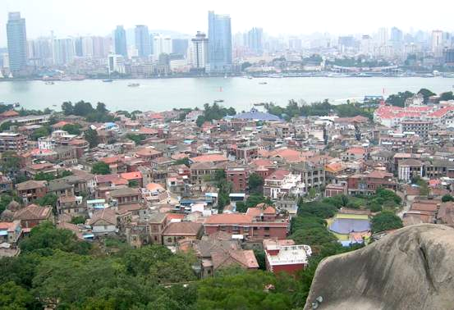
- A view of Gulangyu Island (at the front) and thither Xiamen Island
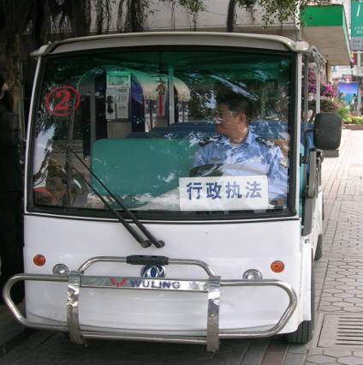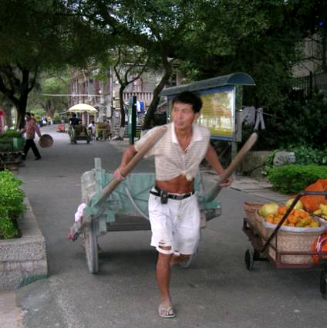
- Common traffic facilities in Gulangyu (Battery Car on the top & Manpower Cart on the bottom)
- 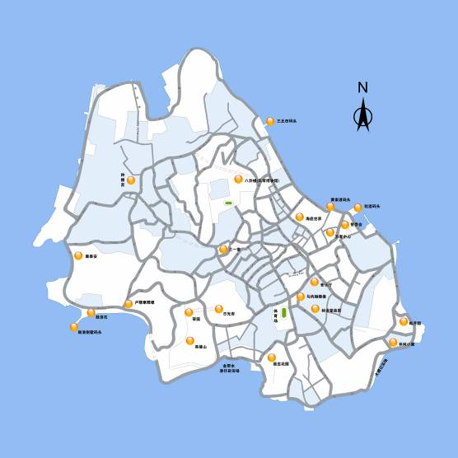
- The road network of Gulangyu
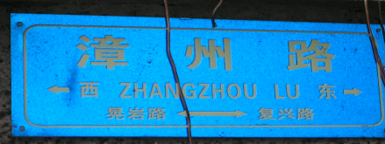

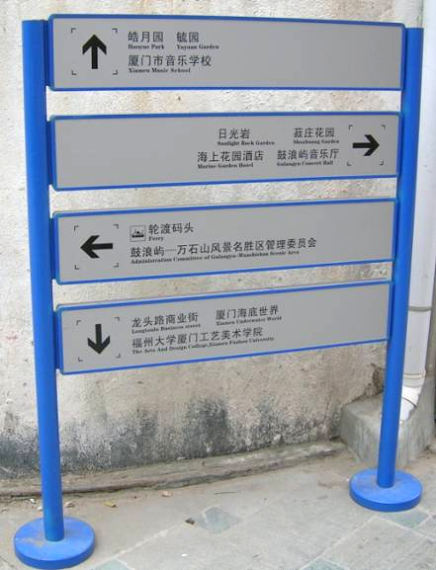
- The guideposts in Gulangyu
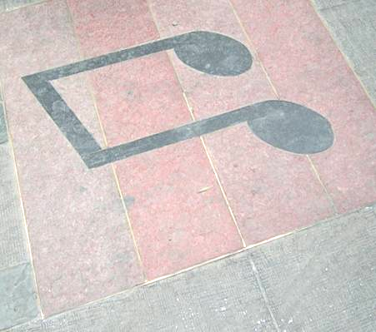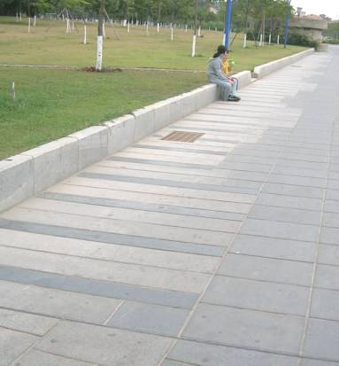
- Design of pedestrian roads in Gulangyu
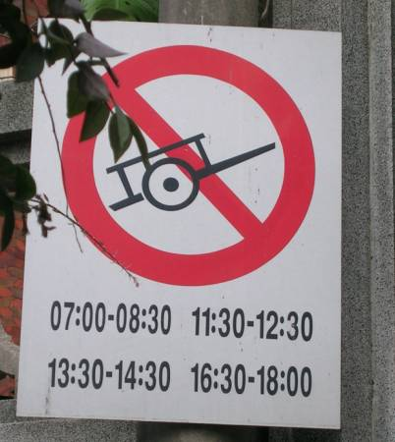
- The sign shows the limitation to the manpower carts
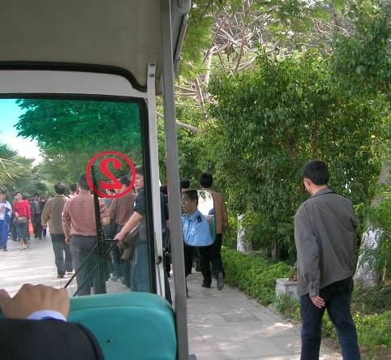
- The underlying danger to the pedestrians brought by battery cars
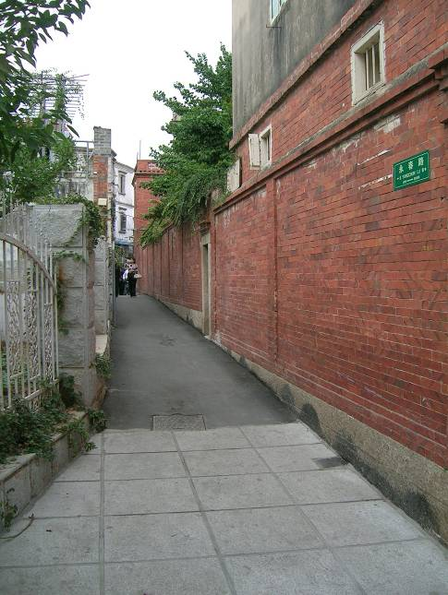
- The narrow alley of Gulangyu
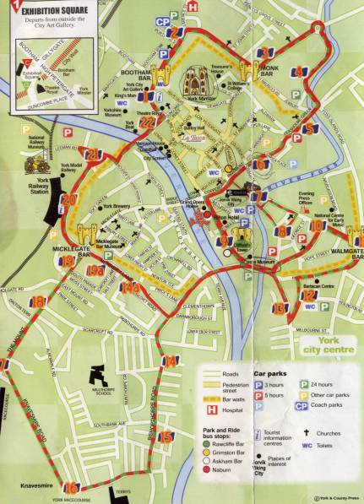
- York central area (the area in the purple circle is the pedestrian block)
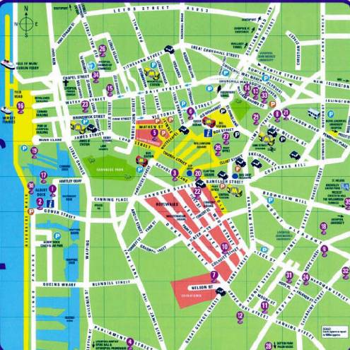
- Liverpool central area (the area in the red circle is the pedestrian block)
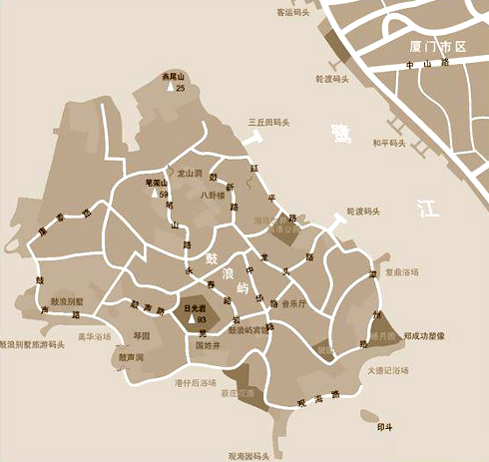
Gulangyu Island
Xiamen Island
- The park nearby the ferry
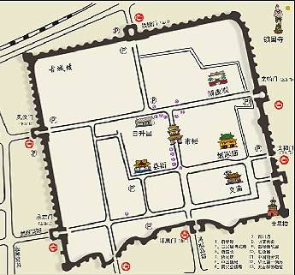
- Parks around the Pingyao Ancient City

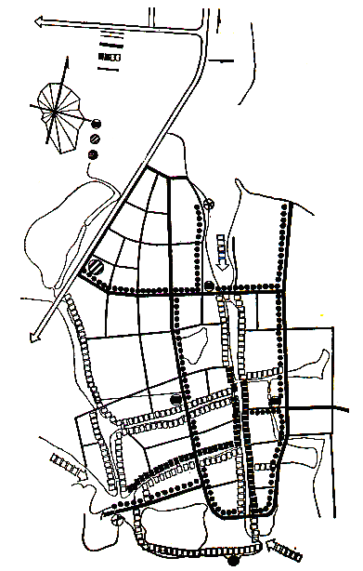
Motorway
Bicycleway

Pedestrian Roads
Bicycle Park
Motor Park
Passenger Port
To Shanghai
To Kunshan
- The transportation planning of Zhouzhuang

