Title: Measurements of Diesel Truck Traffic Associated with Goods Movement

Authors: Douglas Houston¹, Margaret Krudysz², and Arthur Winer²

Submitted for presentation at the 11th World Conference on Transportation Research

April 27, 2007

¹ Department of Urban Planning
School of Public Affairs
University of California
3250 Public Policy Building
Los Angeles, California, CA 90095-1656
E-mails: dhouston@ucla.edu

² Department of Environmental Health Sciences
School of Public Health
Room CHS 46-081
University of California
Los Angeles, California, CA 90095-1772
E-mails: megk@ucla.edu, amwiner@ucla.edu
* Correspondence author: Douglas Houston
Abstract

Direct video measurements of surface street truck traffic at eleven intersections and line segments in communities adjacent to southern California ports document that volumes of port-related trucks often reach 400-600 per hour for several hours, immediately upwind of ‘sensitive’ land uses such as schools, open-field parks and residences. The diurnal fluctuation of trucks on surface streets varies by intersection, local conditions, and passenger car commute patterns. Our data provide new insights into the geographic distribution and intensity of truck traffic associated with the increase in goods movement, and are essential for reliably modeling pollutant exposures in port-adjacent communities.

1. Introduction
Heavy-duty diesel truck (HDDT) corridors in Southern California carry significant volumes of port-related container trucks. Combined, the Ports of Los Angeles and Long Beach import over 40% of the nation’s international trade cargo and are the third largest port in the world after Hong Kong and Singapore. Container traffic at these ports has tripled in the last fifteen years and is expected to nearly triple again by 2020 (Mercer Management Consulting, 2001). These ports have become a dominant source of urban air pollution in southern California, in part due to associated sources that have only recently begun to be regulated including ships, cargo handling equipment, locomotives, and HDDTs. Approximately 84% of containers are transported via HDDT from the port complex to off-dock rail transfer facilities, to trans-loading facilities for repackaging for long-haul transport, or directly to regional and national destinations (Lai et al., 2006).
The health and environmental consequences of air pollution impacts resulting from HDDT container transport are substantial, not only at a regional level but also for those urban inhabitants who reside, work, attend school, or recreate in close proximity to surface streets and freeways with heavy HDDT traffic. A growing body of field measurements and epidemiological studies indicate vehicle-related air pollutants and related health impacts, including the prevalence of respiratory ailments and mortality, are highly localized within approximately 200 meters downwind of major roadways (Brunekreef et al., 1997; Hitchens et al., 2000; Janseen et al., 2003; Lin et al., 2002; Ryan et al., 2005; van Vliet et al., 1997; Zhu et al., 2002a,b). Heavy duty diesel trucks are of particular concern since they emit high levels of particulate matter (PM) and oxides of nitrogen (NO_{X}), and a complex mixture of gaseous air pollutants, many of which have been listed by the State of California as toxic air contaminants. Diesel exhaust PM has also been associated with approximately 70 percent of known potential cancer risk from air toxics in Southern California (South Coast Air Quality Management District, 1999). Over 70 percent of California’s diesel PM pollution in 2001 was from the goods movement sector, and over 70 percent of these emissions were from HDDTs (California Air Resources Board, 2006).
Emission control technologies, such as the particulate filters/traps and fuel-based solutions required for 2007 and newer HDDT models, greatly lower PM emissions and could reduce components of near-roadway HDDT-related air pollution. However, standards for new HDDTs alone will likely not translate into substantial fleet-wide reductions in the near term without an aggressive campaign to retrofit older HDDT vehicles. Furthermore, although some control technologies greatly lower PM_{2.5} mass concentrations, they may increase ultrafine particle number concentrations (Burtscher 2005), which are believed to be associated with heightened near-roadway health impacts.
Recent studies suggest diesel exhaust particulate air pollution varies at intersections in freight corridors and on sidewalks in highly-trafficked areas as a function of diesel truck volume (Kinney, 2000; Lena, 2002). Furthermore, health effects may vary by traffic patterns depending on whether trucks are on high-volume roadway segments or in stop-and-go traffic at intersections (Ryan et al., 2005). Unfortunately, relatively little quantitative information is available concerning the distribution of diesel truck traffic and associated air pollution and health impacts near port facilities in southern California.
Scattered regional air monitoring stations are largely inadequate for assessing localized vehicle-related pollutant concentrations and impacts and roadway-scale monitoring of vehicle-related pollution is expensive and complex. Given these limitations, previous studies have used proximity to roadways and nearby traffic volume to estimate the potential magnitude of near-roadway exposures to provide first-order assessments of the potential impact of vehicle-related pollutants within 150-200 meters of major roadways (Green et al., 2004; Gunier et al., 2003; Houston et al., 2004; Houston et al., 2006). One of the most serious limitations in these studies is the lack of detailed information on diesel truck activity, due in part to disparate data collection methods and limited geographic and temporal coverage (English et al., 1999; Ong et al., 2006; Wilhelm and Ritz, 2003). When available, reliable truck-related volume data largely exist in California only for major freeways or state roadways maintained by the California Department of Transportation (CalTrans). Furthermore, temporal coverage of traffic counts on surface streets varies greatly as such data are not systematically collected.
This paper responds to these limitations by providing new insight into the diurnal variation of traffic patterns on surface streets, including detailed information on port-related diesel truck activity. Our study measured traffic volumes on surface streets in August-September 2006 in the communities of Wilmington, in the city of Los Angeles, and the western portion of the City of Long Beach, immediately adjacent to the Ports of Los Angeles and Long Beach, respectively. Obtaining verified data on diesel/gasoline vehicle splits on surface streets in these port-adjacent communities is an essential component of understanding the air quality, land use, and community health implications of the rapidly expanding heavy-duty diesel goods movement infrastructure. Results provide new insight into the geographic distribution and intensity of truck traffic associated with the massive increase in goods movement in Southern California, and provide a refined characterization of the extent of potential impacts on port-adjacent low income and minority communities.

2. Background

2.1 Near-Roadway Concentrations of Diesel Vehicle Exhaust

Recent field studies indicate that vehicle-related pollutants such as ultrafine particles, black carbon, and carbon monoxide are highly concentrated immediately downwind from major roadways. Their relative concentration declines by as much as sixty percent at 100 meters downwind, drops to near background levels at about 200 meters, and are indistinguishable from background ambient concentrations at 300 meters (Hitchins et al., 2000; Zhu et al., 2002a,b). Roadways such as the I-710 freeway in Los Angeles, which has an average of approximately 25% heavy-duty diesel traffic, mainly from the Los Angeles port system, tend to have higher concentrations of these harmful pollutants than a freeway with less diesel traffic such as the I-405, which has an average of <5% heavy-duty diesel traffic (Zhu et al., 2002a,b).
Levels of diesel exhaust are of particular concern at intersections in freight corridors, and on sidewalks near heavily-traveled roadways. Lena et al. (2002) examined truck traffic and associated pollutant levels in Hunts Point, a major freight transportation hub in South Bronx, New York City. They found that intersection-level elemental carbon (EC) concentrations, an important component of diesel exhaust PM, were elevated in the community and varied as a function of large truck traffic. The Kinney et al. (2000) study of diesel exhaust particles on sidewalks in Harlem, New York City, indicated variation in sidewalk concentrations of diesel exhaust particles is related to the magnitude of local diesel sources, including heavy duty trucks and diesel buses.

2.2 Localized Health Impacts of Diesel Truck Traffic

In 1998 the California Air Resources Board (ARB) declared diesel exhaust particulate (DEP) a toxic air contaminant based on over 40 studies that showed a consistent causal relationship between long-term occupational exposures and lung cancer. Particles emitted by diesel engines vary in size: ultrafine particles, less than 100 nm in diameter, are generated during combustion and at the exhaust outlet of diesel (and gasoline) vehicles; particles less than 2.5 μm, PM_{2.5} or fine PM, are products of combustion, atmospheric photochemical reactions and coagulation of smaller particles. Ultrafine particles are of concern since they are capable of penetrating cell walls and the blood-brain barrier and can be easily absorbed into vital organs (Delfino et al., 2005; Sioutas et al., 2005). Heightened ambient levels of PM_{2.5} have been consistently associated with mortality and respiratory illness endpoints (Englert, 2004; Lippman et al., 2003).
In addition, evidence continues to accumulate that subjects who live near roadways with a high volume of diesel vehicles are more likely to suffer from chronic respiratory ailments and reduced lung function than people who live more than 300 meters or more away from such roadways (Brunekreef et al., 1997; Janseen et al., 2003; Lin et al., 2002; Ryan et al., 2005; van Vliet et al., 1997). These studies generally found such health impacts within 100-400 meters of a freeway, a distance that is consistent with Zhu et al.’s (2002a,b) finding that vehicle-related pollutants are highly elevated immediately adjacent to major roadways.

2.3 Limitations of Available Traffic Monitoring

Available traffic monitoring in southern California harbor communities is insufficient to adequately understand the truck traffic patterns, and growing HDDT volumes. Previous studies have used traffic volume data from the Highway Performance and Monitoring System (HPMS) maintained by CalTrans to assess community impacts of roadway traffic volumes at a regional and state level, and describe the limitation of using these data for monitoring traffic on surface streets (Green et al., 2004; Gunier et al., 2003; Houston et al., 2004; Houston et al., 2006; Wilhelm and Ritz, 2003). HPMS data contain traffic counts for freeways, highways, and major arterial roads, but they do not include counts for local residential streets. Previous studies assumed that residential streets have lower traffic volumes and that their exclusion did not greatly impact results in these regional studies, but there remain great limitations of using such data for exposure assessment purposes (English et al., 1999; Ong et al., 2006; Wilhelm and Ritz, 2003). Moreover, although the HPMS data provide useful information on total traffic volumes on major roadways, they lack detailed information on diesel truck activity.
Caltrans releases data separately for trucks in their Annual Average Daily Truck Traffic on the California State Highway System (http://traffic-counts.dot.ca.gov/). These data are restricted to major freeways and, like the HPMS data, are based largely on CalTrans sampling of traffic volumes using electronic counting instruments throughout the state at infrequent intervals. Only a few locations are monitored continuously. Such data are insufficient to understand truck flows given the large annual increases in the number of container trucks traveling major goods movement corridors (see Figure 1).
Caltrans also maintains a dispersed network of Weight in Motion (WIM) stations throughout the state, which provides the most comprehensive record of vehicle class at select locations on major state freeways. The WIM sensors are embedded in the roadway and are more reliable in their ability to categorize vehicles by class than the pneumonic tube sensors often used by local departments of transportation. Where available, WIM data help to characterize the impact of these goods movement corridors on near-by communities, but they do not identify the impact of increasing container truck traffic on surface streets that serve as feeder routes to the regional goods movement infrastructure.
Traffic monitoring by local departments of transportation is often used to assess the need for, or impact of, traffic controls or facility expansion on surface streets at a given point in time. Although some local traffic studies are conducted by in-person counters, they often include only intersections targeted for improvements and have disparate geographic and temporal coverage. In addition, local traffic studies only occasionally disaggregate trucks and buses.

2.4 Previous Studies

Amidst growing concerns over truck volumes in Wilmington, the Port of Los Angeles commissioned a study of traffic counts at key intersections in 2001 (Port of Los Angeles, 2004). This was the first available study based on in-person counts, which distinguished total traffic from port- and non-port trucks. The study monitored traffic on a single day at key intersections during the “morning peak” (8:00-9:00) and the “evening peak” (16:00-17:00) and showed substantial port-related truck traffic on surface streets in the community of Wilmington. The Port of Los Angeles’ 2001 traffic study documented substantial port-related truck traffic on surface streets near sensitive land uses including residences, schools, and preschool facilities. Truck volumes immediately adjacent to port facilities along Harry Bridges Avenue ranged from about 200 to over 400 port-related trucks per hour in the morning and evening monitoring periods. Truck volumes farther north on Alameda Street where trucks generally converge from the Ports of Los Angeles and Long Beach averaged about 330 port-related trucks per hour in the morning period and over 460 port-related vehicles per hour in the evening period.
This 2001 study demonstrated sizeable truck volumes on surface streets. However, further monitoring is needed given the substantial growth in port container traffic since 2001 when these counts were collected, and to obtain more comprehensive diurnal data for exposure modeling. The average number of monthly standard freight containers, or twenty-foot equivalent units (TEUs), that moved through the combined Ports of Los Angeles and Long Beach was just under 804,000 in 2001. This monthly average increased to almost 1,183,000 in 2005 and again to over 1,307,000 in the months of January-October 2006 (Port of Los Angeles, 2006; Port of Long Beach, 2006). As noted, the 2001 study also did not provide an understanding of the pattern of traffic over the course of the day. Diurnal information on truck traffic on surface streets is important (not just at peaks) especially given the shift towards longer hours of port operation. To our knowledge, the Port of Los Angeles 2001 study is the most comprehensive existing study of HDDT traffic in the port-adjacent areas of Wilmington and Los Angeles.

3. Data and Methods

3.1. Study Area Truck Traffic Patterns.

The study area is located in a major goods movement corridor north of the Ports of Los Angeles and Long Beach, and stretches from the I-710 freeway eastward approximately 6 miles to the I-110 freeway on the western edge of the community of Wilmington in the City of Los Angeles (Figure 2). In Wilmington, the study area reaches from Harry Bridges Avenue, the boundary of the Port of Los Angeles, to approximately 2 miles northward and past the Pacific Coast Highway (PCH). The study area follows Alameda Street in the northeastern direction from Wilmington into the western edge of Long Beach, and extends from Anaheim Street three miles northward to just south of the I-405 freeway. The communities of Wilmington and western Long Beach are predominantly comprised of minority residents and have higher poverty rates than the region as a whole.
Truck corridors for moving containers to-from the ports are the I-110 on the western edge of the port complex, Alameda Street which transverses the study area and connects with the I-405 freeway and downtown Los Angeles, and the I-710 freeway, which crosses the eastern portion of the study area. About 29% of containers from the port complex travel by truck to destinations in the Los Angeles region or Western United States (Lai et al., 2006). Approximately 14% of containers are trucked to “off-dock rail” intermodal facilities near downtown Los Angeles where they are loaded from trucks onto rail. About 29% of containers are trucked further inland to large warehouse complexes in Riverside and San Bernardino Counties for transloading (Lai et al., 2006).
About 9% of containers are trucked to the Union Pacific’s “near-dock rail” facility called the Intermodal Container Transfer Facility (ICTF) in the study area north of Sepulveda. Trucks that deliver containers destined for this facility travel east-west along Sepulveda Boulevard and north-south on the Terminal Island Freeway. As will be shown, this freeway carries large volumes of diesel truck traffic past vulnerable land uses including a preschool facility, an elementary school, a high school and recreational fields. The Pacific Coast Highway and Anaheim Street constitute major east-west corridors for traffic traveling to the I-710 and to local amenities in the nearby communities of Wilmington and Long Beach. Over the course of a day, port-related trucks make multiple trips between terminals, warehouses, container storage yards, and other truck-related facilities. Also, substantial queing occurs as truckers wait for their next load or take a break. As will be shown in the analysis, the majority of traffic east of the I-710 consists of passenger vehicle trips.

3.2. Study Design and Traffic Counting.

We selected intersections for monitoring based on previous traffic studies, input from community leaders through the Harbor Community Monitoring Study sponsored by the California Air Resources Board, and site surveys for safety and feasibility. For example, we used information from the Port of Los Angeles’ 2001 study discussed in Section 2.4 (ie. counts for the 8:00-9:00 morning period and the 4:00-5:00 evening period) for key intersections in Wilmington (Port of Los Angeles, 2004). We prioritized intersections based on their proximity to “sensitive” land uses such as schools.
We collected traffic data using on-site videotaping to obtain counts of traffic by vehicle class and direction for major surface street intersections in order to better characterize the diesel/gasoline split, determine diurnal patterns, and identify the composition and class of diesel vehicles traveling on arterial streets. We videotaped traffic at 15 intersections between August 15, 2006 and September 19, 2006. This sampling period had the highest container volumes in the history of the port complex (Figure 1), and corresponds with a high point in annual container through-put for the ports as higher volumes of goods are transported in advance of the holiday season.
Videotaping coincided with expected peaks of diesel traffic on surface streets, generally between 07:30 and 18:00, and was conducted on weekdays (Tuesday, Wednesday, and Thursday), with a repeat collection day at Site 215 on a Saturday and an extended day at Site 212 in part to assess the port’s shift towards extended hours of operation. As described in the Results section, this extended collection day at Site 212 also replicated our initial count at that site given that port truck volumes may have been lessened by a longshoremen union strike during the first sampling day. Due to limited resources, we were unable to conduct additional monitoring that could help assess the extent to which the monitored truck volumes were representative of traffic patterns on non-observed days. Our analysis assumes that our counts are generally representative of traffic counts during the study period given that to our knowledge the traffic on our collection days was not impacted by external conditions such as accidents or adverse weather (beyond the possible limitation of our first collection day at Site 212).
We videotaped traffic at regular intervals throughout the observation period for 30 minute or 1 hour sampling intervals depending on the availability of nearby amenities for researchers. Each observation day resulted in a minimum of 5.5 hours of videotaped traffic data. We used JAMAR electronic traffic counting boards to tabulate the videotaped traffic counts by direction and vehicle class. All video data were reduced to 30-minute period counts for comparison across days with 30 minute or 1 hour sampling intervals.
Our classifications distinguish passenger vehicles from diesel vehicles. Although a small portion of passenger vehicles use diesel, our discussion assumes that passenger vehicles are overwhelmingly gasoline-fueled in California. In addition to sedans, passenger vehicles include light-duty pickups, pickups, vans, minivans, SUVs, and station wagons. Port-related diesels include trucks in a tractor-only configuration, tractors with a chassis bed without a container, and tractors with a chassis and a container. These include trucks hauling TEUs and large five-axle non-TEU diesel trucks that could be used for shipping port-related goods. Non-port diesels include medium- and heavy-duty diesels, classified by the number of axles, which could include moving vans and platform, public utility, wrecker/tow, delivery, and dump trucks, as well as any of the above with a trailer. This category also includes five-axle non-TEU diesel trucks that are clearly not related to hauling port-related goods, such as soft drink or beer delivery trucks, gravel trucks, and tankers hauling refinery-related materials.

4. Results

4.1. Intersection Port Truck Patterns

Direct measurement of traffic at key intersections in this goods movement corridor north of the Ports of Los Angeles and Long Beach demonstrates that surface streets west of the 710 freeway are heavily impacted by port-related container trucks heading eastward to the 710 and northward to major truck facilities including the ICTF intermodal facility. We present our results in terms of 30-minute totals in order to directly compare traffic volumes across intersections we monitored for 30-minute intervals with those we monitored for 1-hour intervals.
The port diesel truck traffic traveling through Site 111 on the southwestern edge of the study area is heavily influenced by the schedule of container loading operations of the Trans Pacific Terminal (TraPac) since the intersection serves as a major entrance to the facility, and connects trucks to Harry Bridges Boulevard to the east and the Figueroa ramp to the I-110 freeway and Harry Bridges Boulevard to the north (Figure 2). The average number of port-related diesels passing through this site in a 30-minute period on a weekday was 184, with a maximum of 256 (Table 1a). Site 132 to the west, which carries trucks that converge from multiple terminals enroute to-from the I-710 freeway to the east and to-from Alameda Street to the north, had the highest level of port vehicles with a mean of 254 and a maximum of 339 (Table 1a). Those port diesels which travel further north on Alameda Street from Site 132 could pass the segment-count Site 213 which serves as a north-south linkage with the I-405 freeway and downtown Los Angeles. This segment also carried a substantial number of port diesels and had a mean of 241 port diesels in a 30-minute period and a maximum of 308 (Table 1b).
Sites 217 and 215, on Anaheim Street and Pacific Coast Highway (PCH) respectively, are both on the north-south street of Santa Fe Avenue and represent major east-west corridors for container trucks traveling to-from the I-710, to park or queue between loads, or stop by amenities. The average number of port-related diesels passing through Site 217 in a 30-minute period on a weekday was 170, with a maximum of 204 (Table 1a). Site 215 to the north on PCH had an average 30-minute volume of port-related trucks of 148, with a maximum of 177. This lower level could be partially due to the fact that Site 215, which has several chain and local restaurants and a nearby high school, had more weekday passenger car traffic (an average of 1,437 compared to 1,108 at Site 217). Higher volumes of passenger car traffic at Site 215 may encourage truck traffic to travel through Site 217, the more southern route to the I-710 freeway. About half of the port-related trucks at these intersections were five-axle trucks carrying a container, and the remainder were either a tractor-only configuration or a tractor with a chassis and no container. This suggests a substantial amount of port-related truck traffic in the community is for trips between pickup and drop-off destinations.
These volumes of truck traffic raise concerns about the elevated levels of diesel exhaust on nearby sidewalks, at local businesses and eating establishments, and nearby low-income housing. Recent studies suggest that diesel exhaust particulate is a function of the number of trucks passing every hour (Lena et al., 2002; Kinney et al., 2000). Our observed hourly weekday counts at Site 217 were as high or higher than those published in the by Lena et al. (2002) study relating truck volumes to intersection and sidewalk pollution levels, and have implications for human exposures to diesel exhaust particulates at intersections with higher truck volumes in our study area.
We also monitored traffic on a Saturday at Site 215 to provide a snapshot of weekend port-truck patterns. The average 30-minute volume was 69 with a maximum of 91, about half of the observed weekday volume at this site.
Container truck volumes were higher at Site 212, the northern terminus of the Terminal Island Freeway (Table 1a). Trucks are prohibited from traveling east of the intersection on Willow Street. Unlike Sites 217 and 215, which offer trucks an east-west linkage with the I-710 freeway, Site 212 serves as a north-south linkage between Terminal Island in the port complex and the entrance to Union Pacific’s ICTF intermodal facility west of Site 212 on Sepulveda just inside the City of Los Angeles. Sepulveda also links the Terminal Island Freeway and Alameda Street, and provides a northern connection to the I-405 freeway and downtown Los Angeles. The segment-level monitoring Site 211 on Sepulveda Boulevard west of Union Pacific’s ICTF facility documents a mean port diesel volume of 150 per 30-minute observation period and a maximum of 237, with an average volume of 28% port diesel trucks (Table 1b).
Port-related vehicles constituted about 27% of the traffic at Site 212 on both observation days (Table 1a). The average number of port-related diesels passing through Site 212 in a 30-minute period on the first standard weekday of monitoring was 202, with a maximum of 307. This maximum level was sustained for the entire 14:00-15:00 monitoring period, resulting in a maximum total hourly port trucks of 600/hour. Notably, the volume of passenger car traffic was lower at this intersection than at Sites 217 and 215. This intersection was monitored for a second weekday due to the potential impact on the port-related truck traffic caused by the longshoremen union strike during the first sampling day. The sampling period was extended for the second monitoring day from 5:30 to 20:00 to better understand early morning and early evening truck traffic patterns resulting from the shift of the nearby ICTF facility to an extended schedule. The average number of port-related diesels passing through Site 212 in a 30-minute period on the second day was 200, with a maximum of 305. Again, the hourly maximum was over 600 port trucks per hour in the 14:00-15:00 monitoring period.
The truck counts for Site 212 provide a direct measure of the truck traffic on the Terminal Island Freeway passing in close proximity to a preschool facility, Hudson Elementary School and the recreational fields at Cabrillo Senior High School and Hudson Park. The dense heavy duty truck traffic just across a chain link fence from these facilities raises serious health concerns given the growing body of epidemiological evidence indicating heightened prevalence of respiratory ailments and mortality immediately downwind from roadways with major truck traffic. Time spent at these facilities could represent a major portion of a child’s daily exposure to diesel exhaust particulates, especially given the higher rate of inhalation during moderate or vigorous play.
Table 1c provides summary statistics for counts at intersections with a relatively low level of port diesel traffic. Site 118 adjacent to Banning High School in Wilmington is dominated by passenger vehicles which make up on average 96% of intersection traffic, and carried on average 11 port related diesels per 30-minute monitoring period. Sites 311, 312, and 314 in the Long Beach neighborhoods east of the I-710 freeway provide insight into the traffic volume patterns on major passenger vehicle intersections. Traffic counts for these sites east had higher overall traffic volumes, averaging over 1,500 vehicles in 30-minute counts with a maximum over 2,400. All of the sites averaged fewer than 50 diesels per 30-minute monitoring period, only a handful of which were potentially port-related. These intersections with a high-volume of passenger vehicles could still represent significant health risks due to the high levels of ultrafine particles emitted from gasoline-powered vehicles. Furthermore, “gross-emitting” gasoline-powered vehicles on which the emission control systems have failed or have been tampered with remain an ongoing problem with potentially localized effects in these low SES neighborhoods.

4.2 Longitudinal Patterns in Port Truck Traffic, 2001 - 2006

The weekday volumes at our sites are generally comparable to the hourly truck volumes reported in the previous 2001 truck count study conducted by the Port of Los Angeles, with some variation by intersection. Table 2 compares volumes between 2001 and 2006 for the intersections which were monitored by both studies for the time periods contained in the previous study: the 8:00-9:00 morning period and the 16:00-17:00 evening period. The total volume of port diesels passing through Site 111 was about the same in the morning period, and decreased by about 50 in the evening period. Given this intersection represents a main entrance to the Trans Pacific terminal, these variations could be due to the timing of terminal operations and/or ship arrival and unloading schedules. In comparison, port diesels at Site 132 increased by about 175 port diesels in the morning period and about 70 port diesels in the evening period between the 2001 study and our study. Unlike the truck volumes at Site 111, which are strongly influenced by the adjacent terminal, Site 132 represents the convergence of trucks from multiple terminals connecting to-from the I-710 freeway to the east and to-from Alameda Street to the north. Site 217 east of Site 132 on Anaheim is also not as easily impacted by any one terminal and had an increase of nearly 70 vehicles in the morning period, and 12 vehicles in the evening period between the two studies.
These differences in the port diesel volumes between 2001 and 2006 for intersections heavily impacted by port traffic should be interpreted with caution given the limited monitoring coverage in each study. More robust comparisons may have been possible if more days were monitored in each year. The increases at Sites 132 and 217, however, are consistent with the hypothesis that the increase in the total container traffic through the port complex has resulted in increased port traffic on surface streets in the communities of Wilmington and western Long Beach. Site 118 adjacent to Banning High School generally carried about 30 or less port related diesels per hour in the morning and evening periods in both 2001 and 2006, confirming that this east-west corridor of PCH carries relatively smaller volumes of port-related traffic.

4.3 Diurnal Patterns

Results also provide new insight into the diurnal duration and intensity of container truck traffic on surface streets near port facilities. Patterns varied somewhat over the sites with higher levels of diesel traffic (Figures 3a-3b). The sites in Figure 6a generally had two sustained peaks, with one in the morning and one in the afternoon. The mid-day reduction in HDDT traffic could correspond with truckers or dock workers taking lunch breaks and/or drivers avoiding the increased passenger car volumes during the mid-day hours.
Site 132 at the intersection of Anaheim and Henry Ford had the highest intersection-level observed port diesel peak of all sites in the 14:30-15:00 and the 16:00-16:30 periods, accounting for roughly 600 or more port diesels per hour. Site 217 on Anaheim Street had two sustained peaks of truck traffic with a 30-minute total of about 200 port trucks. The first peak was in the morning from about 8:30 until at least 10:30 and the second was in the afternoon from about 14:30 until 16:00. This pattern resulted in an observed hourly total of nearly 400 port trucks in the 10:00-11:00 and 14:00-15:00 hours.
Although the level of port trucks at Site 215 to the north on Pacific Coast Highway was lower overall, the level was sustained just below 150 port trucks per 30-minute period from 8:30 to 10:30 then rose to over or about 150 from 11:30 to 16:30 (Figure 3b). As with Site 217, the average 30-minute number of port trucks dropped to about 100 per 30-minute period by 17:30. This afternoon decline corresponded with a substantial increase in commute-related passenger vehicle traffic. The overall volume of port trucks was lower on Saturday at Site 215 with the highest volumes between 50 and 100 port trucks per hour from 9:00 to 12:00.
Site 212 had higher port truck traffic, resulting in over 300 trucks per 30-minute period in the 10:00-11:00 and 14:00-15:00 hours, accounting for over 600 observed port trucks per hour (Figure 3a). Port truck volumes were over 200 per 30-minute period for nearly eight hours. The peak of over 300 trucks at 14:00-15:00 declined during the 16:00-16:30 period to between 150-200 port trucks per 30-minutes. This decline corresponded with a substantial increase in commute-related passenger vehicle traffic. Monitoring of Site 212 included extended sampling (not shown in Figure 3a) which documents an increase in port truck traffic around 18:30 as commute traffic decreased, to close to 250 port trucks per 30-minute period and remained between 150 and 200 trucks per 30-minute period until 20:00. Almost 375 port trucks traveled through this intersection between 19:00-20:00.
Figure 3c profiles the diurnal port diesel patterns for segment-level count locations. Site 213 on Alameda Street had over 200 port diesels during morning observation periods and close to 300 port diesels during observation periods between 14:00 and 17:00. Site 211 located on the segment of Sepulveda Boulevard immediately west of the ICTF facility had just under 150 port diesels for most of the morning periods, and peaked in the afternoon with nearly 250 port diesels from 16:30 to 17:30. The port diesel traffic at both sites declined substantially with the increase in commuter passenger vehicle traffic.
The diurnal fluctuations of port trucks on surface streets do not necessarily correspond to diurnal patterns on goods movement freeways based on available 2001 and 2002 WIM data for I-710 about six miles north of our study area during the same months as our study. These data indicate that five-axle trucks increased in volume from over 150 trucks/hour at about 5:00 to a peak of about 2,000 trucks/hour at 11:00 then declined after a plateau between 12:00-13:00 to early morning levels by late evening (Figure 4). Although this WIM station is not in our study area and port container volumes have increased substantially since these data were collected, these results show a single mid-day peak in traffic patterns, which differs from the mostly morning and afternoon peaks in HDDT patterns on surface streets in our study.
Diurnal profiles of port truck traffic in the study area demonstrate that the fluctuation of trucks on surface streets varies by intersection, local conditions, and passenger car commute patterns. Levels are often sustained at 400-600 trucks per hour for several hours during the day, raising concerns that users of nearby areas could be exposed to highly elevated levels of diesel exhaust on a regular basis.

5. Discussion

Existing community impacts of container truck traffic in the study area are pervasive and are likely to increase given the expected tripling of port container traffic by 2020. The results of the current study demonstrate that near-port surface streets carry high volumes of heavy duty diesel truck traffic and remain a source of public health concern given their adjacency to sensitive land uses including residences, schools, daycare centers, and playgrounds, which the California Air Resources Board (ARB) recommends should be sited at least 500 feet from high-traffic roadways (California Air Resources Board, 2005). This land use conflict results in community exposure levels of near-roadway diesel exhaust pollution beyond those associated with regional ambient air pollution. High HDDT volumes also impose problems of congestion and noise on surface streets in the low-income and minority communities of Wilmington and western Long Beach. The current truck infrastructure is in many cases insufficient to handle the needs of truckers to park while waiting for cueing to pick up or drop off containers at ship yards.
Near-roadway air pollution from port-related HDDT truck traffic will likely remain a public health concern in the communities of Wilmington and western Long Beach given Union Pacific’s proposal to expand their ICTF yard north of Sepulveda Boulevard and Burlington Northern Santa Fe’s (BNSF) proposal to construct a new large intermodal facility south of Sepulveda Boulevard parallel to the Terminal Island Freeway called the Southern California International Gateway (SCIG). Although the proposed facilities will use “green” alternatives to diesel-powered machinery on site, their operation will result in a substantial increase in HDDT traffic to-from the port complex in close proximity to sensitive land uses. Although proponents claim such expansions of “near-dock” ICTF capacity will divert port truck trips from the I-710 freeway, which currently carries a substantial volume of port truck trips to transfer facilities near downtown Los Angeles, some community advocates call for an alternative expansion on-dock rail within the port complex to protect adjacent communities from the harmful impacts of HDDT-related diesel exhaust.
The extended hours of operations of the ports and truck-related facilities in the community could have substantial impacts on neighborhood truck traffic. This shift is driven by the success of the PierPass program, which provides incentives for cargo owners to move cargo at night and on weekends by charging a traffic mitigation fee on container movements during peak hours. Many facilities such as the ICTF have also shifted to extended schedules to accommodate related container truck traffic. In the first year after its launch of the PierPass program in July 2005, 2.5 million truck trips were diverted from peak port periods, representing 30-35% of the container cargo on a typical day (PierPass, 2006). While the goal of this program is to reduce truck traffic and pollution during peak daytime hours and to alleviate port congestion, this program could extend the hours near-by community residents are exposed to port truck traffic and pollution.
Multiple transportation projects are being planned by the ports to improve the flow of container trucks through adjacent communities, including elevated truck highways and grade separations. The design and environmental review of such projects should consider the importance of maintaining a distance separation of at least 200 meters, or about 650 feet, to help avoid near-roadway human exposure to diesel exhaust.
New federal emission and fuel standards for on-road diesels starting with 2007 models could result in a ninety percent reduction of NOx and particulate matter emissions in new HDDT compared to 2004 diesel standards (Port of Long Beach and Port of Los Angeles, 2006b). Diesel engines are very durable, however, and can last for thirty years, which limits the near-term effectiveness of the new standards. The Ports of Los Angeles and Long Beach have recognized this limitation in their joint adoption of the San Pedro Bay Ports Clean Air Action Plan in November 2006, which includes proposals to replace or retrofit older frequent-caller trucks to ensure that the 16,000 trucks that regularly serve the ports meet at minimum the 2007 control standards by 2011 (Port of Long Beach and Port of Los Angeles, 2006a). The feasibility of this strategy remains a substantial challenge given that thousands of truck owner/operators involved often lack the financial resources to acquire new emission controls for their trucks.
6. Conclusion

The urban planning and transportation communities have only recently begun to understand the public health and planning implications of a growing body of field measurements and epidemiological studies that indicate vehicle-related air pollutants and related health impacts are highly localized within approximately 250 meters of major roadways. Our data provide new insights into the geographic distribution and intensity of port truck traffic associated with the massive increase in goods movement, and are essential to better understand the distribution and extent of impacts from HDDTs and for modeling pollutant exposures in these low income and minority communities. Further research is needed to better understand the near-roadway pollution levels that correspond with various traffic flows we observed on surface streets such as stop-and-go traffic at intersections. We also need to better understand the variations in diesel exhaust particulates across port-adjacent communities, including the extent to which barriers such as sound walls or landscape buffers can mediate the concentration of certain pollutants. Exposure to air pollution could also be compounded by contamination from nearby rail and port activities.
Recognizing the potential benefits of expanding the region’s goods movement capacity, this research provides transportation planners and policy makers with a more comprehensive understanding of local diesel truck traffic impacts, and enhances their ability to develop informed and defensible strategies to avoid and mitigate adverse impacts of heavy-duty freight vehicles in port-adjacent communities.

7. Acknowledgements

This research was generously funded by the University of California Transportation Center and we thank Prof. Elizabeth Deakin, Director of the UCTC extramural grants program. We are also grateful to the Ralph and Goldy Lewis Center for Regional Policy Studies and the UCLA Department of Environmental Health Sciences Community Environmental Health Stars Award for supplemental support. The California Air Resources Board, Kathleen Kozawa of the UCLA School of Public Health, Prof. Paul Ong of the UCLA School of Public Affairs, and Dr. Michael Geller of the USC Department of Environmental Engineering provided valuable assistance in obtaining necessary equipment. We thank the Department of Urban Planning for making office space available for the study. The able assistance of Dorothy Le in videotaping traffic and conducting much of the subsequent videotape analysis was greatly appreciated. We thank Judy Ramierez for her assistance in the field. We are grateful to Prof. Jun Wu of the UC Irvine College of Health Sciences and to Prof. Paul Ong for helpful suggestions during the initial conception of this project.

References

Brunekreef, B., Janssen, A.H., de Hartog, J., Harssema, H., Knape, M., & van Vliet, P. (1997) ‘Air pollution from truck traffic and lung function in children living near motorways’, Epidemiology, 8, pp. 298-303.

Burtscher, H. (2005) ‘Physical characterization of particulate emissions from diesel engines: a review’, J. Aerosol Science, 36, pp. 896-932.

California Air Resources Board, (2005) ‘Draft air quality and land use handbook: a community health perspective’. Sacramento, CA: California Air Resources Board.

California Air Resources Board, (2006) ‘Emission Reduction Plan for Ports and Goods Movement’ (March 22, 2006). Available: http://www.arb.ca.gov/planning/gmerp/gmerp.htm

Delfino, R.J., Sioutas, C., and Malik, S. (2005) ‘Potential Role of Ultrafine Particles in Associations between Airborne Particle Mass and Cardiovascular Health’, Environmental Health Perspectives, 113, pp. 934–946.

Englert, N. (2004) ‘Fine particles and human health--a review of epidemiological studies’, Toxicology Letters 149 (1-3), pp. 235-42.

English, P., Neutra, R., Scalf, R., Sullivan, M., Waller, L., Zhu, L. (1999) ‘Examining associations between childhood asthma and traffic flow using a geographic information system’, Environmental Health Perspectives 107, pp. 761–767.

Green, R.S., Smorodinsky, S., Kim, J.J., McLaughlin, R., Ostro, B. (2004) ‘Proximity of California public schools to busy roads’, Environmental Health Perspectives, 112, pp. 61–66.

Gunier, R.B., Hertz, A., Von Behren, J., Reynolds, P. (2003) ‘Traffic density in California: socioeconomic and ethnic differences among potentially exposed children’, Journal of Exposure Analysis and Environmental Epidemiology, 13, pp. 240–246.

Hitchins, J., Morawska, L., Wolff, L., Gilbert, D. (2000) ‘Concentration of submicrometer particles from vehicle emissions near a major road’. Atmospheric Environment, 34, pp. 51–59.

Houston, D., Wu, J., Ong, P., Winer, A. (2004) ‘Structural Disparities of Urban Traffic in Southern California: Implications for Vehicle-Related Air Pollution Exposure in Minority and High-Poverty Neighborhoods’, Journal of Urban Affairs, 25(5), pp. 565-592.

Houston, D., Ong, P., Wu, J., Winer, A. (2006) ‘Proximity of Licensed Childcare to Near-Roadway Vehicle Pollution’, American Journal of Public Health, 96(9), pp. 1611-1617.

Janseen, N.A.H., Brunekreef, B., van Vliet, P., Aarts, F., Meliefste, K., Harssema, H., Fischer, P., (2003) ‘The Relationship between Air Pollution from Heavy Traffic and Allergic Sensitization, Bronchial Hyperresponsiveness, and Respiratory Symptoms in Dutch Schoolchildren’, Environmental Health Perspectives, 111, pp. 1512–1518.

Kinney, P.L., Aggarwal, M., Northridge, M.E., Janssen, N.A.H., Shepard, P. (2000) ‘Airborne Concentrations of PM2.5 and Diesel Exhaust Particles on Harlem Sidewalks: A Community-Based Pilot Study’, Environmental Health Perspectives, 108, pp. 213-218.

Lai, S., Aryan-Zahlan, D., Leue, M., Hamrick, G. (2006) ‘Port of Los Angeles Port-Wide Transportation Plan’. Presented at the National Urban Freight Conference, Long Beach CA, February 2006.

Lena, T.S., Ochieng, V., Carter, M., Holguín-Veras, J., Kinney, P.L. (2002) ‘Elemental Carbon and PM2.5 Levels in an Urban Community Heavily Impacted by Truck Traffic’, Environmental Health Perspectives, 110, pp. 1009–1015.

Lin, S., Munsie, J.P., Hwang, S., Fitzgerald, E., and Cayo, M.R. (2002) ‘Childhood asthma hospitalization and residential exposure to state route traffic’, Environmental Research, 88, pp. 73-81.

Lippmann, M., Frampton, M., Schwartz, J., Dockery, D., Schlesinger, R., Koutrakis, P., Froines, J., Nel, A., Finkelstein, J., Godleski, J., Kaufman, J., Koenig, J., Larson, T., Luchtel, D., Liu, L-J.S., Oberdörster, G., Peters, A., Sarnat, J., Sioutas, C., Suh, H., Sullivan, J., Utell, M., Wichmann, E., Zelikoff, J. (2003). ‘The US Environmental Protection Agency particulate matter health effects research centers program: A midcourse report of status, progress, and plans’, Environmental Health Perspectives, 111(8), pp. 1074-1092.

Mercer Management Consulting, (2001) ‘San Pedro Bay Ports Cargo Forecast Update’.

Ong, P., Graham, M., Houston, D. (2006) ‘The Policy and Programmatic Importance of Spatial Alignment of Multiple GIS Data Sources’, American Journal of Public Health, 96(3), pp. 499-504.

PierPass, (2006) ‘OffPeak On-Target in First Year of Operation’, Press release. Available: http://www.pierpass.org/files/offpeak_one-year_release.pdf.

Port of Los Angeles. (2004) ‘Port of Los Angeles Baseline Transportation Study’ Los Angeles, CA: Port of Los Angeles.

Port of Los Angeles, (2006) ‘Port of Long Beach Port Statistics Facts & Figures’ Los Angeles, CA: Port of Los Angeles. Available: http://www.portoflosangeles.org/factsfigures.htm.

Port of Long Beach, (2006) ‘Port of Long Beach Port Statistics’ Los Beach, CA: Port of Long Beach. Available: http http://www.polb.com/about/port_stats/default.asp.

Port of Long Beach and Port of Los Angeles, (2006a) ‘San Pedro Bay Ports Clean Air Action Plan’. Available: http://www.portoflosangeles.org/environment_air.htm.

Port of Long Beach and Port of Los Angeles, (2006b) ‘San Pedro Bay Ports Clean Air Action Plan Technical Report’. Available: http://www.portoflosangeles.org/environment_air.htm.

Ryan, P.H., LeMasters, G., Biagini, J., Bernstein, D., Grinshpun, S.A., Shukla, R., Wilson, K., Villareal, M., Burkle, J., Lockey, J. (2005) ‘Is it traffic type, volume, or distance? Wheezing in infants living near truck and bus traffic’, Journal of Allergy and Clinical Immunology, 116, pp. 279–84.

Sioutas, C., Delfino, R.J., Singh, M. (2005) ‘Exposure assessment for atmospheric ultrafine particles (UFP) and implications in epidemiological research’, Environmental Health Perspectives, 113, pp. 947–955.

South Coast Air Quality Management District. (1999), ‘Multiple air toxics exposure study in the South Coast Air Basin–MATES-II’, Diamond Bar, CA: South Coast Air Quality Management District.

van Vliet, P., Knape, M., de Hartog, J., Janssen, N., Harssema, H., Brunekreef, B. (1997) ‘Motor vehicle exhaust and chronic respiratory symptoms in children living near freeways’, Environmental Research, 74, pp. 122-32.

Wilhelm, M., Ritz, B. (2003) ‘Residential proximity to traffic and adverse birth outcomes in Los Angeles County, California, 1994-1996’, Environmental Health Perspectives, 111, pp. 207-216.

Zhu, Y., Hinds, W.C., Kim, S., Sioutas, C. (2002a) ‘Concentration and size distribution of ultrafine particles near a major highway (405)’, Journal of the Air & Waste Management Association, 52, pp. 1032-1042.

Zhu, Y., Hinds, W.C., Kim, S., Shen, S., Sioutas, C. (2002b) ‘Study of ultrafine particles near a major highway with heavy-duty diesel traffic’, Atmospheric Environment, 36, pp. 4323–4335.
Table 1. 30 Minute Intersection Traffic Counts

(a) Intersection Level Counts, Heavy-Diesel Sites

(b) Segment Level Counts, Heavy-Diesel Sites (c) Intersection Level Counts, Low-Diesel Sites
Table 2. Hour Intersection Traffic Counts, 2001 & 2006
* For comparison, 30-minute counts for Site were doubled to approximate hourly counts. 2006 counts for Sites 111, 132, and 217 are based on direct hourly monitoring.
Figure 1. Monthly Volumes of Container, or Twenty-foot Equivalent Units (TEUs).
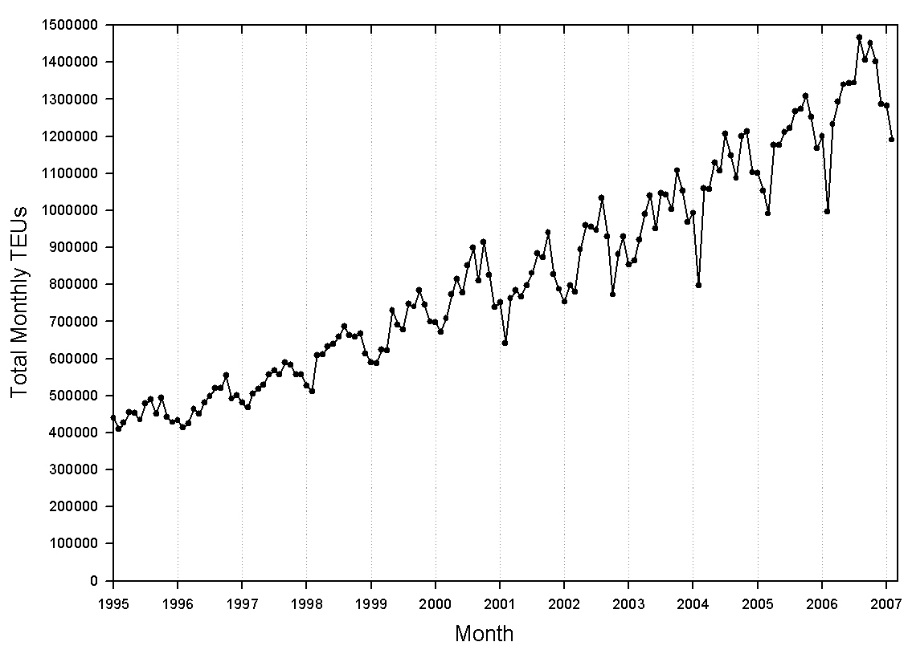
Source: Port of Los Angeles (2006); Port of Long Beach (2006)
Figure 2. Study Intersections, Wilmington and West Long Beach.
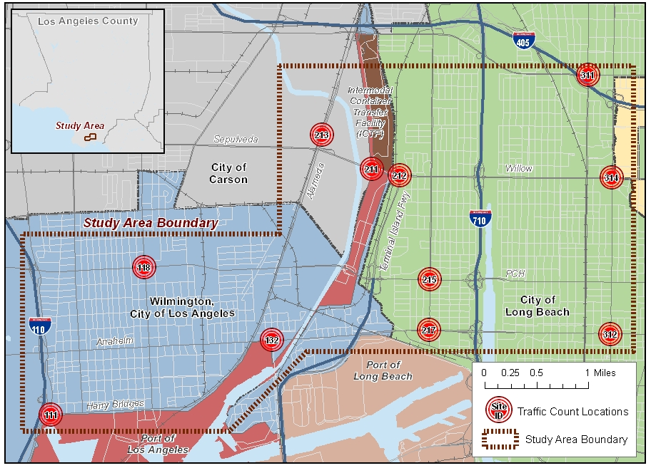
Figure 3. Diurnal Patterns of Measured Port Diesel Traffic.
(a) Intersection Level Counts, Hour Collection Period (b) Intersection Level Counts, 30-Minute Collection Period
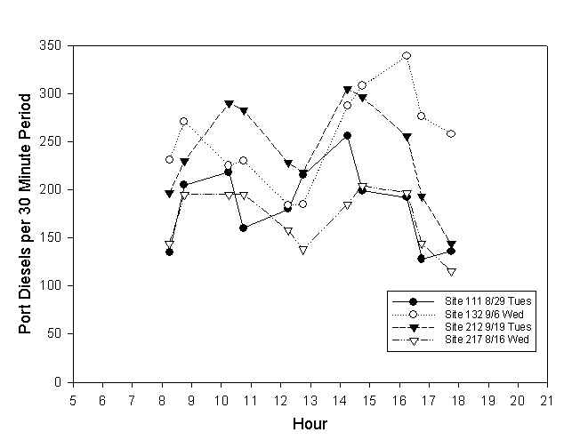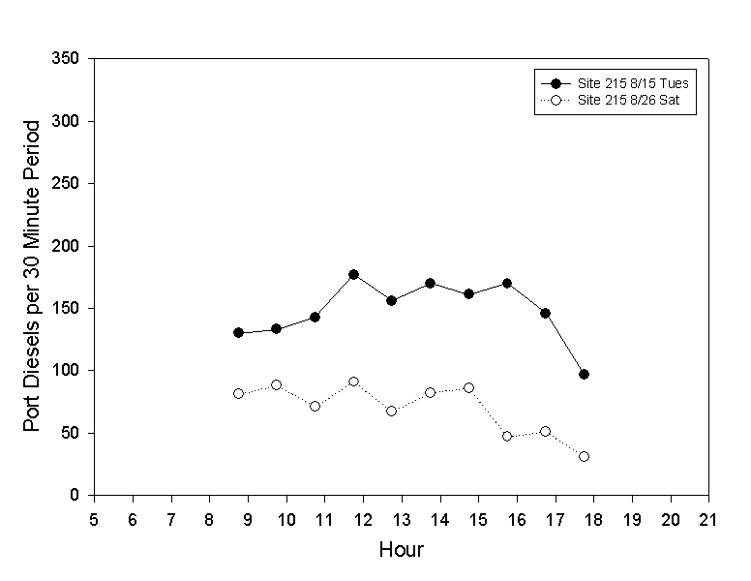
(c) Segment Level Counts, Hour Collection Period
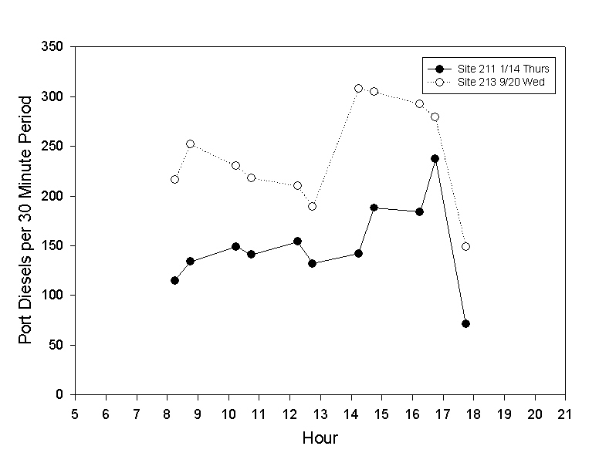
Figure 4. Five-axle Trucks on the 710 Freeway, by Weekday and Weekend in 2001-02.
8/15/01-9/19/01 8/15/02-9/19/02
