Climate change impact as a constraint to the air transport growth
The European case

Dr. Arturo Benito
Head of Air Transport Department, Polytechnic University of Madrid
Plaza del Cardenal Cisneros 3, 28040 Madrid, Spain

Abstract

The publication of the report Aviation and the global atmosphere (IPCC, 1999) set up the basis for the knowledge of aviation contribution to climate change and instituted a consensus on the need of control those effects. However, different management procedures are presently being discussed, most of them with a potential of seriously affecting future air transport development.

This paper discusses the effect on air transport growth of different alternative actions to control aviation climate change impact. Three scenarios are considered: a) No specific action; b) A number of market-based options is introduced in order to externalise climate change environmental cost; c) Measures are adopted to promote competition by other transport modes. A numerical application is made in the European area, for the 2000 – 2025 period. In each one of the scenarios, the variation of climate change impact is compared with the traffic evolution and the economic effects on the industry. In conclusion, emissions trading appear as the only alternative that makes compatible the control of aviation greenhouse emissions and a reasonable offer of air services to the travelling people.

1. About Climate Change

Official recognition about the convenience of taking action on climate change, a phenomenon researched by meteorologists since the early sixties, was issued in the 1972 United Nations Conference on Human Environment. The first World Climate Conference, a specialised meeting on this subject, was held in 1979. The general agreement on the need of a permanent body to lead the monitoring and research on climate evolution, took to the creation, in 1988, of the Intergovernmental Panel on Climate Change (IPCC).

Four years later, Climate Change control achieved legal international status. The United Nations Framework Convention on Climate Change (UNFCCC) was one of the three Conventions adopted at the 1992 “Rio Earth Summit”, with the goal of preventing dangerous human interference with the climate system. The Convention entered into force on 21st of March, 1994, and has been ratified by 189 countries. It sets an overall framework for intergovernmental efforts to tackle the challenge posed by climate change.

In December 1997 the parties of the UNFCCC agreed on the Kyoto Protocol text, identifying six substances (CO_{2,} CH₄, N₂O, HFC, PFC, SF₆) as greenhouse gases, contributing to climate warming, and establishing targets to be reached by developed countries, in order to reduce the emission of greenhouse gases up to the end of the year 2012. The objective was that developed countries (listed in Annex B of the Protocol) reduce their greenhouse emissions by 5% with respect to 1990 levels. This target would become mandatory, for countries ratifying the Protocol, at the moment that ratifications would come to represent 55% of the United Nations countries and 55% of global greenhouse emissions. Following the Russian Government ratification, the Kyoto Protocol entered into force on February 16, 2005, with the relevant absences of United States and Australia (Benito, 2005).

2. Aviation and Climate Change

The Kyoto Protocol provisions cover aviation in two different ways. Domestic aviation emissions are included in the national inventories. Then, those developed countries included in Annex B to the Protocol must take into account internal flights emissions in their national reduction targets.

International aviation had other different problems. First, allocation to national inventories was difficult because many flights not only cross several countries airspace but also move through international skies, out of the sovereignty of any country. Secondly, there is no clear cut between national and international services, all of them carried out by the same aircraft and airlines. Thirdly, most international agreements exempt international aviation kerosene of any tax, as the rest of international flights supplies.

Unable to find an agreement, the signatories of the Protocol decided to entitle International Civil Aviation Organisation (ICAO) with the task of proposing ways and means for dealing with greenhouse emissions from international aviation (Article 2, paragraph 2 of the Protocol). The International Maritime Organization (IMO) received a similar mandate.

In 1998, as a consequence of Kyoto’s mandate, ICAO committed IPCC (Intergovernmental Panel on Climate Change) to prepared a comprehensive study of the effects of worldwide activities on the atmosphere, putting together a wide range of talents from scientific, industrial and rule-making communities. The study, titled “Aviation and the global Atmosphere” (IPCC, 1999) covered not only the effects of air operations and their future expectative, but also the manufacturers development projects and academic research programs. The main conclusions of the report estimated the aviation share of anthropogenic climate change impact to be about 3.5% in the most probable case, with wide margins of incertitude, ranging between 0.7 and 7%, but taking into account that the air transport is forecasted to grow faster than global economy, its share might increase up to 5% in 2050, for the central scenario.

That report also discusses which ones of the aviation emission products may have greenhouse effects. Carbon dioxide is the only one included among the six Kyoto Protocol products but there are others substances that might have indirect effects, like NO_{x}, water vapour and soot (warming effect) or sulphates (cooling). In addition, aircraft at cruise altitude may originate contrails and collaborate to cirrus clouds formation, both being warming elements.

The level of scientific knowledge of those effects goes from fair to poor, with the only exemption of CO₂, a well known substance with an average life as high as 100 years, then causing a cumulative result. Other elements have a much shorter life, making difficult a comprehensive computation. The IPCC report took 1992 as base year for calculating global aviation climate impact, measuring all agents in a compound, non-time related parameter called Radiative Forcing expressed in Wm⁻². Several reviews of the aviation impact were made in 2004 (Sausen, 2005), changing slightly the influence of the different factors, but arriving to a Radiative Force value of 48 mWm⁻², practically identical to the 1992 one (Fig. 1), in spite of the elapsed eight years.

3. Basic traffic forecast

The growth of commercial aviation after the end of the Second World War can be seen in the Figure 2. Impressive as it is, the growth rate has gone diminishing along the time, as corresponds for a mature economic activity, arriving to a relatively stable value of 5% per year, maintained even during the 2001 – 2005 period, marked by the September 11 attacks. In the year 2005, world air passenger traffic surpassed for the first time the figure of 2,000 millions of air trips.

Air transport is an industry tightly linked to the economy evolution and has suffered the consequences of the cyclic movements of the World GNP during the last 35 years. Recent traffic forecasts assume that this trend is going to continue, with robust traffic increase in the new emergent economic areas, the so called BRIC zone (Brazil, Russia, India and China), and moderate growth in more mature economies like United States, Japan and Western Europe. General consensus, shown in manufacturers’ forecasts (Boeing, 2006, Rolls-Royce, 2006, and Airbus 2006), considers a most probable value of 4.5 – 5% annual mean growth of passenger traffic in the period 2005-2025, with a slightly higher figure for freight, in the order of 6 – 6.5%. For the purpose of this paper a world mean value of 5% for the combined passenger and freight traffic has been adopted.

A second forecast needs to be established for translating that traffic increase into emissions growth. It can be done on the basis of historical experience, according to the existing research and development programs or with a mix of both. Existing literature uses to accept the figure of 1% annual improvement in specific fuel consumption, equivalent to the same CO₂ reduction per unit of payload. The source of that hypothesis is unclear. Current statistics of kerosene consumption (International Energy Agency, fuel suppliers, airport authorities) are not related with the Revenue ton-kilometre (RTK) generated and mix all kind of flights.

In the year 2000 the International Air Transport Association (IATA) started a program to investigate the relationship between burned kerosene and commercial RTK, starting from a projection of the existing models. The comparison between theoretical and empirical evidence (Figure 3) shows a faster improvement, in the order of 2.2% during the six years with available data, (IATA, 2006).

Looking at the research programs carried on by United States and the European Union, both NASA and ASD are looking for a 35-45% improvement in Specific Fuel Consumption for future aircraft models in the period 2001 – 2020, roughly 1.6 – 1.8% per year (ICCAIA, 2005). This number is additive to other improvements in the infrastructure elements and in airline operations. ICAO evaluates the potential savings by ATC improvements in 5 – 10% (Figure 4), with a 6% sensibly achievable before 2020.

A second improvement element is the increase in revenue payload of the world airlines. It is driven by two elements: higher load factors and the installation of more seats in the aircraft. The last factor is stressed by the surge of low cost carriers, with a very high seat density. This not only translates in better specific fuel consumption per Revenue passenger-kilometre (RPK) but also forces to traditional airlines to do the same, in order to obtain lower cost per seat. It is interesting to notice that, while new technology aircraft introduction improves efficiency by replacing old models, increasing seating density affects to all the fleet, either new or aged aircraft.

In total, this paper uses the value of 2% average specific fuel consumption improvement per year. As a consequence, the annual increase of worldwide CO₂ emissions, corresponding to a 5% traffic increase, will be about 3%.

Moving from CO₂ to total climate impact, it remains to evaluate the effect of the other aviation emissions with a potential warming effect and less complete scientific understanding. As it was shown in Figure 1, cirrus clouds and NO_{x} emissions are those with a greater warming potential but, in the case of the cirrus clouds, with the worst level of certainty. NO_{x} has a dual effect: increases radiative forcing by creating troposphere ozone and does the opposite by destroying methane. Composed effect is considered to be in the warming side.

While a number of stakeholders consider cirrus cloud formation as a process not enough understood for taking corrective measures, and believe engine certification is the best way to control NO_{x}, others suggest the whole impact might be covered by factoring CO₂ emissions. A range of factors between 1.5 and 2.5 have been recommended. The first approach may underestimate the climate effect of the aviation, but the second proposal links directly kerosene consumption with radiative forcing, something that has no rational behind. Inclusion of non-CO₂ effects in economic evaluations has a number of unsolved problems (Forster, Shine and Stuber, 2006). This paper refers only to CO₂ emissions, although it is fully understood that climate impact may be underestimated in this way.

4. Market based options

In its preliminary meetings dealing with this issue, ICAO Committee on Aviation Environmental Protection (CAEP) studied some measures to control aviation greenhouse emissions and identified a number of technical actions like reducing the fuel consumption of the new aircraft and engines, optimizing operational procedures and improving infrastructures (air navigation aids and airports) in order to be able to fly optimal tracks, and reduce delays and wasting of fuel due to congestion problems.

While all the ways are needed for achieving the goals, some of them, like new aircraft and infrastructure improvements, look like long term processes. In April 1998 CAEP agreed to create a new Group “to identify and evaluate the potential role of market based options, including emissions charges, fuel taxes, carbon offsets and emissions trading schemes”. Four possible courses of action were examined: Voluntary Agreements, Taxes, Charges and Emission Trading. Following Group’s recommendations, 34th and 35th ICAO Assemblies approved a resolution on Voluntary Agreements (a Template Agreement and Guidance document were endorsed) and considered that charges and emissions trading needed further analysis before taking action (ICAO, 2001). After that decision, Canada and Japan have signed voluntary agreements with their aviation industry, committing to implement a number of actions for reducing greenhouse emissions.

The charge/tax and emissions trading options were preliminary evaluated, by means of calculating the cost needed to achieve the same CO₂ reduction goal individually. The emissions trading alternative was divided in two cases. The first one allowed trade among airlines only (closed system), while the second (open system) included aviation activity in the general emission trading system with other economic sectors. The closed one proved to be unpractical because, in a growing environment, there were not enough sellers to support the market growth and the allowance price became a tax. The results of the charge/tax and open emissions trading alternatives can be seen in Table 1.

After the exercise, there was a general consensus on the superiority of an open emissions trading system with respect to the other market based options, both in terms of environmental efficiency (cost per reduced ton of CO₂) and preservation of the potential growth of the industry. However, some countries announced their intentions of retain the possibility of using also the charging option, considering the evident difficulties of implementing a worldwide emissions trading in the near future.

5. Evaluation of the limiting potential for the European air transport

In the European scenario, this paper examines the limiting potential of climate change impact in three cases: unconstrained growth, defined like the absence of any regulatory or infrastructure factor that may reduce the market growth potential, the inclusion of commercial aviation in the existing European Emissions Trading scheme and, last but not least, the application of a mixed tax/subsidy system to favour the transfer of a part of the air transport demand to surface transportation modes, in particular to car, buses or High Speed Trains. The temporal scope is the 20 years going since 2006 to 2025.

6.1. Unconstrained case
In the European region, the aviation forecasts are not very different from the rest of the world, although show growth rates lower than in less developed areas, due to higher level of maturation of the market. Some specialists believe that present traffic increases are based in the expansion of the so called Low Cost Carriers and will come back to a very modest growth as soon as these new entrants develop their full potential. The assumed traffic volume during the studied period, taken from Boeing forecast, can be seen in Table 2. The 4.5% yearly growth refers to all the flights departing or landing in Europe. Airbus figures are consistently one tenth of percent lower.

The payload increase in the European market has been taken from the forecast made by Rolls-Royce Company. Table 3 shows the results of adding the effect of increasing seating density to the expected higher load factors in the different world markets. In the European region the gains would be around 39% in these 20 years.

In spite of those moderate opinions, there are strong pressures by the European governments and by the public opinion in favour of adopting urgent measures to reduce greenhouse emissions from every source, including aviation. The European Union has unanimously ratified the Kyoto Protocol, and adopted a common emissions reduction target (frequently named as “the European bubble”) of minus 8%, with respect to 1990 levels. The distribution of that target, having into account the “per capita” emissions of each country and the initial allocation of allowances in the European Emission Trading scheme can be seen in the last column of Table 4.

The traffic growth assumed for this study (see Table 2) means that 2025 European air transport will be 2.4 times the 2005 one, assuming a global growth of 4.5% per year. On a first approach, infrastructure developments seem to be capable of coping with that traffic, thanks to a better use of medium and small size airports and the implementation of SESAR ATC program. However, it remains to be seen its climate change impact.

The increase in CO₂ will go along the traffic increase, corrected by the improvements coming from productivity gains (see Table 3 giving a 39% for Europe) and the specific fuel consumption enhancements:

E₂₀₂₅ = 20g E₂₀₀₅ /p sfch (6.1)

where E₂₀₂₅ and E₂₀₀₅ are the total CO₂ emissions in those years, g is the yearly traffic growth, p is the net productivity gain coming from payload improvements and sfch is the enhancement of specific fuel consumption achieved by the introduction of new aircraft, engines and ATC technology. The payload improvement increases the operating aircraft weight and needs to be corrected with additional fuel burn. Short and medium range routes may take away about 3% of this gain, while long range flights figure is close to 10%. European traffic mix in Table 2 is composed of 65% long range and 35% medium range, what gives a mean value of 7.55%.

The sfc correction is more debatable. Figure 4 shows the best estimation of the manufacturers about the technology achievements, but gives no clue about the diffusion speed of those improvements in the normal airline operation and the efficiency losses of passing from ideal conditions to the daily practice. Considering historical experience, it seems to take about 40 years to gain full advantage of new aircraft technology, by total replacement of the fleet and the transit from flight test to daily operation brings about 20% efficiency loss. In consequence, the goal value of 50% improvement has been reduced to 20% for the purposes of this study.

Introducing these numbers in (6.1), the increase of CO₂ emissions in the year 2025 with respect to the year 2005 will be about 56%, a sizeable reduction with respect to most estimations. If the Kyoto Protocol 1990 base year is taken into consideration, a 76% has to be added (EU Commission, 2006a), corresponding to the 1990 – 2005 period. In total, 175% increase, much higher than the 8% reduction in 2012 assigned by the Kyoto Protocol to the European Union.

6.2 Emissions trading case
Emissions trading schemes are very complex systems in which boundary conditions often heavily determine the economic results. Since 1st of January of 2005, the European Union has implemented an Emission Trading Scheme covering the CO₂ emissions from six of the most energy intensive stationary sources, producing almost half of total EU CO_{2.}

The European scheme (EU Commission, 2006a) sets an overall limit on total emissions and distributes to companies emission allowances related to this limit. Allowances are handed out for free. The amount is calculated as a high percentage (about 95%) of the forecasted emissions for the 2005-2007 trading period (Table 4). The balance needs to be achieved by efficiency improvements, bought in the carbon market or offset through the mechanisms provided by the Kyoto Protocol (Joint Implementation and Clean Development Mechanism). The first computation, closed at the end of 2005 and made public in May 2006, showed that participating companies made a good work and a large majority of them reached their targets without the need of buying additional allowances. One of the unexpected consequences was the drastic fall of CO₂ permit price in the international market from 30€ per ton to a minimum below 10€ (Figure 5). Allowances prices are now stabilised around 15 – 20€ per ton.

Adaptation of aviation, a mobile source, to the trading scheme requires a number of relevant decisions, like define the type of flights and period to be covered, the substances included in the scheme, who is the trading entity, how high is the emissions cap or how allowances are distributed. After having considered other proposed schemes and for the sake of simplicity, this paper discusses the potential effects of the draft Directive published last December by the European Commission (EU Commission, 2006b).

Main features of this system are as follows:
- Application will start on 1st of January 2011 for intra European flights. All flights departing or landing in an EU airport are included since 1st of January 2012
- The cap of allowances is based on the annual average of CO₂ aviation emissions during the 2004 – 2006 period. The largest part of them will be allocated by benchmarking (taking RTK per ton of emitted CO₂ as the efficiency parameter) and the balance will be auctioned. Member States will decide the total amount of allowances to be distributed
- Trading entities will be the airlines and each one will be controlled by one Member State
- Only CO₂ is covered. By the end of 2008 the Commission will put forward a proposal to address the nitrogen oxide emissions from aviation

Airlines are supposed to be net buyers of allowances due to two reasons: it is a growing industry and is technologically advanced. Then, the cost of the actions needed to save a CO₂ ton will be higher than the same savings in other economic sectors. The additional cost of buying allowances for growth will be a factor in the economic planning of new services. The draft Directive leaves open the cap of allowances that will determine the price to be paid by the airlines and, therefore, the additional cost and its repercussion on demand. The great question mark is how much of the allowances cost will be passed to the customer fare and how much will be internalised in the airline cost.

Most of the available economic analysis (Wit et al., 2005, PricewaterhouseCoopers, 2005 among others), are based on the hypothesis that full allowance cost is passed to the customers, with an immediate increase in fares and the corresponding decrease in demand totally dependent on price elasticity. The price elasticity of air transport demand has been subject of different analysis (Gillen, Morrison and Stewart, 2003). Table 5 listed some of the most recent results, showing a wide range of values, as expected when mixing business, holiday, ethnic and visiting friends and relatives traffic.

The capability of aviation industry of absorbing large kerosene price oscillations, as it has been proven during the last four years, generates some doubts about the pass of allowances cost to the fares. On the contrary, the generalised practice of applying fuel surcharges to the ticket prices might indicate a plausible way to pass allowances cost to the customer. This is the assumption made in this paper. Further hypothesis put the fuel cost as 25% of the total operating cost and the demand price elasticity as -1.1%. Five cases has been considered for the year 2025, with free allowances being 95% of the 2005 levels, and the allowance price going from 12€ per CO₂ ton to 120€. This last value is equivalent to double the present kerosene price, calculated as 1.5 USD/US gallon and 1€ = 1.3 USD.

The results are included in Table 6. If full cost increase is passed to passenger tickets, the estimated 4,063 million RPK for the year 2025 will be reduced between 2.75 and 27.50%. The basic 56% CO₂ increase with respect to 2005 is, therefore, reduced up to 13% minimum. Even in the most extreme case, it seems impossible to cap CO₂ emissions at 2005 levels, and then, the other Kyoto Protocol provisions, like Joint Implementation (JI) or Clean Development Mechanism (CDM), will be needed to compensate this growth.

The inclusion of air transport in the European Emission Trading scheme will bring some changes in the market, due to the buyer condition of the airlines. Allowance price is supposed to climb, having into account the relative importance of air transport needs in the total emissions pool. In 2005 the European Emissions Trading scheme covered 1,917 million ton of CO₂, while aviation might bring other 144 millions, about 7.5% more (EU Commission, 2006a). Allowance price increase will depend on the cap level, marking the amount of credits to be bought. Using some specific analysis (Yeo, 2006) it may be concluded that allowance price would increase between 25 and 40% in the 2005 conditions, putting the price around 20€ per ton. As it is not known the conditions to be imposed on this European market behind 2008, it is difficult to ascertain prices in that period.

6.3. Intermodal transfer
A line of action, looking like having many supporters, is to apply, regulatory, fiscal and/or financial measures to encourage the transfer of air traffic to surface transportation modes. The transfer would exclude individual vehicles because modern aircraft are more fuel efficient that average cars in the European roads. High Speed Train (HST) for passengers and freight trains for cargo, are the principal replacing means.

A key issue is to determine the accessible market for this transfer. The present experience teaches that, with the present fare differential, the market share of the HST versus the aircraft decreases with trip time (Figure 6). Nowadays, HST infrastructure cost is met by States, while air transport pays 100% of airports and ATC cost via charges. Notwithstanding, this balance might be more tilted to the train by additional charges on aviation, special subsidies to HST, or a combination of both, but no economic manoeuvres would be useful for routes too long for travelling HST, with low demand, not justifying the HST high capacity, or with no railway tracks, like islands or high ground areas (Janic, 2003).

The transferable market depends on the particular geography/demography of each country and the adopted transport policy by the governments. In the case of Europe, a realistic figure is about 10% of the intra-European traffic (ITA, 1991, IATA, 2002), representing only 3.6% of the global European aviation emissions. Other analysis, at state level, gives similar figures, changing country to country, according to the geographical configuration. In France the transferable market will be around 13% (Direction Générale de l’Aviation Civile, 2005), and in Spain 9% (Pérez del Campo et al., 1996).

Independently of any proposed transport policy to foster modal transfer, the size of this transferable market would be in the order of 5.2 million tons of CO₂ in 2005 and, all the rest the same, 8.1 million tons in 2025. This is roughly equivalent to the emission reduction obtained in the trading case of 12€ allowance price, and represents an ideal case in which 100% of this transferable market moves from airplane to train. No economic analysis of the incentive cost has been made.

7. Future developments

At the moment of writing this paper, the course of action is unclear and depends not only of the aviation related bodies like ICAO or EU DG Environment or Transport, but also on the international agreements on the post-Kyoto, that may cover from 2013 up to 2050.

In December 2006 the European Union Commission launched a Directive proposal for including aviation activities in the European emission trading scheme, starting in the year 2011. All flights departing or landing at an EU airport will be part of the system, since 1st of January 2012. An emission cap equivalent to the average CO₂ tons emitted during the years 2004-2006 will be enforced and airlines would need to buy emissions allowances in the market for the amount of CO₂ exceeding that cap. The proposed Directive would have to achieve the agreement of both Parliament and Council, a process that might take up to 24 months.

At the same time, the 36th ICAO General Assembly is expected to approve in autumn 2007 some recommendations, proposed during th CAEP/7 meeting, in February 2007 (ICAO, 2007), about the application of environmental charges and emission trading schemes to international aviation. Although ICAO considers unpractical the possibility of setting up a worldwide emissions trading scheme, administrated by the organisation itself, it feels appropriate that States going this way keep a common philosophy in the design and operation of the system.

The practical use of ICAO reccomendation seems limited, because consensus among all the participating countries is required before applying emissions trading. In the European Directive case, only European airline flights might be subject of the trading scheme, unless other countries agree on put their companies operation inside the system. At this moment USA, Canada and other states have strongly refused to do so.

With the present political situation in Europe and the accumulation of evidences on the fast development of climate change, it is very likely that the proposed Directive will be adopted, with more or less modifications. That will mean a more expensive air travel and a clear disadvantage for the European airline industry with respect to other world regions.

8. Conclusions

The European Union policy contemplates a wide array of actions to fight climate change by anthropogenic emissions. It is likely that EU will take measures on aviation activities without waiting the participation of other Annex B countries.

The analysis of the different possibilities for policy action examined in this paper offers the following conclusions:

- Application to air transport of the same emissions targets set for the individual EU States in completely unrealistic, because CO₂ emissions are forecasted to increase 56% over 2005 levels and 175% respect to the Kyoto base year 1990. However these figures are lower than current estimations, which do not properly account for efficiency improvements in the air transport system. The restriction of demand, via taxes or regulation, will pose a serious difficulty to the European economy competitivity and the well-being of the population.

- Environmental efficient modal transfer is only feasible to High Speed Train (passengers) and conventional railways (freight). Due to the special features of HST, the modal transfer potential is limited at about 4% of the 2025 emissions, at a very high investment cost.

- According to the results of the scenarios described in this paper, emissions trading appear like the only way of combining acceptable demand reduction impact and bearable economic penalties. A permit allowance price roughly equivalent to double present kerosene cost would limit CO₂ growth to 13% over 2005 levels. However the build-up of a system capable to keep a balance between economy and environment looks extremely complex and, probably, would require an initial proving period before arriving to its final configuration.
References
Airbus (2006) Global Market Forecast, Airbus S.A.S., Toulouse.

Benito, A. (2005) ‘Developing a national aviation emissions inventory for Emissions Trading application’, Proceedings of IX Air Transport Research Society World Conference, Rio de Janeiro, July 2005.

Boeing (2006) Current Market Outlook, Boeing Commercial Airplanes, Seattle.

Direction Générale de l’Aviation Civile (2005) Mitigation of aviation impact on climate change, DGAC, Paris.

EU Commission (2006a) ‘Europe & Emissions Trading’, Presentation to ICAO Council, November 2006, Montreal.

EU Commission (2006b) Proposal for a Directive of the European Parliament and the Council amending Directive 2003/87/EC so as to include aviation activities in the scheme for greenhouse gas emission allowance trading within the Community (Unofficial advanced version), Brussels.

Forster, P.M. de F., Shine, K.P. and Stuber, N. (2006) ‘It is premature to include non-CO₂ effects of aviation in emission trading schemes’ Atmospheric Environment, 40, pp. 1117-1121.

Gillen, D.W., Morrison, W. G. And Stewart, C. (2003) Air Travel Demand Elasticities: Concepts, Issues and Measurement, Department of Finance, Government of Canada, Ottawa.

IATA (2006) World Air Traffic Statistics, Geneva.

IATA Consultancy Services (2002) Air/Rail European Customer Survey, IATA, Geneva

ICAO (2001) ‘Analysis of market-based options for the reduction of CO₂ emissions from aviation with the AERO modelling system’, CAEP/5, FESG report, ICAO, Montreal.

ICAO (2007) ‘Guidance on emissions trading for aviation’, CAEP/7, IP/20, ICAO, Montreal.

ICCAIA (2005) ‘Reducing aviation emissions. The manufacturers’ perspective’. Presentation at ICAO Aviation Day on December 7, 2005, Montreal.

IPCC (1999) Aviation and the global atmosphere, Cambridge University Press, Cambridge.

ITA (1991) Rail/Air complementarity in Europe. The impact of High-Speed Train services, Institute de Transport Aérien, Paris

Janic, M. (2003) ‘The potential for modal substitution’ in Upham, P., Maugham, J., Raper, D. and Thomas, C. (ed) Towards sustainable aviation, Earthscan, London

Pérez del Campo et al. (1996) ‘Transporte y medio ambiente: intermodalidad’ Paper presented at III Congreso Nacional de Medio Ambiente, November 1996, Madrid.

PwC Economics (2005) Aviation Emissions and Policy instruments, PricewaterhouseCoopers, London.

Rolls-Royce (2006) Market Outlook 2006-2025, Rolls-Royce plc, Derby.

Sausen, R. et al. (2005) ‘Aviation radiative forcing in 2000: An update on IPCC (1999)’, Meteorologische Zeitschrift, Vol.14, No. 4, pp. 555-561.

Wit, R.C.N. et al. (2005) Giving wings to emission trading, CE Delft, Delft.

Yeo, D. (2006) ‘Aviation: impact on allowance prices’ Presentation to EU Aviation Working Group 16-17 February 2006, Department for Environment, Food and Rural Affairs (DEFRA), Brussels.

Table 1

CAEP/5 evaluation of different MBO

Targets: a) reduce in 2010 aviation C0₂ emissions 5% with respect 1990 levels

b) reduce 25% or 50% of forecasted growth to 2010

Tax  (USD/US Gallon) | Demand  (%) | Cost/RTK  (%) | Total annual cost (Billion USD) | CO₂  (%) | Target  achieved
0.70  1.51  5.45 | - 7.5  -14.3  - 33.5 | + 10.1  + 21.7  + 77.1 | 47.4  93.2  245.3 | - 9.3  -18.1  -40.1 | 25%  50%  - 5%

Open Emission Trading
Allowance price  (USD/CO₂ ton) | 5 USD | 15 USD | 25 USD | 45 USD | 100 USD
Demand (%) | - 0.5 | - 1.5 | - 2.5 | - 4.4 | - 9.1
Annual Cost  (billions USD) | 3.6 | 10.5 | 17.3 | 30.4 | 62.9
Target  achieved | - | - | 25% | 50% | - 5%

SOURCE: ICAO – CAEP/5

Table 2

Passenger Traffic Forecast (2005 – 2025)

Routes | 2005 (RPK x 10⁹ ) | 2005 (RPK x 10⁹ ) | ∆ %(annual)
Europe – Africa  Europe – Central America  Europe – China  Europe – Middle East  Europe – North America  Europe – Northeast Asia  Europe – South America  Europe – Southeast Asia  Europe – Southwest Asia  Intra – Europe  CIS – International  Intra – CIS | 112.5  79.6  60.1  78.5  387.7  60.9  69.7  110.6  43.0  557.2  65.5  55.8 | 298.6  184.7  196.6  204.4  935.0  188.1  215.1  282.6  130.3  1,087.5  180.6  159.9 | 5.0  7.8  6.1  4.9  4.5  5.8  5.8  4.8  5.7  3.4  5.2  5.4
Europe TOTAL | 1, 681.1 | 4,063.4 | 4.5
World TOTAL | 4,018 | 10,551 | 4.9

SOURCE: Boeing Current Market Outlook 2006
Table 3

Load factor & seating density productivity improvements
(all figures as %)

 | 2005 LF | 2025 LF | ASK/seat  Improvement | Seats/aircraft  Improvement | 2005 - 2025  Productivity  gain
Europe – Asia Pacific  Europe – Middle East & Africa  North America – Asia Pacific  North America – Europe  Within North America  Within Asia Pacific  Within China  Within Europe | 76.0  72.5  80.3  78.7  75.6  69.5  69.8  68.3 | 80.0  75.0  82.0  82.0  76.0  75.0  76.0  71.0 | 0.5  1.1  0.7  0.9  0.9  0.9  0.5  0.7 | 0.3  0.6  0.4  0.6  0.2  0.3  0.4  0.1 | 23.5  45.1  27.2  40.5  25.2  37.1  30.3  21.9
World TOTAL | 74.2 | 76.5 | 0.9 | 0.6 | 39.0

SOURCE: Rolls – Royce Market Outlook 2006 - 2025
Table 4

Trading Period 2005 – 07
(Indicative data based on national allocation plans approved by the European Commission)
 | Allocated CO2  Allowances  (million tons) | Share in EU  Allowances (%) | Kyoto target (%)
Austria  Belgium  Cyprus  Czech Republic  Denmark  Estonia  Finland  France  Germany  Greece  Hungary  Ireland  Italy  Latvia  Lithuania  Luxembourg  Malta  Netherlands  Poland  Portugal  Slovakia  Slovenia  Spain  Sweden  UK | 99.0  188.8  16.98  292.80  100.50  56.85  136.50  469.50  1,497.00  223.20  93.80  67.00  697.50  13.70  36.80  10.070  8.83  285.90  717.30  114.50  91.50  26.30  523.30  68.70  736.00 | 1.5  2.9  0.3  4.4  1.5  0.9  2.1  7.1  22.8  3.4  1.4  1.0  10.6  0.2  0.6  0.2  0.1  4.3  10.9  1.7  1.4  0.4  8.0  1.1  11.2 | - 13.0 (² )  - 7.5 (² )  -  - 8.0  21.0 (² )  - 8.0  0 (² )  0 (² )  - 21.0 (² )  + 25.0  - 6.0  + 13.0  - 6.5  - 8.0  - 8.0  - 28.0 (² )  -  - 6.0 (² )  - 6.0  + 27.0 (² )  - 8.0  - 8.0  + 15.0  + 4.0 (² )  - 12.5 (² )
Total | 6,572.40 | 100.0
SOURCE: EU Commission
Table 5

Review of Demand Elasticity studies

Market segment | Number of  estimates | Range | Mean value
Long – haul int. business  Long – haul int. leisure  Long – haul dom. business  Long – haul dom. leisure  Short – haul business  Short – haul leisure | 16  49  26  6  16  16 | - 0.48 to - 0.20  - 1.70 to - 0.56  - 1.43 to - 0.84  - 1.23 to - 0.79  - 0.78 to - 0.60  - 1.74 to - 1.29 | - 0.27  - 1.04  - 1.15  - 1.10  - 0.70  - 1.52

SOURCE: Gillen, Morrison and Stewart (2003)

Table 6

Emissions Trading application

Figure 1

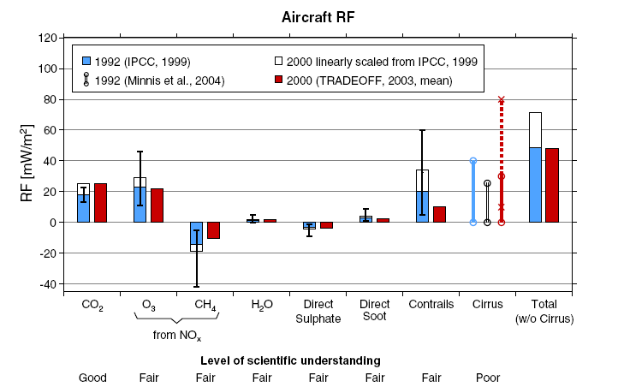

SOURCE: Sausen et al. (2005)

Figure 2

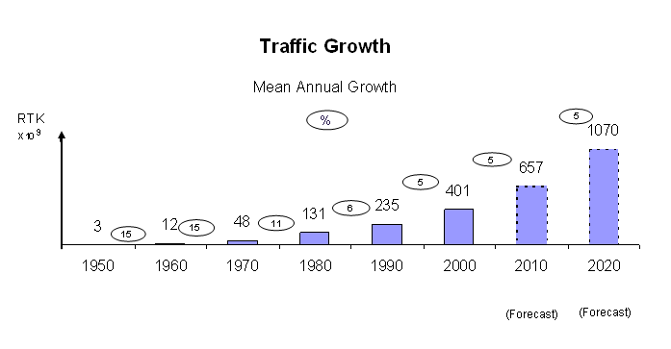

Figure 3

SOURCE: IATA – WATS (2006)

Figure 4

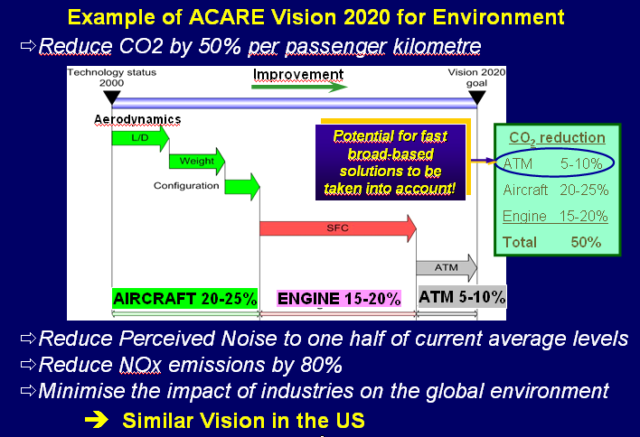

SOURCE: ICCAIA

Figure 5

Market evolution of the price of one CO₂ ton permit

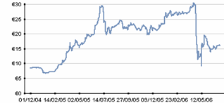

SOURCE: Point Carbon
Figure 6

HST versus aircraft market share

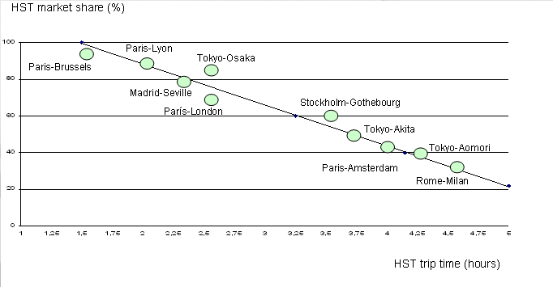

SOURCE: AEA

Corresponding author. Tel.: +3491 3366316 E-mail address: abenito@aero.upm.es
Annex B countries are: Australia, Austria, Belgium, Bulgaria, Canada, Czech Republic, Denmark, Estonia, Finland, France, Germany, Greece, Hungary, Iceland, Ireland, Italy, Japan, Latvia, Lichtenstein, Lithuania, Luxemburg, Monaco, Netherlands, Norway, New Zealand, Poland, Portugal, Romania, Russian Federation, Slovakia, Spain, Sweden, Switzerland, United Kingdom and United Status.

