Public Private Partnerships in Transportation:
Some Insights from the European Experience

Francesca Medda
Centre for Transport Studies
University College London
Gower Street, London WC1E 6BT
Tel. 0044 (20) 7679 1557
email: f.medda@ucl.ac.uk

Gianni Carbonaro
European Investment Bank
100 Bvd K.Adenauer
L-2950 Luxembourg
Tel: +352 4379 2761
g.carbonaro@eib.org

Abstract

Most EU member states and the European Commission regard the PPP as an important tool to attract additional financial resources for high priority investments such as transport. The objective of this paper is to delineate the EU panorama of PPP markets and investigate the impacts of the EU institutions in the development and success of this type of financial arrangement for the transport sector in Europe. We will examine how the scope of the PPP to capture efficiency gains should be weighed against the risks associated with PPP arrangements. These issues will be illustrated on the basis of a number of examples in the transport sector. We conclude by observing that the market for PPPs, although still fragmented nationally, is developing a European dimension and attracting resources from a variety of players.

1. Introduction

In most EU member states during the 1980s and 1990s we observe two specific tendencies: on one hand a growing dissatisfaction with the perceived performance of publicly financed and managed infrastructure, a continuous decline of public investments in relation to GDP, and the need in several member states to contain public budgets required by the monetary union. On the other hand we observe the necessity to improve competitiveness by investing in infrastructure in order to reach targets established by the Lisbon Agenda, and the necessity to reduce the significant social and economic disparities existing both between and within the member states. These two divergent tendencies have provided powerful incentives towards experimenting with alternative approaches for funding transportation infrastructure and service delivery. Pilot projects and concession financing and specific initiatives such as the Private Finance Initiative (PFI), rooted in the privatization/deregulation policies of the 1980s in the UK, have sparked widespread interest in various forms of private sector involvement that have been developed and applied widely in the transportation sector (Button, 2006; European Commission, 2005).

The 27 EU member states differ substantially in their social and economic structure and infrastructure endowment; this should already prepare us for the variety of approaches to infrastructure investment strategy and financing (DLA Piper, 2006; EIB, 2004). We need to keep in mind that member state governments are characterized by very diverse administrative cultures and capabilities and distinct legal and planning traditions. For instance, institutional diversity in the transport sector is considerable, with countries adopting different approaches with respect to user charges and ownership structures. Despite these differences, a framework for what are now referred to as PPPs (Private Public Partnerships) has emerged within the European Union.

Many definitions of a PPP have been presented in the literature, but two best capture the main characteristics of PPPs. The first was given by the UK Commission on PPPs and states that “a PPP is a risk-sharing relationship between the public and private sectors based upon a shared aspiration to bring about a desired public policy outcome” (Boeuf, 2003). According to a more overarching definition adopted by the European Commission, PPP refers to “forms of cooperation between public authorities and the world of business which aim to ensure the funding, construction, renovation, management or maintenance of an infrastructure or the provision of a service” (European Commission, 2004).

Most EU member states and the European Commission regard the PPP as an important tool to attract additional financial resources for high priority investments, such as transport. The objective of this paper is thus to delineate the EU panorama of PPP markets and to investigate the impacts of the EU institutions in the development and success of this type of financial arrangement for the transport sector in Europe.

2. The background – the 90s and after
Starting from the 1990s the European Union had two dominating objectives: the achievement of the Single Market and of the market integration; and the preparation for the European Monetary Union (EMU) (See Figure 1). To achieve these two objectives it was of prime concern to improve the physical integration among European countries and increase the accessibility of the peripheral regions, and therefore target the network infrastructures – energy, telecommunications, and transport. In this context the construction of transport Trans-European networks (TENs) assumed a critical role for European integration.
The TENs policy identifies 30 transnational transport axes on the basis of proposals from member states. “The European Union must aim to promote the development of Trans-European Networks as a key element for the creation of the Internal Market and the reinforcement of Economic and Social Cohesion. This development includes the interconnection and interoperability of national networks as well as access to such networks” (European Commission, 2005). However, by 2003 only one-third of the network had been built, and only three of the 14 specific projects, endorsed by the European Council at Essen in 1994, had been completed. The Trans-European network projects’ investment requirement in 1996-1997 was about €38 billion; however, at present, the financial resources needed to complete the network by 2010 are estimated at €400 billion (European Commission, 2005). For this reason, private sector finance is now considered to be essential for the successful implementation of TENs.
Moreover, in preparation for the European single currency, most member states were required to achieve macro-economic stability necessary to implement a monetary union. The Maastricht criteria were focussed on two key parameters: the public deficit to GDP and the public debt to GDP ratios, which were not expected to exceed, respectively, 3% and 60%. In practice in most countries, this compelled strict control of public expenditures in order to make credible moves towards achieving these parameters. This produced a striving towards innovative ways to finance public expenditures; in particular was the need to involve private sector investment (European Commission, 2004).

Figure 1. The relationship between Single Market, EMU and PPPs
Source: European Investment Bank

Although it is difficult to provide a clear-cut characterisation of the evolution of public works’ financing methods, given the variety of the initial conditions, we can nevertheless observe a shift away from conventional traditional models of transportation service delivery, (characterised by hierarchical decision structures, vertical integration in delivery, and relatively undiversified funding tools) to a more diversified landscape emerging in the 1990s and early 2000s.

- PPPs in Transport – some key features

Despite national differences, the rationale for developing a PPP approach from the vantage point of the public sector is based on similar considerations. First is the opportunity to attract additional financial resources through the involvement of the private sector in order to reduce pressure on public sector borrowing and facilitate closer control of capital-spending budgets. Efficiency gains are another key rational for the use of private finance and private sector skills, it is important to remember that these efficiency gains are not guaranteed, but depend very much on the structure and alignment of incentives in contracts (Standard and Poor’s, 2006). Linked to these gains is the possibility of inducing an efficient service management throughout the whole project life and achieving design optimality to ensure minimum life cycle costing – also in this case the contract design is essential. Additionally, one important justification for a PPP strategy is the transfer of risks from the public sector to the private sector. Risks are allocated to the party best able to manage them, and thus is the party which is able to minimize its costs.

Indirect effects induced by PPP policy are those related to improvements in public sector management. These are associated to the need for the public sector to correctly evaluate transport demand, road capacity and safety levels in ways that private sector parties are induced to achieve best practice in terms of project design, management, and technical innovation. Due to the diffusion of these innovative financing methods, the public sector benefits from the addition of new operators – for instance, specialists in construction and management in transport infrastructure – and new markets, such as the emergence of a bond market for transport infrastructure.

These variables will have to be weighed, however, against possible disadvantages. In particular the risk that, in the case of uncongested transport infrastructure, the user charges necessary to achieve financial sustainability may diverge substantially from the economically optimal price, which can represent a fraction of the price required for cost recovery. The approaches used in Europe has been various. In some cases, the decision has been to adopt shadow tolls (as in the SCUTs project in Portugal); others adopt a targeted approach in applying real tolls.

Another issue of concern is the funding cost and thus the PPP applicability. Recent unpublished research indicates that the ex-ante premium on private finance in road projects is significant and in line with the cost overruns in road projects often observed empirically (see for instance Flyberg, 2004). However, this observed increase in costs generally reflects that a higher funding cost is needed in order to compensate private investors for taking financial risk, which however, may be structured within an incentive mechanism in the PPP arrangement. Nonetheless, the judgment ultimately depends on whether in the PPP we achieve a reasonable and efficient evaluation along with allocation of risks to the private sector, and whether this risk allocation is appropriate from a welfare point of view.

Finally, it is well-recognized that the transaction cost of transport PPP agreements is higher compared to the transport projects supported by traditional financing mechanisms. The higher cost is due to high costs of negotiation and contracting and additional costs for monitoring and regulatory systems. However, standardisation has advanced considerably in EU countries, in particular countries with long experience of PPP projects, as in the UK, where the transaction costs have decreased over time (Beckers et al, 2005).

4. Strategic aspects of transport PPP’s - some illustrations

After the experience of a few toll-based estuary road crossing schemes, the DBFO model (Design Build Finance and Operate) was launched in the early 1990s in the United Kingdom as part of the Private Finance Initiative (PFI). Key features of the DBFO are the application of “shadow” rather than real tolls, and that the private party – normally a special purpose company – is responsible for the financing, design and construction of the project and its operation for a number of years. The solution of the shadow tolls was at that time very innovative. The Highway Agency, which is responsible for transportation planning, project prioritisation, and the selection of the company through a competitive tender, secures debt repayment and any return on shareholders’ funds. The decision to use shadow rather than real tolls was justified on economic grounds so that users would not be discouraged by the need to pay for road access, but also by the fact that imposing road tolls in the UK would have been excessively controversial and politically risky.

The risk transfer to the private sector was very high in the early examples, including not only traffic risk but also delay and civil unrest risks related to environmental and planning obligations. The so-called banding mechanism was devised essentially to facilitate financial engineering. The mechanism allows bidders to address traffic-related revenue risks by structuring their offer through variable unit payments – the traffic band – in order to achieve the revenue to match foreseen capital costs and maintenance costs. In a typical DBFO there would be four traffic bands with the upper band (applying when traffic exceeds a certain capacity) priced at 0, thereby putting a ceiling on the Highway Agency’s payment obligations. More recently, the payment mechanism has changed in ways that give more weight to availability than traffic capacity, particularly in infrastructure subject to intense competition, such as projects in urban road networks.

The DBFO approach evolved in various concession models in other European countries. The German road concession model was conceived in 1994 in order to allow off-balance sheet financing of transport infrastructure. The approach was essentially a pre-financing device, with very limited risk transfer, where the main risk transferred to the private party was construction risk, i.e. cost and time of completion, without any traffic risk. Apart from the possibility of off-balance sheet financing, the main advantage of this approach was that public payments would be easily tradeable on the financial market and provide an easy exit for the builder after construction, and additional liquidity to the road construction market.

In 2005 new financing models were introduced in Germany, by successive legislative amendments, more similar in substance to a private finance approach; these were the A-model and F-model of PPP. Under the A-model a private party can take the construction, operation and maintenance of a federal trunk road section for a period up to 30 years. The private investor receives funds from the public sector, part of which can be raised through the revenue from the HVG federal tolling system. Under the F-model which has been applied so far to schemes like tunnels and fixed crossings, real tolls can be applied. In both cases the maximum amount of public subsidy is limited to a percentage of the overall project cost.

A further example of application of the DBFO model to the transport sector was in Portugal where an impressive massive shadow toll programme, the SCUT, was launched in the late 1990s. However, by 2004 it became clear that shadow toll obligations for the public sector, estimated at € 660m per year by 2008, were becoming overbearing, and thus the government now plans to convert shadow tolls to real tolls. We will next examine three specific cases of PPP application in the European Union.

The Vasco de Gama bridge on the Tagus river is one the main projects of its kind recently implemented in Europe, with its 12km in length (18km with the connecting links to the trunk road network), 140m high central pylons and 47m vertical water clearance across the central span. As a key infrastructure for the Lisbon metropolitan area, it was built according to schedule and within cost, and opened to traffic in March 1998, in time for the Expo 98 universal exhibition (this was a key requirement in the concession agreement). The bridge is currently used by over 65000 vehicles per day. The strategic objectives were to reduce the congestion of the existing bridge, to stimulate development in the northern Lisbon and on the west of the metropolitan region (Montijo), to attract inward infrastructure investment to the city, and secure a funding structure. Despite the complexity of the project and the long preparation period, the need for a second river crossing was apparent since the mid-1970s, the execution of the concession proceeded smoothly, with the international tender in 1992, the selection of the concessionaire in 1994, contract signature in 1995, and works completed in 1998.

The cost was approximately € 900m, covered by shareholders funds for 12%, the Cohesion Fund for 36%, revenues from the existing bridge during construction for 7%, a loan from the European Investment Bank for 35% and other sources 10%. The project is an example of how revenue risk can be reduced by conferring to the private partner rights to an existing asset with consolidated revenue streams – in this case the existing 25th April Bridge – for the length of the concession period.

The Prado Carenage tunnel in Marseille is another remarkable example of early European project finance. It is an example of an “opportunistic” project which exploits an existing unused former rail tunnel which was converted for light vehicle use and was fully funded through private resources. Also in this case the public sector contributed to the project by conferring to the private party an existing asset. This was the first PPP project of this type in France and the first example of toll paying infrastructure within a city. The Marseille municipality was the conceding authority and the special purpose company was the Societe Marseillaise du Tunnel Prado-Carenage (SMTPC), comprised by construction companies and banks. Investment cost was approximately € 175m, funded 15% by shares and subordinated convertible debt, 85% long-term loans.

Work began in 1991 and the tunnel was in operation by 1993, five months earlier than expected. Public reaction, however, was unenthusiastic and, despite a 25% decrease in initial tolls, traffic remained well below the forecast (22000 vehicles per day vs 35000). Through a systematic marketing policy and diversified tariff policy, the traffic target was achieved in year 2000. The Prado Carenage tunnel is an interesting example of how difficult it is to assess traffic risk in an urban environment, since in this context users have access to alternative non-tolled routes. Therefore, the inappropriate traffic modelling in this case was one of the factors leading to substantial over-estimation of traffic and revenues.

The final example is the capacity increase of the access trunk roads to Madrid and the bypass routes around the metropolitan area for a length of 300 km. The overall cost of the concession was approximately €1.5 bn. This PPP project was comprised by three main concessions: the R4 towards the South and Andalusia; the R3 and R5 towards respectively, Valencia and Lisbon; and the R2 towards Guadalajara and Barcelona (Figure 3).
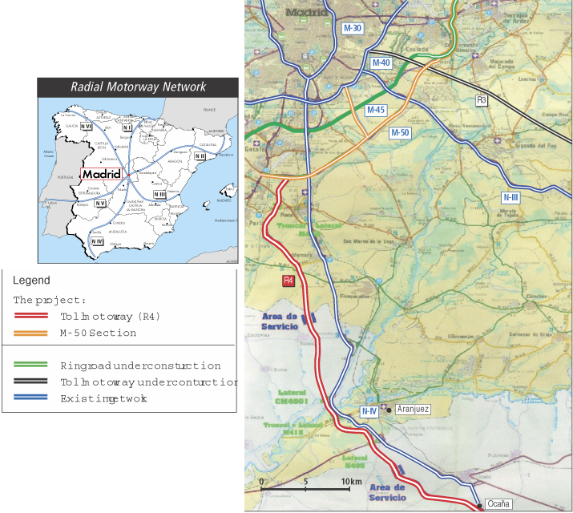
Figure 3. Madrid orbital roads

The broad principle in the Madrid PPP project was to structure the concessions in order to build a road system to include tolled and non-tolled sections; for instance the R-4 concession has two linked segments: a 50km toll road (the R-4 motorway proper) and a 46km non-tolled section of the Madrid orbital motorway (the M-50). Whereas the concession for the R-3 and R-5 motorways around Madrid includes 29kms of the M-50, which remains in government hands and has no tolls.

At this point we need to notice that, in the transport sector, the logic of “pure” project finance, with project revenues associated to user charges as the only support for investment, is not always easy to apply. It is well known that project benefits only partly translate into willingness to pay by final users. In fact, project benefits can spill into network benefits, which may be difficult to capture through revenue streams accruing to a conventional project vehicle. Additionally, traffic and revenues can easily be vulnerable to substantial competition.

5. Institutional diversity in Europe

Although almost all the counties in the EU use PPP arrangements, we have different ways of adopting this policy, due to different cultures and traditions in planning and management of public works, deficiencies in the legal and institutional structures, and political awareness and acceptance of the PPP concept. The UK has the longest and most substantial experience in PPP agreements; other countries have followed the British framework and developed pilot procurements for many years. The two main institutional frameworks are: (1) PPP unit at a central government level and (2) the promotion of PPP legislation. In relation to the PPP units, in certain cases these units have only a consultative capacity, as for example in Belgium, France and Estonia; in other cases, PPP units have a more active role in promoting and facilitating PPPs, in for example Ireland, and the Netherlands (See Table 1).

Table 1.
Member States | PPP Unit | PPP Law | Airport | Ports | Heavy Railway | Light Railway | Road
Austria | X | __ |  |  |  |  | 
Belgium | __ | __ |  |  |  |  | 
Cyprus | __ | __ |  |  |  |  | 
Czech Republic | X | --- |  |  |  |  | 
Denmark | X | __ |  |  |  |  | 
Estonia | __ | __ |  |  |  |  | 
France | __ | --- |  |  | 
Finland | __ | __ |  |  |  |  | 
Germany | X | __ | 
Greece | X | --- |  |  |  |  | 
Hungary | X | __ |  |  |  |  | 
Ireland | X | X |  |  |  |  | 
Italy | X | X |  |  |  |  | 
Latvia | X | --- |  |  |  |  | 
Lithuania | __ | __ |  |  |  | 
Luxembourg | __ | __ | 
Malta | X | __
Netherlands | X | --- |  |  |  |  | 
Poland | X | --- |  |  |  | 
Portugal | X | --- |  |  |  |  | 
Slovakia | __ | --- |  |  |  |  | 
Slovenia | __ | __
Spain | __ | X |  |  |  |  | 
Sweden | __ | __ |  |  |  |  | 
UK | X | __ |  |  |  |  | 
Legend
X : PPP unit existing/ PPP legislation in place
---: In some sectors specific legislation is in place
__: Legislation being proposed
 : Discussion on procurement ongoing
 : Substantial number of closed projects
: Projects in procurement
Source: PriceWaterhouseCoopers (2004)
Table 1 depicts the different experiences among European member states. Among transport investments, road is the most common under PPP agreements, however, only in the UK and Portugal have road PPP agreements had the sufficient depth to determine structural changes in the procurement procedure as well as significant macroeconomic impacts. In new member states, especially for the highway networks, additional investments are necessary due to the transition process, i.e. in order to satisfy EU standards. The World Bank (2002) has estimated € 65 bn over the next 15 years for infrastructure investment in the new member states, whereby Poland has the highest amount of infrastructure investment need (€ 21.4 bn).

There are several determinants related to each country’s PPP approach. One is the planning approach, with some countries applying rationalistic investment planning in transport more systematically than others. Here we observe countries without a strong rational planning tradition, such as Italy, where investment decisions have seldom been supported by master plans or cost-benefit analysis. Conversely, in the EU there are countries with a strong transportation planning tradition – which is either project-focussed on CBA, as in the United Kingdom – or focussed on strategic network development, as in France or the Netherlands.

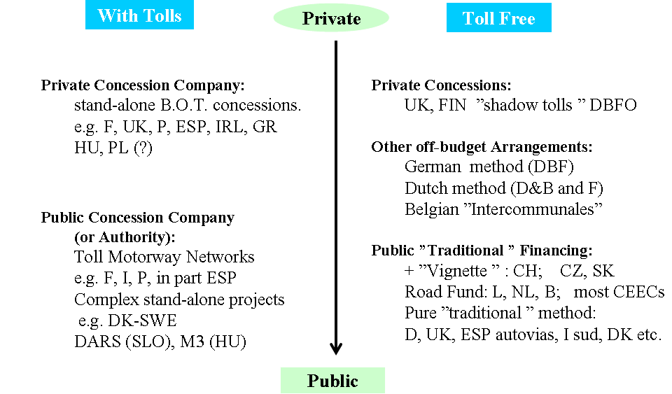
Figure 2. Institutional diversity in Europe
Source: Luigi Marcon, European Investment Bank

Figure 2 indicates various institutional arrangements in the European road sector. The figure presents a number of projects in two dimensions: on the horizontal axis is depicted the approach chosen for the user charges, and on the vertical axis the ownership of the transport infrastructure is indicated. Clearly, several funding strategies have been applied in Europe, in some cases within the same country. But we can certainly conclude that from the 1990s the movement has been from the traditional public provision to more private participation.

6. Conclusions

It is interesting to recall how a senior speaker from the English National Audit Office compared the preparation of project finance operations in the Private Finance Initiative to the art of preparing a “fugu” or moon fish, a very well-known delicacy in Japan. Apparently, the fish is a true delight, but it contains a powerful poison, and if it is not accurately prepared it will kill the unfortunate gourmand. The message here is that although PFI and in general PPP deals do not kill, if they are not well-structured they can cause considerable “pain” to careless public promoters. Several European transport PPPs have encountered problems, from the notorious Eurotunnel mega-project to failures such as the VAL-Orly urban rail connection, the Rostock tunnel, the northern orbital in Lyon, and the Sheffield Supertram, to mention a few.

The intransigent approach to project finance typical of the early generation of PFI projects in the United Kingdom, with its radical transfer of risks to the private sector and a negotiating attitude perceived as excessively antagonistic by private sector operators, has been replaced by a softer approach with more realistic assignment of risks to private parties. But more importantly now is the prevailing attitude which regards partnership as a long-term co-operative relationship for which renegotiation of contract terms is acceptable. The nature of the public sector contribution ranges from conferring assets and providing guarantees to contractual and regulatory measures.

The growth and structure of the European PPP market in the transport sector has been determined by several interlinked and mutually reinforcing factors that fall into two broad categories. The first relates to trends in the market for transport infrastructure services towards increasing integration on a continental scale. Not only have construction companies been consolidating into larger companies active in several countries, but transport operators too have extended their operations geographically.

The second category involves the policy and institutional environment, which has facilitated, stimulated and directed the PPP approach. The impact of the European Union has been threefold, of which the first are institutional and regulatory changes such as procurement directives aimed at harmonising the European market for concessions. Second, the EU has developed and disseminated “soft” instruments such as guidelines for PPPs, and promoted cross-national networks of PPP authorities. And third, the EU has promoted the Trans-European transport networks (TENs) and a number of large-scale cross-border projects. The Commission’s proposal to partly guarantee the debt incurred by private parties to fund cross-border sections of priority TEN projects may indeed encourage private investment through PPP agreements.

The result has been a market for PPPs that, although still fragmented nationally, is developing a European dimension and attracting resources from a variety of players. The European transport PPP market thus far can be regarded as an example of how integration may be pursued. It is a learning process in which the results are controversial, but the essential objectives are clear.

The main potential benefit of the PPP approach, in transport as well as in other sectors is its flexibility on adapting the structure of incentives and risk-sharing to the features of the project and to the economic and institutional environment. But because of this flexibility, it is perhaps unwise to seek a unique model of PPP that can be easily replicated across sectors and across countries. The choice context – PPP or conventional approach – is a multi-objective decision. And in practice the public sector agency has to achieve a judgment about the trade-offs between the various, sometimes conflicting, objectives.

For public sector promoters the difficult task is to avoid PPP transactions that end up as zero-sum games. An intelligent value for money analysis should be an essential step in reducing the probability of negative outcomes. Unfortunately, systematic value for money analysis is not part of the administrative practice in all European countries. However, particularly in the early phases of the process of creating a PPP market, where price signals for PPP transactions, e.g., cost and credit pricing signals, are not yet available, value for money should be seen as an essential step of good practice.

References
Beckers T., von Hirschhausen C., Klatt J.P. (2005). “Current PPP-Models for German Motorways”, Conference on Applied Infrastructure Research, Berlin University Of Technology, October 2005.

Boeuf P. (2003). “Public-private partnerships for transport infrastructure projects”, Transport Infrastructure Development for a Wider Europe Seminar, Paris 27-28 November 2003.

Button M. (Ed.) (2006). A Practical Guide to PPP in Europe. London: City & Financial Publishing.

Deloitte Touche (2006). Closing the Infrastructure Gap: The Role of Public-Private Partnerships. Deloitte Development LLC.

De Pierris L., Medda F. (2003) “Operatori e capitali privati nella realizzazione delle infrastrutture di pubblica utilità”, Economia italiana (3), 2003.

DLA Piper (2006). European PPP Report 2005. DLA Piper, February 2006.

European Commission (2004). Green Paper on public-private partnerships and Community law on public contracts and concessions. [COM(2004) 327 final].

European Commission (2005). The Trans-European Transport Networks
"TEN-T
European Investment Bank (2004). The EIB’s role in Public-Private Partnerships (PPPs). Luxembourg: European Investment Bank

Flyvbjerg B., Bruzelius N., Rothengatter W. (2003). Mega-projects and Risk. Cambridge: Cambridge University Press.

Gomez-Ibanez, J. A. (2003). Regulation of Private Infrastructure: Monopoly, Contracts,
and Discretion. Cambridge, Mass.: Harvard University Press

Guasch J. L. (2004). Granting and Renegotiating Infrastructure Concessions. Doing it Right. Washington, DC: The World Bank.

Johnson & Kramarik (2005). The Application of PPPs in the Financing of Transport Projects from EU Funds. Prague: Ministry of Transport of the Czech Republic.

Klein M., Neil R. (1994). “Back to the Future: The Potential in Infrastructure Privatization.” Public Policy for the Private Sector, n. 30, November.

Perez B. (2004). Achieving Public-private partnerships in the Transport Sector. Universe Inc.

Price Waterhouse Coopers (2004). Developing Public Private Partnerships in New Europe.

Standard and Poor’s (2006). Infrastructure Finance Ratings. Public Private Partnerships. Global Credit Survey 2006. London: Standard and Poor’s.

Turró M. (1999). Going Trans-European: Planning and Financing Transport Networks for Europe. Elsevier.

Turró M. (2006). “Financing perspectives for trans-European transport Networks”. Transportation Finance Review, London, Euromoney Publications.

