Submitted for the 2007 Meetings of the World Conference on Transportation Research (WCTR) in Berkeley, California, USA

Sources of Long-term Port Efficiency Changes:

Malmquist Total Factor Productivity for World Container Ports

(Main body of text: 7555 words)

*Please contact the corresponding author before citing the paper

SANGHYUN CHEON

Ph.D. Candidate

Department of City and Regional Planning

University of California at Berkeley

USA

Email: hcheon@berkeley.edu

DAVID E. DOWALL

Professor

Department of City and Regional Planning

University of California at Berkeley

USA

Dong-Wook Song

Reader in Logistics

Logistics Research Centre

Heriot-Watt University, Edinburgh

UK

April 30th, 2007

Abstract

During the 1990s the global seaport sector has experienced huge sums of port reform and rapid technological development. This paper attempts to systematically estimate efficiency changes of world seaports from 1991 to 2004. The concept of Malmquist Total Factor Productivity Index based on Data Envelopment Analysis (DEA) allows to measure changes in port efficiency and identifying sources of efficiency gains and losses. It also allows us to decompose efficiency change into the different sources: catch-up effect and frontier-shift effect. The results of analysis suggest the following: (1) scale efficiency mainly representing influences from external environments is still one of the important factors to shape port efficiency, while it is neither determining nor predominant. (2) Given the current globalized shipping market and scopes of port activities, the strategies to combine institutional restructuring and capital investment can suggest the potential to partly overcome the limitations of the external conditions. (3) However, the strategy focusing only on aggressive investment in technological progress has limitations in that it is relatively easier for other ports to replicate. Thereby, it could lack the possibility to increase relative efficiency and competitiveness.

Acknowledgement

We would like to thank the reviewers of the track, G3: “Transportation Deregulation and Privatization” and Professor Elizabeth Deakin at UC Berkeley for their helpful comments on this paper.
Introduction

Nations, regions, and localities are more and more embedded in global trading systems. From 1985 to 2000, world seaborne trade has increased annually (UNCTAD 2002). In the US, the share of Gross National Product (GNP) exported has doubled over the last two decades. Within the global systems, international trade policy and infrastructure becomes an extremely important element of economic development of nations. Poor performance of transport infrastructure produces excessive transport costs for many developing and developed countries. While the worldwide average freight costs is 6 per cent of import value, some land- or sea-locked countries with unfavorable transport infrastructure conditions bear the costs of 12 to 40 percent of import (UNCTAD 2001; 2003).

Ports provide the direct linkage from international to regional or local transport systems. The current level of global interactions demands seaports to achieve better productivity as a fundamental link in the overall trade chain so that surrounding localities can gain competitive advantage. There is thus a huge interest amongst port authorities in increasing port productivity. They need to effectively compete with other neighboring ports to deal with growing pressure from shippers for lower port and shipping charges. It is critical within this context to understand sources of port efficiency gains over short- and long-term. A continuous assessment of the port performance and productivity will allow policy makers to devise appropriate strategies for sustain a competitive edge in the global markets.

Few studies have thus far tried to quantitatively estimate changes in efficiency of world seaports during the last decades during which time substantial institutional changes have been realized in the global container port industry. Moreover, it has been rarely discussed what the sources of efficiency gains or losses can be attributed to. This paper attempts to systematically estimate efficiency changes of world seaports from 1991 to 2004. This paper is organized as follows: Firstly, a brief background of this study and the concept of efficiency change measurement are reviewed. Secondly, methodology and data are described. Thirdly, the results of analysis are presented mainly focusing on total factor productivity change for world major ports during the last decade. Finally, this paper discusses different sources of efficiency changes for the ports and typifies 10 different ways of achieving efficiency changes based on the port conditions.

Measuring Port Efficiency Change

Among practitioners like policy makers, port managers, and terminal operators, the analysis of port efficiency and its changes have revolved around partial productivity indicators in the past (e.g. Australian Bureau of Industry Economics, 1993; Australian Productivity Council-Productivity, 1998). Yet, as interest in analyzing efficiency has grown, it has been realized that this type of index is too simple to reflect the real process of port production, representing limited view and conflicting aspects on port productivity. In order to resolve analytically inconsistent results from partial indicators, the concept of total factor productivity began to be applied based on multiple inputs and outputs. While a few different methods (e.g. Stochastic Frontier Production Function; Data Envelopment Analysis) have been proposed and applied, the main idea is predicated on the concept that efficient firms are operating on the production frontier (Farrell, 1957; Cooper et al., 2004).

The concept of Malmquist Total Factor Productivity Index, or Malmquist Productivity Index (MPI) allows to measure changes in port efficiency and identifying sources of efficiency gains and losses. MPI can be estimated based on multiple applications of Data Envelopment Analysis (DEA) to benchmark ports’ efficiency between two different time periods. The basic idea is that if efficiency change has occurred over the long period, temporal changes in efficiency can be attributed to two different sources related to port conditions, planning, and management. These are: (a) frontier shift effects and (b) catch-up effects (Nishimizu & Page, 1982; Grifell & Lovell, 1993; Estache et al., 2004).

On the one hand, the frontier shift effect, represented by the shift of the productive efficiency frontier in a production function, can occur because of such significant change as technological progress. Port efficiency gains from the frontier shift effects can come from the capacity to keep up with latest technologies that are possibly driven by various factors such as institutional reforms to increase (or by increasing) market competition. To keep abreast with new technology requires quite effective long-term strategic planning and timely capital investment at a port and policy making level.

The catch-up effect, on the other hand, is also referred to as technical efficiency change that can be represented by a port’s movement along the production frontiers, which is possible even within a relatively short period of time. The catch-up effect is so termed since the concept implies the capacity of ports to managerially follow best practices in order to operate on the frontiers at any point in time. The efficiency gains caused by the catch-up effect can be mainly attributed to managerial capacity of ports to (a) respond to port demand by flexibly adjusting production scales (changes in scale efficiency) and to (b) adjust input factors timely (changes in ‘pure’ technical efficiency). Not only incentive changing policies but also many other management systems and conditions could possibly promote this sort of behavioral change.

The period this paper is interested in measuring efficiency change is 1991 to 2004 when the global seaport sector during this period has experienced huge sums of port reform and rapid technological development. Since it is quite a long term period, it is reasonable to consider the decomposition of efficiency change into the different sources above stated. It is therefore meaningful to adopt MPI to investigate the overall changes in port efficiency and to separate the efficiency change into different sources. The differentiation produces different policy implications as it identifies the sources of inefficiency of ports. For example, if a port does not efficiently utilize its existing assets and input factors, but tries to attribute its inefficiency to its level of technology and lack of long term capital investment, the result of these courses of actions would be creations of ineffective and unreasonable policies. In this perspective, examining the sources of inefficiency not only enriches efficiency benchmarking analysis but also eventually provides some foundations to further examine the influence of port institutions on port efficiency in later works.
Formal Concept of Index

The MPI index formally measures the total factor productivity (TFP) change between the two time periods. Originally, it calculates the ratio of the distances of data in each time period relative to a common technology. If technology in period t₁ is regarded as the reference technology and the base year for the comparison is period t0, the Malmquist TFP change index between period t₀ and t₁ is represented as the following:
, --- (1)
where represents the distance from the observation in period a to the period t₁ technology. A value of the above index greater than 1 indicates a percentage improvement in TFP during the two time periods, t₀ and t₁.

Fare et al. (1994) refines this index suggesting the alternative practice to avoid having to choose between technologies in periods t₀ and t₁. The alternative concept is based on the geometric mean of two indices that are comprised by two times of benchmarking of one period in comparison to another. The first is evaluated with respect to period t₁ technology and the second with respect to period t₀ technology:
--- (2)

Equation (2), represented by distance functions, can be mathematically rewritten as the following; that is represented by output-oriented efficiency scores (), since the efficiency scores are the ratios of distance in the production frontiers:
--- (3),
whererepresents output-oriented efficiency scores produced by the benchmarking of a Decision Making Unit in the year of in comparison to the year of .

Here, the part of (A) in equation (3) represents change in technical efficiency (catch-up effect) between periods t0 and t1, while (B) measures technological change (frontier shift effects) during the same periods. It has been argued that, in order to properly measure total factor productivity using this concept, constant returns to scale (CRS) distance functions are required. The reason is the following: A change in technical efficiency, representing the catch-up effect, consists of changes in scale efficiency and changes in non-scale technical efficiency, or ‘pure’ technical efficiency. As the DEA under Variable Returns to Scale (VRS) does not measure the impact of production scales on efficiency, the MPI with the VRS distance functions cannot measure change in scale efficiency (Fare et al., 1994). It thus leads to the misspecification of size of shift frontier effects.

By introducing some VRS DEA models, equation (2) or (3) can be turned into a more refined index in equation (4) (e.g. Fare et al., 1994; Zhu, 2003; Cooper, 2004) which has also been recently applied in a MPI study in the port sector (e.g. Estache et al., 2004).
--- (4)
where is output-oriented efficiency scores under VRS and is output-oriented efficiency scores under CRS.

In equation (4), the change in technical efficiency, (A) in equation (2), is separated into the change in ‘pure’ technical efficiency (A') and the change in scale efficiency (A"). Therefore, the index can clearly decompose total factor productivity change into three different sources: ‘pure’ technical efficiency change (A'), scale efficiency change (A"), and technological progress (B). The product between ‘pure’ technical efficiency change (A') and scale efficiency change (A") is called total technical efficiency change (TTEC), representing the catch-up effect. This separation is interesting especially because changes in scale efficiency of ports are often determined by the changes in external demand driven by the economic sizes and strengths of port hinterlands (Estache 2004). Port authorities and managers may not have strong control on these, while it is possible that port planning and strategic management still can do something about over the long term.

Data and Scope

The main goal of this analysis is to survey efficiency changes between 1991 and 2004 for 98 world scale container ports and major national gateway ports. In order to trace the change of port efficiency, we construct a time series database, basically including two years of information for each port: 1991 and 2004. The top 75 ports are firstly selected based on the throughput of 2001. Each of the 75 ports handled at least more than 800,000 TEU per year and their total accumulated throughputs approximately amounts to more than 75 % of a total of 245 millions of TEU handled by 533 container ports in the world. Secondly, data are collected for the largest ports in the countries that do not possess the top 75 ports in the world. The database can thus cover the fairly large scale container ports situated in almost countries. After eliminating some landlocked countries that do not have major seaports and some countries for which port data are not accessible, the data on a total of 138 ports were collected for the year 2004; 100 ports for 1991. The MPI was implemented with the 98 ports that have data on both years.

Economic theory implies that effective handling of container volumes depends largely on efficient use of port land, labor, and capital (Dowd and Leschine, 1990). Currently, information on port labor does not have reliable sources of data generally in the port sector. It is partly due to the fact that the structure of port labor is particularly complex, consisting of different types of full time jobs, part time positions, and contracted jobs, that are not directly managed and administered by port authorities. It is thus very difficult to trace all the information even in one port authority level. Especially when a study deploys large scale benchmarking frameworks across many regions, it is not possible to acquire reliable sources of labor information.

However, it has been recently claimed that port land and capital input such as berth and quay length, terminal area, and capacity of container cranes, directly affects container terminal efficiency (Notteboom et al., 2000) while labor can be measured through other capital input variables. Due to the considerable amount of collinearity, the number of workers in a dock can be proxied by the number of container cranes at a container terminal (Marconsult, 1994; Tongzon, 2005). Yet, Cullinane et al. (2004) states that, with the rapid development of manufacturing and transportation technology, new equipment, such as automated guided vehicle and automatic stacking cranes deployed at the container terminal yard, advanced ports are able to use lower numbers of port labor. Therefore, collinearity, or predetermined relationship, between port labor and container cranes observed in the past will not be necessarily static and continuously linear in the future. In spite of their intuition on the newly emerging relationship, they cannot successfully suggest new ways of measuring labor deployed in ports. Given the characteristics of container port production and the limitation of information, total container berth length (meter); container terminal area (square meters); capacity of container cranes (tonnage) including large quayside cranes and mobile cranes in container terminals, are selected for the proxies of factor input for container production.

There are also multiple outputs produced in a port. While contemporary ports diversify their production activities by integrating more logistics ability like manufacturing, packaging, and delivery into traditional cargo and vessel services, the main focus of large scale container ports is still organized around handling container volumes as much as possible. Moreover, the emphasis on efficient container handling has not weakened as ports seek diversification of their production but are strengthened more and more by trying to become a regional transshipment hub. In other words, the volume of containers handled may be a precondition that ports can develop other types of production activities by integrating new concepts of logistical capacity. Considering the focus of this study to benchmark world-scale and national gateway container ports, this study regards container volumes handled (total throughputs) at a port level as port output, with a unit of TEU handled.

As Cullinane et al. (2004) mention in their critique, the previous DEA analyses of container port efficiency can fluctuate over time; when time is not considered, port efficiency can be biased. In order to reduce the impacts of severe output fluctuation that may be caused by such unexpected external shock as labor dispute or severe weather conditions, we use the averages of three years for outputs to come up with throughput values for the two observation years, 1991 and 2004, respectively. In detail, to come up with the values of throughputs of 1991 for the ports in the sample, we use the average values of 1989, 1990, and 1991 for each port. For the values of throughputs of 2004, the averages of 2002, 2003, and 2004 were used.

The secondary data on port input and output are generally acquired from three different sources and were confirmed by cross-checking. The main source is acquired from Containerisation International-Online (CIO) for the year of 2004 data, and Containerisation International Yearbook (CIY) 1992 for the year of 1991 data. An attempt at confirming the data was made by examining another source of data from Ports and Terminals Guide (PTG) 2005. When there are unreasonable or missing figures in the CIY and CIO data, they were crosschecked with the PTG data. If the PTG data did not provide information needed to confirm the data, individual port websites and official were contacted to confirm the validity of information regarding port inputs and outputs. It is not unusual to have discrepancy on information among these three sources. When this is the case, the majority opinions are usually followed. If the majority opinions do not exist, showing a large scale of gaps among the three sources, the final data takes the median values of the three sources. The descriptive statistics of major input and output variables are summarized in Table 1.

(Table 1 here)

Results: Efficiency Change of World Ports, 1991-2004

Appendix 1 presents the changes in total factor productivity for the major world ports from 1991 and 2004. Overall, during the last decade, the world major hub and national gateway ports improve their efficiency by more than 2.4 times (Average MPI = 2.418). There are three outliers the port of Guangzhou (10.167), the port of Jawaharlal Nehru (12.754), and the port of Salalah (40.758), which show extremely high levels of efficiency changes compared to other ports during the period. Particularly, the port of Salalah achieved its improvement of total factor productivity mostly through changes in scale efficiency. When excluding the outliers, the other 95 ports improved their efficiency by more than 82% (Average MPI = 1.823) over the last decade (Table 2). Their sources of efficiency changes can be attributed to (1) 33.3% increase of ‘pure’ technical efficiency (TEC = 1.333), (2) 26% increase of scale efficiency (SEC = 1.262), and (3) 28.6% efficiency improvement due to technological progress (EFC = 1.286).

(Table 2 here)

Appendix 1 also shows that the majority of ports in the world improve their average total factor productivities (83 ports) from 1991 to 2004, while 15 ports have decreased their efficiency over the same period: Miami, Nagoya, Helsinki, Oakland, Keelung, Bangkok, Manila, Busan, Copenhagen, La Spezia, Fremantle, Houston, Lisbon, Piraeus, Kobe, Rijeka, and Buenos Aires. The problems of some ports above have been well known and reported. For example, port of Busan has recently experienced severe congestion problems in their container terminals. The port now hopes to resolve this problem by opening newly developed privatized terminals, and restructuring of port governing structures in the country with a scheme of corporatization. The port of Bangkok’s deterioration in efficiency could be caused by the port of Laem Chabang, located next to the port of Bangkok. As most volumes of container cargoes have been moving to the port of Laem Chabang, the old port, the port of Bangkok, is intended to focus more on general or bulk cargoes due to its traditional layouts of piers and berths. The port of Houston is the one of the largest oil ports in the world and its focus has been more and more oriented to handling liquid bulks, thereby it may reduce its efficiency in container handling. There are also some other Japanese, US, and Southern European ports which have experienced troubles in improving productivity. Finally, it seems that the port of Manila in the Philippines has not caught up to the higher levels of inter-port competition in the South Asian region.

Table 3 and Figure 1 illustrate clearly the relationships between MPI and three sources of efficiency change of ports.

(Table 3 here)

(Figure 1 here)

In addition to the correlation analysis in Table 3, to statistically examine the relative size of influence by the sources of efficiency on total factor productivity, an OLS regression is conducted with the three sources of efficiency changes as explanatory variables against MPI as a dependent variable. The result of OLS, Table 4, is an identity of equation (4), as it represents MPI through the linearized OLS. All variables are natural log-transformed to linearize the model (MPI = TEC X SEC X EFC). The descriptive statistics for the transformed variables are presented in Appendix 2.

(Table 4 here)

In Table 3 and Table 4, the changes in total factor productivity (MPI) are explained in a statistically meaningful way by all three sources of efficiency changes decomposed by MPI. According to the standardized coefficients of the OLS results, one unit change in the variance of pure technical efficiency have the strongest impact on the changes in total factor productivity.

Firstly, efficiency gains from non-scale technical efficiency have the stronger impacts on the improvement of overall productivity of ports (Pearson’s r = 0.588, see Table 3; , see Table 4). In addition, the standardized coefficient, 1.204 shows that one-unit change in the variance of ‘pure’ technical efficiency can lead to 1.2-unit change in the variance of total factor productivity. The stronger impact of non-scale technical efficiency rather than scale efficiency or technological progress implies that over the last decade, the improvement of port efficiency has been achieved by focusing more on increasing “pure” technical efficiency. In other words, what this analysis implies is that hinterland conditions is neither the strongest nor the single source of change in port inefficiency.

Non-scale technical efficiency can increase mainly by the courses of actions that improve the ability and flexibility to rationalize factor inputs in order to maximize port outputs. These can often be driven by adoptions of port reform efforts and better managerial practices to catch up other best practices. This result is at odds with a preconception that port efficiency is most likely shaped by the external demand for port services from hinterlands and thereby there is not much role for port authorities to play in terms of port management. While port throughputs may possibly be strongly influenced by external demand, improvement of port efficiency certainly requires larger roles of port long-term planning, strategic management, and effective market regulation to create institutional structures and incentives to introduce better port management.

Secondly, efficiency gains from the adjustment of port production scales also have substantial impacts on the improvement of overall productivity of ports, while the impacts are smaller than pure technical efficiency (Pearson’s r = 0.193, see Table 3; , see Table 4). The scale of port production and scale efficiency are strongly influenced by exogenous factors such as demand from hinterlands (Estache et al., 2004). Since they meet the necessary preconditions by which ports can possibly increase their outputs vis-à-vis the given inputs, large and strong hinterland economies are certainly one of the advantages for a port in achieving increased efficiency over the last years. The ports located remotely from the global production networks and shipping routes thus have obviously strong disadvantages in increasing their port efficiency. However, many larger scale ports operate at the size of decreasing returns to scale, which implies that the larger ports do not always reap the benefits of strong hinterland economies by properly sizing their production scales to improve their productivity levels.

Certainly here, the normative roles of ports need to be considered in the sense that ports in many parts of the world still aim to increase their total output levels rather than their efficiency. If they have been traditionally regarded as output maximizers as a way of sustaining regional trades rather than being efficiency maximizers, they have usually been allowed to enjoy the status of regional monopolists or national oligopolists. The business loss made by port authorities or the capital for long-term investment in port infrastructure has been compensated by tax revenues, since under this perspective, it is theoretically reasonable to use public resources based on the amount that a port generates economic externalities for the regions.

However, from a policy making point of view, it is not clear whether allowing the regional monopoly of a port is always an effective choice to achieve multiple but conflicting objectives: sustaining regional trade and effectively utilizing public resources. More often than not, the real issue is not a choice of what values policy makers select, but whether they can come up with appropriate amounts of the public resources to be spent to compensate and support the role of ports under regional monopoly. While their production costs may possibly be clearly estimated, the scopes of the benefits are much vaguer and geographically more disperse, and the social costs of allowing regional monopoly are clearly shown from their lack of interest in increasing productivity and changing the bureaucratic behaviors and organizational inertia.

In the past, the choice between the two conflicting values could be made by policy makers in the national or the upper-level governments that guide port authorities to follow the overall guidelines for managing and operating ports and terminals. However, given the increasingly fiercer competition in the contemporary global port sector, ports are asked to be equipped with the strong capacity to create and respond to the external demand as quickly and flexibly as possible in order not to lose their own competitive edge. Given the current market conditions, achieving the two conflicting objectives simultaneously becomes one of many necessary conditions for ports to sustain their competitive edge in many parts of the world. The strong abilities to analyze the medium-term market demand, monitor the current resources and assets, and match them to find the future gaps through marketing and supply chain management are certainly parts of the areas in strategic planning that port managers and authorities can work on in order to improve the medium-term scale efficiency.

Finally, with the strong influence of total technical efficiency (TEC plus SEC) on total factor productivity change (MPI), technological progress (EFC) also shows a statistically meaningful impact on changes in total factor productivity (MPI). Yet its size of impact on total factor productivity by changing one unit of variance in EFC amounts to approximately 45% of scale efficiency, see Table 4). Over the last few decades, the global port sector has experienced an amazingly rapid development in their container handling, managerial, and security technologies. For example, the port of Rotterdam maintains (non-human) automated driving container cranes that pick up containers from the yards to distribute them directly to rail-cars or trucks. And the recently developed diverse container scanning and monitoring technologies are sometimes argued to be something that could allow ports to improve not only productive efficiency but also cost efficiency eventually in the future. Certainly, ports like Singapore and Hong Kong have been one of conspicuous examples that have made strategic and aggressive capital investment in the most cutting-edge technology. And, more recently, the moves by the European ports such as the port of Rotterdam and the port of Antwerp have been impressive.

However, in terms of technology, many large-scale leading ports can speedily assimilate with each other by a relatively easier way of changing, or at least maintaining, the status quo, i.e. heavy capital investment in the new technology. The fact that the frontier shift effects among ports have a substantially smaller variance (see Appendix 2 and 3) than other sources of efficiency change would certainly imply the limitation of the sole dependence on this strategy. Obviously, the change of technology through strong capital investment may be much easier than changes of behaviors, institutions, or hinterland market conditions. However, an easier way of making changes has inherently low entry barriers so that others can copy the strategies and set up the environments more easily. In this sense, making technical progress does not necessarily become a substantially effective strategy but a minimum necessity when ports attempt to achieve port efficiency, competing with others for advantages in the global market.

This analysis shows that, while it is still one of the important factors in shaping port efficiency, the external environment does not always either a determining or predominant source that causes port inefficiency. This holds especially true if geographical conditions are similar so that the ports share fairly similar sizes of hinterlands and strengths of economies. Ports that have innovative management with emerging technology obviously have stronger potential to operate more efficiently in the long term. If the level of inter-port competition is fierce enough among the ports that share same hinterlands (e.g. Northern Europe), it is more probable that efficient management and technical progress play substantially stronger roles in improving efficiency of ports. Thereby it gives the ports the higher competitive edge in the current global seaport sector. The port of Dubai has been one of the examples of this for the last several years. Dubai has not only tried to formulate its strategy toward new port technologies, but also created new sections of markets by innovating their institutions and increasing the strategic capacity to prepare for and respond to the future demand. It may be unfortunate for the US port sector that the government rejected the deal of purchasing the former P&O terminals by the port of Dubai. This is so because the decision is not driven by economic advantages or disadvantages but mostly by the political dimensions of the deal, which may eventually prevent some US ports from overcoming their inefficiency.

Types of Efficiency Change

Let us turn to the discussion of what patterns of efficiency improvement have been realized during the temporal scope of this study and how ports are categorized into the typology. The analysis is predicated firstly on a statistical classification technique of Hierarchical Cluster Analysis. The methods of between linkages based on Squared Euclidean Distance Functions are used for estimating intervals between data points: technical efficiency change, scale efficiency change, and technological progress of 95 ports. Based on the distributional structure of these data for each port, the technique suggests the similarities and the difference of ports, thereby suggesting ranges of classification alternatives. In the next stage, more qualitative examinations are done though vector data mappings based on Geographic Information Systems (GIS) software, in order to more closely examine the similarities and differences of the ports in the clusters and to investigate the geographical distributions of efficiency improvement and the clusters. These two stages of quantitative and qualitative examination allow us to evaluate the fitness of ports categorized into the clusters and to partly adjust the original clusters to identify the following typology summarized in Table 5:

(Table 5 here)
Type I: Achieve Efficiency Improvement from All Three Sources
3 out of 98 ports in the sample are classified into this category. They show the patterns of productivity improvement from the all sources of efficiency decomposed by MPI. Their total factor productivity has increased by more than three times (average MPI =3.63) during the last decade, which is produced by interaction effects between technical efficiency, scale efficiency, and technological progress. Table 9 shows that Dubai, San Antonio and Port Sudan are included in this type.

Type II: Achieve Efficiency Improvement from both ‘Pure’ TEC and EFC
This type includes 11 ports that improved their overall total productivity (average MPI=2.80) mainly from non-scale technical efficiency and technological progress. The change in scale efficiency is relatively minimal ranging from a 5% decrease to a 17% increase. The average of MPI in this type is secondly ranked among the groups. It is interesting to find three Australian ports here: Melbourne, Sydney, and Brisbane as it shows that the Australian ports seeking port reform policy have been able to increase their total factor productivity mainly from technical efficiency improvement and technological progress, while they do not have had much change in scale efficiency.

Given the limitation of size of hinterland economies it may be reasonable for them not to flexibly change their scale efficiency. As shown in the previous analysis, due to a similar reason, the Australian ports have not yet achieved the same levels of relative efficiency with the best practice in the world. Yet it is here shown that their institutional reform efforts may result in some level of improvement in technical efficiency and technological progress. Port Kelang in Malaysia also has reaped productivity benefits from these two sources. It is possibly by they have sought substantial levels of port reform efforts over the past years, while the flexibility and improvement from scale efficiency could be limited given the severe competition with the port of Singapore and the highly competitive South Asian market.

Type III: Achieve Efficiency Improvement mainly from ‘Pure’ TEC
This type shows the patterns in which the major source of productivity improvement (average MPI = 2.52) should be attributed to changes in technical efficiency, while their scale efficiency changes and technological progress was relatively minimal, totaling from negative 10% to positive 20%, respectively. For example, some Chinese ports like Shanghai and Tianjin and the port of Genoa improved their non-scale technical efficiency by more than 2.5 times over the last decade. Other ports like Southampton also show the typical patterns of efficiency change in this group. Although the port of Honolulu shows patterns of efficiency change similar to ports in this group, the amount of change is substantially smaller than other ports in this group. The port of Jawaharlal Nehru and the port of Guangzhou, two of the outliers included in the analysis, achieve their improvement of efficiency from technical efficiency changes while other sources also show low rates of increase. They are thus classified in this group.

Type IV: Achieve Efficiency Improvement mainly from SEC
This class improves its total productivity (average MPI =2.51) by mainly increasing scale efficiency or a combination of scale efficiency and technological progress, while their ‘pure’ technical efficiency change only ranges from 0.9 to 1.2 approximately. The ports of Tacoma, Xiamen, Puerto Limon, and Belize City show the improvement of both scale efficiency and technological progress, while the ports of Antwerp and Tauranga show an emphasis on the improvement in scale efficiency. In increasing scale efficiency, ports that operated with increasing returns to scale (e.g. smaller ports) and decreasing returns to scale (e.g. larger ports) in 1991 may be successfully able to improve port efficiency by adjusting their production scales in 2004.

Type V. Achieve Efficiency Improvement mainly from EFC
The ports in this group improve their total productivity (average MPI =1.69) mainly from technological progress, while other sources of efficiency do not change much. The ports of Hong Kong, Singapore, Tokyo, Algeciras, and Auckland are included in this category. The traditional large-scale leading ports like Hong Kong and Singapore are included in this category since their levels of efficiency have been continuously the highest in the world. While the port of Auckland may be included in this category since the flexibility to improve scale efficiency is limited due to its relatively small hinterland; and its port reforms were implemented in 1987, which was earlier than the scope of data point in this study (Year 1991). The port of Tokyo may experience similar patterns of efficiency change. Their economic sanguinity in the hinterland has not grown impressively until recently, which leads to a lack of flexibility of changing scale efficiency and mostly makes the port depend on technological progress. The port of Algeciras in Spain also shows similar patterns to Tokyo while its overall MPI is higher.

Type VI. Compensate Deterioration in ‘Pure’ TEC by SEC
This category shows overall deterioration of non-scale efficiency while scale efficiency increased more than the rate of deterioration of non-scale efficiency. Relatively, this type includes many regional leading ports; 18 are included in this category such as the Ports of Rotterdam, Hamburg, Los Angeles, Long Beach, New York/New Jersey, Bremen/Bremerhaven, Felixstowe, Le Havre, Seattle, and Yokohama. In addition, while some ports simultaneously achieve some levels of technological progress ranging from 2% to 60%, the main feature of this category is the fact that they experienced deteriorations of their pure technical efficiency, TEC, ranging from 0.4 to 0.9. Thereby, the improvement of their scale efficiency (SEC: 1.2-2.5) is almost compensated, ending up with a generation of low medium levels of positive MPI, the improvement of total factor productivity, of less than 2. The exceptions to this are Hamburg and New York / New Jersey, which show higher levels of scale efficiency changes than others, thereby having a slightly higher MPI than 2. The port of Salalah, one of three outliers excluded in the analysis, is also categorized into this group. While it shows huge amounts of improvement in scale efficiency, its level of technical efficiency decreased overall. Therefore, even if its total MPI is ranked 1 among 98 ports, its efficiency gains mainly come from scale efficiency.

Type VII. Compensate Deterioration in SEC by ‘Pure’ TEC
This type has various levels of deterioration in scale efficiency while non-scale efficiency increased by more than the rates of deterioration in scale efficiency. As Table 7 presents, 7 ports are included in this category. While ports like Casablanca and Oranjestad also achieved some levels of technological progress ranging from 40 to 50%, this category is mostly characterized by the fact that they experienced deteriorations of their scale efficiency, which is mainly compensated by improvement in ‘pure’ technical efficiency. Thereby, the values of MPI end up ranging from 1.3 to 2.4. The only exception of this range of MPI is found from the port of Casablanca, showing MPI more than 4. Yet it has also experienced the deterioration of scale efficiency similarly to others in the group.

Type VIII. Compensate Deterioration of EFC by TEC/SEC
This group is characterized by the pattern that some levels of deterioration in technological progress are compensated by relatively smaller improvements of total technical efficiency, including both ‘pure’ technical efficiency and scale efficiency. This group includes 4 ports that have experienced small changes in the overall levels of all sources of efficiency. The 3 ports in Europe, Gothenburg, Gdynia, and Aarhus, show changes in total factor productivity of less than 1.9. The port of Mina Sulman in the Middle East only achieves an MPI higher than 2.0 due to relatively higher change in ‘pure’ technical efficiency (2.35) than other European ports in this group.

Type IX. Compensate Deterioration of TEC/SEC by EFC
The ports in this group mostly experienced low levels of deterioration in either technical efficiency or scale efficiency that are also compensated by relatively small improvements in total technological progress. So, the group consists of ports that have not experienced any severe changes in many ways: e.g. Charleston, Jacksonville, Tanjung Priok, Colombo, and Jeddah.

Type X. Not Able to Compensate Deterioration of TEC/SEC by EFC
The most conspicuous characteristic of the ports in this group is that they have had a large amount of deterioration of ‘pure’ technical efficiency, but have not compensated for the deterioration by technological progress. As briefly discussed previously, the port of Busan was one of the most efficient ports in 1991. Yet it was reported in the last few years as having severe congestion problems with their container berths. It now hopes to resolve this issue with newly opened privatized terminals and restructuring of ports with a new scheme of corporatization. The port of Bangkok’s deterioration of efficiency can be attributed to the newly opened the port of Laem Chabang that is located right next to it. As the new port focuses more on containerized cargoes, the port of Bangkok works more on general or bulk cargoes with a traditional layout of piers and berths. Some other Japanese, US, and Southern European ports are also included in this group. Finally, the port of Manila shows deterioration in all of the three sources, not catching up the higher levels of inter-port competition in the South Asian market

Finally, while the specific port by port characteristics are discussed above, the broader regional trends can be generalized to some degree. As is shown in Appendix 3, the overall increase in total factor productivity is conspicuous in East Asia, the Middle East, Oceania, Central America, and some North African ports that are located closed to East Mediterranean and Red Sea. The major portions of ports in the Middle East and Central America show impressive improvement of ‘pure’ technical efficiency.

(Table 6 here)

In Asia, the change in scale efficiency plays little role in the Asian ports except the port of Xiamen. For technical efficiency change and technological progress show mixed impact on total factor productivity port by port, showing relatively large standard deviations. While ports in Malaysia, India, and China show relatively high rates of increase in technical efficiency, others do not follow the best practice in the region. It is also possible to observe that technological progress in South Asia is relatively stronger than other regions. It is mainly because ports in Singapore, Hong Kong, and Malaysia closely followed or lead the practices in other continents through aggressive capital investment. In most South Asian countries, there has been little improvement in their regional economies, compared to those of North America or Europe. Even in the late 1990s some countries in the region experienced severe financial crises leading to the crumbling of the regional economies. Furthermore, they have a smaller size of regional economies compared to North America or Europe while the level of inter-port competition can be much higher due to the number of ports within the regions. In this context, it is therefore difficult for them to achieve an increase of total factor productivity by mainly depending on scale efficiency improvement. Given the context, the ports should compete with each other to increase technical efficiency to survive under the high levels of inter-port competition in the region.

In Europe, a combination of technological progress and scale efficiency change has mainly generated total factor productivity although some ports in the UK and the Northern Europe have improved their ‘pure’ technical efficiency. The size and strength of the European economies are much larger and stronger than the South Asian region. It is still possible for the European ports to enjoy flexibility and room to choose their production scales over the long term. In the mean time, many North European ports face severe inter-port competition. Their efforts should also be directed to increasing technical efficiency and aggressive capital investment for technological progress, while the index shows mixed results of their policies.

In North America, non-scale technical efficiency change has a minimal role as a source of efficiency changes. While the efficient frontier shift effect also sustains the changes in efficiency in the region, the improvement in scale efficiency has the largest source of efficiency. Given the circumstance that the region’s ports enjoy a larger size of hinterland areas and accessibility and stronger economies, it is reasonable that their efficiency improvement mostly depends on these two sources. Unlike the ports in North America, many ports in the Central America region enjoy the interacted effects among technical efficiency, technological progress, and scale efficiency by the order of influence on total factor productivity.

In Oceania and the Middle East, the total factor productivity changes are based on the improvement of ‘pure’ technical efficiency and technological progress. The statistics on Oceania in Table 6 are distorted due to the port of Fremantle in Australia that show significant decrease in technical efficiency which is partly compensated by scale efficiency change. Most of ports in the region depend mostly on the two sources. These regional characteristics of efficiency change, as previously discussed in detail, can be reflected by not only the economic limitations and geographical conditions but also the strategies and institutional reform efforts that ports adopted in their port policy and the ways of innovation in port technology and management.

Conclusion

This study conducts extensive analyses on productive efficiency change of world ports and decomposes the sources of efficiency changes over the last decade to investigate whether port strategies and institutional reforms can be seen as potentials to increase port efficiency vis-à-vis the larger environments that ports cannot control easily. Finally, it has also observed how different patterns of efficiency changes can be typified and how these are influenced by not just regional hinterland conditions, but also policies and strategies that many ports have sought to sustain within the paradigm of contemporary global port industry and to capture the emerging shipping markets.

The interesting points that these analyses demonstrate can be summarized by the following:
- Ports in the world have improved their efficiency over time due to technological progress, production scale adjustment, and improvement in management.
- Some of the most efficiently managed ports in the world can be found in Asia, Central America, and the Middle East, that recently have moved fast and been physically well-structured (e.g. Shanghai and Guangzhou) and some other Asian ports that have been traditionally managed quite efficiently (e.g. Hong Kong and Busan).
- Since there have been substantial levels of reform efforts in Australia and New Zealand, there are promises of improvement in their efficiency over the last decade.
- Although scale efficiency mainly representing influences from external environments is still one of the important factors to shape port efficiency, it is neither determining nor predominant.
- Therefore, for ports of fairly similar sizes and strengths of hinterland economies where levels of inter-port competition are fierce, the roles of efficient management, strategic capital investment and institutional restructuring and reform are not minimal but substantial for the operation of ports over the medium-long term. Given the current globalized shipping market and scopes of port activities, the strategies to combine institutional restructuring and capital investment can suggest the potential to partly overcome the limitations of the external conditions, as can be found from such examples as the port of Dubai and the port of Singapore.
- However, the strategy focusing only on aggressive investment in technological progress has limitations in that it is relatively easier for other ports to replicate. Thereby it could lack the possibility to increase relative efficiency and competitiveness.
- The regional and typified patterns of efficiency change of ports suggest that the characteristics of efficiency changes are influenced by advantages of market and hinterland conditions. Yet they have been also shaped by the strategic efforts to reap the benefits of these conditions and to combat with other ports by creating some supply-oriented strategies. These characteristics can be confirmed by the fact that many ports located in the regions having small hinterland accessibility and higher level of inter-port competition (e.g. Oceania, Middle East) tried to capture the efficiency improvement more aggressively by reforming their institutional and management practice rather than changing their scale of production.
- According to these characteristics and conditions, broader regional trends can be shaped and generalized to some degree, while the specific port by port characteristics still differ in many ways.

References:

Australian Bureau of Industry Economics. 1993. International Performance Indicators in the Waterfront, Research Report 47.

Banker, R. D., Charnes, A. and Cooper, W. W. 1984. “Some Models for Estimating Technical and Scale Inefficiencies in Data Envelopment Analysis,” Management Science, 30: 1078-1092.

Charnes, A., Cooper, W. W. and Rhodes, E. 1978. “Measuring the efficiency of decision making units,” European Journal of Operational Research, 2: 429-444.

Cooper, William W. Lawrence M. Seiford and Joe Zhu. 2004. Handbook on Data Envelopment Analysis. Boston / Dordrecht / London: Kluwer Academic Publishers.

Cullinane, Kevin Dong-Wook Song Ping Ji and Teng-Fei Wang. 2004. An application of DEA Windows analysis to container port production efficiency. Review of Network Economics 3, no. 2: 184-206.

Cullinane, Kevin, Ping Ji, and Tengfei Wang. 2005. “The relationship between privatization and DEA estimates of efficiency in the container port industry.” Journal of Economics and Business 57 (5): 433-462.

Dowd, T. J. and T. M. Leschine. 1990. Container terminal productivity: A perspective. Maritime Policy and Management 17: 107-12.

Estache, Antonio Beatriz Tovar de la Fe and Lourdes Trujillo. 2004. Sources of efficiency gains in port reform: a DEA decomposition of a Malmquist TFP index for Mexico . Utilities Policy 12, no. 4: 221-30.

Fare, R. S. Grosskopf and C. A. K. Lovell. 1994. Production Frontiers. Cambridge: Cambridge University Press.

Farrell, M. J. 1957. The measurement of productive efficiency. Journal of Royal Statistic Society A 120: 253-81.

Grifell, E. and C. A. K. Lovell. 1993. Deregulation and productivity decline: the case of Spanish saving banks. Department of Economics Working Paper 93-02. University of North Carolina.

Marconsult. 1994. Major Container Terminals Structure and Performances Report, Genova.

Martinez, E., R. Diaz, M. Navarro, and T. Ravelo. 1999. A study of the efficiency of Spanish port authorities using data envelopment analysis. International Journal of Transport Economics 2, 237-253.

Nishimizu, M. and J. Page. 1982. Total factor productivity growth, technological progress and technical efficiency change: dimensions of productivity change in Yugoslavia, 1965-78. Economic Journal 92: 920-936.

Notteboom, T. C. Coeck and J. van den Broeck. Measuring and Explaining the Relative Efficiency of Container Terminals by Means of Bayesian Stochastic Frontier Models. International Journal of Maritime Economics 2: 83-106.

Productivity Commission 1998, International Benchmarking of the Australian Waterfront, Research Report, AusInfo, Canberra, April.

Roll, Y. and Y. Hayuth. 1993. Port performance comparison applying data envelopment analysis (DEA). Maritime Policy and Management 20 (2), 153–161.

Tongzon, Jose. 2001. Efficiency measurement of selected Australian and other international ports using data envelopment analysis. Transportation Research Part A, 113–128.

Tongzon, Jose and Wu Heung. 2005. Port privatization, efficiency and competitiveness: Some empirical evidence from container ports (terminals). Transportation Research Part A 39, no. 5: 405-24.

UNCTAD. 2003. Efficient Transport and Trade Facilitation to Improve Participation by Developing Countries in International Trade. Geneva: Commission on Enterprise, Business Facilitation and Development.

UNCTAD. 2002. Review of Maritime Transport. New York and Geneva.

UNCTAD. 2001. Trade and Development. New York and Geneva: Transport Round-table in Brussels, Belgium.

Wang T., Song, D.W.. and Cullinane, K. 2002. “The Applicability of Data Envelopment Analysis to Efficiency Measurement of Container Ports,” Proceedings of the International Association of Maritime Economists Conference, Panama, 13-15 November.

Zhu, Joe. 2003. Quantitative Models For Performance Evaluation And Benchmarking. Boston / Dordrecht / London: Kluwer Academic Publishers.

Appendix 1. Malmquist Productivity Index: TFP Change from 1991 to 2004

PORT NAME | MPI | rank | Change in Technical Efficiency | rank | Change in Scale Efficiency | rank | Change in Technical progress | rank
Hong Kong | 2.119 | 33 | 1.000 | 51 | 1.238 | 33 | 1.711 | 4
Singapore | 1.638 | 50 | 0.902 | 57 | 1.179 | 41 | 1.541 | 15
Busan | 0.734 | 89 | 0.792 | 72 | 0.831 | 95 | 1.116 | 74
Kaohsiung | 1.712 | 46 | 1.217 | 38 | 1.276 | 27 | 1.103 | 77
Shanghai | 3.231 | 12 | 3.138 | 8 | 0.934 | 89 | 1.103 | 76
Rotterdam | 1.447 | 59 | 0.552 | 81 | 2.048 | 9 | 1.281 | 46
Los Angeles | 1.158 | 73 | 0.760 | 75 | 1.488 | 18 | 1.025 | 87
Hamburg | 2.009 | 37 | 0.815 | 70 | 2.055 | 8 | 1.200 | 59
Long Beach | 1.841 | 42 | 0.841 | 68 | 1.934 | 10 | 1.132 | 71
Antwerp | 2.234 | 28 | 1.022 | 49 | 1.855 | 12 | 1.179 | 63
Port Klang | 2.213 | 29 | 1.545 | 28 | 0.980 | 83 | 1.462 | 20
Dubai | 3.173 | 14 | 2.096 | 15 | 1.295 | 25 | 1.168 | 65
New York/New Jersey | 2.337 | 25 | 0.774 | 73 | 2.492 | 4 | 1.211 | 57
Bremen/Bremerhaven | 1.903 | 39 | 0.914 | 56 | 1.694 | 14 | 1.228 | 54
Felixstowe | 1.413 | 60 | 0.846 | 67 | 1.273 | 29 | 1.312 | 43
Tokyo | 1.361 | 62 | 1.088 | 45 | 1.019 | 70 | 1.228 | 55
Yokohama | 1.047 | 78 | 0.651 | 78 | 1.246 | 31 | 1.290 | 45
Manila | 0.774 | 88 | 0.876 | 59 | 0.914 | 90 | 0.966 | 93
Tanjung Priok | 1.065 | 76 | 0.867 | 60 | 0.951 | 84 | 1.293 | 44
Algeciras | 1.755 | 43 | 1.115 | 43 | 1.010 | 74 | 1.558 | 13
Kobe | 0.506 | 96 | 0.341 | 94 | 1.198 | 38 | 1.238 | 49
Tianjin | 4.647 | 5 | 4.207 | 5 | 0.945 | 86 | 1.169 | 64
Nagoya | 0.929 | 83 | 0.551 | 82 | 0.999 | 78 | 1.686 | 6
Keelung | 0.839 | 86 | 0.699 | 77 | 0.982 | 81 | 1.222 | 56
Guangzhou | 10.167 | 3 | 7.983 | 3 | 1.166 | 45 | 1.092 | 79
Colombo | 1.375 | 61 | 0.860 | 63 | 1.040 | 64 | 1.537 | 16
Oakland | 0.886 | 85 | 0.709 | 76 | 1.051 | 59 | 1.190 | 61
Charleston | 1.279 | 68 | 0.856 | 64 | 1.057 | 58 | 1.413 | 27
Genoa | 2.660 | 20 | 2.729 | 10 | 0.877 | 94 | 1.111 | 75
Le Havre | 1.471 | 57 | 0.985 | 54 | 1.441 | 21 | 1.036 | 86
Osaka | 2.249 | 27 | 1.816 | 23 | 1.006 | 75 | 1.231 | 51
Valencia | 1.347 | 64 | 1.358 | 33 | 0.884 | 93 | 1.123 | 72
Barcelona | 1.005 | 80 | 0.767 | 74 | 0.935 | 88 | 1.402 | 28
Tacoma | 1.730 | 45 | 1.068 | 46 | 1.319 | 24 | 1.228 | 53
Seattle | 1.114 | 74 | 0.846 | 66 | 1.141 | 48 | 1.154 | 67
Xiamen | 5.241 | 4 | 0.863 | 62 | 4.789 | 2 | 1.268 | 47
Melbourne | 2.464 | 21 | 1.562 | 27 | 1.145 | 47 | 1.378 | 33
Dalian | 1.051 | 77 | 0.637 | 79 | 1.540 | 16 | 1.072 | 83
Durban | 1.601 | 52 | 1.832 | 22 | 0.936 | 87 | 0.934 | 94
Jawaharlal Nehru | 12.754 | 2 | 8.868 | 1 | 1.204 | 36 | 1.194 | 60
Salalah | 40.778 | 1 | 0.542 | 83 | 52.907 | 1 | 1.421 | 25
Jeddah | 1.219 | 71 | 1.067 | 47 | 0.981 | 82 | 1.164 | 66
Piraeus | 0.512 | 95 | 0.404 | 91 | 1.192 | 39 | 1.062 | 84
Marsaxlokk | 3.281 | 10 | 2.070 | 16 | 1.035 | 66 | 1.531 | 17
Southampton | 2.151 | 30 | 1.907 | 18 | 1.032 | 67 | 1.093 | 78
Vancouver BC | 1.697 | 47 | 1.563 | 26 | 0.898 | 91 | 1.210 | 58
Khor Fakkan | 3.090 | 15 | 1.516 | 29 | 1.174 | 43 | 1.736 | 3
Savannah | 2.134 | 31 | 1.659 | 24 | 1.187 | 40 | 1.083 | 80
Taichung | 1.218 | 72 | 0.892 | 58 | 1.358 | 23 | 1.005 | 89
Bangkok | 0.809 | 87 | 0.493 | 88 | 1.000 | 76 | 1.642 | 8
Houston | 0.568 | 93 | 0.354 | 93 | 1.133 | 50 | 1.418 | 26
Santos | 1.003 | 81 | 0.803 | 71 | 1.097 | 52 | 1.140 | 70
Sydney | 2.054 | 35 | 1.319 | 35 | 1.151 | 46 | 1.353 | 38
Montreal | 2.073 | 34 | 1.304 | 37 | 1.018 | 71 | 1.562 | 11
La Spezia | 0.719 | 91 | 0.359 | 92 | 1.177 | 42 | 1.702 | 5
Miami | 0.970 | 82 | 0.828 | 69 | 0.991 | 79 | 1.182 | 62
Honolulu | 1.301 | 67 | 1.196 | 39 | 1.012 | 73 | 1.075 | 82
Zeebrugge | 1.533 | 55 | 1.315 | 36 | 0.886 | 92 | 1.315 | 42
Haifa | 4.287 | 8 | 2.997 | 9 | 1.026 | 69 | 1.395 | 31
Jacksonville | 1.452 | 58 | 0.993 | 53 | 1.064 | 56 | 1.374 | 34
Gothenburg | 1.735 | 44 | 1.651 | 25 | 1.059 | 57 | 0.992 | 90
Buenos Aires | 0.225 | 98 | 0.127 | 98 | 1.212 | 35 | 1.455 | 21
Damietta | 3.376 | 9 | 2.437 | 12 | 0.991 | 80 | 1.398 | 29
Las Palmas de Gran Canari | 1.855 | 41 | 1.439 | 31 | 1.046 | 61 | 1.232 | 50
Puerto Limon | 3.065 | 16 | 1.191 | 40 | 1.865 | 11 | 1.380 | 32
Veracruz | 1.349 | 63 | 0.515 | 85 | 1.639 | 15 | 1.599 | 9
Izmir | 1.626 | 51 | 0.976 | 55 | 1.228 | 34 | 1.356 | 37
St Petersburg | 1.949 | 38 | 0.865 | 61 | 1.240 | 32 | 1.818 | 1
Brisbane | 2.937 | 18 | 1.845 | 21 | 1.016 | 72 | 1.568 | 10
Auckland | 1.552 | 53 | 1.099 | 44 | 1.065 | 55 | 1.326 | 41
Helsinki | 0.924 | 84 | 0.605 | 80 | 1.135 | 49 | 1.346 | 40
Lisbon | 0.564 | 94 | 0.303 | 96 | 1.284 | 26 | 1.449 | 22
Dublin | 2.452 | 22 | 1.887 | 20 | 1.042 | 63 | 1.247 | 48
Guayaquil | 3.006 | 17 | 2.218 | 14 | 0.950 | 85 | 1.426 | 23
Aarhus | 1.082 | 75 | 1.017 | 50 | 1.077 | 54 | 0.988 | 91
San Antonio | 4.445 | 7 | 1.977 | 17 | 1.442 | 20 | 1.560 | 12
Fremantle | 0.659 | 92 | 0.203 | 97 | 2.277 | 5 | 1.425 | 24
Casablanca | 4.633 | 6 | 4.328 | 4 | 0.767 | 96 | 1.396 | 30
Puerto Cortes | 1.245 | 70 | 0.491 | 89 | 1.503 | 17 | 1.686 | 7
Montevideo | 1.330 | 65 | 0.495 | 87 | 2.186 | 6 | 1.229 | 52
Tauranga | 2.448 | 23 | 1.125 | 42 | 2.093 | 7 | 1.039 | 85
Aqaba | 2.717 | 19 | 2.459 | 11 | 1.202 | 37 | 0.919 | 95
Gdynia | 1.888 | 40 | 1.897 | 19 | 1.083 | 53 | 0.919 | 95
Santo Tomas de Castilla | 3.198 | 13 | 3.256 | 7 | 0.999 | 77 | 0.983 | 92
Shuaiba | 1.668 | 49 | 1.408 | 32 | 1.037 | 65 | 1.142 | 68
Djibouti | 1.688 | 48 | 0.416 | 90 | 2.983 | 3 | 1.362 | 35
Mina Sulman | 2.254 | 26 | 2.352 | 13 | 1.043 | 62 | 0.919 | 95
Dar-es-Salaam | 1.490 | 56 | 1.033 | 48 | 1.265 | 30 | 1.141 | 69
Port Sudan | 3.265 | 11 | 1.468 | 30 | 1.275 | 28 | 1.745 | 2
Pointe-a-Pitre | 1.018 | 79 | 0.856 | 65 | 1.170 | 44 | 1.016 | 88
Constantza | 1.315 | 66 | 0.500 | 86 | 1.705 | 13 | 1.542 | 14
Koper | 1.271 | 69 | 1.127 | 41 | 1.048 | 60 | 1.077 | 81
Bridgetown | 1.550 | 54 | 3.889 | 6 | 0.263 | 97 | 1.513 | 18
Oranjestad | 2.445 | 24 | 8.483 | 2 | 0.247 | 98 | 1.168 | 65
Belize City | 2.130 | 32 | 1.000 | 51 | 1.434 | 22 | 1.485 | 19
Rijeka | 0.499 | 97 | 0.306 | 95 | 1.460 | 19 | 1.116 | 73
Copenhagen | 0.724 | 90 | 0.519 | 84 | 1.029 | 68 | 1.357 | 36
Mombasa | 2.024 | 36 | 1.349 | 34 | 1.114 | 51 | 1.347 | 39
Average | 2.418 |  | 1.470 |  | 1.787 |  | 1.285

Appendix 2. Descriptive Statistics of Transformed Variables

 | LNMPI | LNTEC | LNSEC | LNEFC
Mean | .452 | .050 | .164 | .238
Median | .486 | .017 | .108 | .214
Std. Deviation | .568 | .684 | .371 | .168
Skewness | -.419 | -.026 | -.423 | .082
Kurtosis | .631 | .958 | 7.012 | -.709
Minimum | -1.49 | -2.06 | -1.40 | -.08
Maximum | 1.66 | 2.14 | 1.57 | .60
Appendix 3. MPI: Port Efficiency Change 1991~2004

A. Total Factor Productivity Change
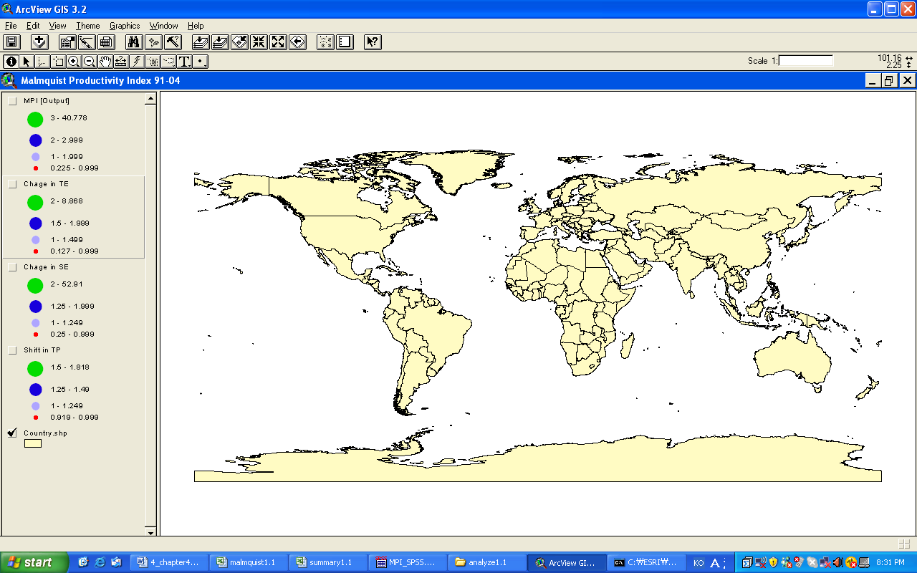
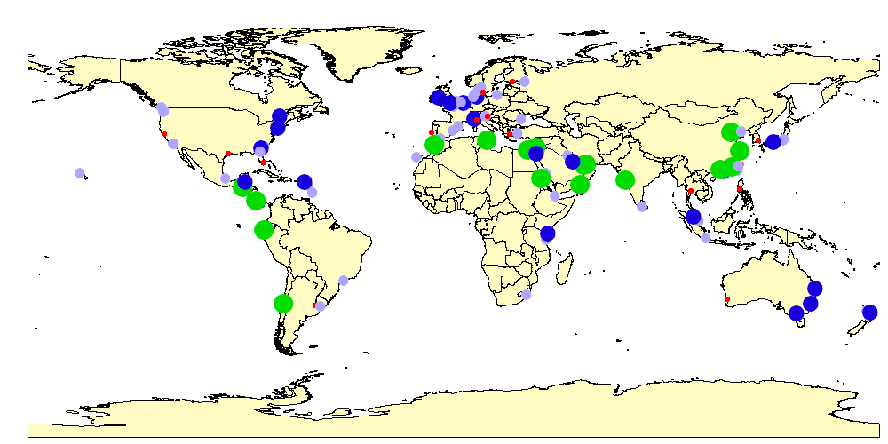
Legend

B. Non-scale Technical Efficiency Change (TEC)
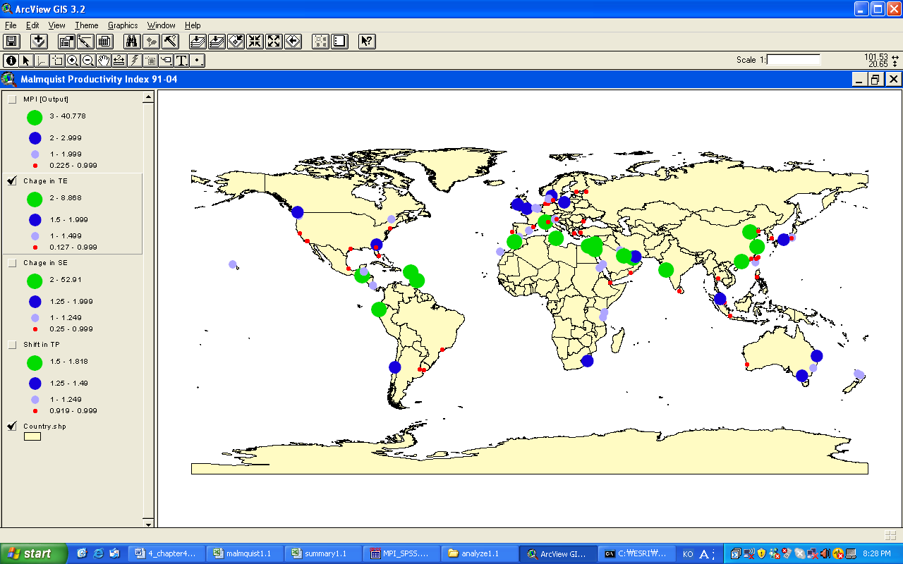
Legend
Appendix 3. MPI: Port Efficiency Change 1991~2004 (Continued)

C. Scale Efficiency Change (SEC)
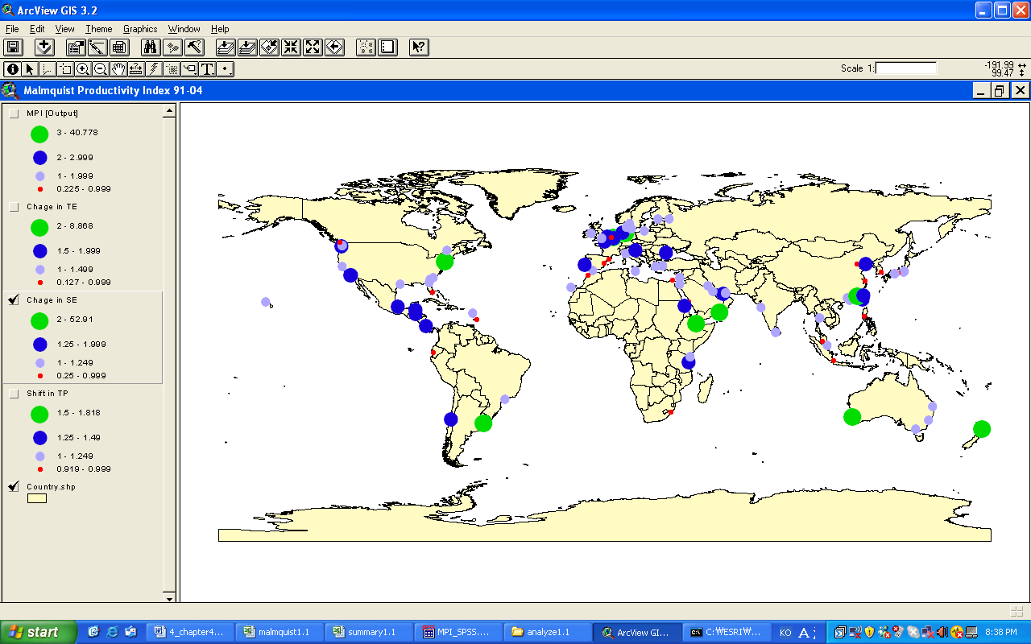
Legend

D. Efficient Frontier Shift: Technological Progress (EFC)
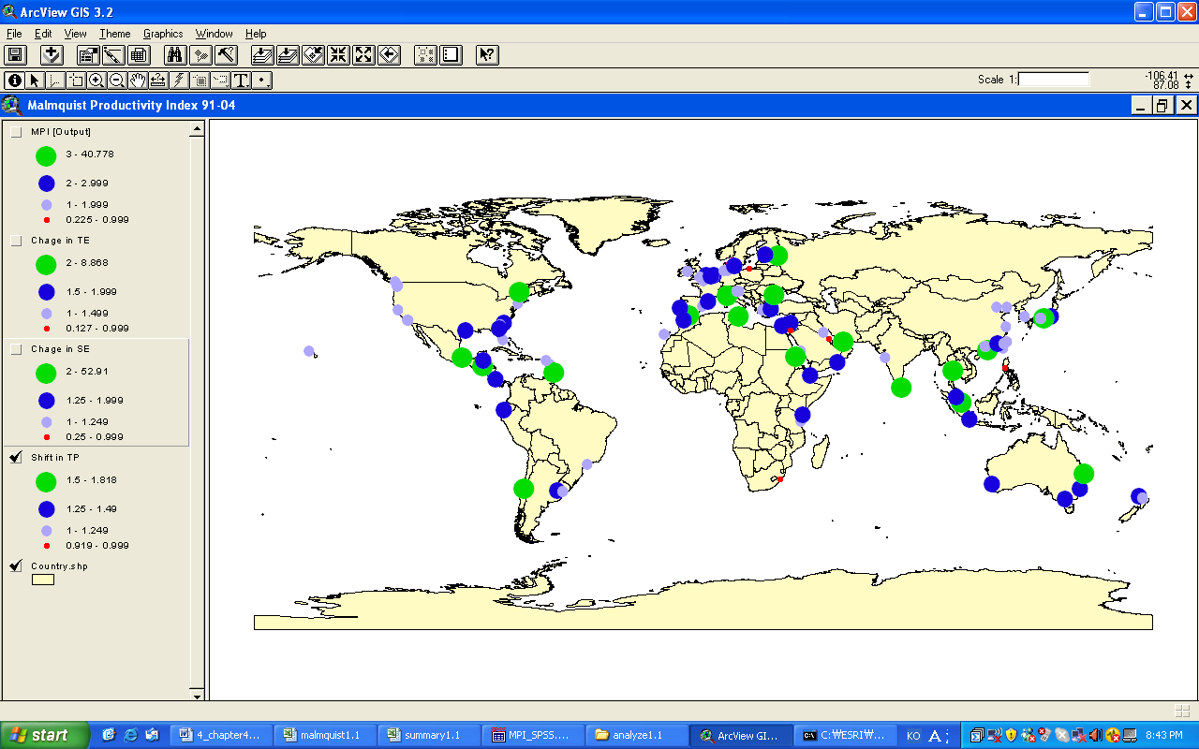

Legend
Table 1. Descriptive Statistics of the Input and Output Variables

 |  | Output | Inputs
 |  | Container Throughput  (TEU) | Berth Length  (m) | Terminal Area  (sq. meter) | Container Crane  (Tonnage)
1991 | Mean  Standard Error  Median  Standard Deviation  Kurtosis  Skewness  Minimum  Maximum  Sum  Total N | 679132  100334  328809  993258  9.33  2.85  606  5313900  66554927  98 | 1906  228  1068  2258  8.31  2.56  92  13799  186748  98 | 694016  82225  362000  813982  5.33  2.15  4500  4441284  68013564  98 | 467  54  267  533  6.47  2.36  31  2925  45729  98
2004 | Mean  Standard Error  Median  Standard Deviation  Kurtosis  Skewness  Minimum  Maximum  Sum  Total N | 2178146  333335  1291486  3299853  15.44  3.62  33208  20508333  213458292  98 | 2885  272  2158  2692  2.92  1.75  91  13329  282771  98 | 1278395  138351  828288  1369609  3.32  1.86  60000  6834710  125282684  98 | 1017  96  739  946  2.55  1.68  50  4254  99626  98

Table 2. Descriptive Statistics of MPI, TEC, SEC, and EFC

 |  | MPI | TEC | SEC | EFC
N | Valid | 95 | 95 | 95 | 95
 | Missing | 0 | 0 | 0 | 0
Mean |  | 1.823 | 1.333 | 1.262 | 1.286
Median |  | 1.626 | 1.017 | 1.114 | 1.238
Std. Deviation |  | 1.006 | 1.119 | .550 | .217
Skewness |  | 1.200 | 3.418 | 3.404 | .401
Std. Error of Skewness |  | .247 | .247 | .247 | .247
Kurtosis |  | 1.541 | 17.572 | 18.198 | -.543
Std. Error of Kurtosis |  | .490 | .490 | .490 | .490
Minimum |  | .225 | .13 | .25 | .919
Maximum |  | 5.241 | 8.48 | 4.79 | 1.818
Sum |  | 173.231 | 126.65 | 119.88 | 122.209

Table 3. Correlations of MPI and Sources of Efficiency Change

 |  | MPI | TEC | SEC | EFC
MPI | Pearson Correlation | 1 | .588(*) | .193(*) | .090(*)
 | t-statistics (2-tailed) |  | (4.928) | (5.216) | (5.184)
TEC | Pearson Correlation | .588(*) | 1 | -.388 | -.145
 | t-statistics (2-tailed) | (4.928) |  | (-.488) | (0.389)
SEC | Pearson Correlation | .193(*) | -.388 | 1 | .005
 | t-statistics (2-tailed) | (5.216) | (-.488) |  | (-.406)
EFC | Pearson Correlation | .090(*) | -.145 | .005 | 1
 | t-statistics (2-tailed) | (5.184) | (0.389) | (-.406)
 | N | 95 | 95 | 95 | 95
* Correlation is significant at the 5% level (2-tailed).
- MPI: Malmquist Total Factor Productivity Index
- TEC: ‘Pure’ Technical Efficiency Change
- SEC: Scale Efficiency Change
- EFC: Efficiency Change caused by Productivity Frontiers Shift

Table 4. Summary of OLS Results

Independent Variables | Unstandardized  Coefficients (B) | Standardized  Coefficients
Constant  (t-statistics) | 0.00002  (.139)
LNTEC  (t-statistics) | 0.9998*  (9422.1) | 1.204
LNSEC  (t-statistics) | 0.9997*  (5232.9) | 0.653
LNEFC  (t-statistics) | 1.0000*  (2698.2) | 0.295
* Parameters are significant at the 1% level.
**Adjusted R-Square = 0.999

Table 5. Patterns of Efficiency Change of World Ports

Type | Index | Average* | Membership
Type I  N=3 | MPI  Pure TEC  SEC  EFC | 3.63  1.85  1.34  1.49 | Dubai, San Antonio, Port Sudan
Type II  N=11 | MPI  Pure TEC  SEC  EFC | 2.80  1.83  1.05  1.47 | Port Kelang, Melbourne, Marsaxlokk, Khor Fakkan, Sydney, Montreal, Haifa, Damietta, Brisbane, Guayaquil, Mombassa
Type III  N=13  N=15* | MPI  Pure TEC  SEC  EFC | 2.43  2.17  1.03  1.11 | Shanghai, Tianjin, Genoa, Osaka, Southampton, Savannah, Honolulu, Las Palmas de Gran Canaria, Dublin, Aqaba, Santo Tomas de Castilla, Shuaiba, Koper, (Jawaharlal Nehru, Guangzhou)*
Type IV  N=8 | MPI  TEC  SEC  EFC | 2.51  1.06  1.99  1.23 | Kaohsiung, Antwerp, Tacoma, Xiamen, Puerto Limon, Tauranga, Dar-es-Salaam, Belize City
Type V  N=5 | MPI  Pure TEC  SEC  EFC | 1.69  1.04  1.10  1.51 | Hong Kong, Singapore, Tokyo, Algeciras, Auckland
Type VI  N=18*  N=19 | MPI  Pure TEC  SEC  EFC | 1.44  0.71  1.72  1.24 | Rotterdam, Los Angeles, Hamburg, Long Beach, New York/New Jersey, Bremen/Bremerhaven, Felixstowe, Yokohama, Le Havre, Seattle, Dalian, Taichung, Veracruz, Puerto Cortes, Montevideo, Djibouti, Pointe-a-Pitre, Constantza, (Port of Salalah)*
Type VII  N=7 | MPI  Pure TEC  SEC  EFC | 2.12  3.25  0.70  1.24 | Valencia, Durban, Vancouver, Zeebrugge, Casablanca, Bridgetown, Oranjestad
Type VIII  N=4 | MPI  Pure TEC  SEC  EFC | 1.74  1.73  1.07  0.95 | Gothenburg, Gdynia, Mina Sulman, Aarhus
Type IX  N=9 | MPI  Pure TEC  SEC  EFC | 1.33  0.89  1.07  1.39 | Tanjung Priok, Colombo, Charleston, Barcelona, Jeddah, Santos, Jacksonville, Izmir, St. Petersburg
Type X  N=17 | MPI  Pure TEC  SEC  EFC | 0.70  0.50  1.17  1.33 | Busan, Kobe, Nagoya, Keelung, Oakland, Piraeus, Bangkok, Houston, La Spezia, Miami, Buenos Aires, Helsinki, Lisbon, Fremantle, Rijeka, Copenhagen, Manila
Total  N =95  N= 98* | MPI  Pure TEC  SEC  EFC | 1.82  1.33  1.26  1.29
* The values are calculated including outliers.
Table 6. Patterns of Efficiency Change of World Ports

Region | N | MPI  Mean (Stdev.) | TEC  Mean (Stdev.) | SEC  Mean (Stdev.) | EFC  Mean (Stdev.)
Oceania | 6 | 2.019 (0.812) | 1.192 (0.560) | 1.458 (0.569) | 1.348 (0.174)
South Asia | 6 | 1.312 (0.553) | 0.924 (0.341) | 1.011 (0.093) | 1.407 (0.245)
East Asia | 14 | 1.920 (1.474) | 1.278 (1.094) | 1.383 (1.000) | 1.246 (0.209)
Middle East | 7 | 2.630 (1.026) | 1.985 (0.682) | 1.108 (0.116) | 1.206 (0.285)
Southern Europe | 10 | 1.532 (0.910) | 1.152 (0.785) | 1.067 (0.146) | 1.353 (0.215)
Northern Europe | 13 | 1.621 (0.522) | 1.080 (0.475) | 1.356 (0.417) | 1.198 (0.132)
East Europe | 5 | 1.384 (0.586) | 0.939 (0.623) | 1.307 (0.275) | 1.294 (0.373)
North America | 14 | 1.467 (0.519) | 0.982 (0.350) | 1.270 (0.439) | 1.233 (0.154)
Central America | 8 | 2.000 (0.840) | 2.460 (2.750) | 1.140 (0.607) | 1.354 (0.267)
South America | 5 | 2.002 (1.702) | 1.124 (0.924) | 1.377 (0.486) | 1.362 (0.172)
North Africa | 4 | 3.240 (1.207) | 2.162 (1.663) | 1.504 (1.008) | 1.475 (0.180)
South Africa | 3 | 1.705 (0.282) | 1.405 (0.402) | 1.105 (0.165) | 1.140 (0.207)
Total | 95 | 1.823 (1.006) | 1.333 (1.119) | 1.262 (0.550) | 1.286 (0.217)

Notes

Figure 1. Correlations between MPI and Components of TFP

Data Envelopment Analysis (DEA) is a methodology directed to creating efficiency frontiers based on a piecewise linear surface, instead of fitting a regression plane through the center of data (least-squared regression approach) in order to benchmark relative efficiency of Decision Making Units (DMUs). The early discussion about the methodology is detailed in (Charnes, Cooper, and Rhodes, 1978) and (Banker, Charnes, and Cooper, 1984). The earlier works to assess port efficiency by using DEA are Roll and Hayuth (1993), Martinez et al. (1999), Tongzon (2001), Wang et al. (2002), and Cullinane et al. (2004; 2005). This paper is one of the few works (e.g. Estache et al. 2004) to evaluate the sources of port efficiency changes through MPI.
The year 2001 was the most recent year for which port throughput data are confirmed.
Twenty-Foot Equivalent Unit
This approach can be partly limited for a full consideration the restructuring of the global port industry as the database leaves out four major container ports that did not exist in 1991 but became the global Top 30 in 2004: i.e. ports of Yantian, Qingdao, Gioia Tauro, and Laem Chabang. Therefore, the impact measured through MPI in this paper may underestimate the total factor productivity changes during the period.
Again, three outliers in terms of MPI are excluded for the OLS regression.
In table 4, since the result of OLS is the identity of equation (4), the Adjusted R-Square is 0.999.

