Children’s local travel behaviour - how the environment influences, controls and facilitates it.

Roger L Mackett*, Yi Gong†, Kay Kitazawa† and James Paskins*
* Centre for Transport Studies, University College London, London, UK
† Centre for Advanced Spatial Analysis, University College London, London, UK

Contact author:
Professor Roger Mackett
Centre for Transport Studies
University College London
Gower Street
London
WC1E 6BT
Great Britain
rlm@transport.ucl.ac.uk

Children’s local travel behaviour - how the environment influences, controls and facilitates it.

Roger L Mackett*, Yi Gong†, Kay Kitazawa† and James Paskins*
* Centre for Transport Studies, University College London
† Centre for Advanced Spatial Analysis, University College London

Abstract

This paper reports results from a project that uses questionnaires, diaries, activity monitors and GPS monitors to explore how children move about in the local environment. The patterns are analysed in terms of speed, energy consumption and sinuosity. Differences are examined for three types of activity: unstructured activities (playing), structured activities (clubs and sports) and walking, and in two types of environment: roads, tracks and paths, and open space. Walking is also examined in terms of differences in children’s spatial behaviour when they are accompanied by an adult and when they are not. Interesting differences are found. Whilst the results are preliminary, they suggest that there is need for more analysis of both this data set, and by extension to other environments.

Key words: Children; Travel behaviour; Diaries; GPS; Activity monitors.

1 Introduction

The local environment offers the opportunity for a variety of activities including recreation and physical activity, and the opportunity to travel to activities including work and shopping. The nature of the environment will influence the nature and extent of these activities and trips, through a number of factors which influence behaviour, some directly in terms of enablers and barriers, others through perceptions about the environment. Given that it is essential to travel through the local environment and the intrinsic benefits of some methods such as walking and cycling, and similar benefits of some activities, it is important to ensure that the local environment facilitates such activity and movement.

All of the above applies to children, except that they will participate in a different range of activities. It can be argued that the local environment allows children opportunities to learn how to make decisions, such as where to go and whether it is safe to cross the road, to build up social networks, and acquire knowledge by observation and experimentation. Equally important, it allows them to enjoy themselves and be active. Many of these processes are likely to be more successful if children can do them without adult intervention. Of course, a baby cannot go out alone, so a child has to go through a process of building up confidence to go out without supervision. Equally important, the child's parents must be willing to allow the children to go out without adult supervision. These means overcoming barriers such as concerns about road safety and possible abduction and the parent acquiring confidence in the child's ability not to become lost and knowing how to cope in an emergency.

In Great Britain, children have suffered a loss of freedom in terms of being allowed to go out of the home alone in recent years. For example, in 1985/86, 21% of children aged 5-10 travelled alone to school. By 2005 this had dropped to 6% (Department of Transport, 2002, 2006). Pooley et al (2005) found similar evidence over a longer period from interviews carried out in Manchester and Lancaster. They found that about 40% of people born in 1932-41 travelled to school alone at the age of 10-11, whereas about 9% of those born in 1990-91 travelled alone at that age.

Hillman et al (1990) looked more broadly at the issue of children being allowed out unaccompanied by an adult. They found that in England, 80% of 7-8 year olds were allowed to go to school alone in 1971. By 1990 this had dropped to 9%. They also looked at various other measures of the freedom allowed to children by letting them undertake various activities unaccompanied: for example, crossing the road, using buses, cycling on roads and going out after dark. In all cases where the equivalent data were collected in 1971 and 1990, the children had less freedom to go out alone. They carried out comparable surveys in Germany in 1990, and found that German children were allowed much greater freedom to go out alone than their English counterparts.

Hillman et al (1990) attribute this trend in the loss of freedom by children to the growth in car ownership, noting the paradox that the freedom that increasing car ownership has offered parents has been offset by constraints imposed on them by the perceived need to escort children more because of the increase in traffic danger.

Pooley et al (2005) identify four factors that have affected the journey to school since the 1940s: first, availability of transport technologies in the form of cars; second, an increase in parental choice in education which has led to longer journeys to school on average; third, increasing pace of life, which has led to people attempting to cram more activities into a limited amount of time; and fourth, perceptions of risk, for example the perceived risks from strangers to children out alone. When the discussion is extended from the journey to school to children going out of the house more generally without an adult, the list of factors can be expanded. For example, home entertainment technology has expanded rapidly so that children now have a range of opportunities at home to listen to music, play electronic games, and watch multichannel television that may have reduced the relative attractiveness of going out to play. The changing perceptions of risk have partly led to the move from free play to organised activities for children (National Institute of Child Health and Development,2000): in the past children would play out on the streets or walk to the local park, now they have to be taken to their football lessons, dancing classes, and so on, and usually this involves a car journey (Mackett et al, 2005). This need to escort children by car has greatly added to the complexity of life for parents, particularly mothers, many more of whom are employed, often part-time, than previously. There is almost an element of competition between parents to encourage children to go to as many of these activities as possible, in order to be seen to be ‘a good parent’. Many children have their out-of-school lives filled by attending these various activities, leaving little time for free play or going out gaining experience from making decisions about where to go and whether it is safe to cross the road, and from social interaction with other children.

Some of the benefits from allowing children out alone have been shown by Van Vliet (1983) who found, from a weekend diary kept by children in Toronto, Canada, that children who usually travelled without adults on the bus, streetcar and metro went out on more trips from home and did so for a greater range of activities.

In Britain, there is evidence that some children are being forced indoors by intolerant adults who claim that the children cause noise or a nuisance according to a survey carried out by The Children’s Society (Children’s Play Council, 2003). There are many examples of bans on playing in many areas, including refusal to allow the erection of a netball hoop on a village green in Oxfordshire, and a skateboard park in Cumbria and signs forbidding ball games in many urban areas.

The trends of increasing car ownership, decentralisation of urban activities, more structured leisure activities for children and greater complexity of family life have interacted to reduce the opportunities for children to walk about alone and with their friends. These tend to be exacerbated by parental perceptions about the risks to children out alone.

A key feature of this paper is the analysis of children's movement patterns at a microscopic level in various activities and to see if these vary in different environments. There has been considerable analysis of the impact of the environment on some aspects of children's behaviour, such as the choice of mode of travel to school (see for example, Kerr et al, 2006; McMillan, 2005; McMillan 2007), but not very much on other aspects of children's outdoor spatial behaviour of this type. A number of reasons for this can be suggested for this, including the difficulty of measuring children's behaviour objectively beyond straightforward factors such as the mode of travel, and even that is not necessarily simple with many children making multi-modal trips, using different modes on different days of the week, different modes to and from school, and breaking journeys, for example at a child-minder's house or at a friend's house from which a different mode is used.

The purpose of this paper is to present findings from a project that brings these ideas together. The project, entitled CAPABLE (Children’s Activities, Perceptions and Behaviour in the Local Environment) which has been carried out at University College London (see http://www.casa.ucl.ac.uk/capableproject/). CAPABLE followed on from a project to investigate the effects of the car on children’s volume of physical activity and long-term car dependency (see http://www.cts.ucl.ac.uk/research/chcaruse/). The most innovative part of that project was to fit about 200 children with activity monitors and asking them to keep diaries from which it was possible to establish the relative contribution of various activities, including walking, to children’s energy consumption (Mackett et al, 2005).

CAPABLE has involved staff from the Centre for Transport Studies, the Centre for Advanced Spatial Analysis, the Bartlett School of Planning and the Department of Psychology all at UCL. In this work, children have been fitted with GPS (global positioning system) monitors as well as using the activity monitors and diaries, so that it is possible to establish where children go for various activities. Another aspect of interest is whether or not children are allowed out without an adult. Questionnaire surveys have been conducted of children and their parents, and various drawing and mapping exercises carried out with the children (Mackett et al, 2006b). The fieldwork was carried out in Lewisham in south-east London, and in Hertfordshire, the area immediately north of London.

2 Methodology

In this paper results are presented from fieldwork carried in a school in Cheshunt in Hertfordshire, using four research instruments: questionnaires, activity monitors, GPS monitors and diaries.

The questionnaires contain questions about the child’s personal details and household, their journey to and from school in terms of length, mode and whom they travel with, their frequency of use of various modes for other journeys, whether they are allowed to travel without an adult, and about going to organized activities, visiting friends and playing. The questionnaires were completed in class, under the supervision of one of the research team. The children were all then invited to participate in the fieldwork, and took a letter home about the research. Only those children who had written consent from a parent and gave written consent themselves were allowed to participate. All children who met these criteria were included, to avoid selection bias and prevent discord between the children by selecting some but not others.

The activity monitors are RT3 tri-axial accelerometers, manufactured by Stayhealthy, USA, which measures movements in three directions, as shown in Figure 1. The RT3s combine all three acceleration vectors to produce an overall vector magnitude (VM) expressed in terms of activity counts. These can be converted into activity calories using formulae programmed into the equipment using data on the age, gender, weight and height of the child. Activity calories are calories used in undertaking physical activity. The RT3s can also convert activity calories to total calories, that is, including the calories that are used by the body to function and develop even when the person is passive, by adding on a constant based on the physical characteristics of the person. Activity calories are used in this work in order to facilitate comparison of the results of this work with other research (it is recognised that the formulae for converting the RT3 outputs to activity calories have not been fully validated for such young children). They were set to record movements on a minute-by-minute basis.

The GPS is a satellite-based positioning system. Twenty four GPS satellites are orbiting the earth at a very high altitude. By picking up signals from these satellites, a GPS receiver can tell the user position over the ground with relatively high accuracy of several metres. Several types of GPS equipment were tested, in order to decide the best in terms of precision, battery life and acceptability to the children. The GPS equipment used in the CAPABLE project is the Garmin Foretrex 201 which is small and light-weight so that children can easily wear it on their wrists all day long, as shown in Figure 2. It monitors children's locations at set intervals and records them in its memory in chronological order. These data can be superimposed subsequently on a map or input into a GIS (geographic information system) so that they can be linked with other spatial data and analysed.

Figure 1 The RT3 activity monitor

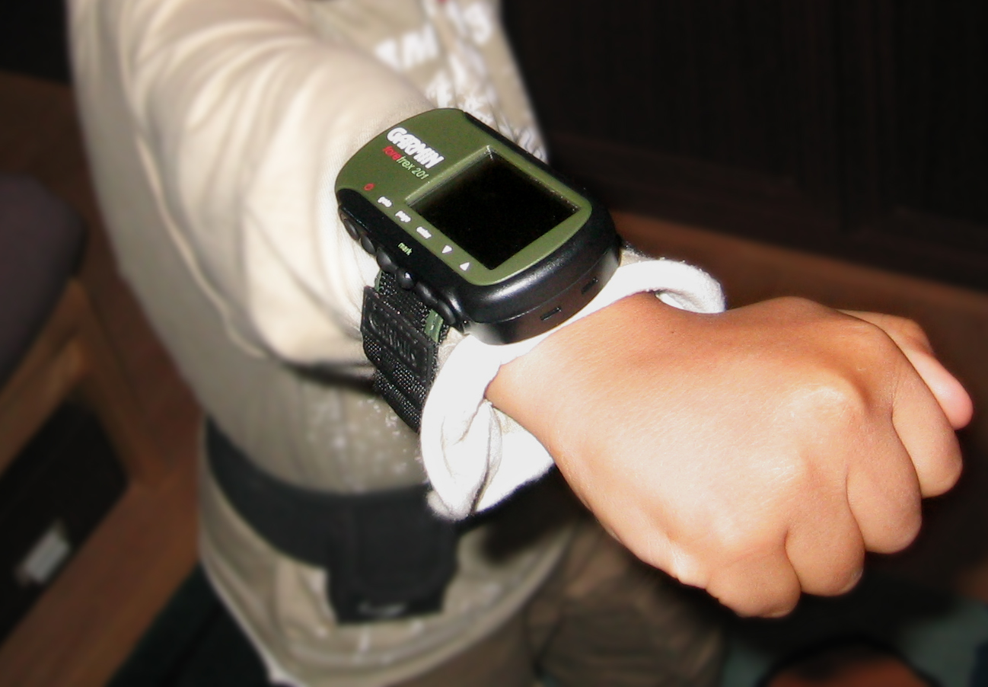

Figure 2 The Garmin Foretrex 201 GPS monitor

The children were asked to complete a travel and activity diary. An example extract from the diary is shown in Figure 3.

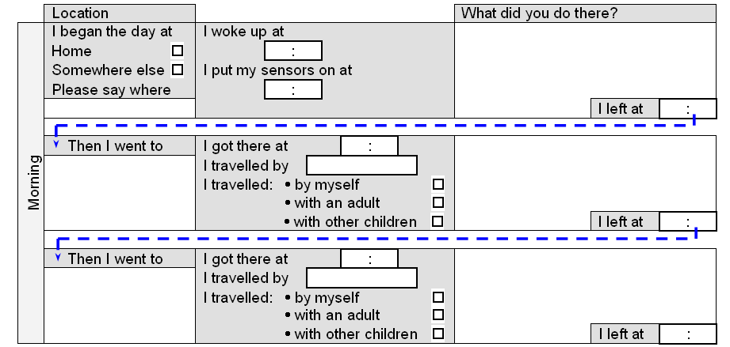

Figure 3 The activity and travel diary

Having explained about the project to the children and obtained their, and their parents’, written consent, groups of about 15 children were surveyed over a week. The procedure was that the researchers went into the school on a Wednesday to weigh and measure the children, issue them with the GPS and RT3 monitors and diaries, and brief them on their use. Trost et al (2000) have shown that four days of monitoring of physical activity in children are required. The children wore the monitors from the Wednesday until the following Monday, with data being collected for the four days Thursday, Friday, Saturday and Sunday. These days were chosen so that both school days and weekend days were included. They were asked to keep wear the equipment all the time except while they were asleep and when equipment might get wet. On the Monday the researchers went back to the school to collect the equipment and download the data at UCL for processing. Individual debriefing meetings were held with each child for initial reconciliation of the outputs from the three research instruments.

Because the RT3s and diaries had been used on the children’s car use project, procedures for verifying and classifying the data had already been developed. The events recorded in the children’s activity and travel diaries were classified, using a typology shown in Mackett et al (2005), and put into an Access database. However, it was necessary to develop new procedures to check and analyse the results from the GPS monitors, as well as integrating the results with those from the RT3s and diaries. There are a number of known difficulties in using GPS monitors including the unavailability of satellite signals and random points, possibly caused by the signal bouncing off buildings. Because the GPS monitors record the location and time of each point it is possible to calculate the implied speed between points. Points that implied unrealistically high speeds were deleted. The data cleaning left 65,549 useable GPS points.

The data were initially entered into Excel spreadsheets. Programs written in Visual Basic were used to integrate the data from the GPS and RT3 monitors into the Access database to give greater flexibility for analysis. The data from the three sources had to be reconciled using the times given. The GPS monitors were regarded as accurate. The RT3s were set to collect activity data in minute intervals using times set from a computer, and so it was straightforward to integrate these two data sets. It was much more complex to reconcile these two data sets with the children’s diaries. Travel diaries have long been suspected of under-recording trips: this is one of the first opportunities to demonstrate explicitly that trips are missed out from diaries. There were cases when the GPS trace made it clear that the child had gone out and the diary showed no such entry. Considerable effort was put into adjusting the times in the diaries to be consistent with the GPS monitors where this could be done unambiguously. Because of difficulties with the GPS equipment, for example, significant loss of points or failure of the battery charger, and children forgetting to complete their diaries, not every child provided a complete set of data. Most of the analysis in this part of the project has been carried out on the 162 children at the two schools in Cheshunt who provided sufficient data to be analysed.

The final aspect of the data assembly was to establish the nature of the place where the GPS points were located. This was done in two ways: field observation and GIS. Field visits were held to Cheshunt. In this paper the nature of the places (or land use) has been based on the Ordnance Survey MasterMap topology layer which has been used in a GIS to classify all the land parcels into different types, such as buildings, natural environment, general surface, path, road or track, roadside, structure and so on. The geo-location data and energy expenditure data have been related to the land use. This analysis is currently under way, with much more work required on defining a robust spatial classification system. For this paper, all the points on private spaces, such as garden attached to houses have been eliminated. The remaining points have either been allocated to the MasterMap category ‘Roads, tracks and paths’ or to any other space, which is essentially open space of some sort. In the paper, the former will be referred to as ‘road’, the latter to as ‘land’. It is recognised that this is rather crude, but it reflects the difficulty of this type of work, which partly arises from the nature of the GPS equipment of which can only locate with a precision of about 10 metres.

In this paper, three measures of children's movement are considered: speed, intensity of energy consumption and mean angles turned. As discussed above, it was necessary to reconcile the outputs from the GPS monitors, the RT3s and the diaries. Because the RT3s recorded energy consumption in one minute intervals, a smoothing process was developed to establish the location at the end of each one minute interval from the GPS points. The activities the children were involved in were then allocated to each one minute interval using information from the diaries.

The results below are shown for three types of activity: playing, clubs and walking. Playing is an informal activity in which children make decisions for themselves, and usually interact with other children. Clubs here refers a structured activity organized by adults for the benefit of children. Some activities could come under both headings: a tennis lesson would be included as clubs whereas a group of children involved in an informal game of tennis would be included as playing.

The results from this work lend themselves to innovative visualization methods. The tracks that are extracted from the GPS monitors and the energy use which is coordinated with these movements imply a real time sequence which can be animated to illustrate different spatial regimes that children generate as they partake in various activities. A series of animated maps have been developed by inserting typical tracks into a non-proprietary mapping package (Google Maps) which is used to illustrate the speed at which children walk, their walking patterns and the energy expended as they walk. This is shown by colouring the track as a series of points, the colours of which reflect the energy used which is also associated with a space-time series. The speed at which a child moves is coded into the animation and this gives a sense of how energy uses, activity types, speed, and regularity of the movement patterns are integrated into the visualization. The basic methodology has now been developed. A more detailed classification of patterns will be developed and animated in the same way. Users can access the data in this way and reach conclusions as to how movement patterns are related to different tasks and different energy expenditures. A sample of these tracks is shown at www.casa.ucl.ac.uk/capableproject/maps.

It must be stressed that these are preliminary results and the findings are exploratory. At the time of writing (April 2007), the results from the different research instruments for children at one of the two schools in Cheshunt have been reconciled, but this process has still to be completed for the other one. Once the full data set has been assembled, more detailed analysis will be carried out and statistical testing carried out to establish the robustness of the results. Despite the preliminary nature of the findings, there is still much of interest, including interesting questions about how this type of micro-level travel and activity behaviour can be analysed.

3 Results

As shown in Table 1, 74 children at Flamstead End Primary School in Cheshunt, Hertfordshire, completed questionnaires, wore the GPS and RT3 monitors and completed diaries. This is not a large number, but it should be borne in mind that the children were being asked to wear two pieces of equipment, one of which required charging every night, and keep a diary of their activities and travel, for four days. This was demanding of both child and researcher time. Not all the children provided complete data sets. Also, the data were collected in the period from October 2005 to March 2006, which includes winter in Britain and therefore not an ideal time to collect data on outdoor activities. The children were in the top three years of primary school, that is, aged 8 to 11. There are 170 children in Years 4, 5 and 6 at Flamstead End, so the response rate was 44%.

Table 1 The children in the survey

 | Boys | Girls | Total
Year 4 (age 8-9) | 15 | 14 | 29
Year 5 (age 9-10) | 13 | 16 | 29
Year 6 (age 10-11) | 8 | 8 | 16
Total | 36 | 38 | 74

Questions were asked in the questionnaire about independent movement by the children, because, as indicated above, this is an important factor in determining the extent to which children use the local environment. As Table 2 shows, which is based on children at the two Cheshunt schools,
56 % of the children were allowed out without an adult. The proportion increases with age, in general, with slightly fewer of the Year 4 boys allowed out than the Year 5. The proportion of boys allowed out is higher than that for girls.

Table 2 Percentage of children allowed out without an adult.

 | Boys | Girls | All
Year 4 (age 8-9) | 52 | 33 | 44
Year 5 (age 9-10) | 50 | 44 | 47
Year 6 (age 10-11) | 86 | 69 | 78
Total | 63 | 48 | 56

The results from the GPS monitors lend themselves to spatial mapping, as shown in Figures 4 and 5. Figure 4 shows the level of intensity of children walking home from one of the schools divided into three levels of intensity: light, moderate and vigorous. The map also shows the location of the school and the homes of the children with the codes for each child. The more vigorous walking seems to be along more definite corridors, whilst some of the light physical activity seems to be more meandering. Figure 5 shows the location of the unstructured activities by the children at one of the schools. This illustrates the range of activities covered, including dog walking, tennis, skating and having a disco on the playing field.

Whilst the maps are very interesting, they do not, in themselves, represent analysis. This is done in this paper using the concepts of speed, energy consumption and mean angle turned, as discussed above.

Table 3 shows the speed at which the children moved. Looking at the overall figures, it can be seen that children move fastest when at clubs. Given that these are mainly outdoor sports this is not surprising. Walking is also fairly fast at 1 metre a second, which is 3.6 km an hour or 2.25 miles an hour, which seems a reasonable figure. When playing, the children move much less quickly, at 0.3 metres a second. Given that playing ranges from running around to sitting chatting, this also seems reasonable. Girls appear to move faster than boys, but this is partly because two of them went horse riding, and this distorts the figures. In playing and walking, the speeds are similar for boys and girls. When the environments are considered, the children move faster on the road than on the land (or open space) in general, although it is not true of boys when they are playing. The children do seem to walk faster on the road than when in other environments, perhaps reflecting a greater numbers of distractions on open space compared with the road.

Table 3 Speeds in metres per second in various activities in different environments

 | Boys |  |  |  | Girls |  |  |  | All
 | Land | Road | Both |  | Land | Road | Both |  | Land | Road | Both
Playing | 0.6 | 0.2 | 0.3 |  | 0.2 | 0.3 | 0.2 |  | 0.3 | 0.2 | 0.3
Clubs | 0.5 | 0.8 | 0.6 |  | 1.2 | 3.9 | 2.3 |  | 0.8 | 2.0 | 1.3
Walking | 0.8 | 1.0 | 0.9 |  | 0.9 | 1.1 | 1.0 |  | 0.9 | 1.1 | 1.0
All | 0.7 | 0.9 | 0.8 |  | 0.9 | 1.3 | 1.2 |  | 0.8 | 1.1 | 1.0

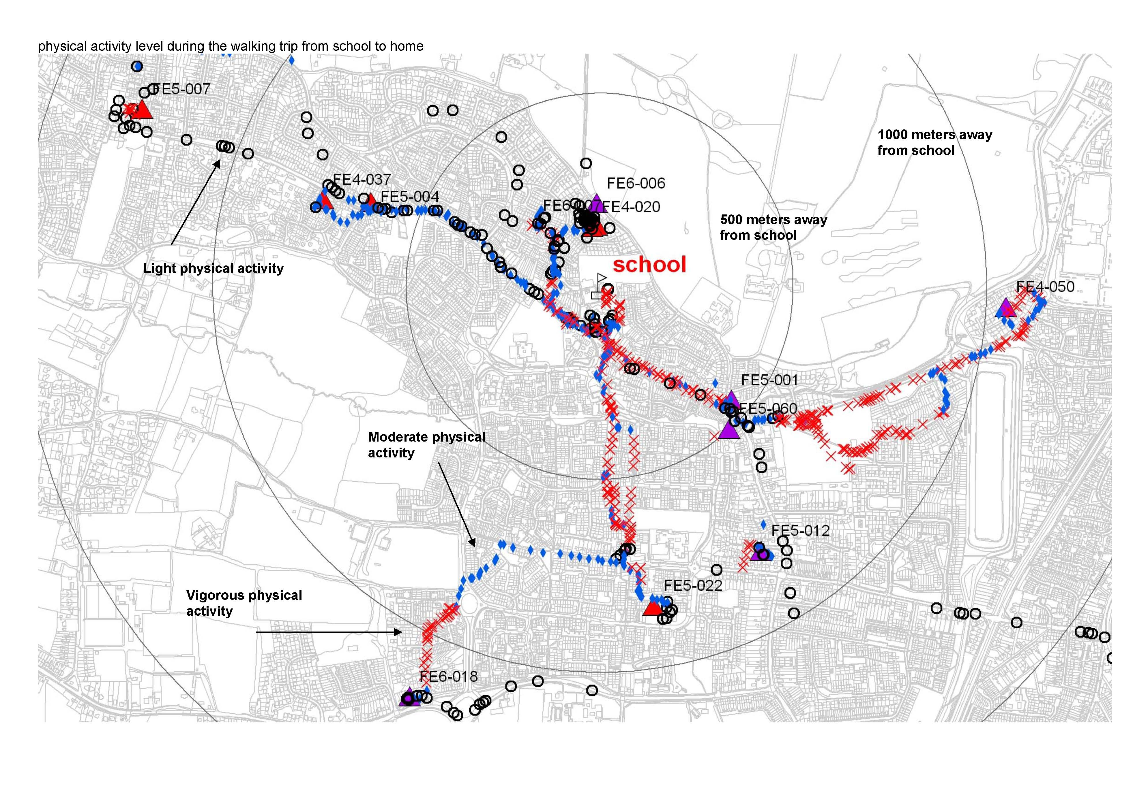

Figure 4 Physical activity levels during walking trips home from school
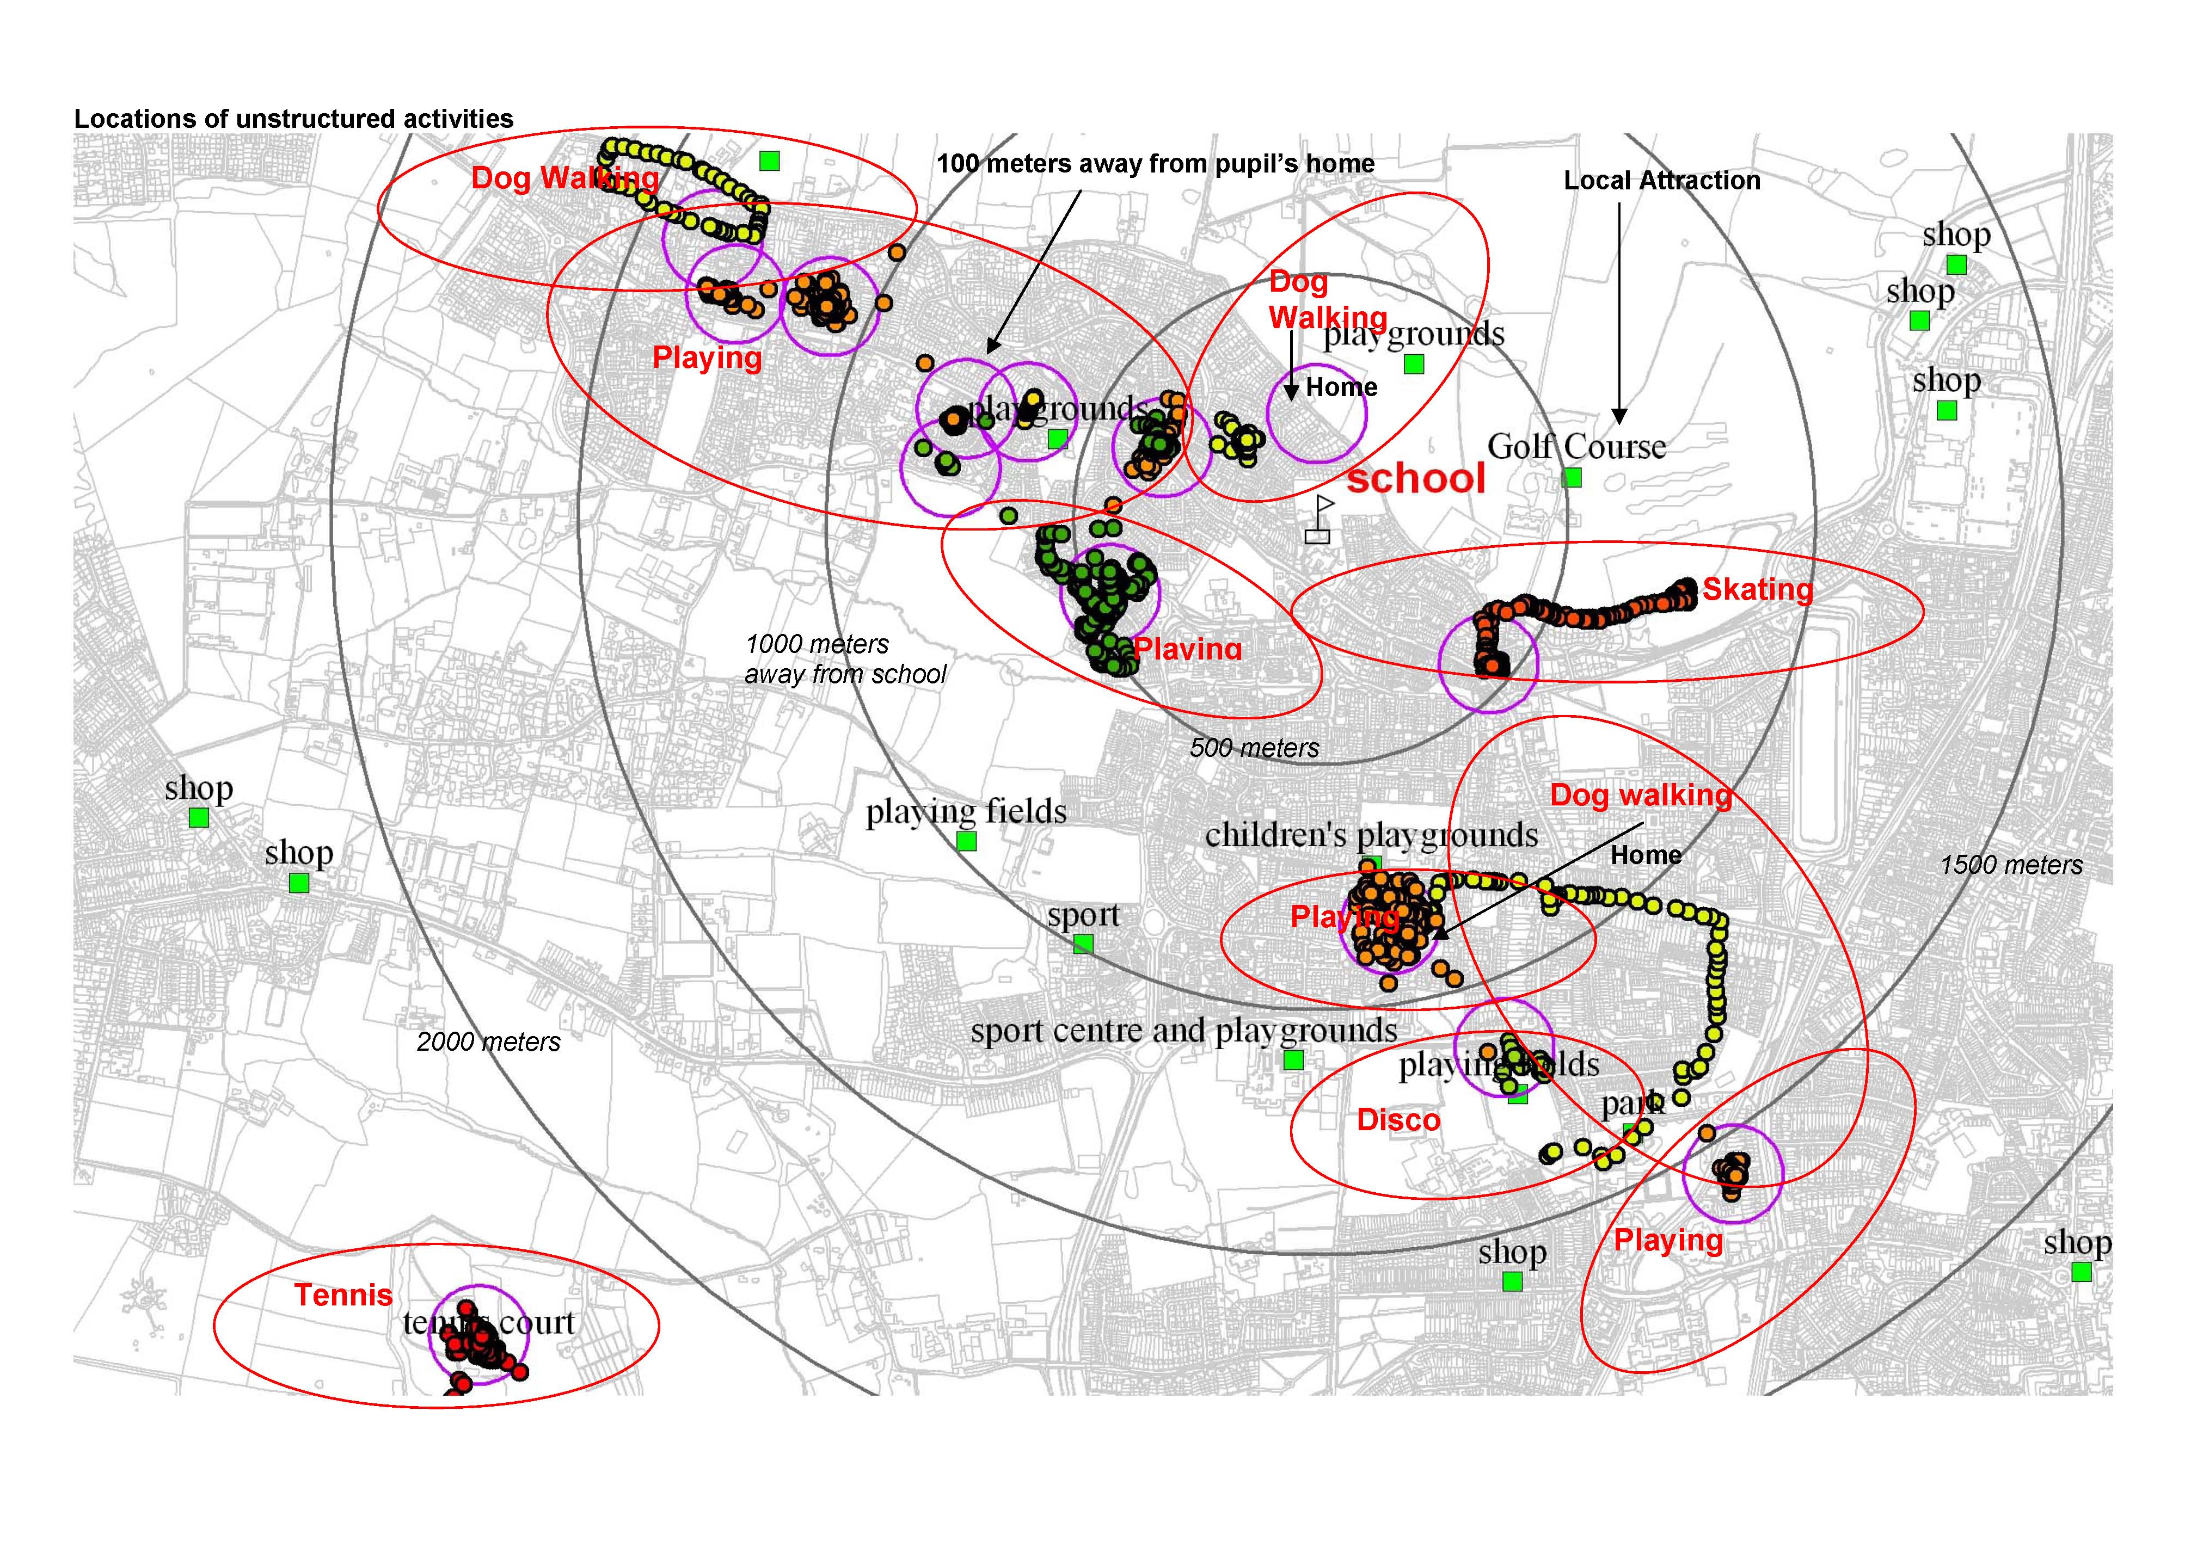

Figure 5 The location of unstructured activities

Turning to the intensity of the activity, as shown in Table 4, a rather different picture emerges. Walking is the most energetic activity, but playing comes second, overall. The finding that playing uses more energy than clubs confirms a finding for children at schools elsewhere in Hertfordshire found in the project on children’s car use (Mackett et al, 2005). The distortion caused by the horse riding disappears because the RT3s are based on acceleration, and this would not be particularly high. There is an issue here which is similar to that found with cycling, because much of the energy used is consumed by movement of the limbs rather than horizontal displacement. The girls are more energetic than the boys overall, but the difference is smaller than for speeds. The boys are more energetic than the girls at clubs while the girls are more energetic than the boys when playing and walking. The same differences were found for Year 6 children in the previous work, which was carried out at different schools (Mackett et al, 2005). Looking at the different environments, the girls are more energetic on the road than on the land, but the boys have similar levels of energy expenditure in the two environments. Both sexes walk more energetically on the road than elsewhere, probably because roads are designed for walking whereas open space may sometimes be more difficult to walk on. However, both the playing and the clubs tend to be more energetic off the road rather than on it. This seems reasonable: it is easier to run around playing on open space rather than the linear form of the street, and the club activities on open space are probably sports whereas on the road they are other types of structured activity.

Table 4 Intensity of energy consumption in 10⁻² activity calories per kilogramme of body weight per minute for various activities in different environments

 | Boys |  |  |  | Girls |  |  |  | All
 | Land | Road | Both |  | Land | Road | Both |  | Land | Road | Both
Playing | 3.8 | 3.3 | 3.4 |  | 5.0 | 4.7 | 4.8 |  | 6.8 | 4.4 | 5.3
Clubs | 5.3 | 4.2 | 4.8 |  | 4.8 | 3.2 | 4.1 |  | 5.1 | 4.2 | 4.7
Walking | 6.1 | 6.3 | 6.3 |  | 6.1 | 7.1 | 6.7 |  | 6.1 | 6.8 | 6.6
All | 5.8 | 5.8 | 5.8 |  | 5.8 | 6.7 | 6.3 |  | 5.8 | 6.4 | 6.2

The third measure of movement is the mean angle turned through. This is a measure of sinuosity or ‘wiggliness’, as shown in Table 5. Two points need to be borne in mind here: first, the GPS points have been averaged to give a point every minute, so much of the lateral movement will have been lost, and second, the slower a person moves, the move the lateral movement will be picked up. Notwithstanding these issues, it is interesting to note the differences in the angularity of the children’s movement in the different activities. In fact, the club activities have the greatest mean angles turned as well as the greatest speed. Many sports, such as soccer and tennis, require both speed and angular movement. On the other hand, play appeared to be relatively slow compared with walking, but it involves more changes of direction, showing the different nature of the activity and partly explaining the fairly high level of energy expenditure in playing: lots of running around, but not necessarily very much change of location. As one might expect, there is less angular movement on the road than on the land because roads are linear, while open space is two-dimensional. However, playing on the road has lots more turning than playing on the land. This may well be because the playing on the road was mainly roller skating, which can have lots of changes of direction (the children tended to skate about in one location rather than use the skates as a form to transport to make a trip).

Table 5 Angles turned in degrees in various activities in different environments

 | Boys |  |  |  | Girls |  |  |  | All
 | Land | Road | Both |  | Land | Road | Both |  | Land | Road | Both
Playing | 13 | 56 | 43 |  | 61 | 84 | 76 |  | 48 | 66 | 59
Clubs | 77 | 40 | 62 |  | 84 | 69 | 78 |  | 84 | 56 | 73
Walking | 44 | 36 | 39 |  | 41 | 33 | 36 |  | 43 | 34 | 37
All | 54 | 38 | 45 |  | 51 | 38 | 43 |  | 55 | 39 | 45

In the diaries the children were asked to indicate whether their travel was made alone, with an adult or with other children (or both the last two categories). In this part of the paper, walking will be considered in terms of whether of not the child was accompanied by an adult. In some cases the child did not answer this question in the diary for the travel, but stated that they were walking and the intensity was measured from the RT3 (it is possible that they walked some of the journey alone and the other part with friends and they did not know which box about accompaniment to tick).

Table 6 shows the speed of walking disaggregated into whether or not the child was accompanied by an adult. It can be seen that the children are much faster when walking with an adult. This is partly because they are often travelling to or from school when they walk with an adult and they may well walk faster when walking to school than on other trip purposes because of time constraints. They walk more intensively on their way to school than for other purposes (Mackett et al, 2006a).

Table 6 Speeds in metres per second walking in different environments

Accomp-  anied by an adult? | Boys |  |  |  | Girls |  |  |  | All
Accomp-  anied by an adult? | Land | Road | Both |  | Land | Road | Both |  | Land | Road | Both
No | 0.2 | 0.6 | 0.5 |  | 0.2 | 0.7 | 0.4 |  | 0.2 | 0.6 | 0.4
Yes | 0.9 | 1.2 | 1.1 |  | 1.0 | 1.1 | 1.1 |  | 1.0 | 1.1 | 1.1
All | 0.8 | 1.0 | 0.9 |  | 0.9 | 1.1 | 1.0 |  | 0.9 | 1.1 | 1.0

It can be seen that children walk very slowly when walking away from the road without an adult. However, the differences for intensity are much less, as shown in Table 7. In fact the boys are more active when walking without an adult than with, whereas girls walk more energetically when accompanied by an adult. The boys are particularly energetic when walking without an adult on the road, but this is a very small part of the sample.

Table 7 Intensity of energy consumption in 10⁻² activity calories per kilogramme of body weight per minute walking in different environments

Accomp-  anied by an adult? | Boys |  |  |  | Girls |  |  |  | All
Accomp-  anied by an adult? | Land | Road | Both |  | Land | Road | Both |  | Land | Road | Both
No | 5.1 | 11.2 | 9.1 |  | 3.5 | 3.9 | 3.6 |  | 4.0 | 7.8 | 5.9
Yes | 6.7 | 6.4 | 6.5 |  | 6.4 | 7.3 | 6.9 |  | 6.5 | 7.0 | 6.8
All | 6.1 | 6.4 | 6.3 |  | 6.1 | 7.1 | 6.7 |  | 6.1 | 6.8 | 6.6

When the turning the movements are considered (Table 8) the children can be seen to walk in much more of a straight line when accompanied by an adult than when alone or just with other children. It can also be seen that boys meander about more when walking about on open space when without an adult than any of the other categories. There are not very large differences between being on the land and on the road for girls when they are without an adult, but in both cases they show more ‘wiggliness’ than when with an adult.

Table 8 Angles turned in degrees walking in different environments

Accomp-  anied by an adult? | Boys |  |  |  | Girls |  |  |  | All
Accomp-  anied by an adult? | Land | Road | Both |  | Land | Road | Both |  | Land | Road | Both
No | 74 | 52 | 61 |  | 50 | 48 | 49 |  | 58 | 50 | 54
Yes | 47 | 36 | 40 |  | 43 | 31 | 36 |  | 44 | 33 | 37
All | 44 | 37 | 39 |  | 42 | 33 | 36 |  | 43 | 34 | 37

4 Conclusions

This paper has presented some findings about the travel and activity patterns of children. Children have been found to move faster and be more energetic on the road than on open space, but tend to move in a more sinuous way on open space. They move faster when at clubs than walking or playing. A different picture emerges when energy consumption is considered, with walking being the most energetic and being at clubs the least. Children tend to move most sinuously when at clubs on open space, which is probably sport, and least sinuously when walking, especially on roads.

Being with an adult affects children’s spatial behaviour. They tend to walk faster, more energetically and straighter when with an adult. Without an adult they tend to ‘potter about’ in a much more exploratory way. Whilst speed has its benefits, there is a need for children to explore the environment at their own pace, gaining experience and leaning about the world.

Three things can be said about the findings: they are fascinating, they are (probably) unique and they require further analysis. It is unusual to consider movement at such a microlevel, but, movements at this level are the fundamental elements of the more macroscopic travel that is usually considered, but not fully understood. Perhaps there needs to be more work at the level shown in this paper to underpin the more usual level at which analysis is usually conducted.

The results are fascinating because they reveal aspects of children’s behaviour which correspond with observation, for example, by parents of their own children, but not normally analysed. For example, parents walking with their children often observe how much further the children walk because they tend to walk laterally and often to and fro longitudinally, sometimes with the occasional handstand or similar, whilst the parents just walk forwards. This analysis suggests that children behave even more discursively when no adult is present, but, by definition, this is very hard for an adult to observe.

Whilst others have fitted children with activity monitors, and others still are trying out GPS monitors, as far as the authors are aware, this is the first time that the combination of activity monitors, GPS monitors and diaries has been used together for children (and only one example of similar work with adults is known about). However, a number of researchers have shown interest in replicating and extending this work, so there may be fruitful collaborations in future.

However, it must be recognised that there is much more work to be done on the data presented here. The first priority is to finish reconciling the data from the other school in Cheshunt which will double the size of the data set. Then there needs to be some statistical testing to see which of the differences are significant. The land use classification needs to be extended, with the GIS data being supplemented with field visits where appropriate. The data from this fieldwork can be linked with the data from the children’s and parents’ questionnaires to see if some of the differences revealed here can be explained by the attitudinal and social variation in the questionnaires. In the longer run, funding can be obtain the build on the experience gained here to take forward the methodology, using bigger samples and comparing behaviour in a wider range of environments, and looking at differences by age and social status.

Overall, there is much to be learnt. It is hoped that the increased understanding that this research contributes helps children to use their local environment more, and so lead healthier and happier lives.

Acknowledgements

This paper has been written as part of a project entitled ‘Children’s Activities Perceptions and Behaviour in the Local Environment (CAPABLE)’ which is being funded by the UK Engineering and Physical Sciences Research Council (EPSRC) under grant GR/T09378/01 for 2 years and 5 months from August 2004. It is being carried out at UCL as a joint project between the Centre for Transport Studies, the Centre for Advanced Spatial Analysis, the Bartlett School of Planning and the Psychology Department. The co-operation of the children who took part in this exercise and their teachers and parents is greatly appreciated, as is assistance from Hertfordshire County Council.

References

Children’s Play Council (2003) ‘Grumpy grown-ups stop children play, reveals Playday research’, News story, 7 August 2003, available on the world wide web at http://www.ncb.org.uk/cpc/news_story.asp?id=116.

Department for Transport (2002) National Travel Survey: 1999-2001 Update, Transport Statistics Bulletin.

Department for Transport (2006) National Travel Survey: 2005, Transport Statistics Bulletin.

Hillman M., Adams, J. and Whitelegg, J (1990) One False Move...: A Study of Children’s Independent Mobility, PSI Publishing, London.

Kerr, J., Rosenberg, D., Sallis, J. F., Saelens, B. E., and Frank, L. D. (2006) ‘Active commuting to school: Associations with environment and parental concerns’, Medicine and Science in Sports and Exercise, 38, 787-794.

Mackett R L, Gong Y, Kitazawa K, and Paskins J (2006a) ‘Where do children walk and what do they do when they get there?’ Paper presented at the WALK21 Conference, Melbourne, Australia, 23-25 October 2006, available from http://www.casa.ucl.ac.uk/capableproject/Publications.html.

Mackett, R. L., Brown, B., Gong, Y., Kitazawa, K. and Paskins, J. (2006b) ‘Measuring the outcomes from active transport interventions for children’, Paper presented at the Symposium on ‘Creating Lively Neighbourhoods: Children and Active Transport’, Melbourne, Australia, 27 October 2006, available from http://www.casa.ucl.ac.uk/capableproject/Publications.html.

Mackett, R. L., Lucas, L., Paskins, J., and Turbin, J. (2005) ‘The therapeutic value of children’s everyday travel’, Transportation Research A, 39, 205-219.

McMillan, T. (2005) ‘Urban form and a child's trip to school: The current literature and a framework for future research’, Journal of Planning Literature, 19, 440-456.

McMillan, T. (2007) ‘The relative influence of urban form on a child's travel mode to school’, Transportation Research Part A, 41, 69-79.

National Institute of Child Health and Development (2000) How do children spend their time? Children’s activities, school achievement, and well being, Research on Today’s Issues, Issue number 11, August 2000, Population Reference Bureau for the Demographic and Behavioral Sciences Branch, Center for Population Research, National Institute of Child Health and Human Development, National Institutes of Health.

Pooley, C., Turnbull, J. and Adams, M. (2005) ‘The journey to school in Britain since the 1940s: continuity and change’, Area, 37, 43-53.

Trost, S. G., Pate, R. R., Freedson, P. S., Sallis, J. F. and Taylor, W. C. (2000) ‘Using objective physical activity measures with youth: how many days of monitoring are required?’ Medicine & Science in Sports & Exercise, 32, 426-431.

Van Vliet, W. (1983) ‘Children’s travel behavior’, Ekistics, 50, 61-65.

