Urban Transportation Demand Based on Travel Behavior of
Elderly People in Japan

Naohiko Hibino
(Corresponding author)
Institute for Transport Policy Studies
Japan Institution for Transport Policy Studies
3-18-19 Toranomon, Minato-ku, Tokyo, 105-0001, Japan
Tel: +81-3-5470-8415, Fax: +81-3-5470-8419
Email: hibino@jtect.or.jp

Akira Okada
Musashi Institute of Technology
School of Environmental and Information Studies
Ushikubo Nishi 3-3-1, Tsuzuki-ku, Yokohama, 224-0015, Japan
Tel: +81-45-910-2584, Fax: +81-45-910-2605
Email: okada@yc.musashi-tech.ac.jp

Kyoji Ohno
Institute for Transport Policy Studies
Japan Institution for Transport Policy Studies
3-18-19 Toranomon, Minato-ku, Tokyo, 105-0001, Japan
Tel: +81-3-5470-8415, Fax: +81-3-5470-8419
Email: ohno@jterc.or.jp
Urban Transportation Demand Based on Travel Behavior of
Elderly People in Japan

Abstract: The aged population in Japan is growing at a faster pace compared to other industrialized countries in the world. Many of the baby boomers are expected to retire soon and make significant changes in the societies’ transportation needs. This study empirically simulated and analyzed transportation demand and urban transportation system in the Tokyo metropolitan area at the time the baby boomers retire. Results show that although there will be changes in travel behavior and preferences of the elderly, aggregate demand for transport will not weaken because of the more active lifestyle of the elderly.

Key words: Japanese aged society, active elderly, transportation demand, mode choice

- Background and objectives
  - Aging in Japan and comparison with other countries
The population in Japan is projected to decline from 2006. This population trend has raised societal concerns particularly on fiscal shortage of health insurance and pension systems. Moreover, considered a more imperative problem than the decreasing population is the changing population structure. The National Institute of Population and Social Security Research (2002) reckoned that, although the population of less than 65 years old has a decreasing trend, the population of over 65 years old has been fleetingly growing (Figure 1). Approximately one in three Japanese will be at least 65 years old by 2030 compared to one in five Japanese now in the elderly.
Another serious societal issue is the short transition period from aging society to aged society. The United Nation defines aging society and aged society as societies with 7% and 14% of the population belonging to age group over 65 years old, respectively. Japan became an aging society in 1970 and an aged society just after 24 years in 1994 (Figure 2). The length of the transition period in Japan is much shorter than in any other European and North American industrialized countries like the United Kingdom, France, Germany and United State of America. This rapid demographic change is one of main concerns Japanese policy makers nowadays and a main challenge in policy setting for the aging society. The two key reasons why Japan faces such rapid aging are higher life expectancies and historically low fertility rates. As far as we can see, the Japanese government can do very little with this current situation both on the soft and on the hard policy side.
Policy studies on the aged society in Japan would be good background to not only industrialized western countries but also to East Asian developing countries. Many East Asian countries will face rapid demographic change like Japan in the future (Table 1). The current paradigm in Japan and the policy measures borne out of it is, thus, deemed valuable for such countries to prepare for achieving desirable situation for their elderly in the future.

  - Transportation issues in the aged society of Japan
One of the pressing issues on the aged society of Japan is the so-called “2007 shock”, which means that baby boomers who were born between 1947 and 1949 may be obligated to retire from their jobs because of the age-limit for retirement. After the World War II, baby boom period took place in Japan as well as in the United States. These baby boomers will start to reach the age-limit for retirement, 60 years old, from 2007 (Figure 3). Policy makers are now concerned about problems of social security, especially fiscal shortage for pension and health insurance system, due to a surge in the volume of retirees.
Transportation service providers and policy makers projected that the 2007 shock will cause some uncertain or unexpected problems in the transport industry. The first problem is the change in transportation demand. After a total of 3.4 million people, 2.5 million males and 0.9 million females, retire, business trips may decline and private trips may rise due to increase of leisure time endowed by retirement. After retirement, baby boomers will have much free time and are likely to have leisure trips more than they ever did before. Therefore, the demand for tourism transportation is expected to increase. The second problem is the so-called “failure of technology transfer”. When workforces retire without perfectly transferring technology knowledge to their successors, much of the explicit or implicit knowledge on technology that the retirees have may be lost. As the baby boomers start retiring in 2007, we expect discontinuities on technology knowledge to take place and cause loss in competitiveness.
The third problem is the growth in the number of elderly with physical disabilities. If the elderly with physical disabilities drive cars, the number of traffic accidents will increase. On the other hand, transportation service providers should make their facilities user-friendly for the elderly. In the near future, when the elderly start to require greater social assistance and care, policy makers are obliged to enhance special transportation service more than ever. These issues need to be addressed right now as the critical years are fast approaching. At present, Japanese policy makers are starting to seriously examine and implement countermeasures in response to the aging population as well as the diminishing number of young population.

  - Objectives
Many studies on traffic accidents involving elderly, universal design of transportation facilities, and special transportation services for elderly, both domestic and abroad, can be found in literature. However, in Japan, only few researches have dealt on problems such as what are the consequences of baby boomers’ retirement, how rapid aging will influence the transportation system, and what measures policy makers and transportation service providers should offer the elderly. To contribute in this research gap, this study implements a quantitative analysis on the prospects of transportation demand and how much change is expected in the urban transportation system at the time the baby boomers retire.

- Literature Review and Scope
Giuliano et al. (2003) and Hakamies-Blomqvist et al. (2004) provided an overview of the research areas on the transportation and the elderly. According to these papers, the research topics can be categorized according to four main areas: i) mobility and the elderly, ii) travel patterns among the elderly, iii) senior drivers’ characteristics, and iv) safety measures and safety improvements in transport infrastructure for the elderly.
The first area, mobility and the elderly, shows the significance of transportation or mobility for the elderly. As surmised in this paper, the significance of transportation and mobility for the elderly means keeping social relations, independence, avoiding social isolation, and maintaining critical elements in life satisfaction. In the same area, some literature investigated how mobility level changes the level of social participation. For example, Glasgow (2000) showed that non-metropolitan elderly with high mobility (car drivers) have higher levels of social participation and interaction than elderly with low mobility (non-drivers). Coughlin (2001) conducted a survey on how transportation is associated with the contentment of the elderly and found that mobility, indeed, is a critical factor of life satisfaction. Further, Banister and Bowling (2004) investigated how mobility, accessibility and social networks determined quality of life (QOL) of the elderly using British statistics.
The second research area, travel patterns among the elderly, entails analysis of travel patterns of the elderly based on official statistics, e.g. National Household Travel Survey and General Social Survey, or secondary data from questionnaires or activity diary surveys. Many researchers from different countries have conducted research on this area. In North America, Rosenbloom (2000) and Collia et al. (2003) analyzed travel patterns of the American elderly based on official statistics and Newbold et al. (2005) investigated driving behavior among older Canadians using cohort analysis. In Europe, Noble (2000) showed travel patterns of older British while Tacken (1998) showed travel patterns of the Dutch elderly. O’Fallon and Sullivan (2003) and Baxendine et al. (2005) analyzed travel patterns of the senior people in New Zealander. Rosenbloom (2001) and Alsnish and Henser (2003) conducted international comparative studies on the travel patterns of elderly based on data and findings of several studies. Most of the studies used country-level statistics and focused on car and the elderly. Very few studies used urban-level or metropolitan-level data for analyzing travel patterns of older people except for that of Scott et al. (2005). Moreover, there are limited studies that focused on transportation and the overall trip purposes of the elderly. An exception is Hibino (2005, 2006) who investigated transportation and tourism behavior of the elderly.
Hakamies-Blomqvist et al. (2004) comprehensively reviewed the third area, senior drivers’ characteristics. Their report contains i) a comprehensive literature review of the research area, ii) an analysis of the characteristics and preferences of senior drivers, iii) situational profile on the increase in the elderly drivers, and iv) reasons for accidents involving older drivers.
Finally, the fourth area on safety driving and safety improvements in transport infrastructure for the elderly focused on policy measures to enhance safety for senior drivers and improvement of infrastructure through design modification. There are many studies on this topic in Japan, e.g. barrier-free facilities and universal design.
This study is in the second area of research. However, three main points distinguish our research from existing literatures. The first point is that we analyzed behavioral changes of older people by trip purpose, by age, and by sex in a very dense transportation network. The second point is that we investigated travel pattern of the elderly in a unique setting - the shorter transition period from aging society to aged society compared to other industrialized countries. Existing studies do not need to consider this situation. Outcomes of this study may provide insights to East Asian countries in preparation to the expected rapid aging in the future. The third definitive point is that we simulated behavioral changes of the elderly in urban and metropolitan area using empirically rich computer simulation model that can depict consequences after baby boomers’ retirement in Japan in a quantitative manner.

- Analysis of the transport demand of elderly passengers in the Tokyo metropolitan area
  - Data description
The Tokyo metropolitan area (TMA) is expected to strongly receive the influence of aging as the area has highest growth rate for elderly people among other metropolitan areas in Japan such as Osaka and Nagoya (Figure 4). The TMA is known to have one of the densest transportation networks in the world. Moreover, mobility choices in the area are diverse – various transport modes are available (e.g. railway, bus, car) and preferences vary not only according to age but also according to variables such as gender, destination, trip purpose. For these reasons, we define TMA as our study area. For the analysis, we used the data: Population Census Data (1980, 1985, 1990, 1995 and 2000); Transportation Census Data of Tokyo (2000); Tokyo Person Trip Survey Data (1998); and Population Forecasts by National Institute Population and Social Security Research (NIPSSR).
The total population in TMA slightly increased from about 34.9 million in 2000 to 36.2 million in 2015. No significant changes in density are visible from the aggregate population density. On the other hand, Figure 5 and 6 show the map of the elderly in 2000 and 2015, respectively. The elderly population in the TMA in 2000 is five million. It is projected to increase to about 8.8 million in 2015. Figure 7 shows the changes between these periods. The figures show that while the number of the elderly increased all over the TMA in 2015, the concentration elderly population is within 30 km from the center of Tokyo. In this regard, one of the policy considerations should be the improvement of general urban transportation service. The distribution map of employees over 65 years old in 2000 and 2015 are shown in Figure 8 and 9. The number of elderly employees likewise increased throughout the TMA area. Increase in the number of elderly employees is one of the particular characteristics of the TMA. In 2015, the density of elderly employees has remained relatively the same as the 2000 density within 30 km from Tokyo. The density has, however, become more dispersed in the suburbs. This tendency calls for a more demand responsive suburban transport policies.
  - Methodology
The analytical flow of this research showing data inputs is shown in Figure 10. We used the four-step estimation method to forecast travel demand of the elderly. Initial steps include forecasting of trip generation and attraction by trip purpose and by age, trip distribution, and modal split. Data from Population Census, Transportation Census, and the Population Forecast of the NIPSSR were used in the demand modeling. The mode choice model is a multinomial logit model based on the revealed preference (RP) data from the Person Trip Survey. Table 2 shows parameter estimates for each trip purpose. Finally, the number of the passengers on each link, trip purpose, and age is calculated through a network assignment analytical model. In this study, we focused on the railway demand, as it is the main transport mode in Japan. The traffic assignment model followed a two-level nested structure - the railway route choice model on the first level, and access and egress mode choice model on the second level. Table 3 and Table 4 present the results of estimation. The model parameters are significant and follow correct signs. The goodness of fit of the different models based on ρ² are also relatively significant.

  - Trip generation and modal split of elderly passengers
From the estimation results, the volume of commuting trips (i.e. trip-to-work and trip-to-school) per day marginally increases 1% from 15.7 million in 2000 to 15.8 million in 2015. The elderly commuting trips, on the other hand, is estimated to increase 85% from 600 thousand in 2000 to 1.1 million in 2005. Moreover, the share of the elderly trips is forecasted to increase from 4 % in 2000 to 7% in 2015. The simulation shows that the volume of private trips increase more notably than the commuting trips. Private trips are projected to increase 5% from 20.1 million in 2000 to 21.2 million in 2015. The share of the elderly in these private trips increased from 17% in 2000 to 27% in 2015.
Interestingly, no significant changes were found in the modal shares of private car, railway, and bus from 2000 to 2015. However, the shares of the elderly in all modes increased. A more remarkable increase is observed in the bus mode. It was estimated that one in every three bus passengers will be over 65 years of age by 2015. Private trips by bus are likewise projected to increase significantly. In 2015, it is foreseen that 50% of the daytime bus passengers will be senior citizens.
These results suggest the need for the government and transit operators, particularly the bus, to consider policies that will cater to the increase and change in trip patterns of the elderly. In view of this, policies on the improvement of transit services that will respond to more active senior citizens should be a priority in the transportation agenda in Japan.
  - Changes in railway network demand
The network assignment model projects three main results. The first result indicates that total number of railway demand will slightly increase from 6.8 million persons per day in 2000 to 6.9 million in 2015, growing about 1%. The number of railway passengers for private purpose will also increase from 400 thousand persons per day in 2000 to 600 thousand per day in 2015, growing about 4%. Figure 11 depicts the difference between 2000 and 2015 railway passenger flow. The figure presents that the number of railway user will not increase all over the area of TMA, but increase/decrease depending on the railway line. Although the overall numbers of railway demand in TMA increase, there are several lines where demand decrease contrary to the overall trend. Because the elderly change their working places from far to close to their homes, and make private trips more than business trips, changes in preferences and behavior cause decrease in the total number of person-kilometers in TMA, i.e. decreasing trip length per trip. Finally, results show that the share of senior passengers from the total railway passengers is greater in 2015 than in 2000. Figure 12 shows the difference in the percentage of private trips by elderly passenger between 2000 and 2015. Simulations show that the percentage share of older passenger will increase all over the TMA network, surpassing 30 % in some line. The results of the simulation provide a wide array of basic information that can be used for specific and strategic policy measures for the aged society.

- Conclusion
In this study, we presented a picture of how transportation will change in the Japanese society due to the baby boomers’ retirement in the near future. Using four-step estimation method, we estimated the volume of transportation demand by purposes, by transportation mode, and by age and sex. Our results show that although the total population in Japan is declining, the total population in TMA will not decline in the near future. The volume of transportation demand will slightly increase due to reemployment of senior people and advancement of women. Modal share in TMA is not expected to have significant change. However, the share of elderly in different transportation modes, particularly the bus, will increase. It is projected that the elderly will account for as much as 50% of bus passengers in the TMA in the next years. On the other hand, while demand for railway will still increase, the total passenger kilometer will decrease as retired baby boomers shorten their trip length due to shift in trip purpose - business trips to private trips, and reemployment near their place of residence. These results suggest that it is important for public transport service providers like railway and bus companies in the TMA to provide improved and innovative services for the active elderly.

Finally, we would like to describe the issue on the periodic changes in the travel behavior of elderly people. The analysis done in this study covers only up to 2015, which is the peak of population and the commencement of gradual decline in the population of the TMA. It is possible that the demand characteristics described in this study are not applicable anymore in the years after 2015 when the population start decreasing and the baby boomers have reached the age of more than 70. It is very important that urban transport policies be shifted according to levers such as the change in the volume of demand and travel behavior of baby boomers. Policy makers should prepare sustainable and dynamic urban transport policies for the aged society based on the results presented in this paper.
Acknowledgement
The authors wish to acknowledge the helpful comments received from Prof. Dr. Shigeru Morichi, Dr. Michelle Parumog, Mr. Suguru Uchida, Mr. Hiroshi Eguchi and Mr. Masashi Inoue. We alone are responsible for remaining errors. This research is supported financially by the Nippon Foundation.

References
Alsnih, R. and Hensher, D.A. (2003) ‘The mobility and accessibility expectations of seniors in an aging population’, Transportation Research part A, 37, pp. 903-916.
Banister, D. and Bowling, A. (2004) ‘Quality of life for the elderly: the transport dimension’, Transport Policy, 11, pp. 105–115.
Baxendine, S., Cochrane, B. and Poot, J. (2005) Demographic change and transport needs in the Waikato Region, Population Studies Centre Discussion Paper No 51, University of Waikato.
Collia, D.V., Sharp, J. and Giesbrecht, L. (2003) ‘The 2001 National Household Travel Survey: a look into the travel patterns of older Americans’, Journal of Safety Research, 34, pp. 461–470.
Coughlin, J. (2001) Transportation and Older Persons: Perceptions and Preferences, American Association of Retired Persons Public Policy Institute, Washington DC.
Giuliano, G., Hu, H.-H. and Lee, K. (2003) Travel patterns of the elderly: the role of land use, METRANS PROJECT 00-8.
Glasgow, N. (2000) ‘Transportation transitions and social integration of nonmetropolitan pled persons’, in K. Pillimer, P. Moen, E. Wethington and N. Glasgow (eds.), Social Integration in the Second Half of Life, John Hopkins University Press, Baltimore.
Hakamies-Blomqvist, L., Siren, A. and Davids, R. (2004) Older Drivers: A Review, VTI Rapport 497A, Swedish National Road and Transport Research Institute.
Hayashi, J., Takaku, H., Yorita, J. and Tadenuma, Y. (2001) ‘Constructing a traffic planning support system using GIS’, Proceeding of the 9th World Conference on Transport Research, Paper No.4408, [CD-ROM].
Hibino, H., Hyodo, T. and Uchiyama, H. (2004) ‘A study on characteristics of non-IIA route choice models on high density railway network’, Journal of Infrastructure Planning and Management, No.765 / IV-64, pp. 131-142. (in Japanese)
Hibino, N. (2005) ‘A study on tourism policies for aged society based on domestic tourists’ behavior by generation’, Transport Policy Studies’ Review, 9(2), pp. 94-97. (in Japanese)
Hibino N., Uchiyama, H. and Yamashita, Y. (2005) ‘A study on evaluation of level of railway services in Tokyo metropolitan area based on railway network assignment analysis’, Journal of the Eastern Asia Society for Transportation Studies, 6, pp. 342-355.
Hibino, N. (2006) ‘Tourist behavior on inter-regional transportation network’, Proceeding of Infrastructure Planning, 33. [CD-ROM] (in Japanese)
Hibino, N. and Morichi, S. (2006) ‘A time-series analysis on domestic tourism behavior by generation’, Infrastructure Planning Review, 23. [CD-ROM] (in Japanese)
Institution for Transport Policy Studies (2000) Transportation Census Data of Tokyo, ITPS, Tokyo.
Morichi, S., Iwakura, S., Morishige, T., Itoh, M. and Hayasaki, S. (2001) ‘Tokyo metropolitan rail network long-range plan for the 21st century’, Transportation Research Board 80th Annual Meeting, Paper No.01-0475.
National Institute of Population and Social Security Research (2002) Population Projections for Japan: 2001-2050, NIPSSR, Tokyo.
National Institute of Population and Social Security Research (2006) Population Statistics of Japan 2006 , NIPSSR, Tokyo.
Newbold, K.B., Scott, M., Spinney, J.E.L., Kanaroglou, P. and Paez, A. (2005) ‘Travel behavior within Canada’s older population: a cohort analysis’, Journal of Transport Geography, 13, pp. 340–351.
O’Fallon, C. and Sullivan, C. (2003) ‘Old people’s travel patterns and transport sustainability in New Zealand cities’, Paper presented at the 26th Australasian Transport Research Forum: Leading Transport Research in the 21st Century, 1-3 October, Wellington.
Pillemer, K. and Glasgow, N. (2000) ‘Social integration and aging’, in K. Pillimer, P. Moen, E., Wethington and N. Glasgow (eds.), Social Integration in the Second Half of Life, John Hopkins University Press, Baltimore.
Rosenbloom, S. (2000) ‘United States’, Transport and ageing of the population, European Conference of Ministers of Transport, Paris, France.
Rosenbloom, S. (2001) ‘Sustainability and automobility among the elderly: an international assessment’, Transportation, 28, pp. 375–408.
Scott, D.M., Newbold, K.B., Spinney, J.E.L., Mercado, R.G., Paez, A. and Kannaroglou, P.S. (2005) Changing mobility of elderly urban Canadians 1992-1998, Centre for Spatial Analysis Working Paper Series, McMaster University.
Statistical Survey Department, Statistics Bureau, Ministry of Internal Affairs and Communications (1980, 1985, 1990, 1995, 2000) The Population Census, MIAC, Tokyo.
Tacken, M. (1998) ‘Mobility of the elderly in time and space in the Netherlands: an analysis of the Dutch national travel survey’, Transportation, 25, pp. 379–393.
Tokyo PT (2000) 1998 Tokyo Metropolitan Region Person-Trip Survey, Tokyo PT, Tokyo.
Yai, T., Iwakura, S. and Morichi, S. (1997) ‘Multinomial probit model with structured covariance matrix for route choice behavior’, Transportation Research part B, 31 (3), pp. 195-207.

Figure 1. Transition of population in Japan in three major age groups, 1950-2050

Figure 2. Trend in the share of population over 65 in selected countries

Figure 3. Japan age and sex population structure, 2010

Figure 4. The change of the elderly population in Tokyo Metropolitan Area

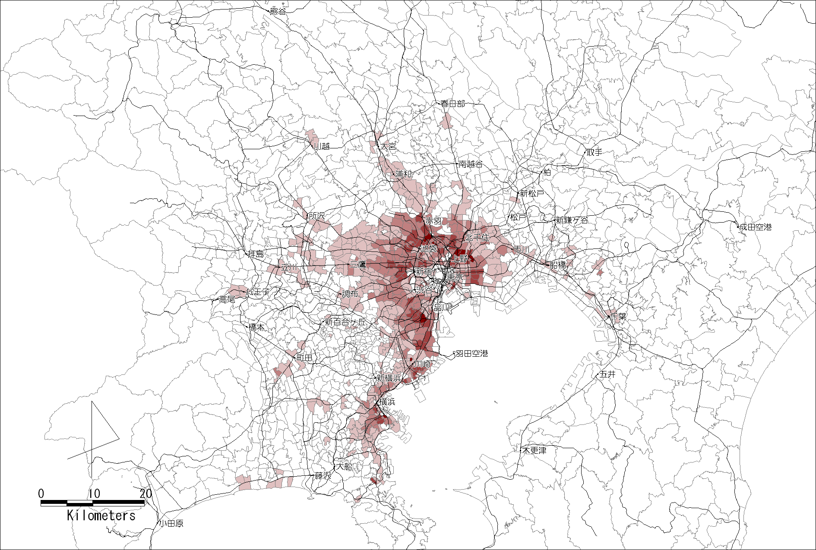
Night-time density of the elderly population, 2000
(person / ha)
Figure 5. Night-time elderly population density in Tokyo Metropolitan Area in 2000

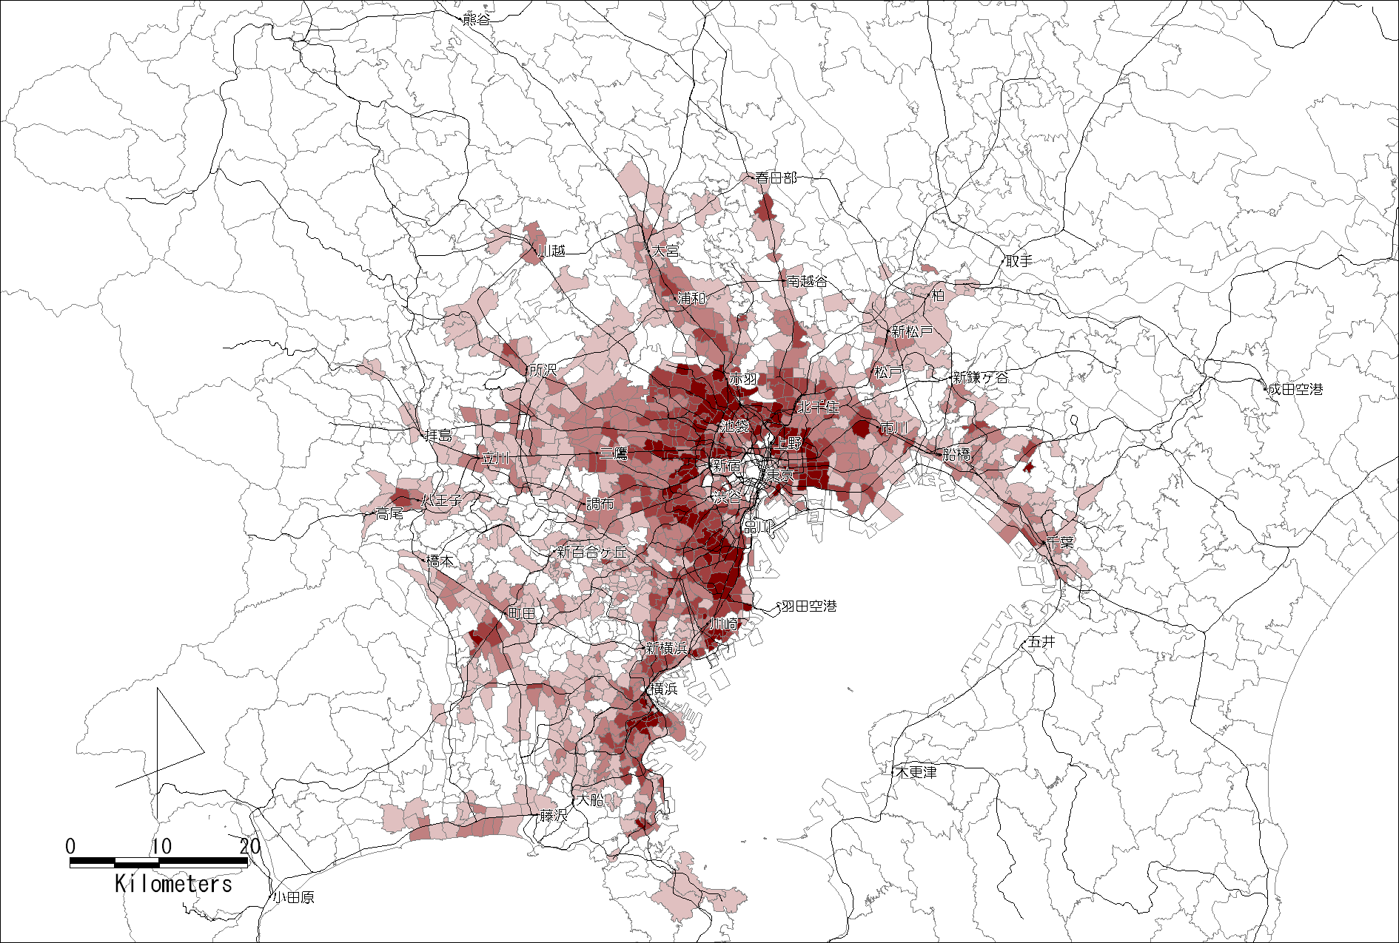
Night-time density of the elderly population, 2015
(person / ha)
Figure 6. Night-time elderly population density in Tokyo Metropolitan Area in 2015

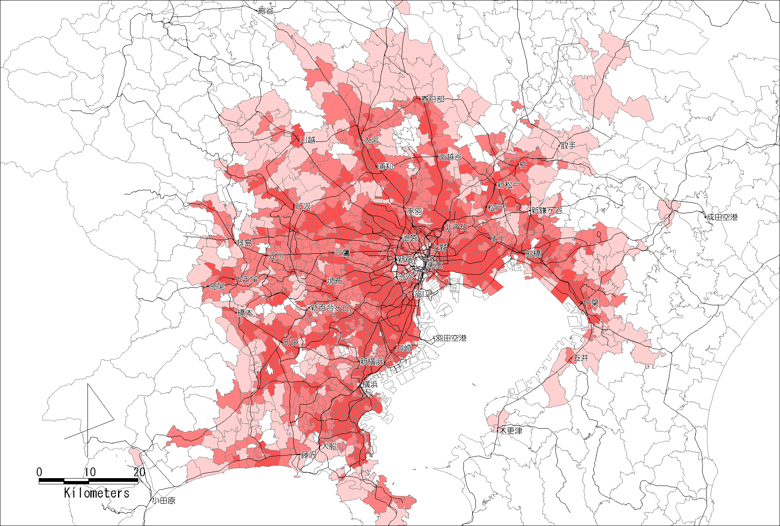
Difference in night-time density of the elderly population, 2000 -2015
(person / ha)
Figure 7. Difference between 2000 and 2015 night-time elderly population density

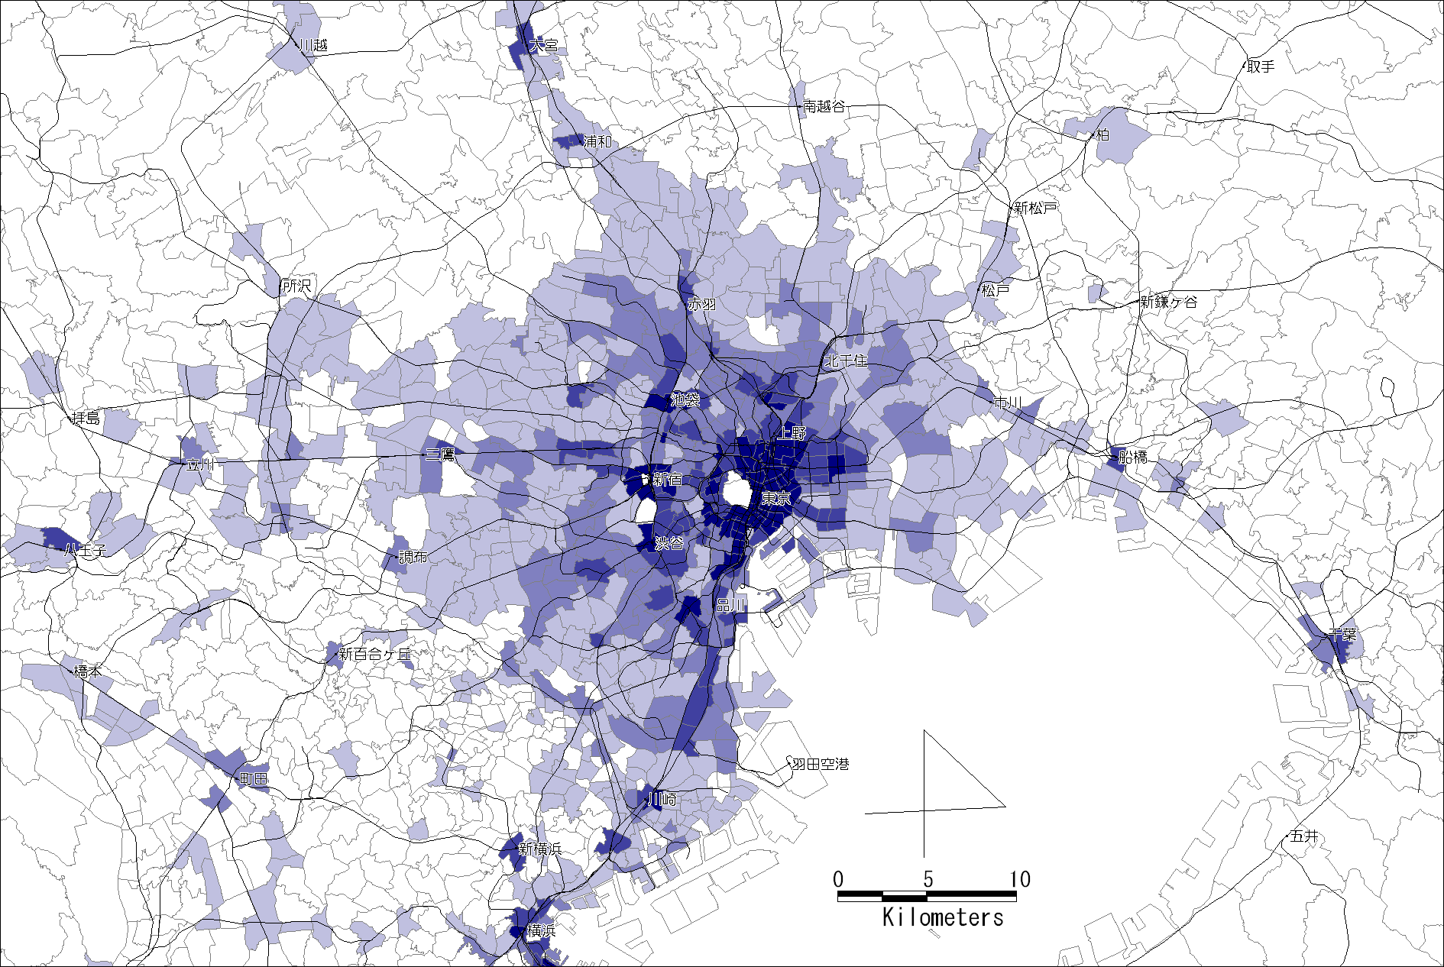
Day-time population density of the elderly employees, 2000
(person / ha)
Figure 8. Day-time population density of the elderly employees, 2000

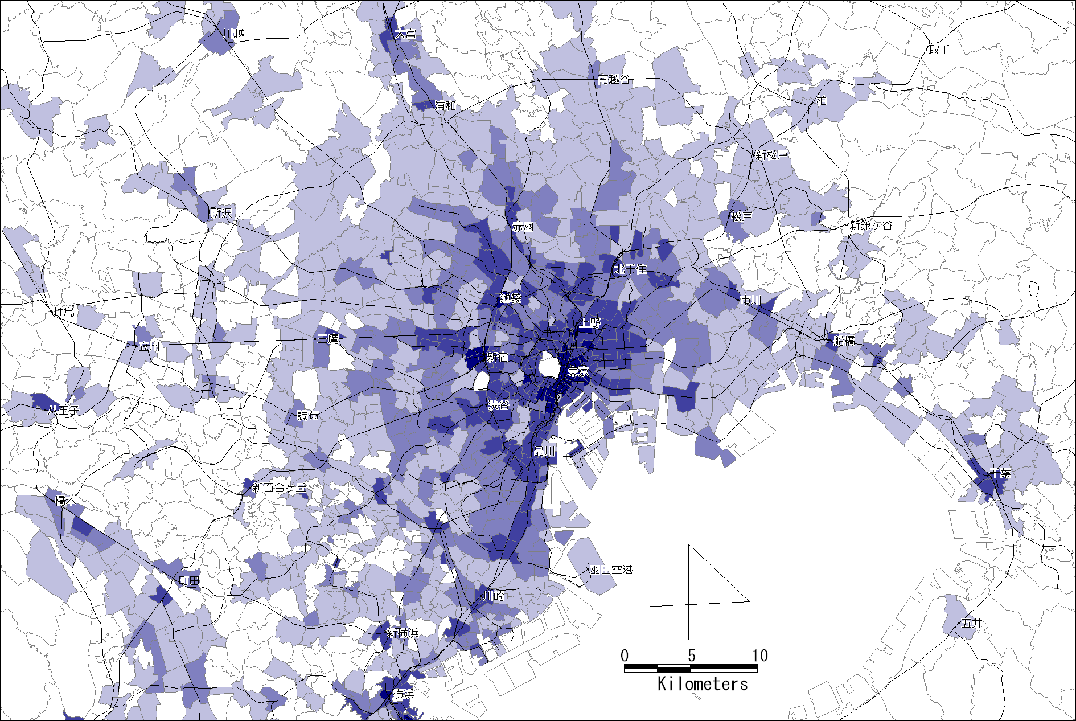
Day-time population density of the elderly employees, 2015
(person / ha)
Figure 9. Day-time population density of the elderly employees, 2015

Figure 10. Research analytical flow

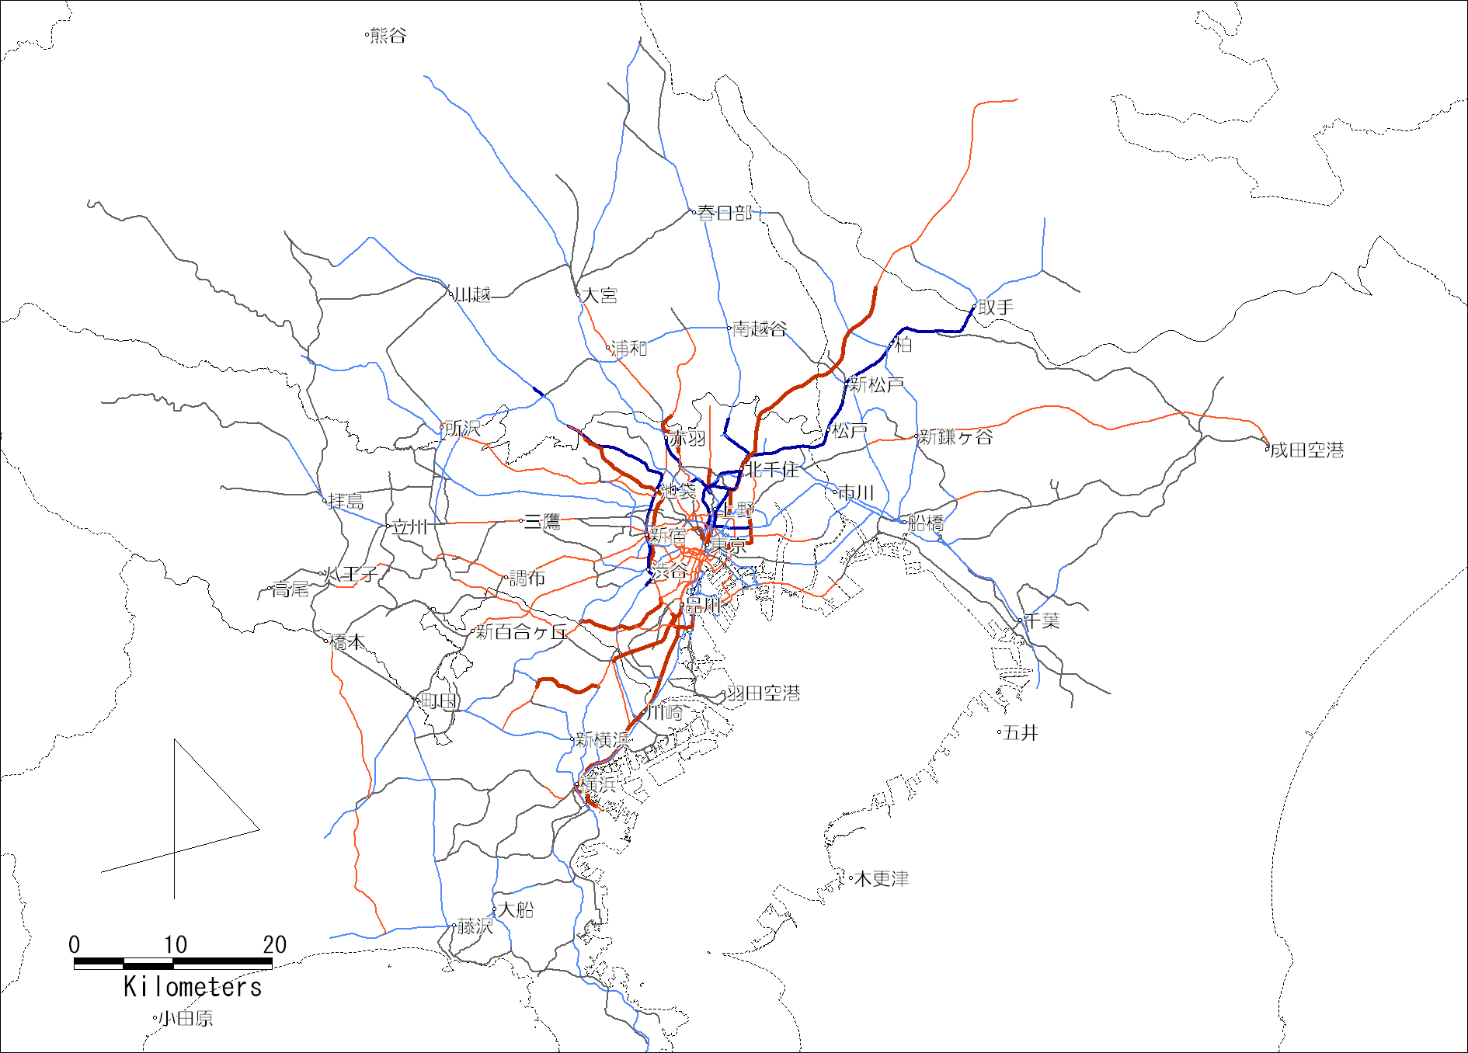
Differential of passenger flow for all purposes, 2000-2015
(thousand persons / day)
Figure 11. Difference between 2000 and 2015 passenger flow for all purposes

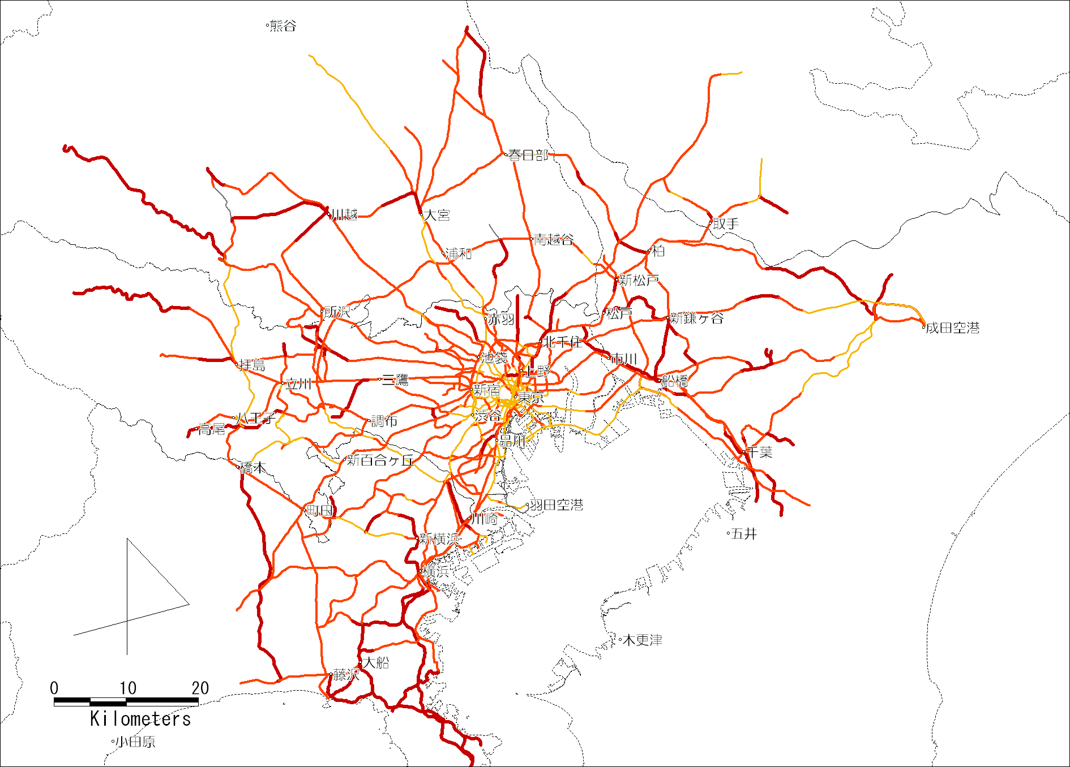
Differential of percentage of elderly passenger flow for private purpose, 2000-2015
(point)
Figure 12. Difference between 2000 and 2015 percentage of elderly passenger flow for private purpose

Table 1. Pace of change from aging society to aged society in East Asian countries
Country | Aging Society | Aged Society | Time span of the change  (years)
Japan | 1970 | 1994 | 24
Philippine | 2026 | 2049 | 23
Thailand | 2005 | 2027 | 22
Indonesia | 2019 | 2041 | 22
Korea | 1999 | 2017 | 18
Singapore | 2000 | 2016 | 16
Source: National Institute of Population and Social Security Research (2006)

Table 2. Parameter Estimates of mode choice model
Trip purpose  Variable name | Estimated Parameters
Trip purpose  Variable name | Home-to-work | Home-to-school | Private | Business
Total time(min) | -0.214 | -0.193 | -0.210 | -0.200
Total time(min) | (26.1) | (42.2) | (42.8) | (24.2)
Total cost(yen) | -0.00472 | -0.0101 | -0.00777 | -0.00463
Total cost(yen) | (1.6) | (13.0) | (7.59) | (1.88)
Walking | 2.57 | 1.11 | 1.94 | 1.78
Bicycle | -2.86 | -2.27 | -2.59 | -2.61
Car | -4.57 | -4.54 | -4.74 | -3.83
Likelihood ratio  Observations | 0.209 | 0.275 | 0.334 | 0.255
Likelihood ratio  Observations | 8349 | 7556 | 9874 | 2927
Value of Time (yen/min) | 45 | 19 | 27 | 43

Table 3. Parameter estimates of railway route choice model
Trip purpose  Variable name | Estimated Parameters
Trip purpose  Variable name | Home-to-work | Home-to-school | Private | Business
Line-haul time (min) | -0.0751 | -0.0524 | -0.0589 | -0.0803
Line-haul time (min) | (-3.6) | (-2.6) | (-3.3) | (-2.1)
Transferring time includes waiting time (min) | -0.114 | -0.120 | -0.105 | -0.134
Transferring time includes waiting time (min) | (-6.4) | (-6.3) | (-4.4) | -(2.5)
Fare (yen) | -0.00188 | -0.00526 | -0.00538 | -0.00186
Fare (yen) | (-1.9) | (-2.4) | (-4.6) | (-1.3)
Log Sum Variables  (Station Access) | 0.586 | 0.651 | 0.758 | 0.642
Log Sum Variables  (Station Access) | (8.9) | (8.7) | (6.2) | (3.6)
Congestion index | -0.0115 | -0.00909 | - | -
Congestion index | (-2.4) | (-1.5)
Ratio of two variances | 0.183 | 0.260 | 0.0794 | 0.506
Ratio of two variances | (2.3) | (2.4) | (1.6) | (1.1)
Likelihood ratio  Observations | 0.309 | 0.277 | 0.449 | 0.192
Likelihood ratio  Observations | 1398 | 1254 | 574 | 483
Line-haul VOT (yen/min) | 40.1 | 10.0 | 10.9 | 43.2
Transferring VOT(yen/min) | 60.5 | 22.8 | 19.5 | 72.2
Station Access VOT(yen/min) | 66.8 | 23.9 | 29.6 | 69.0

Table 4. Parameter estimates of access and egress mode choice model
Trip purpose  Variable name | Estimated Parameters
Trip purpose  Variable name | Home-to-work | Home-to-school | Private | Business
Total time(min) | -0.214 | -0.193 | -0.210 | -0.200
Total time(min) | (26.1) | (42.2) | (42.8) | (24.2)
Total cost(1000yen) | -4.72 | -10.1 | -7.77 | -4.63
Total cost(1000yen) | (1.6) | (13.0) | (7.59) | (1.88)
Walking | 2.57 | 1.11 | 1.94 | 1.78
Bicycle | -2.86 | -2.27 | -2.59 | -2.61
Car | -4.57 | -4.54 | -4.74 | -3.83
Likelihood ratio  Number of samples | 0.209 | 0.275 | 0.334 | 0.255
Likelihood ratio  Number of samples | 8349 | 7556 | 9874 | 2927
Value of Time (yen/min) | 45 | 19 | 27 | 43

