Option generation tools for sustainable urban transport strategies

Anthony D May, Ann Jopson, Sarah Gawthorpe and Charlotte Kelly,
Institute for Transport Studies, University of Leeds
Leeds LS2 9JT, England

and Andrew Cook and Graham Tanner, University of Westminster

Abstract

While techniques for identifying urban transport problems, predicting the effects of possible solutions and appraising their performance are well developed, there is a significant gap in the decision-making chain relating to the generation of those possible solutions. A literature review has identified a number of option generation methods in other sectors which are of potential application to transport. It categorises them into “inside the box” methods which are principally quantitative, and draw on a pre-existing list of solutions, and “outside the box” methods which are more qualitative, but potentially better able to generate wholly novel solutions. It also distinguishes between applications at the levels of formulation of an overall strategy and of detailed design of a particular scheme. An “inside the box” method for strategy option generation is being developed building on the capabilities of an existing web-based knowledgebase, KonSULT. The design principles are described and potential further developments using graphical user interfaces outlined.

1 Introduction

Transport planners face wide ranging challenges in attempting to create more sustainable urban transport systems (ECMT, 2002; DGEnv, 2005). Fortunately they have access to an increasingly wide range of policy instruments. No longer is the focus simply on adding to the transport infrastructure and managing it more effectively; possible solutions can be found also in the fields of land use planning, awareness raising, information provision and pricing (KonSULT, 2006). Guidance is available on the likely impacts of this range of policy instruments (KonSULT, 2006), how to develop strategies based on them and how to appraise them (WEBTAG, 2006). However, very little guidance is available on how to select potentially suitable policy instruments in the first instance; a challenge that has become more significant as the number of possible policy instruments has expanded.

We refer to this process as Option Generation. In the logical structure recommended by PROSPECTS, shown in Figure 1 (KonSULT, 2006) or in greater detail elsewhere (WEBTAG, 2006), planners need first to specify the objectives which they seek to achieve, and the problems which they face, now or in the future, and which are evidence of the objectives not being met. This is the point at which they can begin to identify possible solutions. These can be overall strategies, which will almost certainly involve a number of policy instruments such as a combination of road pricing, bus service improvements and fare changes (May et al, 2005); a specific policy instrument on its own such as road pricing; or the detailed design of a given policy instrument, such as the specific location of a road pricing cordon. Option Generation is needed at all of these levels: the strategy; broad scheme options; and detailed scheme design.

[Figure 1 about here]

What evidence there is suggests that Option Generation is rarely regarded as a key stage in the strategy or scheme formulation process. A recent study for the UK Department for Transport of its Local Transport Plan process (Atkins, 2005) suggests that local authorities, in England at least, tend not to innovate, but rather to pursue schemes which have been under consideration for a long period, and to focus on infrastructure projects and management-based improvements to the infrastructure, rather than considering enhancements to public transport or ways of managing demand.

This is one of the challenges which is being addressed in a four year UK research programme, DISTILLATE (Design and Implementation Support Tools for Integrated Local Land use, Transport and the Environment), which is described more fully in a companion paper (May, Page and Hull, 2007). The programme involves seven integrated projects: one which reviews the barriers which local authorities face in seeking sustainability; one on the use of indicators (Marsden et al, 2006); the one reported here on option generation; one on enhancements to predictive models (Shepherd et al, 2007); one on enhanced appraisal (Jopson et al, 2007); and one on institutional structures and processes. At an early stage in DISTILLATE the 16 local authority partners were asked to assess the barriers which they faced (Hull and Tricker, 2005). Half considered the generation of strategy options problematic, while only a quarter found generation of scheme options difficult. At a strategic level, national guidance and professional judgment dominated the sources of information, followed by stakeholder input. Under a quarter identified option generation tools as currently making an important contribution. Dissatisfaction was greatest with the lack of available tools, followed by that with national guidance. Over half of those who responded thought it important to have access to option generation tools.

This survey confirmed the importance of a focus on option generation and, in particular, on tools for strategy option generation. The project pursued these initially through a literature review in transport and in other sectors, the principal findings of which are outlined in Section 2. That review identified two broad types of approach: “inside the box” methods which are typically quantitative in nature and draw on pre-existing concepts and components, and “outside the box” methods which are typically qualitative and are able to identify radically different approaches (Jones et al, 2006). It was agreed to develop four specific option generation methods for further testing: two “inside the box” and two “outside the box” methods with one of each operating at the strategic and one of each at the scheme level.

This paper focuses on the development of the “inside the box” method for strategy option generation, which is based on an existing knowledgebase, KonSULT (Knowledgebase on Sustainable Urban Land use and Transport (www.konsult.leeds.ac.uk). Further information on the three other methods can be obtained from the programme website (www.distillate.ac.uk). Section 3 describes KonSULT. Section 4 explains the enhancements which have been made to KonSULT to allow it to operate more effectively as an option generator for the sets of policy instruments to be potentially included in a strategy. Section 5 outlines ideas on generating appropriate combinations of such strategies. Section 6 describes the approach to be adopted to testing the new tool in practice. The tool will be operational by the time of the conference, and we hope that participants will be able to contribute to the testing and enhancement process.

2 The literature review of option generation methods

2.1 The range of methods

A comprehensive review of option generation techniques (presented in Jones and Lucas, 2006) was conducted to identify new techniques and approaches to assist transport planners in generating alternative options at the strategy and scheme level. This section looks in turn at some of the different approaches that were identified as potential option generation techniques that either are currently widely applied in the transport field (e.g. databases such as KonSULT) or that could be transferred from other sectors (e.g. mind mapping).

Hull and Tricker (2005) found that transport planners narrow down the potential options available to them based on their experience of ‘what works’. Jones and Lucas (2006) concluded that this approach works under many scenarios, but “where a significant step change in policy making and travel behaviour is required more innovative and radical solutions may be necessary”. These two approaches (applying ‘what works’ and the more innovative options) can be classified respectively as ‘inside the box’ and ‘outside the box’ techniques. Table 1 provides a summary of these two categories. ‘Inside the box’ option generation techniques make use of existing knowledge and either apply it directly to new contexts (e.g. library based approaches) or use the foundations of this knowledge to create alternative options (e.g. morphological box). ‘Outside the box’ methods tend to involve more qualitative techniques allowing decision makers to generate new forms of options that have previously not been considered. These two categories of methods do not work in isolation; any solutions generated by the ‘outside the box’ techniques will become part of the ‘inside the box’ solutions once they have been applied and evidence on effects collated. Some examples of methods identified by the review are provided in Table 1.

[take in Table 1 about here]

2.2 Inside the box methods

‘Inside the box’ methods are commonly used in transport planning utilising both professional knowledge on ‘what works’ and an evidence base built up from the application of certain policy instruments and the results they achieve. This category can be split into three main approaches: library based approaches, morphological box approach and constrained options approach.

Library based approaches have been used for many years by decision makers seeking to solve specific problems or meet agreed policy objectives by referring to databases of evidence and research on policy instruments. For example KonSULT provides evidence on the likely effects on specified objectives of a range of policy instruments. Decision makers then use this information to determine the suitability of specific policy instruments for their purpose. In recent years library based approaches have utilised the Internet to disseminate information. A number of library based approaches in the transport industry, including KonSULT(2006) and the VTPI transport demand management encyclopaedia (VTPI, 2006), have developed internet based search facilities for assessing policy instruments. The key advantage of these library-based approaches is the wide selection of evidence that is brought together, so enabling a large number of options to be considered by transport planners. The key disadvantage is that there may be solutions not in the database that would be more suitable for the specific objectives or locations that are being considered.

Morphological box analysis was first developed by Fritz Zwicky (Zwicky, 1947) as a structure for systematically identifying the complete set of potential permutations for designing a particular aeronautical system. Current applications of morphological analysis utilise this basic methodology to provide a structure to illustrate the range of choices available for a particular instrument or strategy. Once all the options are identified and input into the matrix (morphological box), and any infeasible options eliminated, it is then easier to consider all the potential combinations that could be used to design a particular policy and also identify where the gaps exist in the current options available. The main challenge with the morphological box approach is to narrow down the very large number of potential combinations, by rejecting infeasible sub-sets of combinations. This methodology has been recently been transferred to the transport planning sector through the work presented in Kocak et al (2005). They developed a web based tool to assist local authorities in the UK to investigate the suitability, and then the possible design, of a road user charging scheme for their local area. This approach relies on decision makers knowing all the possible permutations (policy parameters), making use of the library-based approach to generate this information. Its advantage is that it allows options that are infeasible for specific criteria to be removed from the decision, and at the same time potentially creating new permutations that have not previously been considered by decision makers.

The final group of ‘inside the box’ methods is constrained option solutions. These methods are similar to the morphological box approach as they present a range of possible permutations of options to the decision-maker, however the difference is that these options are constrained, in most cases by imposing a budget on the options that can be selected. The priority evaluator is an example of this type of methodology. Hoinville (1971) developed the priority evaluator method to gauge community preferences for improvements to a local area. Participants were presented with a range of attributes in their local community that could be improved and a range of levels to which each option could be improved (including not improving a specific attribute). They were then presented with a budget and told to allocate this budget among the given attributes, so indicating what they would prefer to improve. This type of methodology has also been applied by the ARTISTS project (ARTISTS, 2006). In this project the public was asked how they would like to reallocate highway space along a selection of mixed use urban streets and instead of a budgetary constraint a spatial constraint was imposed on the decision. The key advantage of constrained option solutions is that they introduce an element of feasibility.

2.3 Outside the box methods

Jones and Lucas (2006) identified three main types of ‘Outside the box’ methods that are commonly used: structured approaches and visual and verbal unstructured approaches.

One of the main examples of a structured approach to ‘outside the box’ option generation is mind mapping. It is structured because it is based around a central theme and the aim is to collate all possible links to this central theme. Under this approach potential solutions that had not previously been considered can be generated from new previously unconsidered links to this central theme. Another example of the structured approach is the de Bono (1985) ‘six thinking hats’ technique. Under this approach participants are led through a problem to find potential solutions by taking a different perspective on the problem each time they put on one of the six hypothetical coloured hats. Each of the colours stands for a different perspective. For example when putting on the black hat the participant focuses on the negative analytical approach and when putting on the green hat they focus only on new ideas. These structured approaches allow different and potentially new solutions to be generated for a specific problem. The negative side is that they may generate options that may be unfeasible, which is the key advantage of the ‘inside the box’ methods.

The other methods identified by the review use verbal or visual stimuli to generate options. An example of verbal stimuli is brainstorming, which involves suggestions, discussion on those suggestions and then agreement. Other examples are lateral and creative thinking techniques, which through the use of discussion allow individuals and groups to generate options to specific solutions that may not have been considered. This process is described by de Bono as a “way of thinking that seeks a solution to an intractable problem through unorthodox methods or elements that would normally be ignored by logical thinking” (de Bono Homepage, 2006). Jones and Lucas (2006) identified Eureka as an example of using visual stimuli to generate options. This technique “presents participants with unrelated objects or ideas, and asks people to find a significance or association in their juxtaposition (Townsend and Faviour, 1991)”. The results are then related back to the problem in question. The advantage of these unstructured approaches is that the participants using the option generation methodology can think about the problem without the bias of considering what the ‘experts’ think works or knowing what policies have worked well in similar scenarios, so potentially generating feasible new options.

3 The KonSULT-based option generation tool: background

As indicated in Section 1, this paper describes the “inside the box” tool being developed for strategicx option generation. It combines the principles of a library tool, KonSULT, described in this section and further developed in Section 4, and a morphological box analysis, which is described in Section 5.

3.1 Development

KonSULT is a web based knowledgebase designed to provide up to date evidence on the performance of a wide range of transport and land use policy instruments. It is aimed at professional transport planners at all levels of responsibility, but also at decision-makers, interest groups and members of the public concerned about transport problems. It was developed with support from the UK Engineering and Physical Sciences Research Council, the UK Department for Transport, the Rees Jeffreys Road Fund and a number of specific research grants led by the University of Leeds with inputs from many international partners. A more detailed description of its development can be found in Jopson et al (2004) and May and Taylor (2002).

The list of 60 policy instruments for potential inclusion was developed on the basis of a taxonomy from earlier work by May and Still (2000) and extended by Matthews and May (2001). These instruments are grouped into six categories of land use interventions; behavioural and attitudinal measures; infrastructure projects; management and operational measures; information provision; and pricing. To date the knowledgebase has been populated with 40 of the 60 instruments with new information added when it becomes available (www.konsult.leeds.ac.uk).

3.2 Structure

A consistent approach has been undertaken for describing the structure of each instrument. This covers:
- a taxonomy and description, which defines the instrument, its aims and technological requirements;
- a first principles assessment which looks at why that instrument should be introduced, considers its anticipated demand and supply impacts, assesses the resulting positive or negative contributions to key policy objectives and problems, and identifies likely winners or losers and barriers to implementation;
- evidence on performance, illustrated with a series of case studies describing specific interventions, and empirical evidence on their impacts on the same set of objectives and problems examined within the first principles assessment;
- a summary of the contribution which the instrument is expected to make and the contexts in which it is likely to be most effective;
- an identified set of complementary instruments that would work well with the selected instrument by helping to overcome barriers or enhance its positive impacts.

To illustrate the impacts of each instrument and ensure a consistent methodology the same lists of demand and supply impacts, objectives, problems, barriers, and contexts are used to assess each instrument. The contribution of each policy instrument to each of these is assessed on a common eleven point scale illustrated in Figure 2. The scores assigned are judgmental rather than evaluative, and take account of qualitative and quantified performance, public perceptions and professional assessments. They are thus designed not to replace a formal cost-benefit analysis but to suggest policy instruments which might be developed for subsequent more detailed appraisal.

[Figure 2 about here]

3.3 Current search facilities

Within KonSULT users have the option to search for a specific instrument using a series of drop down menus, a key word search, hyperlinks from the complementary instruments section or a filter search. As illustrated by Figure 3, the filter search option allows users to specify their role and area type. They can also select the policy objectives, problems and strategies that they wish to investigate.

Based on their preferences, KonSULT will give a ranked list of policy instruments that meet the criteria selected. Each policy instrument is rated using its individual assessment scores on the eleven point scales, with the scores added across the fields selected by the user. The user is then given a ranked list of possible instruments. These are offered not as a prescribed solution but as options for further examination.

[Figure 3 about here]

3.4 Weaknesses

The filter search was developed experimentally at an early stage in the preparation of KonSULT, and used a simple additive rule for the scores for all the attributes which the user specified. It was limited to the ten policy instruments on which information was then available. At the outset of work on DISTILLATE, this filter search facility was identified as a potentially valuable option generation tool. However, a number of weaknesses were evident:
- it only applied to the first ten instruments, and was inflexible in its design;
- the implications for different user types were unclear;
- the listing of area types was somewhat inconsistent, and it was unclear how instruments could be selected for different areas in ways which achieved some spatial consistency;
- the ability to select both objectives and problems led to a degree of double counting;
- there was no facility for identifying the relative importance of different objectives (or problems);
- there had been a growing emphasis on the use of indicators and targets (Marsden et al, 2006), yet users were unable to select or prioritise indicators;
- the additive nature of the selection rules led to inconsistencies in the shortlisted instruments and their performance scores.

At the same time, the method was only suited to identifying individual instruments; it could not suggest a combination of policy instruments which might form an effective integrated strategy. It was agreed that further work was needed to overcome these weaknesses and hence strengthen the role of KonSULT as a strategy option generation tool.

4 The KonSULT-based option generation tool: development

4.1 The approach adopted

The development of KonSULT has proceeded in two stages. The first stage is designed to address weaknesses (a) to (g) above, and is described in this Section. The second stage tackles the issue of generating packages of instruments and overall strategies, and is outlined in Section 5. Both will subsequently be tested with end users, as indicated in Section 6.

Work on the first stage involved enhancing the individual fields within the filter search, enhancing the logic for scoring in individual fields and aggregating those scores, and determining the form of output. A deterministic, transparent approach has been adopted which retains as much flexibility as possible for the user, while enabling both user and researcher to identify, in the testing stage, any attributes which are causing problems.

4.2 The user type field

This facility is designed to permit users to identify only the instruments which they are able directly to influence and implement. The default output will be that the user is assumed to be interested in the full set of instruments. A binary (1,0) code against each instrument indicates whether it is available to a specified user type in the look up table. Only those instruments with a (1) code for the user type specified is then output in the priority list. Users are able to pick more than one user category, and where they do, instruments available to any one or more of the selected user types are listed. The user types that will be available for selection are:
- Decision makers from national organisations (e.g., government, regulatory bodies, highways agencies)
- Decision makers from regional organisations (e.g., regional assemblies, development agencies)
- Local authority decision makers (e.g., city councils, local land use and transport planners).

4.3 The area type field

This facility enables the user to specify the type of area being studied. The filter search draws on the KonSULT assessment of the potential effectiveness of a given instrument in the specified spatial context. This uses a 0-5 rating scale, which is normalised to a 0-1 scale indicating applicability for the filter search. The user is able to select one area type, either by settlement type (large town or city >100k; small town or city <100k), or city area (town or city centre, inner suburb, outer suburb, district centre, corridor), or to specify “any area type”. For each instrument, the score for other attributes is then factored by the normalised context score. If “any area type” is selected a normalised default score of 1 is used.

4.4 Treatment of objectives, problems and indicators

The treatment of objectives, problems and indicators is the most complex aspect of the filter search. Users are able to generate policy instruments according to the indicators, objectives or problems that they are most concerned about, by selecting from the appropriate list. The objectives, problems and indicators can be seen in Figure 4; the list of proposed indicators is outlined below. Users are only able to select from one of these lists to avoid double counting, so their first step is to decide whether they wish to focus on objectives, problems or indicators. Users are able to select multiple options from their chosen list, and are then given the opportunity to weight their selected objectives (or problems, or indicators) in terms of relative importance to them. The weighting system uses a score of 1 to 5 (5 = high importance, 1 = low importance), with weightings then being normalised to give weights summing to 1. The default is that all selected objectives (or problems, or indicators) have equal weights summing to 1.

[Figure 4 about here]

The search facility then draws on the score from KonSULT which assesses the contribution of each instrument to the selected objectives (or problems, or indicators) on the eleven point -5 to +5 scale (as described in section 3), which is normalised to -1 to +1. Where several objectives (or problems, or indicators) are selected, the scores for a given instrument are factored by the weights determined by the user and summed over the selected objectives (or problems, or indicators).

The agreed sets of objectives and problems from which users can select are those that already existed within the initial KonSULT filter system, as outlined in Section 3. A new set of outcome and intermediate outcome indicators has been developed based on the work of the indicators project in DISTILLATE (Marsden et al, 2006). The proposed indicators are:

- Objective: Efficiency
  - Congestion (average time lost per person km travelled)
  - Bus reliability
- Objective: Liveable streets
  - Proportion of people who think it is easy and safe to walk in their area
- Objective: Protection of the environment
  - CO₂ emissions
  - Local air pollution
  - Energy efficiency (per trip)
- Objective: Equity and social inclusion
  - Accessibility to key services (based on approximate time thresholds)
  - Access to health care
  - Average cost of journey
- Objective: Health
  - Walking modal share
  - Cycling modal share
- Objective: Safety
  - Killed or seriously injured casualties
  - Slight casualty rate
- Objective: Economic Growth
  - Regional GDP
- Objective: Finance
  - High, medium or low cost policy instrument.

Assessments of each policy instrument within KonSULT against this set of indicators will be added to the KonSULT material within the First Principles sections.

4.5 Treatment of strategy

This facility operates much as that for indicators, objectives or problems. The user is able to select one or more strategy elements (see Figure 3 for the options), and if more than one is selected the user has the opportunity to weight them. The weighting and scoring operate as for the indicators, objectives or problems above. Where no strategy is specified a default score of 1 will be used.

4.6 Calculating the instrument score

The scoring system for each of user type; area type; objectives, problems or indicators; and strategies has been described above. The aggregate scoring system is described below.

The overall score for Instrument I is calculated using equation A.

${\text{Score}}_{I}={\text{UserType}}_{I}∗{\text{AreaType}}_{I}∗{\text{Objective}}_{I}∗{\text{Strategy}}_{I}$ Equation A

Where I is the instrument of concern. Note that depending on the user’s selection, Objective_{I} can be replaced by Indicator_{I} or Problem_{I}.

The user type score is based on a simple binary selection:

${\text{UserType}}_{I}=(0,1)$ Equation B

The area type score is based on a normalised scale:

${\text{AreaType}}_{I}=(0≤{\text{AreaType}}_{I}≤1)$ Equation C

The objectives (or problems or indicators) score is based on:

Objective_{I} = $\sum_{o}{W_{o}∗O_{I}}$ Equation D

where $\sum_{o}{W_{o}=1}$ Equation E

and -1 < O_{I} < 1 Equation F

Where W_{o} is the weight for Objective O and O_{I} is the objective score for instrument I.

The strategy score is weighted in a similar way using weights W_{S} for strategy S and scores S_{I} for instrument I.

4.7 Planned outputs

Users are provided with a list of instruments ranked in descending order of score, with the normalised scores factored by 100. A number of filters have been included to avoid over-long lists. Users can filter by the number of instruments, a minimum score achieved (e.g.>20), the type of instrument (e.g.pricing), and the cost or a combination of the above. For example Figure 5 provides the output from the KonSULT option generation tool using the filter criteria of scores > 20.

[Figure 5 about here]

The list of instruments includes the name of the instrument as a hyperlink to the relevant KonSULT pages, the score, and an indication of whether the instrument is a high, medium or low cost measure in terms of implementation and operating costs. This is made on the following basis:
- High cost: infrastructure measures;
- Medium cost: operational and regulatory activities, traffic management and information systems;
- Low cost: behavioural and other readily implemented measures;
- Neutral cost: pricing measures that will pay for themselves over time.

It is possible to save each output file, so that the user can go back to the filter search, make different selections, and compare the different sets of results.

5 Building on KonSULT functionality

The second stage of the development of KonSULT is concerned with the generation of packages of instruments.

5.1 Library files and graphical user interfaces

In Figure 6 we show a conceptual data flow of the functionalities incorporated, and others which are being considered. Figure 6 differentiates, in broad terms, between library files, which are fixed data structures, populated according to transport planning expertise (on the left), and various graphical user interfaces and dynamic user-outputs on the right.

In essence, the processes already described in the first development stage of KonSULT take us to output [G], a ranked list of outputs, based on user choices and library-based calculations. At this stage, the user is able to refine the choice of scored instruments that are to be considered towards the generation of packages. An external package-development tool (PDT) now takes over, with the ranked list being exported from KonSULT as a delimited-text file, enabling parsing by the PDT.

[Figure 6 about here]

5.2 Development of packages

Once the KonSULT output has been imported into the package-development tool, the user selects the instruments to include from a full scored list - this also allows for the re-introduction of ones excluded from the list displayed in KonSULT. Instrument packages are then built based on the surviving set of instruments, with instrument interactions being assessed for synergies (May et al, 2006). We envisage two possible ways of achieving this.

The first would involve consulting the Complementary Instruments material within KonSULT. For each policy instrument, a complementary instruments table indicates which instruments can reinforce its benefits, which instruments can help overcome any financial and political barriers to its implementation, and which instruments can help compensate any “losers” disadvantaged by the instrument in question. An example Complementary Instruments table is shown in Figure 7. A multiple instrument interaction matrix [C] could be used to incorporate these assessments.

[Figure 7 about here]

The second (and employed by the PDT) would use the concept of synergy in a more aggregate way, with a single interaction matrix [C]. In the example shown in Figure 4, if Instrument 1 (“I1”) and Instrument 2 (“I2”) combine to produce a synergy with a score of “+10” (from [C]), and the Instrument scores are 56 and 54 (from [G]), then the combined score is 120 (i.e. I1 score + I2 score + 10 = 56 + 54 + 10 = 120 (see [H])).

This raises the question of the dependency of these interactions on the objectives/problems/indicators chosen by the user. For example, the synergy of +10 might well be expected to vary according to the context of the objectives/problems/indicators (or even the user type). The default solution to this would be to use the same interaction matrix [C] in each situation, thus relaxing the synergies to be independent under each scenario. Alternatively, in subsequent work, it would be possible to either populate multiple, context-sensitive versions of [C], or, as a simpler option, to develop a rulebook approach, [D], which adjusted the values in [C] according to pre-defined rules and conditions.

5.3 Area representations

Another opportunity for development is represented by [F], which indicates the potential to incorporate a pictorial representation of the (type of) area of interest to the user, which could be developed in one of three ways:
(i) the user selects from a set of existing templates, which could be binary-matched to pre-existing library files [F pictorial ‘weights’];
(ii) by using a free-draw ‘ball-and-stick tool’ to specify the key characteristics of the area under consideration, which could be matched (probably using graph theory) to pre-existing library files [F pictorial ‘weights’] using key parameterisations such as linearity, radiality and central arteriality;
(iii) through a more topological free-draw map, which does not map to a library file, but rather facilitates the user in their thinking of the spatial relationships involved in the area(s) of interest.

5.4 Final output

Whether these optional features are incorporated or not, the user is in any case finally presented with a list of package combinations [J], the ultimate ranking being determined by the initial, user-defined selections and weightings, the instrument scores, the area types specified, the user refinement permitted at [G], and the instrument interaction (correlation) matrix [C].

This process thus furnishes the functionality of the ‘morphological box’, which we have discussed in Section 2. At this point in the Option Generation process, output produced is saved in a separate file (spreadsheet or delimited-text file format) allowing a comparison to be made between the packages produced by a series of runs of the PDT. Future development could additionally produce output as HTML, such that the user could read it directly in KonSULT.

6 Testing the product

The developments described in Sections 4 and 5 are complete, and it is planned to demonstrate them at the conference. In addition it is intended to test them in a number of practical situations in the UK. The first set of opportunities arise from the UK Department for Transport’s Transport Innovation Fund (DfT, 2006). This provides 50% funding for studies, and subsequently for strategies which include congestion charging or related price-based methods for reducing car use in urban areas. Local authorities have to bid for funding at each of a number of stages. In the first round, seven local authorities obtained support for studies into a range of options. These include the conurbations around Birmingham, Bristol, Manchester and Newcastle upon Tyne, the cities of Cambridge and Durham (which will add to its small existing scheme) and the town of Shrewsbury. In the second round the polycentric conurbation around Nottingham, Derby and Leicester together with Reading and Norfolk have been selected. All of these will need to develop integrated strategies which include pricing. The first group are already well advanced in doing this, but it is hoped that the second cohort will provide an opportunity for testing the option generation tool.

A key question for these provincial cities will be the extent to which they can influence public transport provision. London’s success has been due in part to its ability to channel revenues into enhancements in bus services and fares structures. Provincial cities are less readily able to do this because, in their deregulated environment, service patterns and fares are determined by private operators. There is now considerable pressure on government to change this, at least in those areas which commit themselves to congestion charging (Travers and Glaister, 2006). The option generation tool should be able to alert them to public transport policy options which they have not to date considered.

At a later stage all English local authorities will be expected to develop a third round of Local Transport Plans for the period 2011-6. The requirements for this process will be formulated over the next two years, but the Department for Transport is already aware that option generation has been a weak link in the second round of Plans (DfT, 2004), and is expected to promote enhanced methods for doing so.

At whatever stage the tool is tested, it will be important to adopt both a sequential and a cross-sectional approach. In the first, local authority users will be asked to apply the tool, comment critically on the outputs and then, with the researchers, investigate elements in the selection process which lead to unwanted instruments being output and preferred ones being excluded. Users will be asked to assess all stages of the process, including the instruments included in KonSULT, the attributes against which they are assessed, the scoring system, the weighting process, the aggregation process and the resulting outputs.

In the second, and subsequent approach, some local authorities would use the tool while others did not, to investigate to what extent users generated a richer or more effective set of policy instruments. We aim to seek the views of a wider range of users in this second stage.

On the one hand, these processes could help users realise benefits of instruments which they had not previously perceived, or implications of their preferences that they had not previously understood. On the other hand they could highlight elements in the deterministic selection rules which require enhancement.

References
ARTISTS (2006): www.tft.lth.se/artists/
W S Atkins (2005) Long term process and impact evaluation of the Local Transport Plan policy: interim report. London, Department for Transport.
de Bono, E. (1985) Six Thinking Hats. Little, Brown and Company: Boston.
De Bono, E. (2006). www.edwdebono.com
Department for Transport (2004) Full guidance on Local Transport Plans. London, Department for Transport.
Department for Transport (2006) The Transport Innovation Fund. London, Department for Transport.
Directorate General of the Environment (2005) Expert working group on sustainable urban transport plans. Brussels, DGEnv.
European Conference of Ministers of Transport (2002) Implementing sustainable transport policies: key messages to governments. Paris, OECD.
Hull, A and Tricker, R (2005) An assessment of the barriers to the delivery of sustainable local surface transport solutions. Proc European Transport Conference. London, PTRC.
Hoinville, G. (1971). Evaluating community preferences. Environment and Planning 3, pp. 33-50.
Jones, P., and Lucas, K. (2006) DISTILLATE Project B Option Generation http://www.distillate.ac.uk/reports
Jopson, A.; May, A.D.; Matthews, B. (2004) Facilitating evidence based decision-making - the development and use of an on-line knowledgebase on sustainable land-use and transport. Proceedings of 10th World Conference on Transport Research, Istanbul
Jopson A F, Menaz B and Page M (2007) Appraisal: a barrier to sustainable transport? Paper submitted to the 11th WCTR, Berkeley.
Kocak N., Jones P., and Whibley, D. (2005) Tools for Road User Charging Scheme Option Generation. Transport Policy 12, 5, pp. 391-405.
KonSULT (2006) www.konsult.leeds.ac.uk
Marsden, G., Kelly, C. and Snell, C. (2006) Selecting Indicators for Strategic Performance Management. Transportation Research record.
May, A. D., Still, B. J. (2000) The instruments of transport policy, Working paper WP545, Institute for Transport Studies, University of Leeds.
May A D and Taylor M A P (2002) KonSULT – developing an international knowledgebase on urban transport policy instruments. Presented at 25th Australasian Transport Research Forum, Canberra, October 2002
May A D, Shepherd S P, Emberger G, Ash A, Zhang X and Paulley N (2005) Optimal land use and transport strategies: methodology and application to European cities. Transportation Research Record.
May A D, Kelly C and Shepherd S P (2006) The principles of integration in urban transport strategies. Transport Policy (13).
May A D, Page, M and Hull, A (2007) Decision support tools for sustainable urban transport. Paper submitted to 11th WCTR, Berkeley.
Matthews, B and May A D (2001) Initial policy assessment. Deliverable 4, PROSPECTS. Leeds, Institute for Transport Studies.
Shepherd S P et al (2007) [paper being submitted to 11th WCTR, Berkeley]
Townsend, J. and Faviour, J.P. (1991) The Creative Managers Pocket Book, Alresford, Hampshire: Management Pocket Books Ltd.
Travers A and Glaister S (2006) Improving local transport: how small reforms could make a big difference. London, Local Government Association.
Victoria Transport Policy Institute (2006) Online Transport Demand Management Encyclopaedia: http://www.vtpi.org/tdm. VTPI, Victoria
WEBTAG (2006) Web-based Transport Appraisal Guidance. London, Department for Transport.
Zwicky, F. (1947) Morphology and Nomenclature of Jet Engines, Aero Engine Review, June 1947

Categories | Description | Approach | Examples
‘Inside the Box’ | Pre-existing solutions | Library based approaches | KonSULT(2006)  VTPI (2006)
‘Inside the Box’ | Existing parameters new permutations | Morphological box approach | Road User Charging (Kocak et al, 2006)  Zwicky (1947)
‘Inside the Box’ | Constrained options | Constrained by specific parameters | Priority Evaluator (Hoinville, 1971)
‘Outside the Box’ | Generating new forms of options including some new parameters | Structured Approaches | Mind/ cognitive mapping  Six Thinking Hats (de Bono, 1985)
‘Outside the Box’ |  | Unstructured Approaches: Verbal stimuli | Brainstorming
‘Outside the Box’ |  | Unstructured Approaches: visual stimuli | Eureka (Townsend and Faviour, 1991)
Table 1: Methods for outline option generation
Source: Adapted from Jones and Lucas (2006)
Figure 1

The Logical Structure

Figure 2: An example of the instrument contribution scores

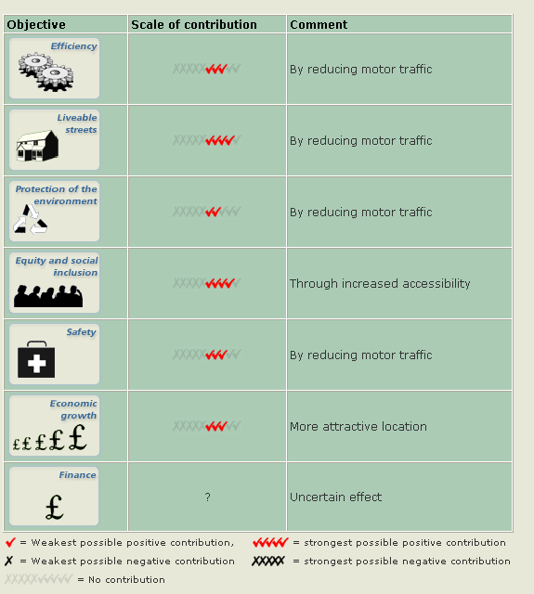
Figure 3 Original KonSULT Filter Search Screen

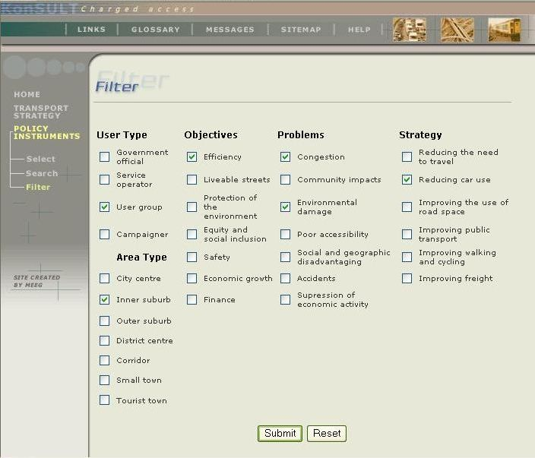
Figure 4 KonSULT Objectives, Problems and Indicator filter

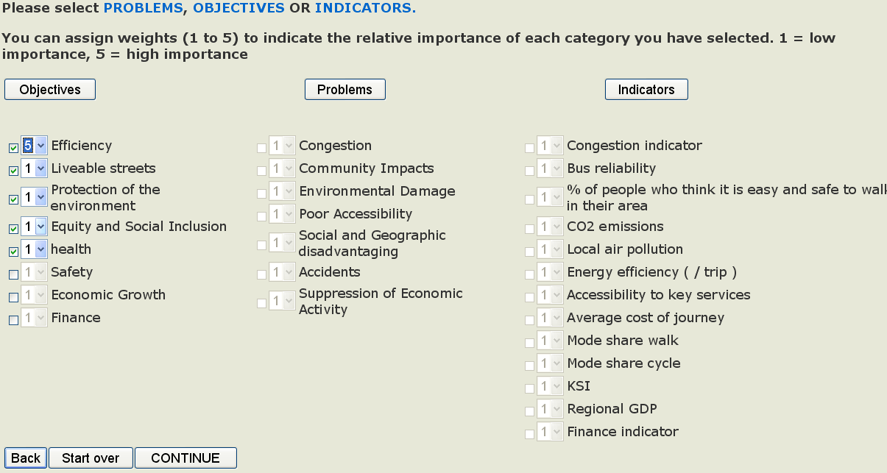

Figure 5 KonSULT Option Generation Output Example (presented for scores> 20)

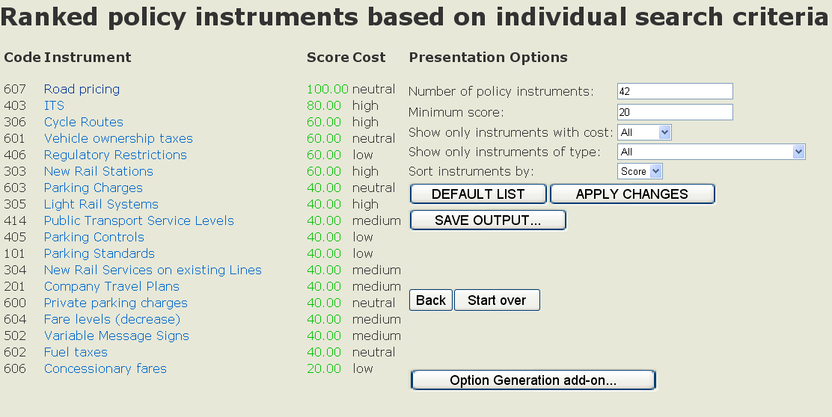

Figure 6 Data Flow functionalities

A] filter matrices (workbook)
filter type (e.g. ‘problems’)
P1 P2 P3 P4 P5 P6 P7 P8 …
instrument I1 2 2 3 4 5 1 0 -2
instrument I2 3 4 5 1 2 1 5 1
instrument I3 2 1 1 2 5 2 3 4
instrument I4 4 5 5 5 4 3 2 1
instrument I5 3 2 1 1 4 2 1 5
instrument I6 0 0 0 1 -4 5 5 2
. . . etc . . .
E] GUI 1 (select filters, assign weights)

Select filtersAssign weights

problems . . .P1 [1]
objectives . . .P2 [0]
indicators . . .P3 [4]
P4 [0]
P5 [2]
. . . etc . . .

C] instrument interaction matrix (worksheet)
instruments
I1 I2 I3 I4 I5 I6 I7 I8 …
instrument I1 - - - - - - - -
instrument I2 10 - - - - - - -
instrument I3 0 3 - - - - - -
instrument I4 0 0 0 - - - - -
instrument I5 0 -2 0 0 - - - -
instrument I6 0 0 0 -1 0 - - -
. . . etc . . .
J] build final list (CSV)

instr. I1 & I2 120
instr. I1 & I3 105
instr. I2 & I3 105
instr. I1 & I4 93
instr. I2 & I4 91
. . . etc . . .
B] area specification matrix (worksheet)
area type (e.g. city centre / linearity)
A1 A2 A3 A4 A5 A6 A7 A8 …
instrument I1 2 2 3 4 5 1 0 4
instrument I2 3 4 5 1 2 1 5 1
instrument I3 2 1 1 2 5 2 3 4
instrument I4 4 5 5 5 4 3 2 1
instrument I5 3 2 1 1 4 2 1 5
instrument I6 0 0 0 1 3 5 5 2
. . . etc . . .
D] instrument interaction rulebook (worksheet)
IF ‘area’ = 1 OR 4..5 / AND ‘objective’ NOT 1
THEN I1 ∩ I3 +1

IF ‘area’ = 2 AND NOT 3 / AND ‘objective’ NOT 2
THEN I6 ∩ I5 -2

. . . etc . . .

F] GUI 2 (describe area)

Verbal ‘weights’ Pictorial
‘weights’
city centre A1 [1] template X A5 [0]
inner suburb A2 [0] template Y A6 [1]
outer suburb A3 [0] template Z A7 [0]
district centre A4 [0] ---OR---
. . . etc . . . linearity A5 [4]
radiality A6 [1]
arteriality A7 [4]
H] build & adjust instrument combo scores
instruments
I1 I2 I3 I4 I5 I6 I7 I8 …
instrument I1 - - - - - - - -
instrument I2 120 - - - - - - -
instrument I3 105 105 - - - - - -
instrument I4 93 91 85 - - - - -
instrument I5 91 87 83 72 - - - -
instrument I6 88 86 80 68 65 - - -
. . . etc . . .
G] build ranked list

instrument I1 56
instrument I2 54
instrument I3 48
instrument I4 37
instrument I5 35
. . . etc . . .
Refine choice …

Figure 7 KonSULT Complementary Instruments Table

