The 11th World Conference on Transportation Research, Berkeley, USA,
24-28 June 2007

“Urban attractive centers” in
Niamey (Niger) and Puebla (Mexico)

Emmanuel RAVALET, Enrique BUENO-CEVADA
“Urban attractive centers” in
Niamey (Niger) and Puebla (Mexico)

Introduction

Thinking about preferences the city dwellers have for urban spaces is not an easy task, as it comes down to broach their relationship with the city. Their views and/or their behaviors are in fact the carriers of their diverse and changing “values” of neighborhoods. In this paper we study the dynamics of urban territories attractiveness by considering some real patterns of individuals.
History teaches how, territories gained a specific importance in the city. An imbalance exists nowadays between strong attractive areas and others, where actually nobody goes anymore(dwellers excepted). A citizen uses daily a little space of the urban area where he lives: his space of life. Then, what is the place of urban attractive centers in this space of life?
After setting up an overview of our theoretical approach, we present here two case-studies to shed light on our main question: Niamey in Niger and Puebla in Mexico. For a wide part of citizens, trips are constrained, their relation with the city is tenser therefore, more fraught, more rewarding…
On the 15th of June 2006, a “Dead Country” campaign began in Niamey (Niger) to protest against a social malaise: most Nigeriens considered basic utilities and services out of their reach at that time. Here we want to explain a part of this tendency, which is geographical exclusion.

- Contemporary Southern cities

1.1. A recent and rapid development

Disregarding any slight differences and exceptions, urban populations in Southern countries have increased very strongly. During the twentieth century, the whole population of Sub-Saharan Africa multiplied by ten and its urban population by one hundred (SAH/DLR, 2000). In Niger, the number of inhabitants in Niamey increased very quickly, particularly after the independence (in 1960). Urban growth rates were especially high and lead to a tricky urban conjuncture. The increasing of the citizens number in some main African cities was the result of a high natural growth rate and the arriving of people from countries, secondary towns or abroad. Another explanation links up to the absorption of minor villages by big cities outskirts. Facing rapid urban changes, city planners had no other choice than practicing a “remedial urbanism”. In Latino-America, the situation is quite different but equally worrying. The frantic cities growth is nowadays over and the situation can be better-controlled by planners. Since 1975, the urban population increase has come from the structure itself of the (very young) population.
Structural Adjustment Policies have not improved the sanitary and social situation of Southern citizens (Antoine, 1997). In Africa and in Latino-America, many of them are excluded of basic services as electricity or water. Neighborhoods where they live are often located in outskirts, and the resources weakness forbids a certain part of their mobility, a mobility that reaches beyond the neighborhood’s limits. Social consequences are often horrendous for these families, cut off from the urban activity and benefits associated (Diaz Olvera et al, 2002). Because of the falling down of urban investments, life conditions turn sour (drainage network is old, wealth services are less and less adapted to the urban population needs) and the number of jobs that they generate are increasingly low (Dubresson, 1996).

  - Territorial inequalities

In Southern cities, some contrasts are impressive. Some business districts are next to precarious areas, “unblessed” with the minimum of infrastructures and services. (Diomande, 2001). Exacerbation of tendencies inherent to an over-urbanization becoming a wrong-urbanization, strength of inequalities surprises in Sub-Saharan Africa and in Latino-America.
One of the most famous expressions of these inequalities is urban segregation. It clearly emerges from numerous studies carried out on the topic, that residential locations relate to a socio-demographic specialization (in Northern cities as in Southern ones). Without any negative connotation a priori, it can refer to a will from urban residents to remain within their own social group. One may speak of a wilful separation concerning the wealthiest or the poorest (Jaillet, 1998). In other cases, poorer inhabitants have no other choice than to dwell in some specific neighborhoods (thus creating segregation patterns); Places of residence are therefore sometimes chosen, sometimes endured, depending on the strength of constraints weighing on the urban residents in question. This tendency can be observed in working class suburban areas, gated communities, Chinatowns, artist quarters, gay villages, etc… Segregation is probably constituent of the city, but studying and trying to understand the phenomenon is important to find means to fight it if social consequences prove to be problematic.
While there is a great deal of literature on the socio-economic specialization of residential spaces, little was written on some existing differences in terms of variable attractiveness of urban territories. In Southern cities, downtowns are generally swarming with people and activities, where citizens from many places of the city can meet. The “Petit Marché” and the “Grand Marché” in Niamey or the “Centro Historico” in Puebla are good examples. Other areas structure in the same idea the city and its activities, as hospitals or universities. But what about the other spaces of the city, the areas where few people (and sometimes nobody) go, except for the dwellers of these areas. They belong to the city and to any citizens’ life though, and are subjected to connotations from urban dwellers… These differences in territories attractiveness have to be considered as an important trend of contemporary Southern cities. Transition between segregation and exclusion become thus possible.

  - The constrained city

Reaching services and activities is a challenge for poor inhabitants of Latino-American cities outskirts. Without mode of transport and because of their low incomes, they have to walk very long distances, or to stay in their neighborhood (Henry, 1994). It is important to add that prices have increased in public transports, which excludes poorest or require an important economic sacrifice. « The crisis manifests itself through an endemic poverty of population »1 (Diaz Olvera and alii, 2002). A large part of the urban population in Sub-Saharan Africa walk to reach activities (the modal share of walking trips is close to 70% in Niamey). Some associated environmental living conditions conditions are sometimes very difficult to bear (pollution, dust, noise, warmth, aggression, road safety problems, etc…). These citizens thus stay in their living area or keep constrained within the city limits (Plat, 2003).
Under these conditions, the access to basic services and activities becomes difficult and the urban space recalls a sort of constraints’ node. These constraints function as borders that limit individual behaviors in space and time (Di Méo, 1999:79). When constraints are too strong, individuals concerned may find themselves in situations of social exclusion as described by T. Litman (2003).
« Social exclusion refers to constraints that prevent people from participating adequately in society, including education, employment, public services and activities. Inadequate transport sometimes contributes to social exclusion (…) » (Litman, 2003:1). The transport role in social exclusion has already been addressed in the literature on Northern cities (Gaffron and alii, 2001; Lucas, 2001; Church and alii, 2000), but what about the situation in Southern cities, where urban spaces were not fashioned by cars.
In some cities, there are wide social inequalities mediatized by a strong variability in constraints. Their consideration and study is fundamental to understand the relationship between the citizens and their city. Is the term “inequalities” however well chosen?

Inequalities and mobility disparities

  - From constraints to inequalities

There are different kinds of constraints weighing on individuals. « Constraints on travel can be imposed by a person’s social or economic status, by one’s household and societal roles, or by one’s location vis-à-vis the transport system and activity sites » (Salomon, 1980). The variability of constraints weighing on each person is therefore a source of inequalities, but we should not assimilate inequalities and differences. To our mind, the nuance existing between them finds an echo in the highlighting of citizens forced or chosen behaviors. When some differences can be construed in terms of a constraints differential, it is possible to talk about inequalities. We have to note that this choice refers to a value judgement of the specialist, however.
The paper also begs the question of the capacity for citizens to use urban space in close relation to their needs? That is why we study the constraints that people carry daily through their mobility patterns within the city, that is through their trips and activities. In the paper, we are not taking a keen in describing social inequalities but in their consequences in terms of mobility disparities and differences in using the urban space.
Which sort of inequalities can be observed and related to discrepancies in “urban attractive territories”? These places around which the city is organised are neither necessarily used by the same citizens, nor for the same reasons or at the same time. Moreover, any individuals are excluded from the activity existing in these spaces. This approach aims at offering a perspective of segregation and exclusion in daily spaces tendencies.

  - A study of segregation and exclusion: method

The gain or loss of value in a specific area is a process associated to the evolution of its function in the urban space and to its place in the daily life of citizens. That is why we have to precise which activities exist in attractive areas. Considering that there are many kinds of living in a city, we thought about the relative attractiveness of urban territories. We do use the word “relative” in order to underline the dependence of such processes upon the individuals considered. This work lies within the larger scope of a daily practical experiences study.
This research concerns contexts where individuals are strongly constrained. In opposition to contemporary Western countries, and their facilitated mobility, we have there to understand the functioning of these spread out cities in which distances are long and means to cover them are weak. Niamey in Niger and Puebla in Mexico are at the heart of our approach. In this first city, around 70 % of trips are walking ones, despite of a horizontal urbanism and low densities. In Puebla for instance, the public transport share is historically high, and the individuals’ equipment is increasing very slowly. Buses and minibuses allow citizens to do longer trips, but their cost can be the source of a social exclusion and the non-servicing of any areas the source of spatial exclusion. Niamey and Puebla do not represent the whole African or Latino-American cities, but they offer two contrasted cases of large cities where citizens are individual trip modes ill-equipped.

Tableau 2: Generalities on household trip surveys
Country | Urban  area | Population2  (1995) | Survey’s year | # households | # individuals | #  trips
Niger | Niamey | 570 000 | 1995 | 866 | 1360 | 11772
Mexico | Puebla | 1 616 000 | 1994 | 3505 | 14841 | 27603

This study is based on two household trip surveys (the first was carried out in 1994 in Puebla and the second in 1995 in Niamey). The availability of these data sources has contributed to choosing these cities. This kind of survey offers a large insight of urban trips because it concerns a great deal of citizens, urban spaces, activities and trip modes. The data analysis was carried out in two phases. First of all, to point the most attractive territories of each city, we precised travel destinations of the whole trips outside the residence area. Activities done far from home have a special sense because they need an economic and/or time investment. From this photography of daily attractive urban spaces, any of them have been chosen. The attractiveness of urban territories and associated functions are evaluated therefore on the basis of real behaviors of citizens. In a second phase, we decided to concentrate on the individuals who moved to these spaces (is there a socio-demographic exclusion?), what sort of travel modes they used (is there a modal exclusion?) and where is there residential area (is there a spatial exclusion?). This approach offers a rewarding insight of daily dynamics in contemporary Southern areas and allows a better understanding of exclusion process.
Finally, this work has two aims; we do not study only citizens behaviors in space, but equally spatial configurations through citizens and their daily habits.

Urban attractive centers and their uses

  - Case study: Niamey in Niger

    - General presentation

The city of Niamey is recent. Settled on the banks of the Niger River, this old colonial city was only a village at the beginning of the 20th century. Its development came in step with extremely rapid demographic growth. Today the city counts nearly 800,000 inhabitants3. Its enlargement encompasses a great deal of urban landscapes. It revolves around the center and its three markets (Main Market, Small Market and Katako Market). Non-parceled outer peripheries are continuing to grow, despite an ill-access to activities and services for inhabitants dwelling in there (tendency frequently observed). It should be noted that only the Kennedy Bridge allows the river Niger to be crossed, while the city is also spreading Harobanda (across the river).

Map 1 : Differences in attractiveness of Niamey territories

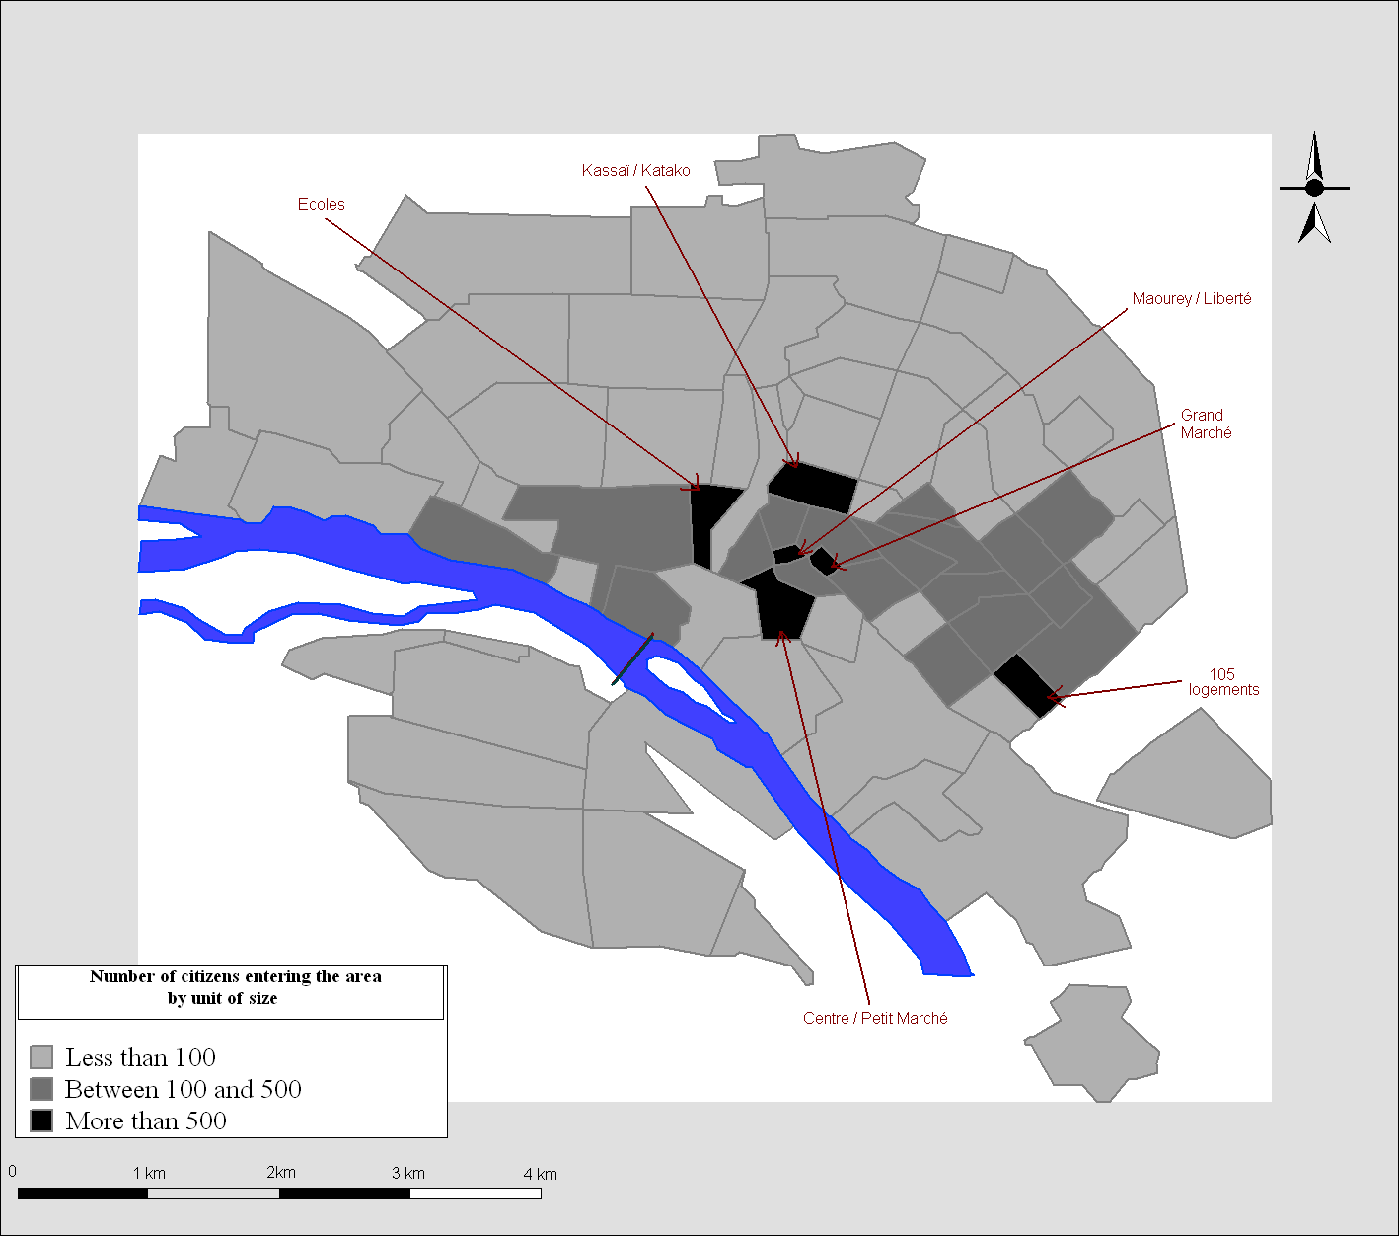
Differences in attractiveness of urban territories are particularly strong in Niamey (map 1). To highlight them, we calculated the number of citizens entering each area during the survey day (without living inside). The city division used there is the smallest we had (these limits were chosen by specialists who organized the survey). To avoid potential pitfalls due to the size of urban territories considered, we divided by unit of size (square kilometers). It allows us to appreciate the density of activities and to answer the question: Which areas are attractive and why?

    - Attractive territories and their attributes

Six territories turned out to be the most attractive in the urban space of Niamey. City center is particularly concerned and five of them are situated there. Long trips (during which citizens go out of their residence area) appear to be linked with specific functions in the city. Three urban functions are associated with the attractiveness observed: the politico-administrative function, the commercial function and education.
The area named Center/Small Market, is centrally located and close to it, there are the Urban Community of Niamey and several banks and Niger government departments. Citizens who come into this area are very different therefore according to the motive for their coming. The most numerous ones are formal workers living in rich neighborhoods as the Plateau (former colonists area, quite wealthy), rather educated. They are often well-equipped in trip modes (37% of them come into the area with their car, 21% with their road-bike). The politico-administrative function is associated with centrally-located administrations. The attractiveness of the area is therefore explained by The Small Market. Many citizens come to sell or to buy fruits or vegetables on the marketplace. They are often women from several neighborhoods. They have to walk if their residence area is not too far and any of them use taxis, in spite of its high price).
The commercial function attractiveness is as well called up with the Grand Marché area (that corresponds precisely to the marketplace). Many people work in this place, without being employees. They are qualified by a great deal of ages and a rather low education level. Products sold there are diversified, excluding foods. They have generally to walk or use taxis because few are equipped. Concerning the Marché Katako, it is located on the same area than the Lycée Kassaï (a big high school). This marketplace is the poorest of those we studied, the major part of citizens who come there are from adjacent poor neighborhoods (particularly Boukoki, to the north to it). The social diversity is less obvious in this marketplace, known for diverse equipment- and scrap-merchants. Except for these places, many small neighborhood marketplaces exist in Niamey (and itinerant sellers), but prices are largely higher (Diaz Olvera and al., 2003).
Education equally turns out to produce long trips. We already talked about the Lycée Kassaï, but among urban attractive centers, we can note the presence of the area named “Ecoles” to the West of the Gounti Yena thalweg. As its name assumes, this area groups together several high schools. Two profiles can obviously be highlighted, pupils and teachers… Almost all of them come from far neighborhoods, but the problem concerns chiefly pupils (without trip modes). Into the area named 105 logements (the only area not located in the city center), a high school explains the attractiveness of the area. Scholar catchments area is smaller however, and pupils come from adjacent neighborhoods. 75% of citizens considered there are men (generally young). Most Niamey urban areas have first and secondary schools but high schools are rare in Niamey and best ones are centrally-located.
We can note that streets around attractive structures (marketplaces, schools, offices for formal workers) are bustling with activity. Beggars, itinerant sellers, coxers (people who have to find customers for a specific service or shop) choose well-patronized places, which are those we emphasized. Formal and informal sectors thus work hand in glove.

  - Case study: Puebla in Mexico

    - General presentation

The city of Puebla, which is the fourth most populated city in Mexico, was founded in the XVIth century by Spanish, who applied the principal of orthogonal development by spreading towards the four cardinal points (Polèse and alii, 1994). Situated two hours far from Mexico, this former colonial city lies on the Mexico/Veracruz axis, which makes it an important industrial center with a strategic position. A tertiary economy is developing but still remains relatively weak today, in part because of the proximity of Mexico City (Pérez Mendoza, Rojas and Vazquez, 1996). Puebla today boasts a large university and a historic center which is known for its heritage but has relatively few major cultural facilities. In 2003, the agglomeration reached 2 million inhabitants4.

3.2.2. Attractive territories and their attributes

Map 2: Differences in attractiveness of Puebla territories
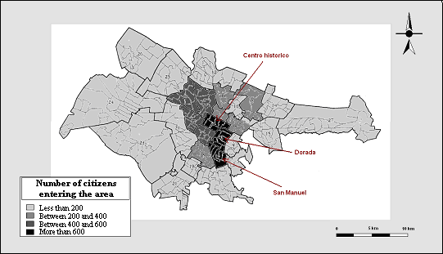

We used the same methodology in both cases. However, we could not correct in the case of Puebla the number of citizens entering into each area relatively to its surface. The problem is relative because we would have obtained the same result (the most attractive areas of Puebla we highlighted are the littlest). As we observed in Niamey, they turned out to be located in the city center (map 2). Their names are The Centro Historico, the Plaza Dorada and the area San Manuel. The surveyed areas size is too large however to associate precisely urban functions to attractiveness. Several tendencies can be propounded however…
The Centro Historico appears like the area Dorada from urban functions point of view. Many reasons are able to explain a long trip toward these areas. More citizens come in the Centro Historico than in the area Dorada to make a purchase (18% and 10 % respectively of the whole citizens coming into each area). Other frequent motives are work (36 and 38% respectively) and studies (25% and 26% respectively). They are as many women as men concerned. A difference exists between these areas however. The modern nature of the area Dorada makes it being more attractive for wealthy citizens. Cars fit very well to this kind of urban area. The citizen catchments area is not really spread-out, which is the case for the Centro Historico (only several outskirts municipalities are not concerned, as Amozoc).
Concerning the area San Manuel, its attractiveness is mainly due to the presence of the University (Benemérita Universitad Autonoma de Puebla, BUAP). Many students and professors come into this area. The formers use by a majority public transports and live in adjacent neighborhoods. The latter are divided between those who have cars and those who use public transports. Many of them live in the richest neighborhoods as La Paz. It is important to remark that the area San Manuel is well-serviced in public transports because of the high student proportion interested.

    - Exclusion dynamics at play

As explained previously in the theoretical part of this work, we aim at understanding exclusion dynamics at play in the urban areas studied. Three kinds of exclusion from urban attractive centers will be considered, social exclusion (are there social groups excluded?), modal exclusion (are users of a specific travel modes excluded?) and spatial exclusion (are there neighborhoods in the city whose dwellers are excluded?). Of course, these three kinds of exclusion are linked together but studying them separately is very rewarding (particularly because associated political and social consequences are different).
The characterization of citizens coming into attractive areas is interesting. In Niamey, except in the area Petit Marché where many formal workers come daily (we could talk about some social diversity), each attractive area appears to be socially-marked. It seems therefore difficult to point a specific social exclusion from attractive areas, but spatial exclusion is more evident. Citizens who live in several outskirts (largely inhabited by poor people) do not come into attractive centrally-located areas. It is possible to distinguish two different groups. The former are from North and West outskirts. Many neighborhoods are growing up nowadays there. Citizens who just settle in there are necessarily excluded from the lively and attractive areas of Niamey. The latter are citizens from Harobanda (across the river), who come rarely in the attractive areas we highlighted. Only the Kennedy Bridge allows the river Niger to be crossed. The river Niger is not just a physical divide… Citizens dwelling in these outskirts areas are often transportation modes ill-equipped. That is why the lack of affordable transportation associated with the land use monocentric city model is a source of exclusion.
Whether a comparable share of men or women is going into center’s attractive areas, the formers use more often a car. The household equipment in travel modes is largely higher in Puebla than in Niamey, but bi-motorization is still rare and men use in priority their vehicle. As in Niamey, any inhabitants of Puebla go very rarely into the city center. The standard of living of the citizens who work into the center appears to be variable but lightly higher than the whole workers mean. This is probably linked to the numerous public services and banks existing in the center. The residential location appears therefore to be discriminatory. In fact, the areas number 23 to 27 (map 2) are separated from Puebla’s heart. Despite a public transport network well developed, these kinds of neighborhood are low-serviced. The exclusion process from attractive areas in Niamey is quite the same as in Puebla so. In the African city, a large part of citizens are walking to access facilities (sometimes far ones), but in the Mexican city, the solution of a majority is the choice of the public transport (with very long trips sometimes). Mobility conditions associated with these trips (walk trips in Niamey and public transport trips in Puebla) are often extremely difficult to live with and they represent a real challenge for city planners.

Beyond individual status, age and gender, we observed that the possibility of accessing attractive areas was depending on three conditions:
- The individual trip mode equipment
- The residential location (next to the center or far from it)
- The possibility of using public transports (taxis or buses)

Scheme 1: The process of exclusion from attractive areas

If a citizen has a trip mode, lives next to the center, or has the possibility of taking public transport, he or she won’t be excluded from the central attractive areas. The description of the exclusion process rests on several remarks linked with the contexts studied. In Niamey, because of negative connotations about the bicycle (it is associated with poverty and country), few use it and for industrial and commercial reasons, there are few motorbikes too. The travel modes equipment is still low in both cities and horizontal urbanism does not enable easily other citizens to settle in the city center. So the problem transferred to the public transport, often expensive for poorest citizens and associated with a bad servicing of many peripheral neighborhoods (Ravalet, Bueno Cevada, 2006).

Conclusion

The study presented above is quite original because of its methodology. It offers the possibility of emphasizing several broad tendencies.
The attractiveness imbalance between territories appears in both cities to be in favor of central territories, which conserves a front rank role (which is less obvious in Western cities). Meanwhile, far outskirts are growing up with new inhabitants. The access conditions to the city centers and the inner activity of theses territories is developing very slowly, with the social and sanitary consequences we know.
These attractive territories have not the same role and exclusion pointed in this paper concerns mainly the politico-administrative function, the commercial function and education. An interesting point is that they are sometimes associated with specific social groups. This social connotation aims at contributing to segregation in daily urban spaces. High schools, public services and commercial areas really attract citizens from a large part of the city. Despite its constraining feature, the citizens mobility toward these areas does not appear to be insurmountable for several social categories. As regard to the poorest, however, they can easily be excluded from them and they suffer from this relative attractiveness of urban territories. Southern urban sprawl is not a consequence of a use of car by citizens. But cities seems to be organized as if the whole citizens could overcome the space… That is while we could talk about a car dependency in Niamey and Puebla.
Because of the attractiveness imbalance between territories, modal exclusion (from individual trip modes at first and from public transport then) finally appears as a vector for exclusion from attractive urban centers.

Bibliography

Adamou, A., 2005. Parcours migratoires des citadins et problème du logement à Niamey, Mémoire de D.E.A., département de Géographie, Université A. Moumouni de Niamey, 157 p.
Aloko-N’Guessan, J., 2002. « Les relations difficiles entre le transport collectif et l’espace urbain à Bouaké », in Recherche, Transports et Sécurité, no 74, p. 67-88.
Amar, G., 1993. « Pour une écologie urbaine des transports », Les Annales de la Recherche Urbaine, no 59-60, 15 p.
Antoine, P., 1997. « L’urbanisation en Afrique et ses perspectives », Aliments dans les villes, Programme FAO, 21 p.
Bassand, M., 1997. Métropolisation et inégalités sociales, Presses polytechniques et universitaires romandes, Science, Technique, Société, 245 p.
Bussière, Y., Madre J.L., 2002. Démographie et Transport: villes du Nord et villes du Sud, l’Harmattan, 477 p.
Bussière, Y., 2005. Transporte urbano en Latinoaéricamérica y el Caribe: Estudios de casos (San José, Puebla, Puerto España, Puerto Príncipe, Editions FLACSO, Costa Rica et GIM, 236 p.
Clément, C., 2000. Espaces de vie, espaces en ville, Université Lumière Lyon II, thèse de doctorat en Sciences Économiques, 354 p.
Del Rio, F., Vargas C., 1998. « Historia de las comunicaciones y de los Transporte en México » in El autotransporte, Secretaría de Comunicaciones y Transportes, p. 27-54.
Di Méo, 1999. « Géographies tranquilles du quotidien », in Les Cahiers de Géographies du Québec, Volume 43, numéro 118, p. 75-93.
Diaz Olvera, L., Plat, D., Pochet, P., 2003. « Transportation conditions and access to services in a context of urban sprawl and deregulation. The case of Dar es Salam », in Transport Policy (10), p. 287-298.
Diaz Olvera, L. and Kane, C., 2002. « M comme marche ou crève », in Godard X. (éd.), Les transports et la ville en Afrique au Sud du Sahara, Karthala-Inrets, coll. Économie et Développement, p. 191-202.
Diomande, M., 2001. Péril social et réurbanisation en Afrique, L’ Harmattan, 128 p.
Dubresson, A., 1996. « Crise (s) et peuplement des villes en Afrique au Sud du Sahara » In Crise et population en Afrique, dir. Coussy J. and Vallin J., Les Études du CEPED n° 13, p. 375-405.
Gaffron, P., J.-P. Hine and F. Mitchell, 2001. The role of transport on social exclusion in urban Scotland, Litterature Review, Transport Research Institute, Napier University, 35 p.
Germain, A., Polèse M., 1995. « La structure sociorésidentielle de Puebla, Mexique: essai d’écologie urbaine », Cahiers de géographie du Québec, no 107, p. 309-333.
Groupe Interuniversitaire de Montréal (GIM), 1994. Enquête ménages-transport, Puebla (Mexique), 1993-94. Rapport final. (sous la dir. de R. G. Rice, Y. Bussière, R. Chapleau), réalisé pour le Gouvernement de l’État de Puebla, 61 p.
Godard, X. (dir.), 2002. Les transports et la ville en Afrique au sud du Sahara, Le temps de la débrouille et du désordre inventif, Karthala, INRETS, 408 p.
Hanson, S., Hanson, P., 1981. « The travel-activity patterns of urban residents: dimensions and relationships to sociodemographic characteristics », in Economic geography (4), p. 332-347.
Henry, E., 1994. « Le défi des transports urbains: contrastes latino-américains et brésiliens » in Problèmes d’Amérique Latine, numéro 14, juillet-septembre 1994, p. 217-233.
Islas, V.R., 2000. Llegando tarde al compromiso: La crisis del Transporte, El Colegio de México, 118 p.
Jaillet, M.C., 1998. A propos de la mixité. Les cahiers de la DSU, 21, p. 38-43.
Litman, T., 2003. Social inclusion as a transport planning issue in Canada: Contribution to the FIA Foundation G7 Comparison, Victoria Transport Policy Institute.
Litman, T., 2006. Evaluating Transportation Equity, Victoria Transport Policy Institute, 42p.
Lucas, K., T. Grosvenor and R. Simpson, 2001. Transport, the environment and social exclusion, Joseph Rowntree Foundation, 54p.
Mignot, D., 2001. Mobilité et Grande Pauvreté, final report, PREDIT et l'UTP, Laboratory of Transport Economy - Lyon Urbanism Agency – Lyon Social Observatoire , 150 p.
Motcho, H.K., 1991. Cadres de vie et systèmes de santé à Niamey (Niger), Tropical Spaces Geography PhD Thesis, Université Montaigne de Bordeaux3, 310 p.
Pérez- Mendoza, S., Castañon Herrera, A., Romo Romero, E., Hernandez Cruz, J., 2002. Analisis de la demanda del Tranporte Publico en Puebla, Facultad de Economía, B.U.A.P, 20 p.
Plat, D., 2003. Mobilités quotidiennes en Afrique subsaharienne, Université Lumière Lyon 2, thèse d’habilitation à diriger des recherches, 140 p.

Perez-Mendoza, S., L. Rojas, J. Vazquez, 1996. « La basa económica de la ciudad de Puebla dentro del sistema urbano mexicano », In S. Pérez Mendoza, M. Polèse, Modelos de análisis y de planificación urbana. Estudios sobre la evolución y tendencias de la ciudad de Puebla. México, Universidad Autónoma de Puebla, Villes et Development, Plaza y Valdez, p. 17-39.

Perry, M., 2000. « Car Dependency and Culture in Beirut: Effects of an American Transport Paradigm », Third World Planning Review (University of Liverpool), 22(4), p. 395-409.

Polèse, M., Pérez, S., Baragan, C., 1994. Estructura urbana interna y desarrollo nacional: la localizacion de la actividad economica en la ciudad de Puebla, Mexico, Cahier/discussion paper 5-94-E, Série Recherche, Villes et développement, 17 p.
Ravalet E., 2006, « Segregation and daily mobility, an international comparison », in Brebbia C.A. et Dolezel V. (dir.), Urban Transport XII: Urban Transport and the Environment in the 21st Century, WIT Press, p. 491-500.
Ravalet, E., Bueno Cevada, E., 2006. « La non-planification des transports collectifs urbains et ses conséquences en termes d’usages: les cas de Niamey (Niger) et de Puebla (Mexique) », colloque du S.I.TR.A.S.S., Evolutions institutionnelles et gouvernance dans le système des transports en Afrique Sub-Saharienne, Ouagadougou, 15 p.
SAH/DLR, 2000. Urbanisation, liens entre milieu rural et milieu urbain et implications stratégiques pour le développement rural et agricole: Etude de cas en Afrique de l’Ouest, 17 p.
Salomon, I., 1980. Life style as a factor in explaining travel behavior. PhD Thesis, Dept. of Civil Engineering, M.I.T.
Scheurer, J., 2001. « Automobile dependence and Urban Form: Sustainability in the work of Newman and Kenworthy », In Urban Ecology, Innovations in Housing Policy and the Future of Cities: Towards Sustainability in Neighbourhood Communities. PhD Thesis, Murdoch University, Chapter8, p.145-152.
Vasconcellos, E.A., 2001. Urban transport, environment and equity, the case for developing countries, Earthcan, London, 333 p.

Laboratoire d’Economie des transports, ENTPE-Université Lumière Lyon2-CNRS-Rue Maurice Audin, 69518 Vaulx-en-Velin Cedex, FRANCE
Institut National de la Recherche Scientifique, Urbanisation, Culture et Société, 385 Rue Sherbrooke-Est, Montréal (Québec), H2X 1E3, Canada Abstract Our study underlines the impact of daily mobility patterns on the spatial and social organization of urban territories. Any part of a city can attract some city dwellers from the surrounding through activities. Such places, around which the city is organised, are neither used by the same types of citizens, nor for the same reasons or at the same time. Many city dwellers actually suffer from a difficult access to urban activities in some Southern cities. We therefore consider here the relative attractivity of urban territories, depending upon individual uses of the urban space. We study “urban attractive centers” (localisation and functions associated) in both Niamey (Niger) and Puebla (Mexico). Our purpose is to study accessibility of these areas emphasizing the role of affordable transportation. The imbalance between various attractive poles is finally considered as a growing trend and a major issue of contemporary Southern cities. Key-words : mobility, accessibility, territories, attraction, Niamey, Niger, Puebla, Mexico
1 Translation done by authors
2 population estimated from U.N. data.
3 www.un.org
4 www.un.org

