Jitney Operations in City Traffic:

Observations and Analysis for a Congested Developing City
Kaysi, I.¹, Younan, B.² and Bassam, A.²
Abstract:
Jitneys are a dominant form of mass transportation in several developing countries. They play a major role in providing a significant supply of transport services by filling the gaps left by the use of private cars and mass transit, mainly due to their remarkable spatial and temporal coverage. However, jitney drivers are infamous for erratic driving, unsafe loading and unloading practices, and contributing to congestion. It goes without saying that jitney systems influence the traffic conditions of each city they operate in. This paper generally aims at analyzing this important mode of transportation and modeling its traffic attributes based on the case study of Beirut, Lebanon. A description of the jitney system in Beirut, along with a depiction of the prevailing situation and the traffic operational features in the city, is first presented. Data related to jitney operations was collected in the city as a whole as well as in a commercial area with particular network and operational features. Comparison of the performance of normal and jitney traffic is undertaken based on a travel time/delay study as well as the two-fluid model of town traffic. Modeling and analysis results indicate that while little differentiation exists between the overall performance of normal and jitney traffic in the commercial area, jitney operations in general have significantly different traffic characteristics in Beirut. Basic conclusions are documented and suggestions to mitigate the impacts of jitney traffic are identified.

¹ Professor of Civil and Environmental Engineering, American University
of Beirut, P.O. Box 11-0236, Riad El-Solh 1107 2020, Beirut – Lebanon. Email:
isam@aub.edu.lb
² Research Assistant, Department of Civil and Environmental Engineering, American
University of Beirut, P.O. Box 11-0236, Riad El-Solh 1107 2020, Beirut – Lebanon.

Keywords: Jitney operations; Two-fluid model; Network attributes; Travel time/delay studies.

1. Introduction
Jitneys are a dominant form of mass transportation in several developing countries. They play a major role in providing a significant supply of transport services by filling the gaps left by the use of private cars and mass transit [1], mainly due to their remarkable spatial and temporal coverage. However, jitney drivers are infamous for erratic driving, unsafe loading and unloading practices, and contributing to congestion [2]. It goes without saying that jitney systems influence the traffic conditions of each city they operate in. This paper generally aims at analyzing this important mode of transportation and modeling its traffic attributes based on the case study of Beirut, Lebanon. A description of the jitney system in Beirut, along with a depiction of the prevailing situation and the traffic operational features in the city, is first presented. Two areas of the city (Municipal Beirut and Hamra/Ras Beirut) were selected for the study since they exhibit different network and operational features. Comparison of the performance of normal and jitney traffic is undertaken based on a travel time/delay study as well as the two-fluid model of town traffic. Basic conclusions are documented and suggestions to mitigate the impacts of jitney traffic are identified.

2. Jitneys: description and background
A jitney can be defined as "5-to-12 passenger car, station wagon, van and/or minibus that is operated along a fixed or semi-fixed route or routes". The jitney picks up customers anywhere along these routes until it is filled. Then, passengers are dropped off wherever they want at their desired destination [2]. In their operation, jitneys can deviate easily from their route to satisfy customer needs or to avoid congested areas. Thus, their performance can be characterized as dynamic and adaptable [1].

Jitneys first came into the transportation scene in 1914, and they quickly became popular due to their flexibility and speed [3]. Since 1917, jitney systems have emerged in many countries especially in developing ones; many Middle Eastern, Asian and Latin American countries use jitney services nowadays. Asia houses the largest of these systems in Manila, Hong Kong and Kuala Lumpur. In Latin America, major jitney systems can be found in Caracas, Mexico City, Buenos Aires, Bogotá and several cities in Puerto Rico. In the Middle East, major jitney centers include Beirut, Istanbul and Riyadh [4].

In Beirut, jitneys, known locally as “service”, are considered the backbone of mass transportation services. These vehicles typically consist of 5-passenger seat Mercedes cars most of which are more than twenty years old. They operate independently and are characterized by their frequency of service and flexibility in routing and scheduling; they respond to hail calls by passengers anywhere along the route and stop at any point for drop-off. Before the war which started in Lebanon in 1975, jitney operation was regulated whereby legal jitneys would hold a red plate with the number of such plates limited at around 10,650. In 1994, following the end of the war, the government adopted a policy that tripled the number of such plates in the market; however, due to the lack of proper governmental regulation, the majority of jitneys ended up circulating in the Beirut Metropolitan Region [5]. A study carried out on Lyon Street in the Hamra commercial district of Beirut in 1999 revealed that jitneys accounted for approximately 40% the total traffic volume. The same survey, which was conducted by students at the American University of Beirut (AUB), exposed the aggressiveness of jitney operators in their work schedule. In fact, about 96% of the drivers work more than six days a week and, on average, 10.6 working hours per day as this service is available between 4:00 am and 12:00 am daily. Despite the abundance of jitneys circulating in Beirut and their long service hours, another study [6] showed that they carry only 23.5% of person trips in Beirut with the highest percentage (63.3%) supplied by private autos for reasons explained later. The AUB survey also indicated that 77% of the jitneys were traveling with one or no passengers at all (excluding the driver), hence, with an average passenger occupancy rate close to 0.9. The same survey estimated the average number of revenue riders per jitney as forty-three passengers per day and the average net revenue as 18,200 L.L. ($12) per day.

3. The context of Beirut
The last major transportation planning study in Beirut was undertaken in 1994 [6]. The city of Beirut has witnessed notable changes in its travel characteristics over the period extending from 1970 to 1994. Perhaps the most critical occurrence has been the significant increase in auto ownership and the extensive reliance on the private auto for trip making at a time when the road network remained practically the same due to the fifteen years of war.

Municipal Beirut has an area of approximately 20 sq. kms (0.2% of the area of Lebanon). While its population has slightly decreased over the period 1970-1994 from 430,000 to 400,000 (14% of the population of Lebanon), the number of private cars owned by its residents has increased by a factor of more than two, from 51,000 to 111,000 (10% of the total car registration in Lebanon). This increase in the number of private cars was accompanied by their prevalence in trip making as 72% of the motorized person trips, completed by residents of Municipal Beirut, depended on their use, compared to only 45-50% in 1970 [6]. This reliance on the private auto might be partly due to the lack of adequate mass transport and absence of enforcement of vehicle condition and use restrictions such as mechanical inspection and parking bans [7]. At the same time, the network, on which these cars operated, has experienced minor improvements over the last twenty-five years. In fact, the following operational features have characterized traffic conditions in the city since the end of the war in 1990:
- Illegal curb parking and pedestrians trafficking the roadways instead of using sidewalks occupied by vehicles.
- Capacity problems at intersections due to inadequate geometric design and bad traffic handling by inexperienced policemen.
- Undisciplined driving behavior including one-way traffic violations, aggressive driving especially by taxi-service drivers, and disrespect of priorities [7].

4. The study areas
This research analyzes urban traffic network performance in Municipal Beirut as a whole, as well as in a study area inside Beirut.
The road network in Municipal Beirut is composed of approximately 286 kms of roadways of which 76% are one-way, 13% two-way undivided, and 11% two-way divided. It also consists of about 130 signalized intersections (not all are operational) of which 35% are of four approaches and 40% of three approaches [7]. Since it was difficult to analyze traffic operations in the network of Municipal Beirut in its entirety, a smaller study area was chosen to perform the study. The chosen area consisted of several districts, selected to be representative of the whole network as shown in Fig. 1 below.
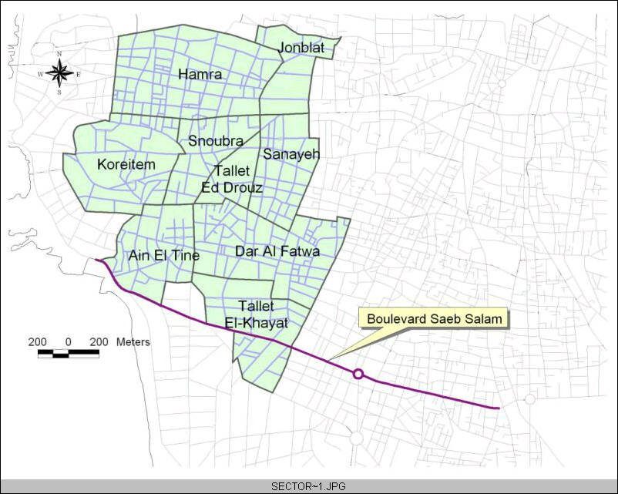
Figure 1. Study areas in Municipal Beirut

The other study area is located in the Hamra/Ras Beirut sector of Beirut (see Fig. 2). It includes an important commercial arterial, namely Hamra Street and several educational, cultural, business, and shopping activity centers in addition to numerous residential buildings. This study area has an area of 768,000 sq.m and consists of 15,420 m of streets among which only 235 m are two-way, and the rest are one-way streets, with a density of 0.02 m of roads per sq.m of land area, or 0.22 sq.m of roads per sq.m of land area. Road widths vary from 4m to 14m with an average of 11.4 m including the travel lane(s), the parking lane(s) and the sidewalk(s). Most of the 44 street links constituting this small network act as streets with one travel lane; only 8 links comprise two lanes in part or all of them. Nevertheless, for all the streets, the lanes are not well defined and illegal parking has reduced some two-lane streets to one-lane during several hours of the day [7].
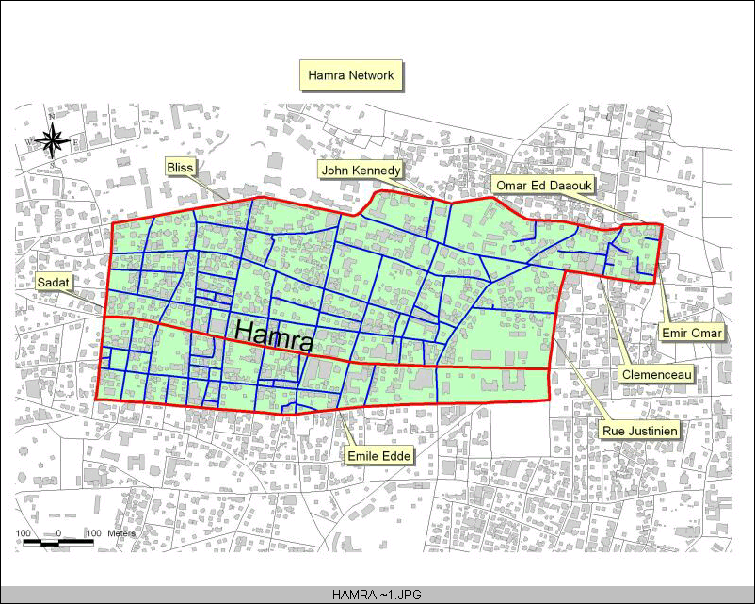
Figure 2. Hamra / Ras Beirut study area

5. Travel Time / Delay Study
5.1 Overview
Travel time and delay are two standard measures of roadway system performance used by traffic engineers, planners and analysts. A travel-time study provides information about how long it takes to traverse a certain path, the time needed to pass certain control points set out on that path, and the type, location and duration of delays along it. An evaluation of the route’s characteristics then follows after computing many related parameters such as running speed and mean travel speed at specific locations and times of the day. Usually, analysts study travel time and delay during the peak hours in the directions of heaviest traffic flow, and compare them to travel times, speeds, and delays during off-peak periods or under other conditions, as is the case in this paper.

5.2 Description of the routes
In order to obtain a representative travel time/delay study, nine routes along main corridors/arterials were chosen to cover the two networks: the Municipal Beirut network (routes 1, 2, 3, 4, 5 and 6) and the Hamra network (routes 7, 8 and 9); these are major routes that usually incorporate the highest volumes of traffic (Fig. 3). Seven runs, on average, were carried out on each route during peak traffic hours to provide a reasonable basis for characterizing travel time and speed along these routes.

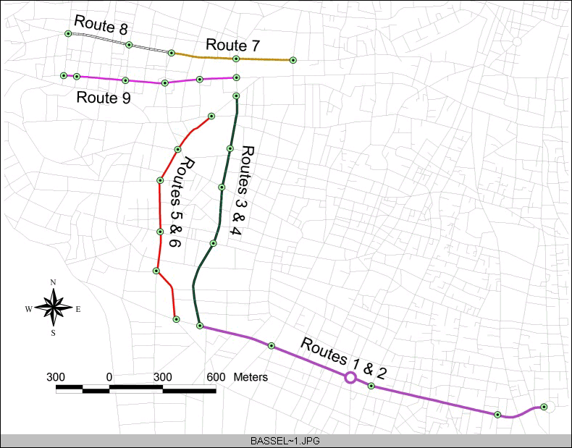
Figure 3. Description of the routes of the travel time / delay study

5.3 Data collection procedure
The travel-time/delay study required the driver to go over a selected route for a number of runs and the TDC-8, a traffic data recorder by Jamar Technologies Inc., was used to record all needed information for the study. This equipment was connected to the gearbox of the car, from which it received pulses that were transformed into instantaneous speed-readings (every second). The driver of the test vehicle proceeded along the study route using the floating-car technique by maintaining the travel speed approximately equal to that of the traffic stream. However, in the case of jitneys, another technique was used whereby the jitney driver was asked to drive as he usually does in order to record with accuracy the effect of jitneys on the network.

5.4 Data analysis
The traffic characteristics of jitney systems were analyzed using the travel time/delay study; the analysis focused on the travel time, travel speed and delays of jitneys as compared to normal traffic.

5.4.1 Travel time and delays
Ideal travel time is, by definition, the time that a car takes to travel between two control points having a reference free-flow car speed (50 mph in this case). The actual travel time, however, is the elapsed time between the two control points in seconds. The delay is computed as the difference between these times.

Fig. 4 below presents average values of delay as percentage of travel time for the different routes considered.
Figure 4. Percentage delay of travel time for each route and for each type of driver

What is noted from the figure is that, for all the routes, the average percentage delay is higher in the case of jitney drivers than in the case of normal car drivers; this result is logical and expected due to the driving characteristics exhibited by a jitney driver. As a matter of fact, the average number of stops that a jitney driver makes during a trip is greater than that which a normal car driver makes during the same trip; this is because the jitney driver goes into a complete stop each time he perceives a potential customer standing on the right side of the street. Fig. 4 also shows the close similarity in trip patterns between normal and jitney traffic in the Hamra network whereby both drivers experienced approximately the same delay on the selected, mostly single-lane routes. This is not the case in the Municipal Beirut network where the effect of jitneys on normal traffic is more pronounced.

Most of the average percentage delays lie in the 80% to 90% range of travel time. These are relatively high average values; they reflect the peak hours of the day during which the study was conducted. These high values also show the extent of side friction resulting from excessive curb parking on narrow roads and the amount of delay experienced on each intersection. As a matter of fact, the extent to which curb parking, and even double parking, influence the time one is delayed is widely experienced when making a trip in the Hamra district. The highest values of average percentage delay occurred on routes 7, 8 and 9, which all lie in the vicinity of that district; routes 7 and 8 pass directly through Hamra while route 9 runs parallel to it.

5.4.2 Travel speed
Travel speed is calculated by dividing the total distance covered by the elapsed time (in mph). The average travel speed for each driver on each route is shown below.
Figure 5. Average travel speed for each driver on each route

The average travel speed varies from one route to another (3.4mph → 11.9mph) and from one type of driver to another as on route 4 (7mph → 11.9mph). It decreases from 8.4mph (average speed on routes 1 to 6) in Municipal Beirut to 4.7mph (average speed on routes 7, 8 and 9) in the Hamra district. This difference is due to the same reasons discussed earlier.

It is also notable from Fig. 5 that, on the same route, normal car drivers exhibited higher travel speeds than jitney drivers; this result was expected due to the driving patterns of jitney drivers.
5.4.3 Time below speed threshold
Time below speed threshold is the time spent by the test car under a certain speed (in seconds). In our case, three speed thresholds are chosen: 0mph, 10mph, and 30mph. These three thresholds are used to stratify the data into four broad regimes of the travel situation respectively: stopped, queued, delayed and free running.

Tables 1 and 2 below show respectively the average time spent (as percentage of travel time) by the two types of drivers and in the two networks considered, under the three speed thresholds.
Table 1. Average time spent below a speed threshold for each type of driver
Type of Driver | Time Below (as % of Travel Time)
Type of Driver | 0mph (stopped) | 10mph (queued) | 30mph (delayed)
Normal | 34.0% | 62.7% | 99.8%
Jitney | 27.0% | 75.2% | 98.7%

Table 2. Average time spent below a speed threshold in each network
Network | Time Below (as % of Travel Time)
Network | 0mph (stopped) | 10mph (queued) | 30mph (delayed)
Municipal Beirut | 29.0% | 62.3% | 98.9%
Hamra | 33.4% | 84.3% | 100.0%

It is obvious from the tables above that a driver spends approximately 100% of his time under the 30mph speed. This result confirms that the networks of Municipal Beirut and Hamra suffer from a low level of service.

Table 1 shows that, on average, a normal car driver spends more of his travel time stopped than a jitney driver (34% compared to 27%). This seemingly unlikely result can be explained by the pattern of usage of brakes. During the study, it was observed that the jitney driver minimizes the usage of the pedal brakes of his car by trying to maintain a low speed to the greatest extent possible. Jitney drivers justify this behavior on economical grounds and consider that it saves fuel and car brakes. This outcome also explains why, under the 10mph threshold, the jitney driver spends, on average, more of his travel time queued than the normal car driver (75.2% compared to 62.7%). In fact, jitneys use the right lane of a street and drive at lower speeds than normal traffic. This does not only affect normal cars using the right lane but also the traffic as a whole; this effect increases dramatically in narrower streets as shown in Table 2 where a driver spends in the Hamra network a larger fraction of his travel time stopped and queued than in the Municipal Beirut network.

5.5 Conclusions of travel time / delay study
The conclusions that one can draw after completing a travel time/delay study on the nine routes considered reveal the poor efficiency of the two networks during peak hours since 100% of a normal driver’s time is spent under the 30mph threshold. Due to the effect of side friction, the Hamra network proves to be worse with lower travel speeds and higher delays, reaching 93.5% of the travel time, on certain segments.

The results also indicate that the large number of jitneys is likely to impose a critical effect on overall network performance. This is related to the driving characteristics of jitney drivers, which are closer to aggressive and/or conservative drivers than to normal ones. In fact, jitney drivers combine characteristics from the two extreme types of drivers; they maintain relatively low speeds (similar to conservative drivers) and come to a stop suddenly and make sudden maneuvers (similar to aggressive ones). These acts of sudden stops or maneuvers to pick up or deliver passengers often lead to high accident rates; these rates are also affected by the aggressive behavioral patterns that characterize jitney drivers due to the intense competition for passengers. These aggressive patterns cause many traffic conflicts as well since the jitney drivers tend to force their way through, thus ignoring the higher priority of other movements and showing disregard to the rest of the driving population [8]. Such driving patterns share some attributes with aggressive driving behavior that has been identified in previous research and which included: “high accelerations and decelerations, breaking away and trying to stay ahead of the platoon, frequent lane changing, accepting short gaps at stop signs, and crossing during late amber/early red indications” [9].

6. The Two-Fluid Model
6.1 Overview
The two-fluid model of town traffic was first proposed by Herman and Prigogine in 1979 as an extension of the multi-lane kinetic theory to describe, in a similar overall fashion, the traffic in a non-highway urban network [10]; it is usually used to assess the quality of traffic in central networks of cities and compare the quality of service in those cities. This model came mainly as a consequence of the difficulty associated with trying to assess the quality of traffic service in urban networks based only on characterization of traffic at the microscopic level. Such an undertaking requires great efforts and considerable resources, such as the knowledge of traffic movements on all links and junctions, to be able to determine the quality of the prevailing service at the network level [11]. On the other hand, the macroscopic two-fluid model yields a simple curvilinear relation between two traffic variables namely the trip time per unit distance and the stop time per unit distance [10]. This methodology has been applied successfully in many cities around the world such as Mexico, San Antonio, Tehran and London since the parameters obtained suggested a useful way of assessing the quality of service in those networks [12].

6.2 Theory
The two-fluid model treats the traffic on nonhighway routes as two fluids: one composed of moving vehicles and the other of vehicles that are stopped due to congestion, traffic signals, stop signs and other traffic control devices and obstructions resulting from construction, accidents, or other factors. It, however, excludes any count of parked vehicles and considers them as a part of the geometric configuration of the street [13].

This model quantifies the features of the network based on two parameters [10]:
- T_{m}, the minimum trip time per unit distance in the network (min/mile)
- n, a theoretical parameter reflecting the degree of congestion and the traffic conditions in the network

The network with the lower T_{m} or n is the one with the higher average speed, representing a more efficient network geometry and control system. “The quality of traffic service refers to the ability of the network to carry traffic with a better street system having smaller T, T_{s} and T_{r} for the same demand” [13], where
T: trip time per unit distance (min/mile)
T_{s}: stop time per unit distance (min/mile)
T_{r}: average running time per unit distance (min/mile)

It follows that:
T = T_{s} + T_{r} | (1)
Another important parameter used in the theory is f_{s} or the fraction of vehicles stopped in the system and it is assumed to be of the fraction of stopped time for a circulating vehicle in the network regardless of the duration of observation, the number of vehicles, and the traffic conditions [13]:
f_{s} = T_{s}/T | (2)

This assumption holds as long as the concentration does not fluctuate rapidly during the time of a trip. It has been shown through the use of aerial photographs in the two Texas cities of Austin and Dallas that f_{s} did not vary greatly for a given level of concentration [14]. This is due to the fact that the average fraction of vehicles stopped during a time period is mainly a function of the average concentration in the network during that time.

6.3 Model Formulation
The two-fluid relation developed between the trip time per unit distance and the run time per unit distance is:
T_{r} = T_{m}^{(1/n+1)}.T^{(n/n+1)} | (3)

The two-fluid model yields a curvilinear relation between the trip time per unit distance and the stop time per unit distance. It is of the form:
T = T_{s} + T_{m}^{(1/n+1)}.T^{(n/n+1)} | (4)

(3) can be transformed into a linear relation between logT_{r} and logT by applying the logarithm to both sides of the equation:
logT_{r} = (1/n+1).log T_{m} + (n/n+1).log T | (5)
or:
logT_{r} = A + B.log T | (6)
where:
A = (1/n+1).log T_{m} | (7)
and:
B = (n/n+1) | (8)
with:
n = (B/1-B) | (9)
and:
logT_{m} = (A/1-B) | (10)
or:
T_{m} = 10^{(A/B-1)} (11)

6.4 Data collection procedure
There are usually two methods followed in recording the data needed for estimating the parameters of the two-fluid model: the chase car method and the fixed route method. In this study, the chase car method was selected because the networks being considered are grid networks. First, the data collector parks at the edge of the study boundary. He then selects the first car he sees entering the network, starts the run, and follows the car. He must drive in a fashion that emulates the driving characteristics and follows the same route as the selected car. When the car parks, leaves the study area or makes an unsafe and/or illegal maneuver, he ends the run and waits for the next vehicle entering the network to repeat the process. By always selecting the first available car after being in position, the randomness of the study is maintained. What the driver is after in this process is the trip time and stop time of test vehicles making trips of known distances, one mile in this case, in the network area.

6.5 Data collection in Beirut
The data collected for the calibration of the two-fluid model was obtained from a number of chase car studies. The experiments resulted in the following number of observations:

Table 3. Total number of observations for both networks
Network | Number of Observations
Municipal Beirut | 44
Municipal Beirut (Jitney) | 44
Hamra | 37
Hamra (Jitney) | 33

6.6 Data analysis
The results of the estimation of model parameters T_{m} and n based on data, obtained from the study, are presented in Table 4 below for the two networks considered.

Table 4. Results of the two fluid-model parameters
Network | T_{m} | n | R²
Municipal Beirut | 1.91 | 2.05 | 0.8927
Municipal Beirut (Jitney) | 4.00 | 1.00 | 0.6934
Hamra | 4.65 | 0.85 | 0.8092
Hamra (Jitney) | 4.97 | 0.90 | 0.8626

6.6.1 Normal car drivers versus jitney drivers
Figs. 6 and 7 present curves representing the two-fluid model in (4) for the estimated values of T_{m} and n for Municipal Beirut and Hamra respectively.
Figure 6. Two-fluid model for Municipal Beirut

Figure 7. Two-fluid model for Hamra network

In the case of Municipal Beirut network, the difference in behavior between normal traffic and jitney is clear. The comparison is done for the same fraction of stopped vehicles (f_{s} = 0.4), which represents normal traffic conditions for the daytime periods when the surveys were carried out. It is apparent from Fig. 6 that normal traffic exhibits significantly lower values of T and T_{s} at f_{s} < 0.4, hence, better quality of service. This result was expected since a jitney driver shows different driving characteristics than a normal car driver as explained earlier.
In the case of Hamra network, Fig. 7 confirms that, for both types of drivers, values of T_{s} and T are close. This can also be inferred by comparing the estimated values of T_{m} and n (Table 4). Therefore, little differentiation exists between the driving patterns of normal and jitney traffic due to a number of critical factors including a very high proportion of one-way streets, a very high intersection density, and a very high occurrence of curb side parking coupled with a minimal number of street lanes [7].

6.6.2 Municipal Beirut network versus Hamra network
Fig. 8 is a representation of the two-fluid model for Municipal Beirut and Hamra networks. The curves are for normal traffic and the comparison is done at 40% stopped vehicles (f_{s} = 0.4). The performance of the Municipal Beirut network is superior to that of Hamra network for all values of f_{s} that are normally experienced in normal as well as in heavy traffic conditions.
Figure 8. Two-fluid model for Municipal Beirut and Hamra
Figure 9. Two-fluid model for Municipal Beirut (Jitney) and Hamra (Jitney)

Fig. 9 shows that in the case of jitneys, the two curves are almost parallel with a slight margin of difference. For all levels of concentration, Municipal Beirut network has a slightly better quality of service. This was expected since the geometric features of Municipal Beirut as a whole are better than Hamra.

6.7 Conclusions of two-fluid model analysis
The conclusions drawn from the application of the two-fluid model on the networks of Municipal Beirut and Hamra are consistent with those stated earlier. The modeling results indicated that traffic performance of jitneys in Municipal Beirut is significantly different from that of normal traffic, and consequently that the existence of a large number of jitneys operating in the Beirut network is likely to have a tangible influence on its level of service. On the other hand, little differentiation was found to exist between the overall performance of normal and jitney traffic in the Hamra area, mainly due to the geometric and operational features of that network. It is obvious that the Hamra network in particular suffers from a low quality service. This is related to the high intersection density in the study area as well as the high congestion level in this area with major commercial centers, with narrow streets and heavy pedestrian-vehicle interactions [7].

7. Conclusions
There is no doubt that jitneys provide a valuable transportation service to the city of Beirut. They provide wide coverage across the city as a result of their maneuverability and flexibility in comparison with other forms of public transport. Yet these “service” vehicles are criticized for being very difficult to discipline, often showing wild disregard for other traffic. This paper investigated the jitney system in response to such claims and demonstrated that it negatively affected the level of service in the city, mainly due to the abusive driving of jitney operators and their frequent stopping at any location along the routes they serve for passenger pick ups and delivery.

To rectify this situation, the government must exercise major changes on both the operational and organizational levels. From an organizational perspective, the government must regulate and organize the operation of jitneys in Beirut, thus benefiting the most from the services they offer without allowing them to disrupt the existing traffic. In fact, due to the large number of jitneys and their low ridership, the total number of operating vehicles may need to be limited so that no jitneys will circulate with less than a minimum number of passengers on board. “Other regulatory measures involve licensing of drivers, managing the frequency of service and confinement of operating rights to specified districts or routes. In certain instances, regulations may stipulate that jitneys may not pick up or discharge passengers at bus stops. Stricter regulations may involve a prohibition of soliciting, picking up, or discharging passengers at points along transit corridors” [5].

In addition, it is becoming evident that the dramatic increase in the number of jitneys during the 1990’s did not correspond to an actual demand in the market. This excessive number of jitneys in the market, along with the lack of restrictions on operation areas, led to a high concentration of jitneys in Beirut. Accordingly, and in an oversupplied market where a large number of service providers compete over a relatively low demand, jitney operations suffer from a situation of destructive competition. Operators are obliged to cut their costs (mainly bypassing maintenance and quality measures), and to aggressively solicit passengers to preserve an increasingly thinning profit margin. Moreover, the excessive number of jitneys contributes to the traffic problems analyzed in this paper. While attempting to win over passengers, jitney drivers tend to exhibit inappropriate driving behavior, moving irregularly and stopping randomly and suddenly without regard to other vehicles, which further worsens traffic problems.
In 2001, the government passed a law that included a provision permitting it to buy back 10,000 jitney operating licenses from the market for the same price that was previously paid by jitney license holders. The law resulted in virtually no reduction in the jitney fleet size since the process of reducing the fleet size was completely voluntary and depended on having drivers willingly return their operating licenses. Provisions of this law were further amended in 2003, permitting the government to buy back 7,500 jitney operating licenses, however at 50% more than the original sale price. The amendment again resulted in virtually no reduction in the jitney fleet size since the decree, like the previous one, apparently lacked a clear mechanism of ensuring the sellback of licenses

8. Acknowledgements
The authors are grateful to the Lebanese National Council for Scientific Research for its financial support.

References
[1] S.W. Lau, Strategies for improving jitneys as a public transport mode, Masters
Thesis, Massachusetts Institute of Technology, Boston, MA, 1997.
[2] I. Takyi, An evaluation of jitney systems in developing countries, Transportation
Quarterly, 44(1), 1990, 163-177.
[3] D.B. Klein, A.T. Moore, & B. Reja, Eliciting competition and entrepreneurship
in urban transit, The Independent Review, 2(1), 1997, 29-54.
[4] R.F. Teal & T. Nemer, Privatization of urban transit: The Los Angeles jitney
experience, Transportation, 13, 1986, 5-22.
[5] I. Kaysi, N. Wilson, & F. Salvucci, Structuring entrepreneurial production of
mass and affiliated transit services, Working Paper, Department of Civil and
Environmental Engineering, AUB (2004).
[6] TEAM International – IAURIF – SOFRETU, Greater Beirut transportation plan
(Technical reports), Council for Redevelopment and Construction, Republic of
Lebanon (1994).
[7] I. Kaysi & G. Alam, Characterizing traffic conditions in urban networks with
minimal control: A case study of post-war Beirut, World transport research (H.
Meersman et al., (eds.), Pergamon 1999).
[8] I. Kaysi & G. Alam, Driver behavior and traffic stream interactions at
unsignalized intersections, Journal of Transportation Engineering, 126(6), 2000,
498-505.
[9] R. Herman, L. Malakhoff, & S. Ardekani, Trip time – stop time studies of
extreme driver behaviors, Transportation Research A, 22(6), 1988, 427-433.
[10] R. Herman & I. Prigogine, A two-fluid approach to town traffic, Science, 204,
1979, 148-151.
[11] S. Ardekani, J. Williams, & S. Bhat, Influence of urban network features on
quality of service, Transportation Research Record, 1358, 1992, 6-12.
[12] S. Ardekani & R. Herman, A comparison of the quality of traffic service in
downtown networks of various cities around the world, Traffic Engineering and
Control, 26(2), 1985, 574-581.
[13] R. Herman & S. Ardekani, Characterizing traffic conditions in urban areas,
Transportation Science, 18(2), 1984, 101-140.
[14] S. Ardekani & R. Herman, Urban network-wide variables and their relations,
Transportation Science, 21(1), 1987, 1-16.

APPENDIX.NOTATION
The following symbols are used in this paper:
T_{m} = minimum trip time per unit distance
n = theoretical parameter reflecting the degree of congestion and the traffic conditions in the network
T = trip time per unit distance
T_{s} = stop time per unit distance
T_{r} = average running time per unit distance
f_{s} = fraction of stopped vehicles in the system

