Exploring Policy Options and Strategies in Enhancing the Safety of Non-Motorized Transport Modes in African Cities: The Case of Nairobi City

By
Mr. Calvine Kayi*
Kenyatta University, Department of Geography, P.O. Box 43844 Nairobi, Kenya
Tel. 812722/811622 ext. 321/540, Mobile: 0721-214463
Email:jtkayi@yahoo.co.uk or ckayi@justice.com

A paper prepared for presentation at the 11th World Conference on Transportation Research, University of California, Berkeley, June 24 – 28, 2007

Abstract

Transport policy and planning remains a poorly understood and applied issue in African cities. Although majority of major trips in these cities are made through non-motorized transport (NMT), especially walking, transport policy and planning remains motor vehicle fixated. Most investments in the transport sector are directed at facilities that primarily benefit the motor vehicle users. This puts NMT users in a precarious position with regard to mobility and safety. Using Nairobi as an example, this paper discusses the modal-split, risks and challenges to NMT use, and explores the policy options and strategies for enhancing the mobility and safety of NMT users in African cities.

Key words: Non-motorized transport; African cities; Transport policy and planning
1. Introduction

Although the majority of the African population is still rural, Africa experiences the highest urban growth rates worldwide. The United Nations Population Division (2001) estimates Africa’s annual urban growth rate at about 4 per cent, which is the most rapid in the world, and nearly twice the global average. Africa's high urban growth rate is attributable to rural-urban migration, natural population growth and, in some areas, conflict. The result is that not only are more and more people living in cities, but the cities are themselves becoming larger, and more numerous. A growing concern in many urban centers, particularly large cities, in Africa is that the rates of economic growth and infrastructure development have lagged urbanization rates. In particular, transport infrastructure and services have been put under great stress due to the high increase in urban populations. The provision of affordable, secure and sustainable urban transport in most large cities in Africa is, therefore, an issue of great concern.

In view of the phenomenal expansion of African cities and the growth in their populations, there is need to develop long-term appropriate and practical urban transport policy interventions and strategies that would have a positive impact on the economy and enhance the daily mobility of residents, especially the poor. The current urban transport planning and policy framework in most African cities is motor-vehicle centered. This continues despite the well known environmental problems, the resulting traffic jams leading to immobility instead of mobility and the in-direct costs associated with car-oriented transport systems. Rapid motorization levels are seen as inseparable from high levels of civilization and economics (Monheim, 2002). The non-motorized transport (NMT) users, pedestrians and cyclists, are the most obvious victims of this skewed urban transport policy framework in African cities. There is, therefore, need for a radical reorientation of transport policy and planning if the mobility needs of the majority of residents in African cities are to be met. This paper uses the case of Nairobi to explore the policy options and strategies in the transport sector with special references to enhancing the mobility and safety of non-motorized transport (NMT) users in African cities.

2. What moves African cities?: The role of NMT in urban mobility
2.1 Characteristics of modal-share in Nairobi

The city of Nairobi exhibits the general urban travel characteristics that are common to other large metropolitan regions in Sub-Sahara Africa. The majority of trips are predominantly made through non-motorized forms of transport, mainly walking although a small number of trips are made by bicycle. It can be seen from Figure 1, that walking as a modal choice is particularly dominant among the low and middle-income groups accounting for 61.07% and 42.43% respectively. The cost of public means of transport, mainly provided by the Matatus, is far beyond affordability for most low-income earners in Nairobi. Most residents, therefore, make the majority of their daily most important trips on foot. They walk to work, to school, to businesses, to social places like football stadium and to health centers among other destinations.
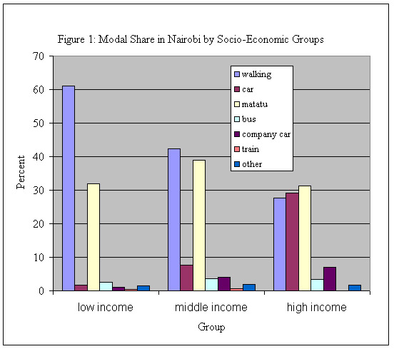
Source: Own using data from Aligula et al (2005)

The results presented in Figure 1 do agree with the earlier works of Rukunga (1990) and Omwenga, Obiero and Malombe (1994). Rukunga (1990) carried out a survey in four low income residential areas in Nairobi (Dandora, Makadara, Kibera and Makongeni) on the mode of transport used to work. He found that 67% of the inhabitants walked to work, 22% used public transport while 11.2% were transported using company vehicles. Four years later, Omwenga and colleagues undertook a survey of modal choice among 302 households in Nairobi’s low to medium income areas. Their findings reveal that walking was the most dominant (47%) modal choice for combined first four trips of the day. Public transport and private car accounted for 41% and 7% respectively while bicycle and other means accounted for 1% each. Post Buckley International (1998) observes that pedestrian flows in Nairobi are particularly high in Nairobi’s low-income settlements of Kariobangi, Mathare Valley, Kibera, Dandora, Umoja, Makadara and Eastleigh among others. Some common features of all these areas include the fact that they are characterized by informal settlements and insufficient service infrastructures including roads. This not only makes the provision of public transport services inadequate, but also expensive for the inhabitants, majority of whom are poor.

The basic unfolding pattern is that walking is the most important means of transport among low to middle income earners, not only in Nairobi, but in other larger African cities as well. The distances covered are relatively long. Omwenga et al (1994), for example, found that the average travel length among the households was 5 – 8 kilometers. Given the city’s rapid expansion and growth (Figure 2), the travel length is undoubtedly longer today. The city has responded to the fast population increase by growing horizontally rather than vertically. This sprawling of the city means that more and more people live farther and farther away from their places of work. In contrast, industrial and commercial areas which are the main trip attraction points have continued grow in the same place. They have tended towards a vertical expansion, owing mainly to economies of scale. The result is that the same commercial and industrial areas, which are the main employment centers, continue to serve an ever increasing population with increased distances for mobility and access.

Figure 2: Nairobi Boundary Changes
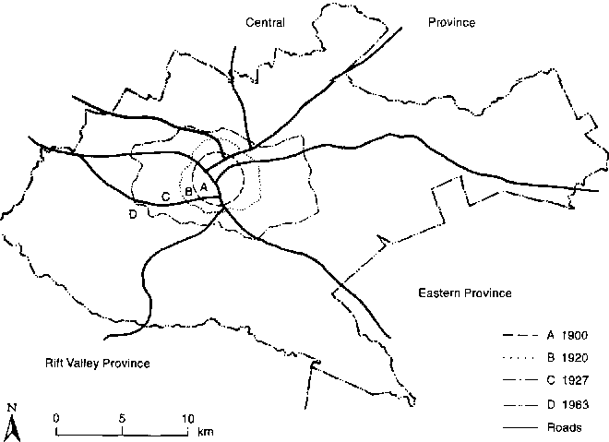
Source: Obudho (1997)

The above scenario has several implications for the Nairobi residents who rely on non-motorized transport for making their daily major trips. Those walking to work, for example, do have to wake up very early to prepare and start their journeys in order to get to their work places in good time, and always get back to their dwellings well into the night. The dominance of walking as a mode of transport in Nairobi can rightly be attributed to lack of adequate and affordable public transport services, especially for low-income groups living in Nairobi’s expansive slums, and the difficulties associated with operating a bicycle over Nairobi’s congested and poorly maintained road network that has given little consideration for cycling facilities. The long trips that poor pedestrians have to make also do arise from poor urban land-use planning that is largely responsible for the location of residential areas far away from places of work, shopping zones and even entertainment places.

2.2 Non-motorized transport infrastructure: Walkability of Nairobi streets

Litman (2003) describes walkability as the overall support for pedestrian travel in an area. In broad terms, walkability takes into account the availability and quality of pedestrian facilities, roadway conditions, land use patterns, community support, security and comfort for walking. Despite the dominance of walking as a means of transport in Nairobi and other African cities, almost all previous investments in road infrastructure have gone into facilities that primarily benefit only the motor vehicle users. A survey carried out in 1998 estimates that Nairobi city has a classified road network of 1530 kilometers. Given the role that walking in particular, and non-motorized transport in general play in the mobility of the people in Nairobi, it is dismaying that only 8% or 123.25 kilometers of Nairobi’s road network had some form of NMT infrastructure. Out of the city’s total network, a mere 2.7% or 41.35 kilometers were designated as footpaths while 5.35% or 81.9 kilometers were supposed to double as footpaths and bicycle lanes.

More disturbing is the fact that even the dismal NMT infrastructure that is claimed to exist in Nairobi has not been maintained, but ignored and left to dilapidate. According to Post Buckley International (1999), for example, while 84% of the main road corridors in the city had motor vehicle pavements in good conditions, only 3% of these roads had walking and other NMT facilities in good condition. This illustrates a great misplacement of the city’s policies and priorities for investment in the transport sector. The transport policy and planning, not only in Nairobi, but other African cities as well, is motor-vehicle oriented and largely ignore NMT. In short, walking, and arguably cycling are not given due consideration as modes of transport. The distribution of NMT infrastructure in Nairobi by type and road class as well as their prevailing conditions are summarized in Tables 1 and 2 respectively.

Table 1: Distribution of NMT Infrastructure in Nairobi by Road Class, 1998
Road Class | Footpaths (km) | % of Total | Foot/Cycle paths (km) | % of Total
International Trunks | 14.00 | 34.15 | 1.40 | 1.71
Primary | 10.20 | 24.67 | 31.10 | 37.97
Secondary | 0.80 | 1.93 | 24.90 | 30.40
Access | 11.95 | 28.90 | 19.10 | 23.32
Unclassified | 4.40 | 10.64 | 5.40 | 6.59
Total | 41.35 | 100 | 81.90 | 100
Source: Own using data from Post Buckley International (1999)

Table 2: Conditions of Footpaths and Cycle Lanes in Nairobi, 1998

Type of Condition | Footpaths (km) | % of Total | Foot/Cycle paths (km) | % of Total | All NMT Network | % of Total
Good | 5.90 | 14.26 | 1.40 | 1.71 | 7.30 | 5.92
Inadequate | 6.10 | 14.75 | 4.00 | 4.88 | 10.10 | 8.19
Poor | 13.90 | 33.62 | 21.00 | 25.64 | 34.90 | 28.32
Very poor | 10.25 | 24.79 | 55.50 | 67.76 | 65.75 | 53.35
Non-Existent | 5.20 | 12.58 | ---- | ---- | 5.20 | 4.22
Total | 41.35 | 100 | 81.90 | 100 | 123.25 | 100
Source: Own using data from Post Buckley International (1999)

The data presented in Tables 1 and 2 reveal a worrying scenario. For example, 58.82% of the available footpaths exist on international trunks and primary roads which are less trafficked by pedestrians. Research has shown that pedestrian flows in Nairobi are particularly heavy in Nairobi’s low-income settlements such as Kariobangi, Mathare Valley, Kibera, Dandora, Umoja, Makadara and Eastleigh, which are not served by international trunks. The few secondary roads which connect most of the low-income areas and informal settlements to workplaces in Nairobi accounted for only 1.93% of the footpaths available in the city. More revealing is the fact that only 5.90 km of the pedestrian paths in the whole of Nairobi was found to be in good condition! Moreover, only 1.40 km (or 1.71%) of the walkways supposed to be shared between pedestrians and cyclists was in good condition. About 70% of such facilities were found to be in very poor conditions.

The problem of poor and inadequate NMT infrastructure is exacerbated by uncontrolled encroachment and roadside parking (see Plates 1 and 2). The capacity of the existing NMT facilities has been further reduced and compromised by significant encroachment by hawkers and other small-scale traders who mount makeshift structures in order to sell their wares. Although this problem is ubiquitous throughout Nairobi, it is more serious on the roads serving low-income and informal settlements. Encroachment of footpaths and cycle lanes means the pedestrians and cyclists are pushed to the motorways increasing chances for traffic conflicts, and therefore road accidents. As a result, people walk under very difficult and unsafe conditions, especially on routes leading to low and middle-income settlements and the major trip attraction centers – the CBD and industrial area which offer employment to majority of residents. For the few bicyclists, daring enough to take to the Nairobi roads on their bicycles, they must surely be leaving their safety to fate as their journeys may end in deaths or injuries following a road traffic accident.

Plate 1: Hawking on pathways and a service road outside CBD

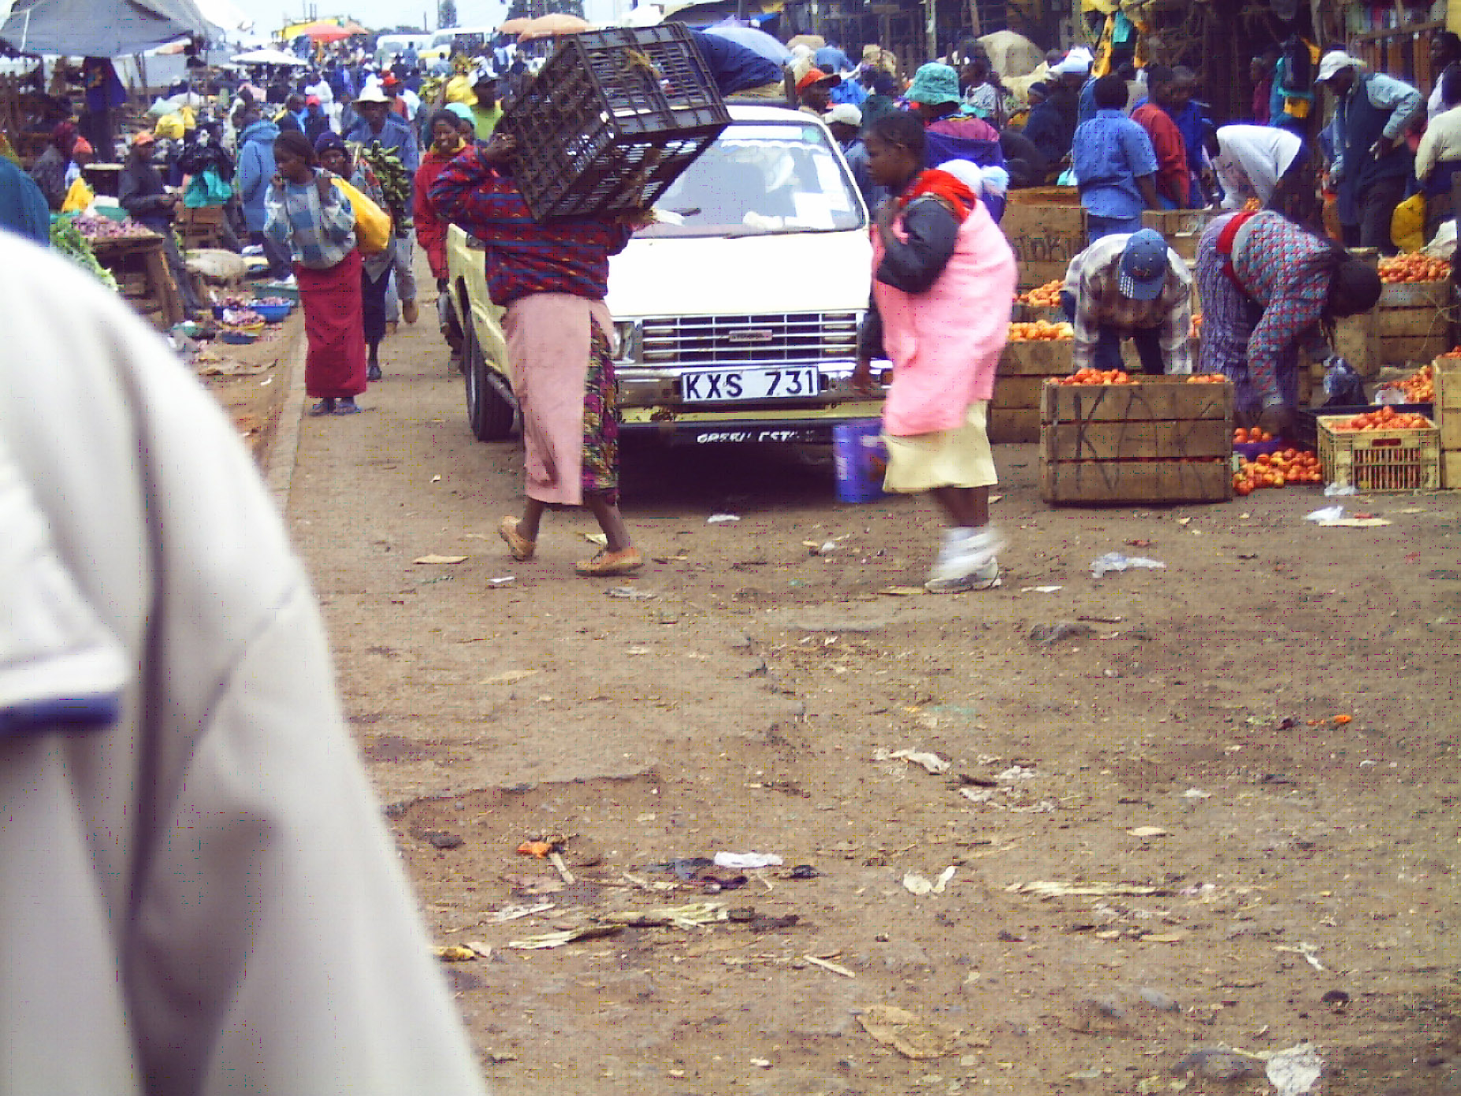

Plate 2: Hawking within central business district
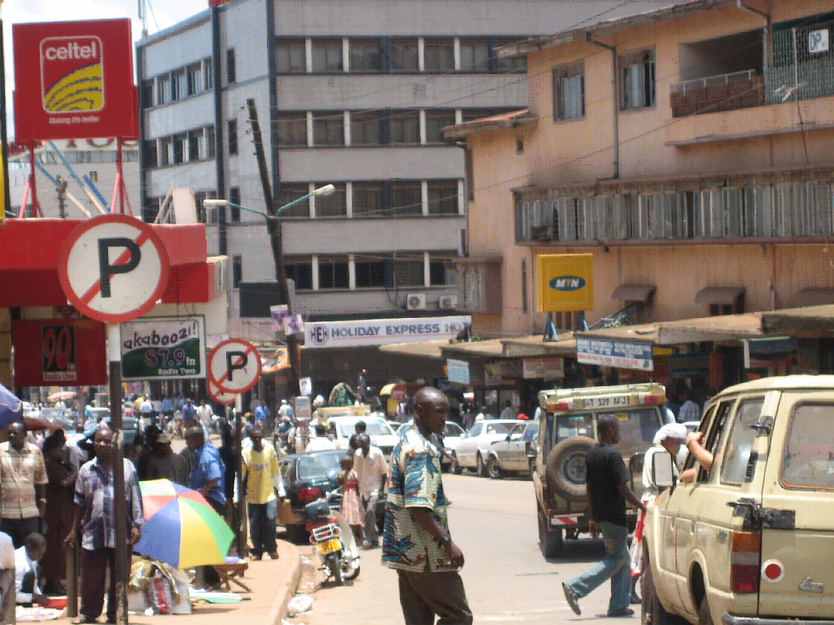

2.3 Challenges and risks for pedestrians and cyclists in Nairobi

From the discussions in the foregoing paragraphs, it is clear that people making their trips in Nairobi by walking or cycling are faced with a number of challenges and risks. Some of the specific risks and challenges are highlighted in the following sections.

2.3.1 Inadequate quantity and quality of NMT facilities

The results presented in section 2.2 clearly show that the NMT infrastructure are grossly inadequate both in quantity and quality. Given that the population of Nairobi is currently estimated at about 4 million and is increasing, a combined total of 123.5 kilometres of both pedestrian paths and bicycle lanes is remarkably inadequate. The few NMT facilities in the form of footbridges, underground passages, pedestrian crossings and paths as well as cycle lanes have been largely mismanaged and neglected without routine maintenance. For this reason, most of the existing NMT infrastructure like sidewalks in Nairobi are in an unusable state, especially during the rainy seasons (Lamba, 1994). In some cases, the NMT facilities like the footbridges have been situated in places that are not convenient for pedestrian use. Inadequate NMT infrastructure, poorly designed and dirty walkways, long detours and poor street lighting have been identified as some of the factors that greatly affect mobility of pedestrians and cyclists (Monheim, 2002).

2.3.2 Long distances and travel times

Closely linked to the problem of poor and inadequate infrastructure, are the long pedestrians and bicyclists – travel times. Many people cover extremely long distances on foot and under very dangerous conditions. With the continued expansion of settlements (especially informal ones) in Nairobi, the problem of long distances for the low-income population may remain for a long time to come. A solution, however, could be partially found in the use of bicycles. It is, therefore, imperative that the bicycle lanes be improved to enhance travel speeds. But improving infrastructure alone without addressing the question of accessibility and safety will not yield much. Rukunga (1990) and Omwenga et al (1994) have noted that one of the reasons the bicycle has a low modal-share in Nairobi is due to prohibitive costs for the low income earners. Among the reasons given by low income households for not using a bicycle are: lack of cycle paths, financial limitations, long distances to work and past accident on a bicycle among others (Rukunga, 1990). According to Omwenga and colleagues only 12% of the households reportedly owned a bicycle. Action, therefore, needs to be taken at the legislative and administrative level to zero rate taxes on bicycles and their spare-parts to make them more affordable to low-income earners.

2.3.3 Pedestrian and bicyclist safety

One of the central challenges to the use non-motorized transport in African cities is the problem of safety of pedestrians and bicyclists. The problem of safety concern is twofold. First, due to the long distances they travel to their places of work and back, the pedestrians normally leave their dwellings before day-break so that they can get to their working stations in good time and are normally back after dusk. By starting their journeys early and returning late, they expose themselves to the risk of petty and violent crime by gangs, some armed with guns and machetes. In Nairobi, as in other larger cities in Africa, high levels of murder, assault, rape, robbery and other crimes are very prevalent. Crime adds to the deleterious effects of exclusion of the poor pedestrians and cyclists, and farther deters their mobility. In major urban areas, especially low-income settlements, crime constitute the basis of the feeling of insecurity and greatly impacts on the daily mobility of residents, especially pedestrians and cyclists.

Second, NMT users also face the risk of death or injury due to road traffic accidents. Analysis of road traffic crashes for Nairobi between 1999 and 2004 shows that pedestrians are the single largest most vulnerable group of road users (Kayi, 2007). Over this period, pedestrian casualties accounted for 59.1%, 50.2% and 56.2% of all road accident fatalities, serious and slight injuries in Nairobi respectively. Bicyclists accounted for 2.5% of those killed, 3% of seriously injured victims and 4.9% of total slight injuries. This means that pedestrians and cyclists combined accounted for 62% of road crash fatalities in Nairobi over this period. Figure 3 illustrates the road crash fatalities by road-user group in Nairobi over the 1999 - 2004 period.
Source: Kayi (2007)

The findings presented above are consistent with those of some of the past studies not only in Kenya, but other African countries as well. SSATP (2002), for example, conducted a study on the urban mobility of three East African cities of Dar-es-Salaam, Addis Ababa and Nairobi, and found that pedestrian casualties in Nairobi accounted for 68% of all fatalities, about 50% of all serious, and 48% of all slight injuries. Khayesi (1999) found that between 1977 and 1994, pedestrians accounted for 64.5%, 43.6% and 41.3% of total fatalities, serious and slight injuries in Nairobi respectively. In Swaziland, pedestrian deaths account for half of the national road fatalities (IRIN, 2004). Apparent differences emerge when the results are compared to those of the Asian region or in highly industrialized nations. In Asia, for example, pedestrians and motorcyclists (and not passengers) have the highest rates of injury (Yang and Kim, 2003). In most OECD countries such as Germany, France and Sweden, car occupants represent more than 60% of all fatalities (WHO, 2004). This is a reflection of the high number of motor vehicle use in these countries.

The implication of these findings is that in Nairobi, and by extension in most African cities, pedestrians are a high road traffic accident risk group. As depicted by the modal-share, the majority of residents, especially in the low to middle-income categories, accomplish most of their mobility needs through walking. However, priority in transport policy and planning in Nairobi has tended to focus on the development of infrastructure that enhances motorized transport at the expense of non-motorized transport. If the mobility of the majority in African cities is to be improved, then a re-orientation of the transport policy and planning framework is inevitable. A major challenge in the future development of transport system in African cities, therefore, exists in striking a balance between the distribution of investment by mode and taking into account the actual travel needs and travel behaviour of the population. Given that walking comprises the majority of person-trips, and that NMT has a big potential to enhance mobility of the population, it is only reasonable to expect that the development of pedestrian and NMT friendly infrastructure should receive high priority. This has not been the case in the past. Even when construction companies are contracted to renovate/rehabilitate city roads, pedestrian paths and bicycle lanes have not been included in their terms of references (TORs). This must change in future if we expect to enhance the mobility of the poor and ensure their safety. In particular, there is need to give priority to the development of infrastructure that will allow pedestrians and bicyclists to move freely and safely on the main corridors, to create conditions that will allow them to safely cross junctions on the main roads. The next section discusses some of the policy options and strategies that may be adopted in order to enhance the use on NMT and the safety of the users.

2.4 Policy options, strategies and institutional framework for improvement of NMT in African cities

In light of the fact that NMT plays (and will continue to play) an important role in urban transport sector in Nairobi as well as other urban areas in Africa, there is need for a policy-shift regarding NMT. The policy options for encouraging an efficient and safe use of NMT in African cities, should and must involve improvement of infrastructure, reorganization of institutional set-ups and adoption of an integrated urban, land-use and transport planning approaches.

2.4.1 Policy options and strategies: The need for radical reorientation

In attempting to improve the NMT network, three options may be considered. The first policy option may involve a comprehensive city-wide development of the NMT network for the city. This option would require long term planning and can only be achieved over a long period of time. Under this option, the city authorities may undertake to rehabilitate all the existing pathways and bicycle lanes in addition to building new ones where non-existed earlier. It would also involve aggressive improvement of facilities at all crossing points and junctions as well as investing in traffic management systems that would ensure adequate time allocation at intersections and mid-block crossings. For the city council authorities to implement this, a heavy capital resource-base would be required. The shaky financial base of the council authorities like Nairobi City Council may be used as a scapegoat to dismiss this option as being too expensive to implement. But experiences from elsewhere have shown that with a well thought out long-term planning, a city-wide investment in NMT facilities is achievable, and enhances mobility and quality of city life. The achievability of this option is best exemplified by Bogota where mayor Enrique Penalosa led the transformation of that city from a congested and dangerous mess, into the world's leading model for sustainable urban design within just about three years.

Penalosa's administration substantially changed the physical aspects of the city including pedestrian zones, bicycle lanes, sidewalks and the implementation of the Transmilenio bus rapid transit system. With a strong political will Bogota's transport system was transformed, within a fairly short period of time, to a system friendly to both the environment and NMT users. By January 2003, for example, about 270 kilometers of bicycle paths had been completed (Montezuma, 2005). This is the largest network dedicated to bikers in Latin America and the rest of the developing world. Pedestrian facilities like sidewalks, traffic signals and lighting were either substantially renovated or constructed a new. Montezuma (2005) notes that a total of approximately 917,000 square meters of public space, including 432,000 square meters of sidewalks, were either recovered or newly constructed. In order to finance the NMT-friendly programs, gasoline tax was increased from 14% to 20%. Further resources were obtained from the United Nations Development Program (UNDP).

The cost of constructing and/or rehabilitating the whole NMT infrastructure in Nairobi may seem to be well above the possible financial resources of the city council. However, the Bogota model has shown that, with a strong political will, it is possible to mobilize donor, public and private sector resources, and to implement city-wide NMT-friendly programs that enhance the mobility and safety of pedestrians and bicyclists. The Nairobi city council may initially seek funding from development partners in order to satisfy the immediate need for capital funding to bring the infrastructure to maintainable condition. Thereafter, sufficient funds can (and should) be raised from the road-users to meet the recurrent network maintenance budget. Some of the ways through which this could be achieved include increasing parking fees, fines accruing from traffic offences and fuel levy.

The second policy option may be that of giving priority to transport corridors with high pedestrian and cyclists flows. In Nairobi, for example, the candidate roads for this consideration would be Juja, Likoni, Race course, Enterprise, Lusaka, Outer ring, 1st Eastleigh avenue and Kibera drive among others. These roads are among the major corridors that link low and middle-income settlements with major work locations, and are heavily traveled by pedestrians and cyclists. Although, this option may not result into a comprehensive infrastructural improvement, it is likely to substantially improve the NMT facilities used by a majority of Nairobi residents. This would, of course, be only some sort of a short-term stop-gap measure.

The third suggested policy action would be to combine both the first and the second options. The rationale here is that the city council authorities may need to develop a short to medium–term as well as a long – term NMT network improvement and mobility enhancement programmes. The short to medium–term programmes would be aimed at preventing the already poor situation from getting worse by enhancing the use of the existing facilities. The long-term programmes on the other hand would be intended at a city-wide construction of NMT facilities over a relatively long period of time. Similar to the first option, substantial financial resources would be needed to implement this option. Whichever policy strategy that may be adopted by any city council, maintenance must be an integral part of the whole planning and implementation process. It is only then that the NMT facilities may be kept in good and usable conditions when the construction phase is over.

2.4.2 Establishment of relevant institutional framework

Any of the above options would have to be accompanied by institutional and personnel considerations. Within the Nairobi city council, for example, there is currently, a lack of institutions and persons wholly and directly responsible for NMT issues. The same applies to a majority of other African cities. There is, therefore, need to create NMT related institutions. This could be done in two possible ways. First, a unit may be created that would be entirely responsible for development, management and maintenance of NMT infrastructures. This unit may work under the chief engineer’s office or the city council’s roads department, but would develop policy programmes relating to NMT matters within the city.

The second approach may involve hiring or appointing one of the officers in either the roads department or chief engineer’s office to start working on NMT related issues while he/she is still attached to the parent department or office. The officer may, however, require further training on NMT needs and policy matters. Although this strategy may not work well initially, it is likely to slowly develop to become a full and efficient unit or department.

While the policy strategies suggested above are concentrated to a large extent on infrastructure, policy options for improvement of public transport in Nairobi (and other African cities) should fundamentally be concerned about the organization, structuring, and management of the sector rather than construction of new roads. This argument is based on the premise that with good management of the public transport sector, the existing roads could serve Nairobi residents sufficiently well for a long time to come. Policy changes should, therefore, be focused on enhancing the operations of high-capacity buses. High-capacity buses will not only help in moving masses of people, but will also help decongest the city roads. In addition, well maintained high-capacity buses will reduce the negative effects (e.g. noise and air pollution) that motor-vehicles have on the environment. There is, therefore, need for policy guidelines that will give priority to public transport on the existing road network in Nairobi. Some of the strategies which can be either individually or collectively employed by the city council for a start include: separate lanes for public transport buses, traffic signal priority for public transport and giving public transport priority at stops among other traffic management schemes. The whole idea should be to redistribute parts of the existing road network to public transport and give public transport buses and non-motorized transport priority at the potential points of conflicts with other vehicles.

The policy options suggested above should, however, not be considered in isolation, but together within the context of an integrated urban transport planning for the cities. The public transport, NMT and the commuter rail service can play a complementary role to one another in enhancing mobility within the African cities. The improvement of NMT infrastructure, for example, should not be seen as a mere facilitation of pedestrian and bicyclist travel, but should be considered in the wider context of encouraging access to public transport and enhancing the overall mobility of the residents. Walking and cycling should be seen as a means of transport on their own right as well as a means preceding public transport and after embarking from public transport. Figure 4 shows the potential integration of NMT (especially the bicycle) and public transport. The hurdle of implementing an integrated network service in Nairobi, may come in the form of resistance from tens of thousands of Matatu operators who may see themselves as losing the grip on the lucrative public transport market in Nairobi. Matatu operators should be encouraged to gradually join hands and venture into high-capacity buses business. Those that will still be in operation should be allowed to operate on the out-skirts of the city and act as feeders to the main public transport network.

Figure 4: The potential integration of route network, NMT and public transport
CBD
Major roads (High-capacity buses)
Feeder roads
Plied by Matatus
Major trip-generation
& attraction points

Source: Author’s Own
2.5 Conclusion

Transport policy and planning in African cities needs a refocusing. Policy makers and planners are busy repeating the same mistakes that were made by the industrialized countries in the early to mid 20th century when the car was given priority over the other forms of transport within urban areas. There are now attempts to tame the car and reclaim the livability of streets in western cities, but planners and policy makers in Africa are refusing to learn from the past mistakes. Although majority of major trips in African cities are made through non-motorized transport, especially walking, most investments in the transport sector are directed at facilities that primarily benefit the motor vehicle users. As a result NMT facilities lack in quantity and quality putting pedestrians and cyclists in a precarious position. Given that a larger proportion of the population in African cities rely on NMT, there is need for more emphasis to be placed on the provision of a user-friendly pedestrian and cyclist environment.

Depending on resource availability, some of the policy options that may be adopted in order to achieve such an environment include: a long-term comprehensive city-wide development of the NMT network; short to medium term planning where priority is given to transport corridors with high pedestrian and cyclists flows or a combination of both the short–medium and long–term strategies. These strategies should, however, be considered within an integrated urban transport planning framework.
References
Aduwo, I.G. (1989) ‘The role, efficiency and quality of service of matatu mode of public transport in Nairobi’, M.A. thesis, University of Nairobi.
Aligula, E.M. et al. (2005) ‘Urban public transport patterns in Kenya: A case study of Nairobi city’. Special report No. 7, April. KIPPRA, Nairobi.
IRIN (2004) ‘Southern Africa: Special Report on Road Traffic Injury Prevention’, www.irinnews.org
Kayi, C. (2007) 'An analysis of road traffic accidents using Geographic Information System (GIS): The case of Nairobi city, Kenya', PhD thesis submitted to Faculty of Geography and Geosciences, University of Trier.
Khayesi, M. (1999) ‘An analysis of the pattern of road traffic accidents in relation to selected socio-economic dynamics and intervention measures in Kenya’, PhD thesis, Kenyatta University.
Lamba, D. (1994) Nairobi’s environment: a review of conditions and issues, Mazingira Institute, Nairobi.
Litman, T.A. (2003) ‘Economic value of walkability’, Transportation Research Record 1828, Transportation Research Board (www.trb.org), pp. 3-11; available at the VTPI website (www.vtpi.org/walkability.pdf).
Monheim, H. (2002) ‘Strategies and Elements for the Promotion of Pedestrians: Lessons from the case of Germany’, in Dominique F. (ed) A City for Pedestrians: Policy-making and Implementation, European Communities, Luxembourg.
Montezuma, R. (2005) 'The transformation of Bogota, Colombia, 1995-2000: Investing in citizenship and urban mobility', Global Urban Development, 1(1), pp. 1-10
Obudho, R. A. (1997). 'Nairobi: national capital and regional hub', in Carole Rakodi (ed) The Urban Challenge in Africa: Growth and Management of its Large Cities, United Nations University Press, Tokyo.
Omwenga, M.E., Obero, S. and Malombe, J. (1994) ‘Non-motorized urban transport studies, Eastern and Southern Africa: Nairobi household and corridor survey analysis: Urban mobility of the low and middle income population’, Report No. 11
Post Buckley International (1999) ‘Nairobi: Long-Term Transport Study’, A Report Submitted to the Ministry of Local Authorities in association with Kaburu, Okelo & Partners, Nairobi.
Rukunga, D. N. (1990) ‚Viability of the bicycle as an alternative mode of transport in Nairobi’, M.A. thesis, University of Nairobi.
SSATP (2002) Scoping Study: Urban Mobility in Three Cities, SSATP working paper No. 70
United Nations Population Division (2001) ‘World Urbanization Prospects: The 1999 Revision. Key Findings’, United Nations Population Division. http://www.un.org/esa/population/pubsarchive/urbanization/urbanization.pdf [Geo-2-203]
World Health Organization (2004) World report on road traffic injury prevention, World Health Day, 7 April, World Health Organization, Switzerland.
Yang, B. M. and J. Kim (2003) ‘Road traffic accidents and policy interventions in Korea’, Injury control and safety promotion, 10: 83 - 87

* The author is a Tutorial fellow, Department of Geography, Kenyatta University (Kenya), but currently pursuing a PhD program in Transport studies at Trier University, Germany.
Matatus are small-scale motorized means of public transport in Kenya. The term is derived from a Kikuyu (Kenya’s most populous tribe) word “mang’otore matatu” which means “thirty cents” which was the standard fare charged when matatus started operations in Kenya (Aduwo 1989)
SSATP: Sub-Saharan Africa Transport Policy Program

