SOCIO-ECONOMIC INVESTIGATIONS FOR RURAL VALUE OF TIME STUDIES IN DEVELOPING COUNTRIES: COMBINING QUALITATIVE AND QUANTITATIVE METHODS

Paper for the 11th World Conference on Transport Research

Kirit VAIDYA
Aston Business School
Aston University
Birmingham, B4 7ET, UK
E-mail: k.g.vaidya@aston.ac.uk

Farhad AHMED
IT Transport Ltd., The Old Power Station
Ardington, Nr Wantage
OXON, OX12 8QJ, UK
E-mail: farhad.ahmed@ittransport.co.uk

Marcus WATTAM
COWI Uganda
Tel +256 41 34 30 45
Fax +256 41 34 32 43
E-mail: mjw@cowi.co.ug
SOCIO-ECONOMIC INVESTIGATIONS FOR RURAL VALUE OF TIME STUDIES IN DEVELOPING COUNTRIES: COMBINING QUALITATIVE AND QUANTITATIVE METHODS

Abstract
Value of time studies in rural areas in developing countries require careful complementary socio-economic investigations. Three aspects requiring particular attention are: (a) whether rural travellers have sufficiently objective perceptions of time and time savings and other attributes of travel conditions; (b) how preference questionnaires should be designed to obtain robust responses on the trade-off between time savings and monetary costs, and (c) the choice of indicators of the socio-economic status and incomes levels of travellers. The combination of qualitative (focus groups and participatory rural appraisal) and quantitative methodologies were found to be highly effective in rural localities in Ghana and Tanzania.

Key Words: rural / developing countries / time saving values / socio-economic studies

1. Introduction

Travel time savings estimated by preference methods are a major benefit arising from transport infrastructure investments in developed countries. However, such savings are rarely included in the appraisal of rural transport projects in developing countries. An important objection to the use of preference methods in the rural context in developing countries is that the socio-economic situation and perceptions of time and time savings are so different from those in western economies that preference methods cannot be applied. The authors have conducted studies in Bangladesh, Ghana and Tanzania to demonstrate that the stated preference (SP) method supported by appropriate socio-economic investigations can be used in the rural context in developing countries. The SP studies and their results have been discussed elsewhere (IT Transport, 2002 and 2005, Farhad, Vaidya and Wardman, 2007). This paper reports on the combination of qualitative and quantitative socio-economic investigations which complemented the SP studies. The methods were initially developed in the Bangladesh study (IT Transport, 2002) and further refined, adapted and extended in Ghana and Tanzania.

Figure 1 Overview of socio-economic investigations and their relationship to the value of time studies
Figure 1 shows an overview of the socio-economic investigations and how they relate to the SP studies. Apart from obtaining a general understanding of the socio-economic context, the investigations were required for:
- determining whether rural travellers have sufficiently objective perceptions of time and time savings and other attributes of travel conditions;
- designing and administering preference questionnaires to obtain robust responses on the trade-off between time savings and monetary costs, and
- choosing indicators of the socio-economic status and incomes levels of travellers to enable assessment of the influence of these features on the value of travel time savings.
The darkly shaded box at the top in Figure 1 indicates the use of qualitative Participatory Rural Appraisal (PRA). PRA is used by researchers and policy makers to improve understanding of the local situation by communicating interactively with local people (extractive and consultative modes) or by local people to make decisions and take initiatives (empowering mode). PRA is a pragmatic process which uses a range of tools (Pretty, Guijt, Thompson and Scoones, 1995 and Mukherjee, 2002). For the studies reported here, PRA was used in extractive and consultative modes rather than the empowering mode. While PRA has been used extensively in research and as part of rural development projects (for examples, see McAllister, 1999), the authors are not aware of its application in supporting value of time studies in developing countries.

The studies also addressed the issue of whether the values of time savings were different for travellers with different socio-economic characteristics and especially for members of poor and better-off households (the two lightly shaded boxes on the left in Figure 1). The authors developed a methodology for estimating the standards of living of respondents to SP questionnaires without directly asking them for information on household income or expenditure. Different approaches to differentiating between poor and non-poor travellers were also required in the three countries because of lack of consistent data.

Section 2 describes the qualitative PRA methodologies used in Ghana and the most important results derived. The more limited PRA methodology in Tanzania is considered in section 3 and compared with the approach in Ghana. Section 4 reports on the household surveys and regression analysis used to assess the living standards of travellers. The expenditure thresholds required to distinguish between poor and non-poor travellers are examined in section 5 which is followed by conclusions and lessons for future work.

2. Qualitative methodology in Ghana
2.1 Overview

Table 1 Summary of qualitative data collection approaches in Ghana
Type | Number | Objectives
1. Semi-structured interviews | Many | To obtain initial information on the study area.
2. Focus group discussions | 8 | To explore a range of subjects, including household structure and wealth groups drawing from the experiences of small groups of either men or women. The aim was to inform the design of the SP questionnaires and to provide context to data from the SP and household surveys.
3. Activity diary | 6 | To gain an understanding of the time people spend on different activities throughout the year. Men and women representing different socio-economic groups (poor, average and wealthy) were asked to participate.
4. Time line activity | 2 | To gain an understanding of how people measure and understand time, what indicators people use to tell the time and what activities people undertake on a seasonal basis.
5. Ranking and scoring | 6 | To understand people’s preferences between, for example, different modes of transport.
6. Community mapping | 2 | To gain an understanding of the services available to a community, access routes for a village and the distances people travel to reach services that are not available within it.
7. Wealth ranking | 6 | To gain an understanding of socio-economic groups within the area and how these can be identified, for example, through the type of housing, number of income earners in the household and livestock ownership. The aim was to identify indicators to be included in household surveys and to provide context for the analysis of household survey data.
8. Validation discussions | 4 | To validate data from the household questionnaire.

The qualitative methods used in Ghana were mainly focus group discussions and key informant interviews. PRA methods of community mapping, activity diaries, time lines, simple ranking and scoring, pair-wise ranking and wealth ranking were used. Fieldwork took place in six communities along three roads in Yendi District chosen because of their location along the three study roads on which the SP and RP studies were to be conducted. The programme of focus group discussions, key informant interviews and household data collection is set out in Table 1 and described in the following sections.

2.2 Key informant interviews and focus group discussions

Initial key informant interviews were with village chiefs and their elders, the village chairperson and women leaders followed by a series of focus group discussions with men, women and children to collect two types of data. In the first phase, general livelihoods and household-related questions were discussed in the first four focus groups and time use and SP related issues in the second four focus groups. In the second phase, further four focus groups specifically considered modal preferences between genders and different socio-economic groups. There were separate focus groups for men and women to ensure better participation by women. In addition, two focus groups with children (a group of school children and a group of out of school children) discussed time and time measurement, and transport mode preferences. Further validation meetings were carried out in each community to feed back on study activities and to verify the conclusions from the focus groups.
2.3 Activity diary

Activity diary surveys were conducted with a small sample of men and women from different socio-economic backgrounds, a man and a woman each from poor, medium and wealthy households. Individuals were interviewed about their typical daily activities in the dry season and then asked how these changed in the rainy season. The results were recorded in a log table showing the start, finish and duration of various activities.
  - Time Line
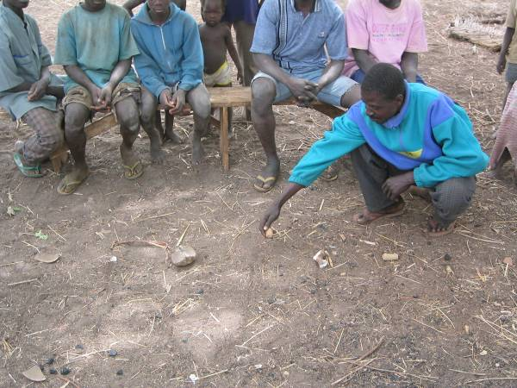Time lines were used to get a picture of the daily activities of various groups and individuals (key informants) in the dry and wet seasons. Participants were asked to draw a line on the ground and asked to describe the various indicators they used to tell the time (sun, shadows, temperature etc.). These time indicators were represented by objects or symbols, which were placed along the line to represent a 24 hour period. The participants were then asked to recall the various activities carried out in a typical day in the dry and the rainy seasons. Objects were again used to represent the various activities and placed on the line, indicating the time of the day the activities were undertaken. This activity was time consuming and impractical to do on a large scale and so was limited to one focus group in each community.
  - Ranking and scoring

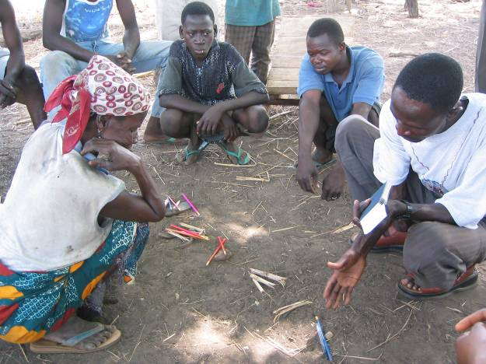
The ranking and scoring tools were used to determine the modes of transport most often used as well as participants’ preferences under various circumstances. For the ranking and scoring of preferred modes of transport, participants were first asked to list the different modes available to them and place symbols on the ground to represent them. Participants were then given 20 stones and asked to share them among the various modes, giving more to the mode that they use often or prefer most. Pair-wise ranking was also used to elicit participants’ preferences. In this exercise each mode of transport is judged against each of the other modes. The number of times that each mode is chosen indicates their ranking.
2.6 Community mapping

These exercises were done in each of the chosen communities to gain an understanding of the physical layout of the settlement and the local amenities serving them. Participants were asked to draw an outline map of their community and asked to use symbols or markings to place amenities such as schools, water points and markets on the map.

2.7 Wealth ranking

Wealth ranking was used to identify indicators of wealth and how the preferences and choices of transport for the different wealth categories differ. The wealth ranking exercise started with a discussion of participants’ perception of wealth and wealth categories in their communities. They were then asked to give criteria for measuring wealth or wealth categories in their communities. Symbols were used to represent the different categories of wealth in the community. Participants then shared 20 stones among the various categories, giving more stones to the category in which more people in the community fall.

2.8 Summary of findings

Table 2 summarises the findings of the qualitative surveys in Ghana. The wealth indicators for households were used in designing household questionnaires for identifying the indicators of living standards of rural travellers (see section 4 below). The important issues of perception and measurement of time, their implications for SP questionnaire design and the estimating children’s time savings are considered in the following sub-sections.

2.9 Measurement of time and design of SP questionnaires

The focus group discussions and interviews on time and time measurement provided invaluable insights into how people perceive and understand time. It appears that most people use a combination of physiological, social, mechanical and natural indicators to tell the time.
- Mechanical indicators include the use of watches, clocks and radios.
- Natural indicators include observing the movement of the sun and shadows, moon and stars, and observing or hearing the activities or calls of various birds and animals.
- The physiological indicators include feeling tired, feeling the effects of the heat or feeling hungry.
- Social indicators include observing the activities of others, hearing the call to prayer in the village, interacting with others and asking those who own watches.

The relative importance of these indicators is dependent on the age, gender and social position of the person. It could not be assumed that most travellers would have perceptions of time based on reliable mechanical indicators. The natural indicators were considered to be too imprecise. The most important measures of time appeared to be associated with the five daily prayers that are mandatory for all practising Muslims. The call to prayer and the prayers that follow provide a regular pattern through which people know the time of day. Those that call the prayers (Muezzin) generally use watches and clocks to start prayers at correct times. Prayer times therefore play an important role in structuring people’s daily activities and their awareness of time.

This knowledge proved invaluable in the design of the SP studies. The blocks of time between call to prayer, prayer, and end of prayer were used to convey fixed periods of time to SP questionnaire respondents where necessary. The 15 minutes between call to prayer and prayer, and the 30 minutes between call to prayer and end of prayers were used to help explain the time differences between the two different options. The questionnaires were designed to accommodate multiples of 15 minutes since it was felt that smaller periods of time would be difficult to explain and difficult for some of the respondents to understand. Interviewers carried a card containing the explanations of different time blocks (Table 3).

Table 2: Summary of findings of qualitative investigations in Ghana
Type | Objectives | Summary findings
General Background/wealth indicators/household data | To find out wealth indicators, household structures and community composition to develop household questionnaire. Conducted mapping exercise. To find out about local travel and transport options. | Within the area, there is a certain amount of wealth differentiation between individuals and households. This differentiation is evident in a number of ways: (a) the standard of housing (zinc or thatch roofing, cement or mud walls, and cement or mud floors); (b) ownership of transport; (c) ownership of livestock; (d) size of farm and ability to use mechanised as opposed to manual means of farming, and (e) the standard of dress and physical appearance.
Time measurement | To find out how people perceive, value and measure time to assist in the design of the SP and RP questionnaires. Conducted time line activity. | People use a combination of physiological, social, mechanical and natural indicators to tell the time. The relative importance of these various indicators is dependent on the age, gender and social position of the person. These discussions revealed that few people measure time, particularly women and the elderly. This raised the issue of the validity of SP and RP questionnaires, which rely on people being able to understand the notion of time. However, the consistency of prayer times (between call to prayer, ablutions, prayer and finishing praying) revealed through these discussions, allowed the team to redesign the questionnaires using blocks of time
Children’s value of time | To test the feasibility of investigating children’s value of time and their transport preferences | The test revealed that children freely responded to questions when they were interviewed alone (without their parents/guardians) but hardly contributed to discussions when their parents/guardians were around. It was therefore concluded that interviewing children together with the parents gave the same response as interviewing the parents alone on behalf of their children.

Table 3: Time block definitions
Time Block | Definition
15 minutes | From call to prayer and start of prayers (except morning prayers)
30 minutes (1/2 hour) | From call to prayer and finishing prayers (except morning prayers)
45 minutes | Time between end of 6 o’clock prayers and start of 7 o’clock prayers
60 minutes (1 hour) | Call of morning prayers to start of morning prayers.

2.10 Children’s Travel Time
The Bangladesh study did not attempt to value children’s travel time savings. Children’s economic contributions to households in rural areas in developing countries are recognised
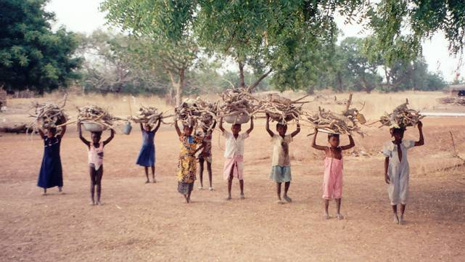
and their education is affected by ease of access to schools. World Bank (2005) recommends inclusion of children’s time saving values in transport project appraisal. Therefore the Ghana and Tanzania studies included attempts to estimate children’s value of time. A number of case study interviews were conducted with boys and girls and group discussions were held to determine whether meaningful responses could be obtained from children and the best way of interviewing them. It was found that children responded more freely to questions when they were interviewed in the absence of their parents or guardians).

3. Qualitative methodology in Tanzania and comparison with Ghana

  - Setting up the studies
The studies were conducted in a number of villages and markets as well as at roadside interviews with travellers. The chosen villages were on and off the SP study roads to identify possible differences related to ease of access. Investigations at markets were undertaken to obtain insights into the perceptions of traders and customers and were used to validate data from the quantitative analysis discussed in section 4 below. A sample of passengers was chosen to include a good mix of male and female respondents. A range of methods were used as in Ghana to target specific areas of investigation (see Table 4). The main findings have been summarised below.

3.2 Wealth and poverty indicators for the household questionnaire

The initial focus group discussions were used to discuss key indicators of wealth and poverty in the communities. Groups of men and women initially identified and ranked wealth and poverty indicators. The results were then compared and discussed between the groups. While the indicators identified by the groups were similar, there were significant differences in rankings of indicators between men and women. The most common indicators across the groups were:
- Quality of housing, especially the house roofing and wall materials.
- Number of acres owned and cultivated.
- Number of children at secondary school.
- Method for carrying water (particular to the lowland areas). Richer people can afford to pay cyclists or cart owners to collect water instead of head loading.
- Ownership of transport, primarily bicycles and motorcycles.
- Quality of agricultural tools used.
Some of the above indicators were included in the household survey questionnaires (see section 4 below).

Table 4 List of focus groups conducted in Tanzania
Focus group aim | Techniques used and types of group.
Preliminary road data.  Background data for the design of SP and RP questionnaires. | Semi structured interviews.  Village Chairman and Secretary and others. Validation with District Engineer.
Perception of time and daily activity to: (a) have better understanding of perceptions and methods for measuring time, and (b) inform the interpretation of results on time budgeting from daily activity data. | Semi-structured discussions.  Daily Routine maps.  Two male and two female groups from a mixture of backgrounds.
Community travel and transport. To give context to the SP and RP design in the types of trips people make and trip purposes. | Area mapping.  Transport discussions.  Two female and two male groups from a mixture of backgrounds.
Wealth and poverty. To validate and given context to results from the household survey and indicators to be used in SP and RP questionnaires. | Wealth ranking.  Two mixed groups from different backgrounds.

3.3 Perception of time

Two focus groups, one male and one female, were conducted to assess rural residents’ perception of time. The results indicated that people used a number of means to measure time from watches to when the cows come home. In both groups the use of watches and radios to tell the time was prominent. The majority of men and women could read a watch. The men were able to differentiate between 5 minute blocks, possibly due to the tight allocation of irrigation water in the area whereas women decided they could not easily distinguish between 5 minute gaps but could conceptualise 10 minute time blocks. All could differentiate between blocks of time above 10 minutes. Based on these findings, the time difference between choices offered in the SP questionnaires was not less than 10 minutes.
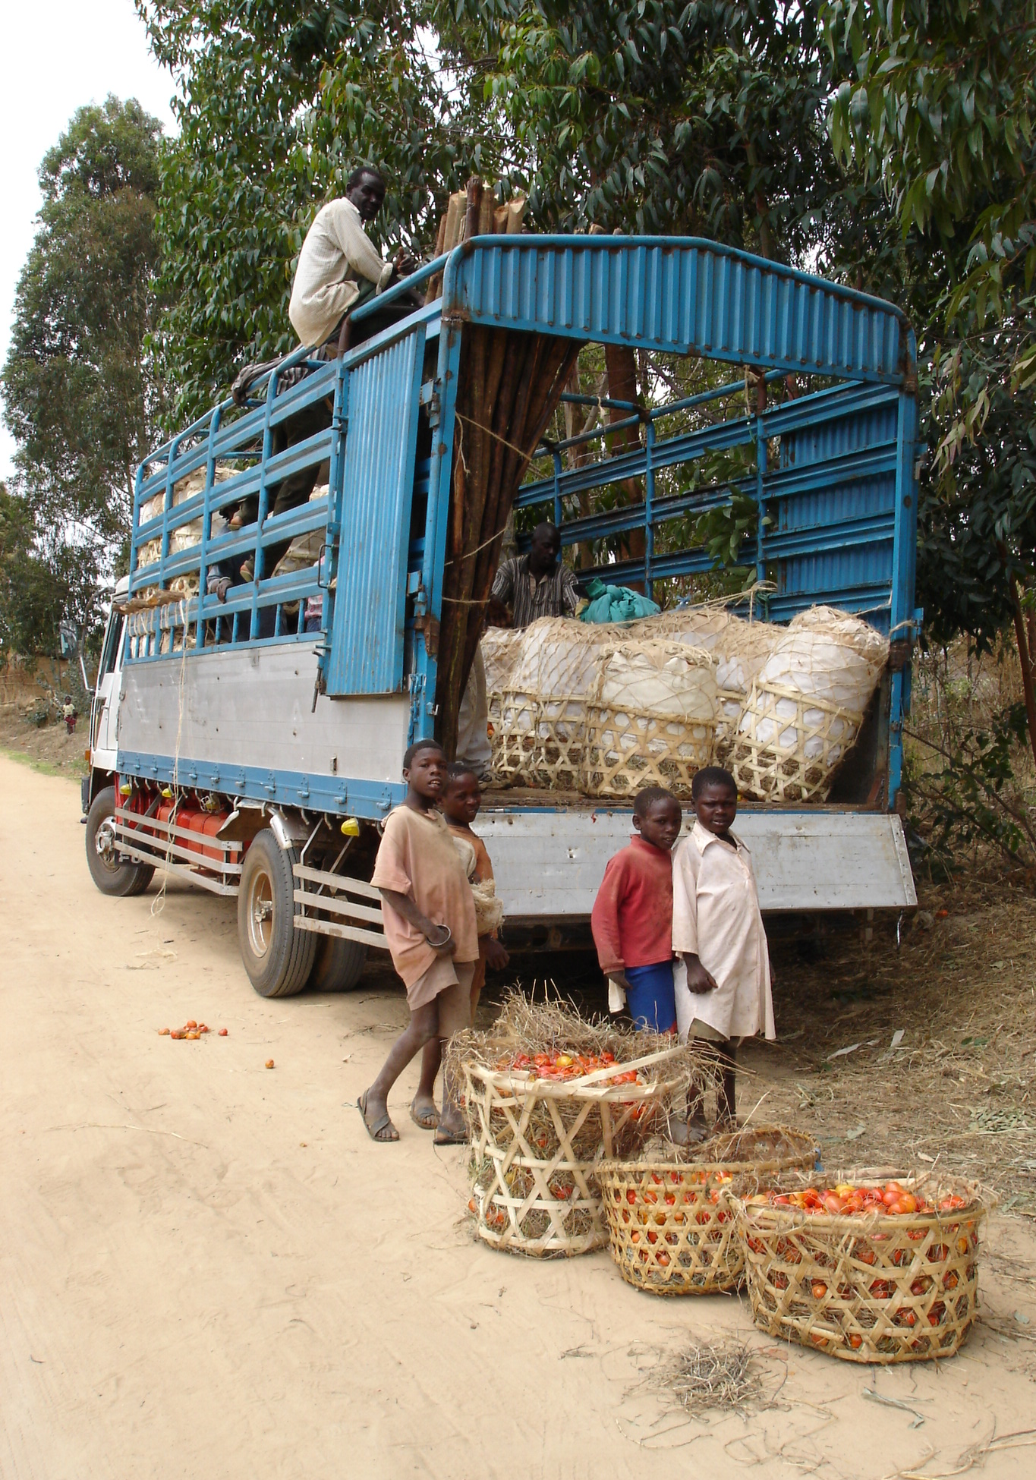
3.4 Transport variables for RP and SP questionnaire design

The initial focus group discussions were also used to identify the key things people think about when making a journey choice. Mixed groups were asked to sketch out a map of the key places to which they travel. A discussion was then held on the variables they consider when making these trips. Although price was a significant variable they felt that there was little they could do to influence this and so the main issues they consider are comfort and speed. For minibuses there was often some debate on the speed being too fast or too slow. Two groups identified safety as an important variable. Based on this finding a question was included in the SP questionnaire to gauge respondents’ willingness to pay for safer travelling conditions.
3.5 Interviewing children
A group of secondary school children discussed a number of issues related to travel and transport. The choice of children attending secondary school (i.e. not including children who do not attend school) introduced a bias, but children who travel the most are likely to be those attending school. It was apparent that children have little influence on their mode of transport and the paying of fares. However, they appreciated the amount of money their parents paid and apparently knew the worth of money. They also knew when money was tight as they would have to walk instead of going by bus. The issue of a student fare was raised by the children indicating awareness of costs and value of money. The evidence suggested that children have sufficient understanding of money and time to make choices involving trade-offs and justified the administration of the SP questionnaire directly to children.
3.6 Comparison of qualitative methodologies used in Ghana and Tanzania

The qualitative methodologies used in the two countries are briefly compared here to draw some broader lessons. The methodology in Ghana was more elaborate than in Tanzania and could be described as a more typical PRA using a wide range of techniques to obtain information relevant for developing the questionnaires and for validating results. The methodology in Tanzania was more focused and designed specifically to obtain the relevant inputs. Both the approaches have their pros and cons. If time and budgets are constrained the more direct and specific approach is appropriate. There is little reduction in the quality of the data as long as the investigators are clear about their focus and a good rapport is developed with participants and respondents.

Both approaches provided inputs essential for the design and administration of household survey and SP questionnaires and for explaining the results. For example, understanding rural people’s concept of time helped in the design of SP experiments in both Ghana and Tanzania, safety as a travel attribute was included in the questionnaire in Tanzania following focus group discussions and the wealth ranking exercise provided local indicators of wealth which were used in designing household surveys which were required to assess the socio-economic status of travellers.

4. Assessing the living standards of travellers from household survey data: Quantitative studies

An important question in value of time studies is the effect of the standard of living of a traveller on the value of time. For rural travellers, for a number of reasons it is difficult to collect such information reliably. Income and expenditure are difficult to quantify in monetary terms because they typically consist of a combination of cash and kind and interviewees may be reluctant or unable to give such information in a roadside or in-vehicle interview. IT Transport (2002) and Vaidya and Ahmed (2004) discuss the problems in more detail and provide details of the methodology developed as a part of the Bangladesh study.

Table 5 Determinants of household consumption: Bangladesh study
Independent Variable | Coefficient | T-ratio
Land per capita (Acres) [LANDCAP] | 440 | 2.564
Number of persons involved in income earning activities in the household [NO_INCOME] | 3813 | 9.180
Dummy for household owning motorized transport including motorcycle (Yes=1, No=0) [D_M_TRAN] | 12215 | 4.401
Dummy for any member of the household with permanent job (Yes=1, No=0) [D_P_JOB] | 5758 | 3.385
Dummy for any member of the household with established business (Yes=1, No=0) [D_P_BUSI] | 3474 | 2.486
Adjusted r² = 0.75, all coefficients significant at 95% confidence, F value shows significance of the equation at 1% confidence level.

In general the approach is to start with indicators of wealth identified from the qualitative PRA. Surveys are conducted to collect data on these indicators and income and expenditure for a sample of households. Regression analysis is used to identify the combination of variables which best explain household expenditure and to estimate their co-efficient values. The identified indicators are subsequently used in the preference questionnaires to differentiate the responding travellers on the basis of their socio-economic status and especially to determine whether the respondent’s household could be categorised as poor or non-poor. The independent variables and their coefficients in the linear equation chosen as being the best predictor of per capita household expenditure are shown in Table 5.

For Ghana and Tanzania respectively, data from 116 and 110 households were used in the econometric analysis. Table 6 shows the independent variables tested in the linear regression equation. Linear relationships of combinations of variables in bold were found to provide the best fits. The dependent variable in both cases was the total yearly household “expenditure” representing the standard of living of respondents’ households. Household “expenditure” consists of expenditure in cash and “expenditure” in kind calculated from the amount of produce a particular household consumed in the last twelve months and the market prices of the produce.

Table 7 shows that in Ghana the significant variables that explain the total yearly household consumption are: (a) number of household members engaged in meaningful income earning activities; (b) total land area available to the household; (c) number of goats and sheep owned by the household; (d) at least one member of the household engaged in permanent off-farm income earning activities, and (e) at least one member of the household engaged in an established business. In Tanzania all the variables found to be significant in Ghana with the exception of the number of goats and sheep and the dummy variable for a household member engaged in an established business were found to be significant. In addition, two other variables (households with houses of permanent construction and a dummy for households with motorised transport) were significant in explaining differences in household expenditure levels.

It was surprising that in Ghana the number of cattle owned by the household was found to be insignificant while the number of goats and sheep was significant. Household survey data showed that approximately one out of four and three out of four surveyed households owned cattle and goats and sheep respectively. Field investigations and UNICEF (2001) suggest that in the Northern Region in Ghana cattle are seen as property of the extended family rather than the immediate household and proceeds from their sales are mainly used for exceptional expenditures relating to social obligations (e.g. funerals). On the other hand goats and sheep are sold more frequently to raise cash for normal household expenditure.
Table 6 Independent variables used in Ghana and Tanzania
Ghana |  | Tanzania
Independent variables | Form | Independent variables | Form
Number of persons engaged in meaningful income earning activities (NOOCCU) | Continuous | Number of persons engaged in meaningful income earning activities (NOOCCU) | Continuous
Total Land area (acres) (TOTLAND) | Continuous | Total Land area (acres) (TOTLAND) | Continuous
Number of cattle | Continuous | Number of cattle | Continuous
Number of goats/sheep (NOGOATS) | Continuous | Number of goats/sheep (NOGOATS) | Continuous
Total number of bicycles in the household (BIKETOT) | Continuous | Not used
At least one household member engaged in “permanent” off-farm employment (D_P_JOB) | Dummy | At least one household member engaged in “permanent” off-farm employment (D_P_JOB) | Dummy
At least one household member in an established business (D_TRAD) | Dummy | At least one household member has an established business (D_TRAD) | Dummy
Household with CI sheet roofing (D_CI_ROOF) | Dummy | Household with permanent structure (D_P_CON) | Dummy
Ownership of motorised vehicle by household (D_T_MOT) | Dummy | Ownership of motorised vehicle by household (D_T_MOT) | Dummy
Sex of household head (D_SEX) | Dummy | Sex of household head (D_SEX) | Dummy
Note: The combination of variables in bold provided the best statistically significant fit.

While in Tanzania the type of house construction material was a significant explanatory variable for total household expenditure it was not the case in Ghana. An overwhelming majority of the homes of surveyed households in Ghana had mud walls and thatched roofs. It appears that better off households prefer traditional thatched roofs to corrugated iron because of very high summer temperatures. Although in Ghana an established business came out as a significant indicator in explaining total household expenditure, this was not the case in Tanzania. Conversely, while the ownership of motorised transport was a significant factor in Tanzania, it was not significant in Ghana.

Table 7 Coefficients of significant determinants of expenditure: Ghana and Tanzania
Ghana [a] |  | Tanzania[b]
Variables | Coefficients | Variables | Coefficients
NOOCCU | 748,028 | NOOCCU | 104,130
TOTLAND | 220,168 | TOTLAND | 81,859
NOGOATS | 274,143 | (D_P_JOB) | 522,410
(D_P_JOB) | 7,209,735 | D_T_MOT | 309,144
(D_TRAD) | 6,989,506 | D_P_CON | 214,770
Notes: [a] F-value of the model = 59.7. Adjusted R² = 0.717. All variables and the equation are significant at 95% confidence level. All values in Cedi.
[b] F-value of the model = 54.7. Adjusted R² = 0.709. All variables and the equation are significant at 95% confidence level. All values in TZS.

5. Distinguishing between poor and non-poor travellers

Evidence from developed countries indicates that travellers with higher incomes have higher time saving values. Studies in the UK and Netherlands show that the income elasticities are approximately between 0.5 to 0.8 (Institute for Transport Studies, 2003). Conclusions from the Bangladesh study were not entirely consistent with the developed country evidence. While time saving values for travellers from higher income households were higher than the average, for travellers identified as being from poor households, the time saving values were higher than the average. The counterintuitive result for poor travellers may be explained by the very tight time budget of the poor in Bangladesh. The poor need to devote more time to income earning and subsistence activities to meet basic household needs. Arguably, the higher value of time savings can be explained by their willingness to pay more to reduce unproductive travel time.

In the light of the Bangladesh result, it was thought important to examine the relationship between household income and time saving values and especially whether a difference could be identified between the travel time saving values of travellers from poor and non-poor households in the Africa studies. The Bangladesh study used the lower World Bank international poverty level threshold corroborated by evidence from a recently completed cost of basic needs study to distinguish between poor and non-poor travellers. In the absence of local corroborating evidence for the World Bank thresholds, two alternative approaches to distinguish between poor and non-poor households were used in Ghana and Tanzania.

For Ghana, the Government of Ghana (2003) extreme poverty threshold (consumption expenditure of 700,000 Cedi or US$78 per adult per year) was used. According to this threshold, using the linear regression relationship between socio-economic indicators and household expenditure, 37 per cent of the preference survey respondents were estimated to be poor.

For Tanzania, appropriate poverty threshold figures could not be found at the time of the study. In the absence of this information, the study used the “self perception method” to identify poor and non-poor respondents. This is a subjective method which asked respondents to state how well the household’s food requirements were satisfied over the year. Households were categorised into four groups: ‘chronic deficit’, ‘occasional deficit’, ‘break even’ and ‘surplus’. This method is quite common in the analysis of poverty in developing countries, especially in Bangladesh (Hasan and Iglebaek, 2004). The method defined poor respondents as those whose households’ were unable to meet their yearly food requirements (i.e. they faced either chronic or occasional food shortages over the year). A question on households’ food security was included in the Tanzania preference questionnaires. Results of the analysis show that approximately 34 per cent of respondents to the preference questionnaires can be classified as poor using the self perception method. Time saving values for poor travellers in Ghana and Tanzania respectively were 11 per cent and 43 per cent lower than the base values (Farhad, Vaidya and Wardman, 2007).

6. Final remarks and qualifications

This paper demonstrates that an understanding of the socio-economic context is essential for designing and implementing rural time saving value studies in developing countries. Investigation of the socio-economic context requires a range of qualitative approaches. Their successful application in the studies in Bangladesh, Ghana and Tanzania made it possible to show that rural people do value travel time savings (Farhad, Vaidya and Wardman, 2007) and by doing so have overcome some of the important objections to the application of preference methodologies in rural time value studies in developing countries.

The paper also describes a rapid appraisal methodology combining qualitative and quantitative techniques for assessing rural household income levels and poverty assessment. The qualitative assessment through focus groups provides broad indications of the relevant socio-economic variables for predicting household welfare. The quantitative analysis of evidence from the survey of households validates the qualitative results and identifies more precise relationships between household expenditure and the most significant socio-economic indicators.

In carrying out a rapid appraisal, there is inevitably a trade-off between speed and economy on one side and precision on the other. The adjusted correlation coefficients (r²) of 0.75, 0.72 and 0.71 respectively for Bangladesh, Ghana and Tanzania indicate that the equations explain large proportions but by no means all of the variation in per capita expenditure. This clearly has implications for the predictive power of the relationships. For example, comparison of the per capita expenditure calculated from survey data and calculated from the estimated equation for Bangladesh shows that 77 per cent of the poor were correctly identified by the equation. For the purpose of this study, this level of accuracy was thought to be adequate. More precision and validity can be achieved by increasing the sample size, more careful selection of independent variables and/or stratifying the sample to better represent population characteristics. The qualitative self perception method applied in Tanzania can also be used as an alternative to the quantitative regression approach or as corroboration of the quantitative approach.

Socio-economic investigations require specialist skills and are time consuming, expensive and context specific. The implication for the applicability of rural travel time saving studies and the complementary socio-economic investigation is that they should be used sparingly in carefully selected studies to produce results which can be representative of a range of contexts.

REFERENCES:

Ahmed F and Vaidya K (2004) “The valuation of travel time savings in Least Developed Countries: Theoretical and empirical challenges and results from a field study” Proceedings of the 10th World Conference on Transport Research, Istanbul, 4-8 July.

Ahmed F, Vaidya K and Wardman M (2007) “Rural travellers’ time savings in developing countries: Can they be measured and do they matter?” Paper for the 11th World Conference on Transport Research, Berkeley, June.

Government of Ghana (2003) Ghana Poverty Reduction Strategy 2003-05: An Agenda for Growth and Prosperity, Government of Ghana, Accra.

Hasan, M E and Iglebaek M (2004) Microfinance with un-reached people in the rural area: Experience and learning, Paper Presented in Asia Pacific Region Microcredit Summit Meeting of Councils, 18 February, Dhaka [also available online at: http://www.safesave.org/Hasan%20Emrul%20workingpaperextremepoorandMF.pdf]

Institute for Transport Studies (2003) Toolkit for the Economic Evaluation of World Bank Transport Projects: Final Report, Institute for Transport Studies, Leeds. [also available online at: http://www.transport-links.org/wb-toolkit/]

IT Transport (2002) The value of time in Least Developed Countries (Knowledge and Research (KaR) 2000/01 DFID Research No. R7785): Final Report, IT Transport Ltd, Ardington.

IT Transport (2005) The value of time in Least Developed Countries: The African studies (Knowledge and Research (KaR) 2003/04 DFID Research No. R8307, Final Report, IT Transport Ltd, Ardington.

Kanbur R and Squire L (1999) “The evolution of thinking about poverty: exploring the interactions”, based on paper presented at “Symposium on future of development economics in perspective”, 13-14 May 1999, (http://www.worldbank.org/poverty/wdrpoverty/evolut.htm).

McAllister K, 1999, Understanding participation: monitoring and evaluating process, outputs and outcomes, paper for the International Development Research Centre, Ottawa, July.

Mukherjee, N. (2002) Participatory learning and action: With 100 field methods, Concept Publishing Co, New Delhi.

Pretty, J N, Guijt, I, Thompson, J, Scoones, I (1995) Participatory learning and action: A trainer’s guide, IIED, London.

UNICEF (2001) Integrated community based development: Household baseline survey, Yendi District Assembly, Yendi

Vaidya K and Ahmed F (2004) “A practical methodology for identifying poor and non-poor travellers in roadside surveys and defining poverty thresholds” Proceedings of the 10th World Conference on Transport Research, Istanbul, 4-8 July

World Bank (2001) World development indicators database
[http://www.worldbank.org/data/wdi2001]

World Bank (2005) Notes on the economic evaluation of transport projects, Transport Note No TRN-15, World Bank, Washington

The authors gratefully acknowledge the UK Department for International Development (DFID) support for this study through a research grant.
All three countries are “Least developed countries” (LDCs) according to the UN classification based on income, human resources and economic vulnerability criteria. The paper refers to developing countries since the issues discussed are relevant for LDCs and low income developing countries which do not have LDC status.
As noted earlier, this paper reports on the supporting socio-economic studies. The SP studies and the resulting value of time estimates are reported elsewhere.
While both SP and RP studies were conducted, the RP studies did not produce satisfactory results (Ahmed, Vaidya and Wardman, 2007).
Islam is the predominant religion in the study area.
In western economies, economic status is usually represented by income.
Income or expenditure can be used as an indicator of the standard of living or welfare of a household. In line with most other analysts, expenditure (or more precisely consumption) has been preferred as an indicator of standard of living in this study (see Vaidya and Farhad, 2004, and Kanbur and Squire, 1999, for justification of choice).
This threshold is the 1985 PPP US$1.00 per person. According to the most recent rebasing, the threshold is equivalent to US$1.08 (World Bank, 2001).
Since the completion of the study the authors have been made aware of a poverty baseline report (National Bureau of Statistics and Oxford Policy Management, 2000) which would have been relevant.
The initial reason for including this question was to assess the effectiveness of the qualitative approach in identifying respondents’ living standards.

