Research on Driver Tension Based on Virtual Reality Technique

Author：QIAO Jiangang Doctor's associate professor;
Email: qiaojg@emails.bjut.edu.cn;
Tel.: +008613503546378, +008610-86196616
Address: Traffic research center Beijing University of Technology 100022 Beijing China
or College of Mechanical Engineering, North University of China, Taiyuan 030008, China

WANG Shuling Engineer
Tel:+008613810209089
Address: Beijing Transportation Research Center 100055, China

RONG Jian Professor
Tel: +008610-67392082
Address: Beijing University of Technology, Beijing Key Lab of Transportation Engineering, Beijing 100022, China

REN Futian Professor
Tel:+008610-67391532
Address: Beijing University of Technology, Beijing Key Lab of Transportation Engineering, Beijing 100022, China

Research on Driver Tension Based on Virtual Reality Technique
QIAO Jiangang ^{1,} ², WANG Shuling³ RONG Jian¹, REN Futian¹
（ 1. Beijing University of Technology, Beijing Key Lab of Transportation Engineering, Beijing 100022, China
2. College of Mechanical Engineering, North University of China, Taiyuan 030008, China

3.Beijing Transportation Research Center 100055, China）
Abstract: This paper presents a new method to solve safety problem with theory of psychology physiological and principle of vehicle dynamics. The facilities such as driving simulator dome, dynamic ECG and so on are used to check driver tension by mountainous-area dual-driveway simulation system. Using computer as assistant the simulation results are analyzed to grade the driver tension, confirm the range of driving coziness. This provides a reliable base for auditing roadway linear security and a new method for confirming highway traffic accident in our country.
Key Words: Tension, safety, heart rate

0 INTRODUCTION
Traffic accident perplexes people nowadays, for every year there are nearly about hundreds of thousands people died in accidents [1]. According to the data revealed by the Chinese Ministry of Public Security , 450254 traffic accidents happened in 2005 ,which caused 98738 people died, 469911 people were injured and the direct damage was up to 1,880 million RMB [2 ].
Lots of domestic and international scholar's research results show that there is direct relationship between traffic accident and driver behavior. For instance, American security council said that 85% of accidents had relationship with incorrect driver behavior in USA in 1975; In England 95% of traffic accidents related to driver behavior; In Germany the proportion was 77%[3].. In China the driver should be responsible for 62.2% of total fatal accidents in 1989[3].
So for reducing traffic accident number, fatalities and injured people and damage, it is important to carry out the research on driver’s tension degree. It also can contribute to embody the idea of harmony society combine with Chinese conditions in road design and construction, develop highway transportation of " human-oriented "design.
1 EXPERIMENT
Experiment is the foundation of scientific research. It will guarantee the success and correct result of experiment by controlling experimental condition and research object and designing correct experiment steps. Before experiment design, the first step is to make sure the purpose of experiment and other relevant contents [5].
Current domestic and international relevant research states there are few reports of road traffic problem studied from the perspective of the change of various physiological electric current tested from human body; the reports using medical, psychology and physiologic instruments and methods to study road geometric alignment and traffic safety are even less [6].
So it is important to draw lessons from current domestic and international relevant research method on tension degree, to observe the character of driver's psychological or physiological reflection adopt the way of sampling and counting. Then analysis can be made to reflect the driver’s feeling such as comfortable, nervous and frightened. Base on this analysis, the rule of driver’s tension degree can be found and proven. This rule will become a reference for road safety audit in geometric alignment design[7].
It can be found that dynamic heart electric detector responses steadily nervous situation of psychology of people through testing, comparing and analyzing the psychological or physiological instrument which measure people. Besides, the detector equipment is small, installation is convenient and the data measured are accurate. For the field survey, it needs many inputs of manpower and material along with lower efficient, higher danger possibility and poor precision of investigated data caused by influence beyond control. So using driving simulation cabin system in experience can overcome those above shortcomings[8].

1.1 BRIEF INTRODUCTION OF SIMILATION CABIN
AutoSim Car Simulator system consists of the visual system, drive operating system and control centre (as Fig. 1 a) shows). AutoSim Car Simulator system can reconstruct the true road and driving environment (as Fig. 1 b) shows). Using this system, studies can made directly aiming at the driving behavior of different roads, different topography, city and rural road. In addition this system can measure the physiological and psychological character and parameter of driving driver and the driver's response and operation characteristic, then carry on research to behavioral characteristic parameter of the traffic (as shown in Fig. 2), which can provide and accumulate valuable basic data for relevant research of traffic engineering
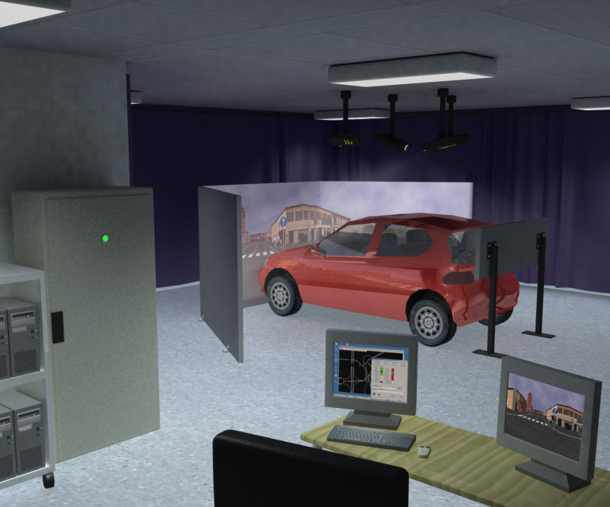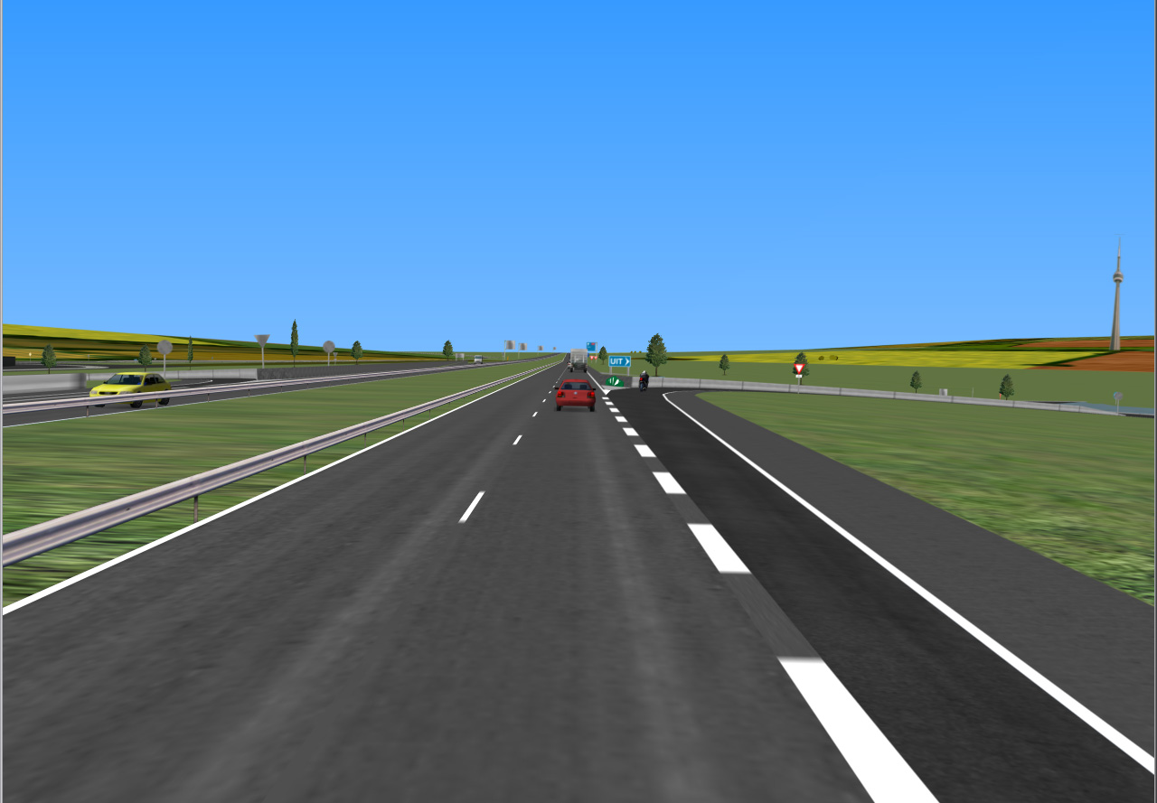
a) Over View of AutoSim Car Simulator System b) Simulation Scene
Figure 1 Aotusim Car Simulator System and Scene
Figure 2 Work Flow Diagram Of Aotusim Car Simulator System
Control centre: realize the experiment environment by the special-purpose software, adjust traffic flow, design of highway geometric design and vehicle type and etc.
Scene system: Eight cluster computers control three pass ways of projectors, which is used in the image formations of traffic flow and road environment. The computer program controls the movement of the vehicle, left deviation, right deviation, rear-view mirror and indoor rear-view mirror projector through automatically controlled cupboard, and feedback the road conditions information to the control centre, works together with projector control system and sound system to make the driver come into being on the presence of driving in a true road.
Operating system: it is a Toyota yarls true car without engine, but installed with various transducers. This system can measure driver's psychology and physiological response data at the time of driving and record the respond data together with information of vehicle, environment, road conditions in the database for subsequent use.
  - EXPERIMENT DESIGN
The connection between counties and villages in China is mainly realized through the two-lane highway, and in recent period, the pattern of communications and transportation that relying mainly on two-lane highway inChina will not change. So it has great realistic meaning and historic significance to study the driver's tension degree through Aotusim Car Simulator System. For there are many influence factors that the experiment involves, it can be analyzed through some relevant research that driver, vehicle, road geometric alignment and environment as the mainly control the factor. It is usually to choose the driver with more skilled driving technology with 25-55 years old, the experimental vehicle is the main type of the highway at present, road geometric alignment is the most common type road in China, environment chosen in sight view section with artificial or form naturally. Experiment should be carried out with sunny weather day when the traffic flow is not a peak, the satisfied sample counts is 26 [9].
1.3 FLOW DIAGRAM OF EXPERIMENT
With the progress of science and technology, it already becomes very easy to utilize the computer to optimize, simplify the complicated experiment. In order to minimize the error that experiment produced, to control influence factor unfavorable to experiment and to stress the favorable influence factor, the work flow diagram of the experiment was designed (as shown in Fig. 3)
It carries on three-dimensional modeling concretely according to the selected road geometric alignment first, and then turns into design program by transforming software special-purposely, finally inputs the design program into the simulation cabin to realize the reconstruction of the sample highway section. At the same time installed the driver with the detect instrument, when simulation cabin and detect instrument working together, the database will record the measure data and store the data for future analyzing, until the measure data reached the necessary sample count. We can get the data result dealing with special-purpose software.
Figure3 Framework Of Experiment
- DATA ANALYSIS
This research carried out an experiment based on the above framework and collected the test data. Then did clustering treatment of these data to find driver's tension degree rule. For some specific spots, it is necessary to come back to the videotape record to analyze the reason produced diversity, and then remove the exceptional experimental data. The dealt result fills in the following Table 1 (the heart beat at the driver's resting time is 67.7 times / min)

Table 1 Experimental Data
Item | 1 | 2 | 3 | 4 | 5 | 6 | 7 | 8 | 9 | 10
Comfortable increase rate of heart beat（%） | 24 | 18 | 23 | 21 | 30 | 24 | 13 | 20 | 25 | 23
Nervous increase rate of heart beat（%） | 30 | 27 | 32 | 29 | 38 | 30 | 24 | 27 | 35 | 32
Frightened increase rate of heart beat（%） | 43 | 39 | 49 | 40 | 49 | 43 | 37 | 57 | 52 | 62

Figure 4 Tension Degree
As shown in table1, there are three vertical straight lines to represent driver's comfortable, nervous, frightened feeling by the data. The length of the straight line describes its dispersed intension, that is the area of comfort, nervous and frightened degree of drivers. In order to study the threshold value of tension degree accurately, it connects the maximum, minimum, average, 15% value and 85% value of the comfortable, nervous and frightened sense respectively, then it is the comfortable district below the blue line, it is the frightened district above the purple line. In order to get a rational theory base value, it used the tension degree threshold value of the increase rate of heart beat of the drivers whose increase rate satisfied 85% heart rate with consideration of traffic safety. That is shown in Fig. 4, the points of intersect of every straight line and curve 15% of the value are the comfortable, nervous and frightened threshold value of theories. They are 18%, 27% and 39% of the comfortable, nervous and frightened threshold values calculated with the law of inserting value by the chart data separately. Then we can get tension degrees of heart rate model as formula (1) shows regressed by 15% curve.
$y=\text{12}\text{.}\text{306}e^{0\text{.}\text{3866}x}$ （1）
Which, y is increase rate of heart rate, and
x is tension degree.
The correlation coefficient is: R=0.9996
Verified by F_{0.05} $F_{0\text{.}\text{05}}(n_{1},n_{2}−1)=\text{161}\text{.}4$ in statistics table.
For $F_{a}(n_{1},n_{2})=\frac{R^{2}(n−2)}{(1−R^{2})}$,then $F_{0\text{.}\text{05}}(1,3−1)=\text{1249}\text{.}\text{25}>\text{161}\text{.}4$; So formula 1 can meet the curve exactly.
To be notice : for the limitation of sample amount and experiment terms, this study just probed into the threshold value of driver's tension degree in a preliminary discussion, further research will be carried out based on the follow-up survey data .
- VARIFICATION
In order to examine the reliability of the experimental result, it was compared between the experimental data and survey data, table 2 shows the contrast of lateral force coefficient calculated by tension degree of driver and result detected by ball inclinometer in America [10]. It can be seen from the table, when the increase rate of heart beat is 28%, the lateral force coefficient is 0.1 and correspondingly the driver can not feel the existence of curve and no feeling of nervous; when the increase rate of heart rate is up to 30%, it is nervous to begin, the driver can feels slightly that there are curves; when the increase rate of heart rate exceeds 30% and reaches 32%, driver will feel nervous, thus 28% is the threshold value for nervous, it is closer to calculated result. With Consideration of the
Table2 contrast of lateral force coefficient and increase rate of heart beat
lateral force coefficient | increase rate of heart beat | Feeling drive on curve
0.10 | 28% | No feeling of curve, no feeling of nervous
0.15 | 30% | Slight feeling of curve, no feeling of uncomfortable and nervous，tireless
0.20 | 32% | General feeling of curve, no uncomfortable, slight feeling of unstable, obviously nervous。
0.25 | 34% | feeling of uncomfortable of 40% drivers
0.30 | 36% | feeling of uncomfortable of Total drivers
0.35 | 38% | Strong feeling of uncomfortable, sharp increase of nervous, danger of slipping to roadside, unstable
0.40 | 40% | Strong feeling of unstable for passengers, difficult to stand, danger of toppling
0.5 | 45% | Strong feeling of nervous, vehicle easy to topple. stop value
0.6 | 50% | Strong feeling of nervous, vehicle extremely topple. stop value
difference of experiment environment and the realistic environment, actual value may be a little bigger than the experiment value, so it is more rational to suggest 30% of increase rate of heart rate as threshold value of driving behavioral studying. When the increase rate of heart beat exceeds 38%, the driver has strong feeling of road curve and tension mood increase sharply, at the same time the vehicle is unstable and has danger of slipping to the roadside. When he increase rate of heart beat exceeds 40%, the passenger feels very unstable, east upside down, the vehicle has danger of toppling. Therefore 40% of increase rate of heart rate is the threshold value of the safety degree .

4 CONCLUSION
In order to solve the traffic safety problem, this paper intergraded driving simulation cabin, and dynamic apparatus of heart beat proceeding from psychology and physiologic theory and vehicle dynamics to measure driver's psychological and physiological response data in driving based on the support from the virtual reality artificial system of two-lane highway in the mountain area. Driver's nervous feeling was analyzed on those measure data to get driver's tension grade classification, to find a threshold value of drive tension degree, which was validated. This study about driver’s tension degree will offer the solid foundation of the subsequent road safety research, and also offer the reliable basis for road safe audit of geometric alignment design. In addition the result of this has important effect on reducing road accidents and this paper probed a new way to identify traffic accident black section.
References
1 Ren Futian,. Psychology of Traffic Engineering. Beijing University of Technology Press, 1993.3
2 Jiang XueFeng. Ten thousand trucks of mortality are dropped to the units in the whole country for the first time. Journal of Road Traffic Safety, 2006.1:43
3 (Su) Babb but, Jing Tianran. Road status and traffic safety. Tongji University Press, 1990.6
4 Chen Yongsheng, Basic theory in Safety Design and key technology in freeway. Beijing University of Technology Dr.'s academic dissertation: 2001.5
5 Yuan Zhifa, Zhou Jingqin, Experiment Design and Analysis. Higher Education Press. 2000.3
6 Li Xingwang, Physiology and Psychology. Science Press, 2001.8
7 (Japan) Zuo Tengqing, Physiological burden of the train driver when 160km/h operates. Foreign diesel locomotive. 1997.6: 19-25
8 Qiao Jiangang, Xu Jihai, Ren Futian, Rong Jian, Research on drive detection. Journal of Test technology (supplementary issue). 2004.4,18: 191-194
9 QIAO Jiangang, RONG Jian, REN Futian, LIU Xiaoming. Study on Relation Between Traffic Safety and Driver's Psychology and Physiology Responds E. PROGRESS IN SAFETY SCIENCE AND TECHNOLOGY, (VOL Ⅳ). PARTB.2004.9: 2594-2597
10 Qiao Jiangang, Research on key parameter of two-lane highway of mountain area based on driver's factor. Beijing University of Technology Dr.'s academic dissertation: 2006.6

Fund project: Fund subsidy project of center for doctors of Ministry of Education (20040005003); Fund subsidy project of Municipal Education Commission of Beijing (05004011200507);

Author's profile:
Name: Qiao Jiangang, birth: 1963; sex: male; Education: Doctor's associate professor;
Research area: traffic safety, drive behavior, vehicle engineering.

Email: qiaojg@emails.bjut.edu.cn;
Tel.: 13503546378, 010-86196616
Address: Traffic research center
Beijing University of Technology 100022
Beijing China

