Land Uses around Urban Rail Stations:
A Case Study of Shanghai
Dr. Pan Haixiao, Professor
Department of Urban Planning, Tongji University, Shanghai 200092
E-mail:hxpank@online.sh.cn

Ren Chunyang， Yang Diaoyun
Former Research Assistant，Department of Urban Planning, Tongji University, Shanghai 200092.

Abstract
This study examines the land uses around urban rail transit stations to assess the impacts of urban rail transport to the station area has been analyzed .This research investigates the land use around 48 stations on Shanghai Metro Line 1(L1), Line 2(L2) and Line 3(L3). On the basis of analysis of the overall impact on land use and variation of the impact with the proximity to rail station, research findings indicate that construction period, the location of rail transit lines all have the diffident implications on land use. Moreover, due to control of land use around the station house, the land use characteristics in the core areas of rail transit stations contrary to the basic principles of urban land economics. This evidently in the future urban planning control needs to be improved.

Keyword: Urban Rail Transport, Station Area, Land Use, Empirical Study, Shanghai

Introduction
The construction of large scale of metro systems is now a major strategy being used to improve urban transport in China’s mega-cities. By 2020, Shanghai’s metro system will have more than 400 kilometers of trackway, and Guangzhou 250 kilometers. Experience throughout the world indicates that the introduction of metro systems at the early stage of urban expansion will significantly impacts urban spatial structure. One expected structural change is changes in land-use intensity and composition in the area adjacent to transit stations. According to the principles of land-market economics, the introduction of a metro system changes the relative location advantage of the station area. The change in land use around the station in turn provides sufficient passengers to support rail transit. Introducing of metro also change the accessibility of the land around the station, and providing with the relative location advantage. So that there will be a concentration of development of high dense residential and commercial facilities, then the original urban structure will be changed. But further more on our observation, there also a significant variation in the impact on land use with the difference in location and development stage. Therefore it worth of study and review, which will be the valuable experience for other city or for rail transit system development in the future in the same city.

Rail construction in Shanghai has accelerated in the past ten years. Line 1 (L1) officially opened in 1995, and subsequent extensions and new lines brought the network trackway to 147.8 kilometers in 2005. That network serves both the densely-populated central areas of Shanghai, and also extends to some less-dense peripheral areas (for example, the southern and northern extension of Line 1). Due to the city’s high network density in the central city, the impact of the metro on the overall urban spatial structure of Shanghai is still quite limited. However, in the areas of the city served by rail transit, the effects of the service are already quite apparent and display some unique characteristics. The success, for instance, of Xujiahui, which was designated as one of the four sub-centers more than twenty years ago in Shanghai master plan, is largely depended on the operation of Metro Line 1. The development of the other three planned sub-centers – areas not accessible by metro – is far behind Xujiahui. And with the opening of the southern extension of Line 1 (Xujiahui – Xinzhuang), population along this corridor is increasing rapidly from 17000 to 32000 people with in 300 buffer area in 5 years and in a desirable compact pattern. The relatively-recent implementation and large scale of Shanghai’s rail transit system provides an opportunity for an analysis of land use changes occurring concomitantly with the implementation of a rail system.

Theoretical Background and Objectives

Market land-economics principles dictate that transportation improvements generally increases in land rent and, concomitantly, increases in land-use intensity. Alonso’s (1964) microeconomic theory is used as a framework for this analysis. This work essentially states that transport costs and land rent are inversely related. In its simplest form, his bid-rent curve (shown in Figure 1) indicates that land values will decrease with distance from the highly-accessible central city, in conjunction with increases in travel costs to the CBD. Figure 1 also shows the theoretical effect of a transport improvement along a radial corridor. Increased accessibility to the CBD raises land rents in outlying areas and the city boundary will be extended.
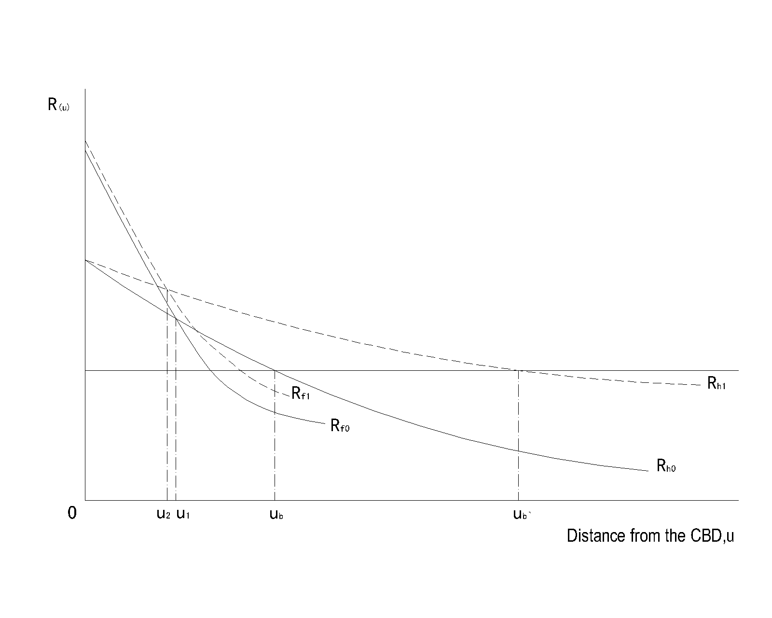
Fig. 1 Land Rent Change with the Transport Improvement (Broken Lines)

At a smaller scale, an improvement in accessibility (such as the introduction of an urban rail system) could generally raise the land rents in the vicinity of a station area. These higher land rents in turn induce changes in the intensity of development to higher and better uses. In short, the introduction of an urban rail station should lead to higher local land rents, which over time lead to higher residential and commercial densities, and the relocation of less-efficient land uses.

This research examines the land uses adjacent to rail transit stations in Shanghai to determine whether land use structure, intensity and land prices correspond to the theoretical assumptions of market economics. This study also attempts to exam how the land use responding to the introducing of rail transit system (a spatial coupling model) in different urban locations and development stages.

Data
A survey of station-area land uses was completed between September 2 and September 16, 2003 by students from the Department of Urban Planning at Tongji University. Cordons of 500 meters or 1000 meters (explained below) were established around all of the 48 stations along Metro Lines 1, 2, and 3 (L1, L2, L3), and land use types and intensity within these cordons were catalogued in detail. These cordons were carefully considered, as it is well-known that the specificities of definition can significantly impact the results of a study. There are four ways to define the boundary in practice: radial distance, functional-context factors, terrain boundaries, and development boundaries. All have their advantages, but considering practicality and the importance of quality walk-oriented space, a 500-meter radial distance (roughly 10 minutes walk time) was used as a basis to place the cordon around each rail transit station. For stations outside of the Inner Ring Road, bicycling is widely used as a connecting mode, so the cordon was extended to 1000-meter radial.

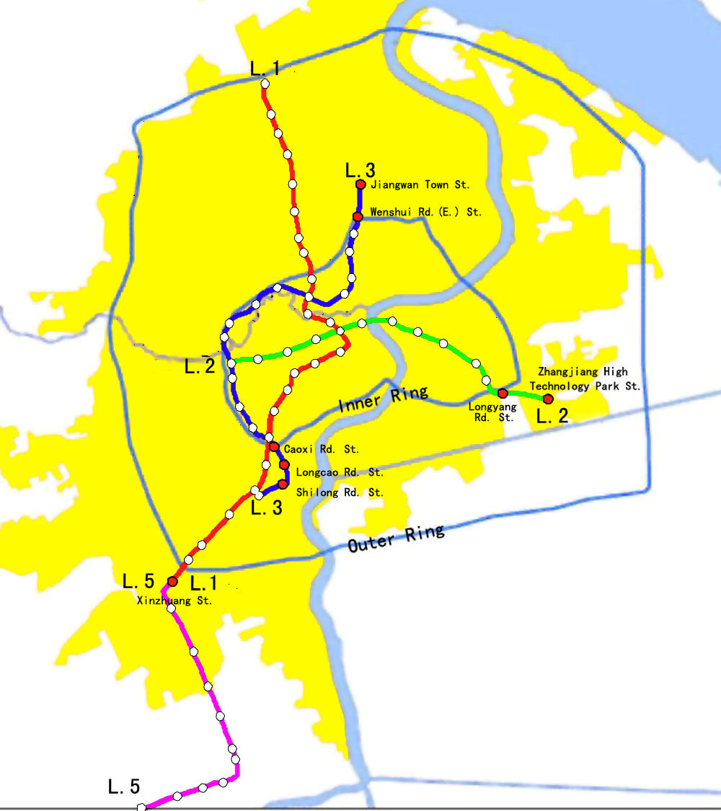
Fig 2. Metro Lines in Shanghai (2003)

The land use around the station was categorized as follows: residential(R), commercial (C2), office (C1), other public facilities and utility (C3-C8, U), manufacture and warehouse (M, W), road and transport (T, S), Green Space (G), unused and other (D, E). Additionally, development intensity was defined according to the criteria of the floor space ratio control in the "Shanghai Urban Planning Management Technical Regulation (land-use construction management)": FAR<1.0 is considered “low intensity”; FAR between 1.0 and 2.5 “middle intensity”; and FAR over 2.5 “high intensity.”

Results

Overall land use characteristics

Based on an overall comparison of the land-use composition adjacent to the three metro lines, we can conclude that both line alignment and recency of construction impact adjacent land uses. Table 1 shows the land use composition, by percent, for the stations along each Metro line. The table indicates that land-use composition is quite similar for L1 and L2, but L3 is substantially different with respect to office, commercial, public facilities, manufacturing/warehouse and green space land uses. This pattern is easily explained by the relative locations of the lines and also the duration of their presence. Metro Line L1/L2 links the city's major activities centers in east-west and north-south direction. Metro Line L3 follows the route of the former inter-city railway loop, passing various city activity centers en route through the western part of the central city. Historically, this heavy-rail route served factory and warehouse land uses. With the recent economic restructuring and land reforms, factory and warehouse uses have been moved out of the central city to clear the way for residential buildings. So, along L3, residential uses are seen in higher ratio than in L1 or L2, but the ratio for office, commercial and other public facilities is far below metro line L1 and L2.
Table 1. Land use composition within 500 meter radius
Rail | land use composition ％
Rail | residential | public |  |  |  | Industry-warehouse | Green space | Transportation
Rail | residential | office | Commercial | Other | Sub-total | Industry-warehouse | Green space | Transportation
L1 | 34.7 | 4.5 | 17.5 | 7.5 | 29.5 | 2.0 | 12.6 | 16.4
L2 | 33.9 | 4.5 | 15.9 | 6.7 | 27.1 | 2.8 | 14.4 | 15.7
L3 | 42.0 | 2.1 | 9.2 | 8.3 | 19.6 | 8.7 | 4.1 | 23.2
Core Area（Within the inner ring 2002) | 37.9 | 16.1 |  |  |  | 6.2 | 5.0 | 19.1
Central city（within the outring）current land use | 28.9 | 9.6 |  |  |  | 22.9 | 6.1 | 13.6
Central city land use plan（2020） | 38.8 | 8.3 |  |  |  | 14.1 | 14.9 | 21.3

There is also still a high proportion of industrial land along L3. Furthermore, L3 is newer than L1 – five years after L1 opened. This land is still in transition and may display land-use compositions similar to those along L1 and L2 in the future with urban spatial changes.

In addition to overall comparison of the three lines, we further compared the land use composition along the three metro lines with that of the central city averages. The results indicate that land used for public facilities (e.g. retail, office) is much more prevalent along the three metro lines than in the city on average: 29.5 percent for L1, 27.1 percent for L2 and 19.6 percent for L3, which is far higher than that of Shanghai central city (9.3 percent), and even higher than that of the core city (16.1 percent). This implies the rail transit network effectively links various activity centers. The composition of industrial land along the three metro corridors is also lower than that of the central city, which makes sense from a market-economics perspective. And the green space area ratio along metro line L1/L2 is more than two times higher than that of the central city. This reflects new planning regulations and the general effort made during the metro construction to improve environmental quality.

Land use characteristics near rail transit stations
Table 2 itemizes these figures by Metro line and both 500-meter and 100-meter buffers.

Land Use Composition

Table 2 land use compositions in the buffer areas around Shanghai’s metro stations.
 | Residential | Office | Commercial | Other public uses | Industrial /Warehouse | Green Space | Transportation | Vacant | Total
Metro Line-1
Inner Buffer | 24.5 | 3.0 | 24.0 | 8.1 | 0.9 | 16.7 | 18.8 | 4 | 100
Outer Buffer | 36.6 | 4.8 | 16.3 | 7.4 | 2.2 | 11.8 | 16.0 | 4.9 | 100
Differences | +12.1 | +1.8 | -7.7 | -0.7 | +1.3 | -4.9 | -2.8
Metro Line-2
Inner Buffer | 26.4 | 6.3 | 18.1 | 5.5 | 0.5 | 15.9 | 22.4 | 4.9 | 100
Outer Buffer | 35.3 | 4.2 | 15.5 | 7.0 | 3.2 | 14.2 | 14.4 | 6.2 | 100
Differences | +8.9 | -2.1 | -2.61 | +1.5 | +2.7 | -1.7 | -8.0
Metro Line-3
Inner Buffer | 25.7 | 2.8 | 10.7 | 3.5 | 8.6 | 7.7 | 38.6 | 2.4 | 100
Outer Buffer | 45.1 | 2.0 | 8.9 | 9.2 | 8.7 | 3.5 | 20.2 | 2.4 | 100
Differences | +19.4 | -0.8 | -1.8 | +5.7 | +0.1 | -4.2 | -18.4

Table 2 indicates that: The inner buffer (500 radial meters) contains a smaller share of residential use than the outer buffer (1000 radial meters). For instance, residential use accounts for 36.6% of the total land in the outer buffer zones along L1. In the inner buffer zones of L1, the figure is 24.5%. Similar residential land use patterns occur in the station areas along L2 and L3. Likewise, land for industrial or warehouse uses has smaller shares in the inner buffer than in the outer buffer.
Concomitantly, the inner buffer contains a greater proportion of commercial land use than the outer buffer across all three metro lines. In the inner buffers, the proportions of commercial land use are 24%, 18.1%, and 10.7% along metro L1, L2, and L3, respectively. The corresponding figures in the outer buffer zones are all smaller. Specifically, they are 16.3%, 15.5%, and 8.9%, respectively. The between-buffer differences indicate a nodal concentration of commercial (re)development around rail transit stations, and a ring of residential development surrounding a highly-commercial core. The land use pattern of having commercial land uses closer to the stations and residential or industrial uses farther away suggests the existence of land market forces that shape land use patterns in the station area along Shanghai’s rail transit lines. A station area is like a mini land market, with the station being the market center. Different land uses bid for being closer to the station. The bidding outcome displays a typical mono-centric land use profile similar to that described in the classic urban economic theory at the city scale.
Additionally, as expected, the share of land for transportation uses in the inner buffer is larger than that in the outer buffer. This is due to the presence of train stations and related facilities. Notably the inner buffer has larger shares of green space than the outer buffer, which seems contradictory to the common knowledge because the inner Shanghai has been known for its high density and lack of open space. Explanation lies in the process that, when the new rail transit stations were planned and constructed, it was mandatory by the national planning and design code to provide a certain level of green space for new development projects.

With regards to industrial and warehouse uses in the station areas, L3 has much larger proportions than those of L1 and L2. In both the inner and outer buffers of L3, industrial or warehouse land uses occupy 8.6-8.7% of station area land. In the station areas of other two metro lines, the number is about 3% or less. As previously mentioned, this is mainly because L3 was developed along an existing heavy rail alignment. Along the L3 alignment there remain a large amount of industrial sites or warehouses, which offer significant potential for future redevelopment.

Land Development Intensity

Development intensity, as measured by FAR, was also examined. There appears to be significant differences among the three lines, and also among the inner and outer buffers in an overall comparison.
Table 3 shows that the inner buffer has been developed more intensively than the outer buffer for L1 and L2. For example, along Metro Line-1, the percentage of lots with FAR greater than 2.5 in the inner buffer (45.7%) is much larger than that in the outer buffer (35.6%). Similar patterns can be observed with L2. For L3, however, the opposite is true: the inner buffer is even less developed than the outer buffer. The reason is the same as mentioned above: L3 is relatively new and the alignment generally follows an industry-serving rail track. Redevelopment of the station areas has not yet taken place.

Table 3: Comparison of development intensity between 0-200 and 200-500 buffer zones in Shanghai

Metro Line | FAR<1 | FAR=1-2.5 | FAR>2.5
Metro Line-1
Inner Buffer | 29.4 | 22.9 | 45.7
Outer Buffer | 26.5 | 35.4 | 35.6
Differences | -2.9 | +12.5 | -10.16
Metro Line-2
Inner Buffer | 42.9 | 34.2 | 22.9
Outer Buffer | 37.5 | 41.9 | 20.6
Differences | -5.4 | +7.6 | -2.28
Metro Line-3
Inner Buffer | 48.1 | 30.0 | 15.3
Outer Buffer | 42.8 | 40.1 | 17.1
Differences | -5.3 | +10.1 | +1.8

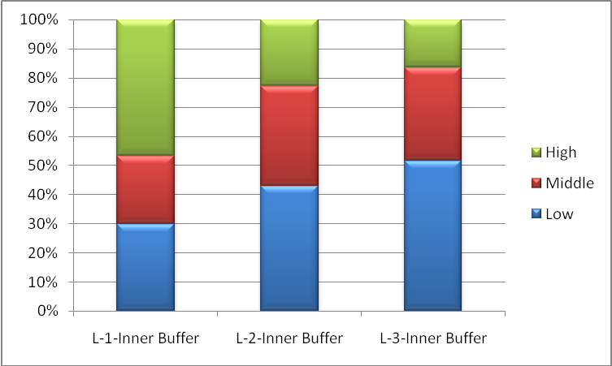
Fig 2 Intensity in inner buffer

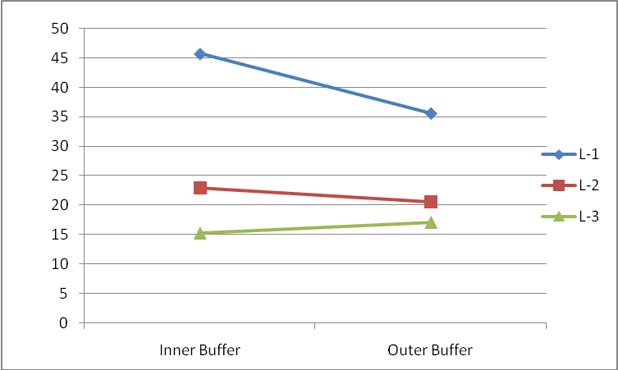
Fig. 3 Intensity gradient

Figure 2 shows generally the there is higher intensity of development in the inner buffer, but there still quite big proportion of low intensity area around the metro station. Fig.3 shows the intensity gradient curve based on Table 3, for each of L1, L2, and L3. The overall picture shows that the intensity in inner buffer is higher than that of outer buffer, which follows the general principle based on the bit-rent curve. But it shows that the curve for L2 is much flatter than L1. It presents the diminishing effects of the new metro on land use change. And in the case of metro line L3, the curve is even reversed, which does not follow the theoretical hypotheses mentioned above.

Except for the reason to provide the space for connecting transport, the land use control on the vicinity of station house limits the economical potential for the intensity development which could be the big revenue source to cover the construction and operation cost of metro system. The land use control regulation needs to be improved. Currently the land around station is controlled only for no-profitable purpose such as connecting transport, station house and green space, this largely prevent the potential for more efficient use of land around the metro station. The intensity around the station of metro line L1 is quite high, more closing to the station more intensive. For metro line L2/L3, there still quite large proportion of low/medium intensity old development. There was not significant changing in land use and building density after the opening of the metro system, and further more there were still vacant land and rural residential settlement, this is largely due to the relative short duration of operation, the line alignment of L3 and also the diminishing marginal effects. Even more the revered curve for L3 indicates that big change in land use along L3 was still expected.

Land Use in the Peripheral Areas

As Table 4 indicates, the proportion of residential land uses within the outer buffer is much higher than that within the inner buffer (nearly 8 points higher). This indicates that the land very close to metro station is not dominated by residential purpose as the typical transit village “TOD” model even in the peripheral areas. Land used for office/commercial is much smaller than that in central Shanghai, so there will be less employment opportunity.

Table 4: Land use composition in suburban stations of Metro Line-1, Shanghai

 | Residential | Office | Commercial | Other public uses | Industrial /Warehouse | Green Space | Transportation | Vacant | Total
500-meter | 0% | 1.60% | 8.90% | 5.30% | 3.80% | 14.80% | 20.30% | 3.30% | 100%
1000-meter | 49.90% | 0.90% | 5.30% | 5.40% | 10.40% | 12.20% | 11.70% | 4.30% | 100%

One disadvantage of this balance of land uses in a particular node is that, if it occurs on a wide scale, it can lead to inefficiencies and imbalances in the transportation system. Were this land-use composition to be optimized to take advantage of the location’s accessibility, it could help to balance the in- and out-flow of passengers on this line. Figure 4 shows the inflow and outflow of passengers on L1 and L2 in the morning peak. L2 is relatively balanced; however, L1 has a high ratio of inflow to outflow. Using some of the station-area space for public/office use could help to balance the flow of passengers inbound and outbound.

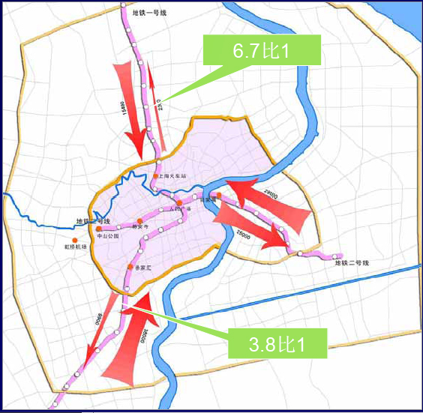
Fig.4 Tide Passenger Flow

Another phenomena observable in the peripheral areas is that there are a comparatively more new buildings within the 500 meter buffer than beyond this boundary to the 1000 meter buffer. Outside of the inner buffer, most of the buildings were established years before the opening of rail transit. This implies that, in the peripheral areas, the impacts of the system are relatively contained within a 500 meter radius – a walk-able distance. Figure 5 shows that the land use will be at its highest value in 200-500meter radius than declines in the far periphery(Jian Jiang, Out-Ring Station) which is different from that of CaoBo Lu station locating close to the inner ring.

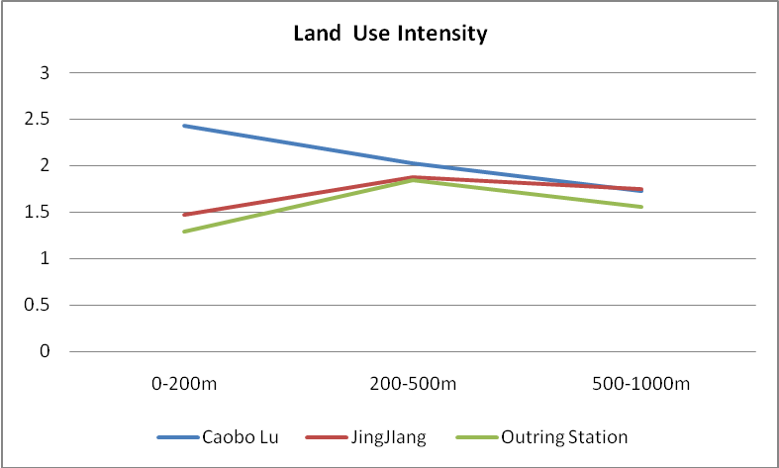
Fig 5. Land intensity around some far periphery metro station of L1

Comparing the land uses around the peripheral stations on L1 with L2 and L3, Table 5 indicates that the land use composition for industry use is still much higher along L2/L3 than along L1 in the periphery areas. The table also indicates that L1 has higher concentrations of green-space and transportation facilities close to the station.

Table 5: Comparing land use in periphery along metro L1, L2 and L3
 | Residential | Commercial | Office | Other public | Industry and warehouse | Transportation | Green Space | Vacant | Other
500 meter buffer
Average L1 | 42.0% | 8.9% | 1.6% | 5.3% | 3.8% | 20.3% | 14.8% | 1.6% | 1.7%
Average of L3and L2、 | 39.2% | 8.9% | 1.8% | 6.4% | 20.3% | 11.1% | 4.4% | 2.2% | 5.7%
1000 meter buffer
Average L1 | 49.9% | 5.3% | 0.9% | 5.4% | 10.4% | 11.7% | 12.2% | 1.8% | 2.5%
Average of L2/L3 | 49.6% | 5.3% | 1.8% | 5.3% | 14.8% | 8.0% | 6.2% | 3.4% | 5.5%

The intensity around the station of metro line L1 is quite high, more closing to the station more intensive. For metro line L2/L3, there still quite large proportion of low/medium intensity old development. There was not significant changing in land use and building density after the opening of the metro system, and further more there were still vacant land and rural residential settlement (Figure 6).

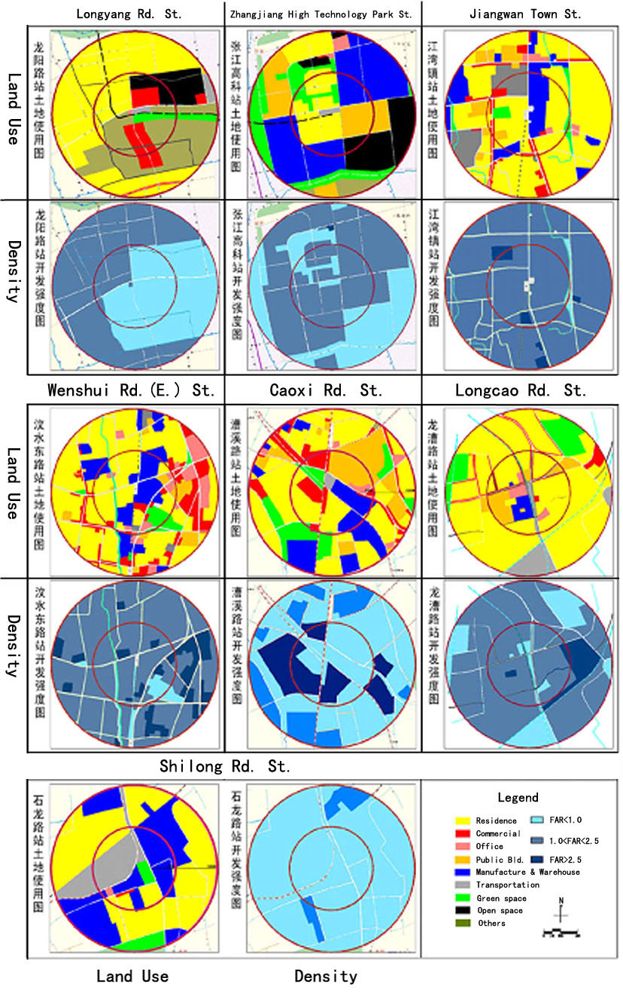
Fig 6 . The land use around the metro station

Three years behind the opening of the metro line L1, after the operation for three years, the land use around metro line L2/L3 was still at the very preliminary stage of development with the characteristics of land use in the periphery area: low intensity, large share for industry/warehouse, less green space. After six years of operation of metro line L1, land use has responded to the changing of accessibility with a higher intensity, more logical land use composition and the gradient around the station.

Conclusion

Based on the above analysis of the survey, it can be concluded that:

- Land uses in station areas do not appear to conform to the principles of market economics. This may due to the recency of land reforms and the newness of the metro lines. It is noteworthy that the stations along the oldest metro line (L1) appear to adhere most to market principles, which indicates that the others may follow suit in time.

- The intensity of land use, generally overall intensity of development is high, but there still not shows significant gradient features in intensity distribution with the distance to the station. The regulation on the municipal utility limits the floor area ratio of the station house site, in contrary to the land economic theory of high-intensity development; the intensity valley was formulated around the station house site. Land use regulation needs to be reformed to use the advantage of accessibility

- Comparing the impact of the Metro lines on land use, we can found that metro line L1 has a stranger impact than the other two lines. This evidence shows the effect of the Law of Diminishing Marginal Returns with the extension of the network. Therefore, we have to consider the size of rail transit network to be constructed, and also the marginal effect of rail transit system on land use. Thus ensuring in the future, with a quite dense rail transit network, there will be still enough passenger to support the transit system along each segments, which will be of great important for economic viability of operation for a rail transit system.

- For a more balanced travel demand, land use policy should also be used to establish employment center of service and office particularly with reference to land at the urban periphery. Current urban spatial structure should be carefully reviewed with the consideration to establish secondary city center not only just within the inner ring, but also in the periphery with there still large industry area to be transformed.

- In the periphery, when the metro networks is still in low density, the land use model should not follow the typical transit village, good connecting transport should be provide to extend the metro service coverage area.

Reference and Notes

This research is supported by China Natural Science Foundation
Robert Cevero, The transit metropolis-a global inquiry, island press, 1998
Chen Bizhuang，Zhu Hong(2003), Transport Strategy to Shanghai Urban Spatial Restructure, 20th Conference on Urban Transport Research, China Urban Transport Society.
Alonso,W. (1964). Location and Land Use: Toward a General Theory of Land Rent. Cambridge, Harvard University Press.
Patrick S. McCarthy(2001), Transportation Economic/Theory and Practice/a Case Study Approach Blackwell Publishing
Current land data is to the year of 2002, planning data is for year 2020。Source：Shanghai Urban Planning Bureau, Shanghai Urban Design Institute.

